**Title of the Paper (Verdana 12, bold, centered)**

**Name Surname1, Name Surname2 (Verdana 9, bold, centered)**

1 University

School, Department

Address

E-mail: email@email.cz

2 University

School, Department

Address

E-mail: email@email.cz

***Abstract:*** *Abstract (6-15 lines, Verdana 9, italic, block-aligned), abstract (6-15 lines, Verdana 9, italic, block-aligned), abstract (6-15 lines, Verdana 9, italic, block-aligned), abstract (6-15 lines, Verdana 9, italic, block-aligned), abstract (6-15 lines, Verdana 9, italic, block-aligned), abstract (6-15 lines, Verdana 9, italic, block-aligned), abstract (6-15 lines, Verdana 9, italic, block-aligned), abstract (6-15 lines, Verdana 9, italic, block-aligned), abstract (6-15 lines, Verdana 9, italic, block-aligned), abstract (6-15 lines, Verdana 9, italic, block-aligned), abstract (6-15 lines, Verdana 9, italic, block-aligned), abstract (6-15 lines, Verdana 9, italic, block-aligned).*

***Keywords:*** *five keywords at most (separated by comma)*

***JEL codes:*** *five JEL codes* ***at most*** *(see* [*http://www.aeaweb.org/jel/jel_class_system.php*](http://www.aeaweb.org/jel/jel_class_system.php)*)*

# Introduction (First-level heading, Verdana 11, bold)

Text (Verdana 9, block-aligned), do not number Introduction and Conclusion(s), Text (Verdana 9, block-aligned), do not number Introduction and Conclusion(s).

Text (Verdana 9, block-aligned), do not number Introduction and Conclusion(s), Text (Verdana 9, block-aligned), do not number Introduction and Conclusion(s), Text (Verdana 9, block-aligned).

# 1 Methodology

Text (Verdana 9, block-aligned), text (Verdana 9, block-aligned), text (Verdana 9, block-aligned), text (Verdana 9, block-aligned), text (Verdana 9, block-aligned), text (Verdana 9, block-aligned).

**1.1 Model Specification (Second-level heading, Verdana 9, bold)**

Text (Verdana 9, block-aligned), text (Verdana 9, block-aligned), text (Verdana 9, block-aligned), text (Verdana 9, block-aligned), text (Verdana 9, block-aligned), text (Verdana 9, block-aligned).

**Other heading (not numbered, Verdana 9, bold)**

Text (Verdana 9, block-aligned), text (Verdana 9, block-aligned), text (Verdana 9, block-aligned), text (Verdana 9, block-aligned), text (Verdana 9, block-aligned), text (Verdana 9, block-aligned).

# 2 Data

Text (Verdana 9, block-aligned), text (Verdana 9, block-aligned), text (Verdana 9, block-aligned), text (Verdana 9, block-aligned), text (Verdana 9, block-aligned), text (Verdana 9, block-aligned).

# 3 Format Guidelines

Tables and figures have to be numbered and references to them must be in the text. The text should be composed in such a manner that there are not a greater number figures or tables on a single page.

**Table 1** Title of the Table (Verdana, 9, centered)

|  |  |  |  |  |
| --- | --- | --- | --- | --- |
|  | 2009 | 209 | 2011 | 2012 |
| Trade value, USD | 111 | 222 | 333 | 444 |
| Trade volume, USD |  |  |  |  |

**Source:** Please provide a source (Verdana, 8, centered)

**Figure 1** Title of the Figure (Verdana, 9, centered)

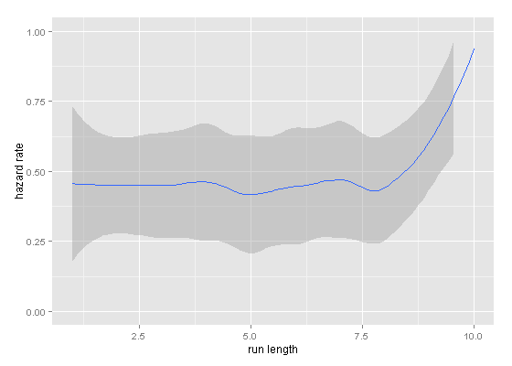

**Source:** Please provide a source (Verdana, 8, centered)

Equations and formulas are denoted by numbers in round parentheses. Please create them by Equation Editor (not a picture).

 (1)

 (2)

 (3)

**IMPORTANT:** *Use citation continuously in the text. The list of references should be complete and accurate. For each work shown in the list of references must be a reference in the text.* Example:

* Markowitz (1952) or (Markowitz, 1952)
* Black and Scholes (1973) or (Black and Scholes, 1973)
* Phillips et al. (2009) or (Phillips et al., 2009)

# Conclusions

Please do not use footnotes for citation. Do not number pages. Please do not use footnotes for citation. Do not number pages. Please do not use footnotes for citation. Do not number pages. Please do not use footnotes for citation. Do not number pages.

# Acknowledgments

Information on acknowledgments and financial support are posted here.

# References

Make the list of references in alphabetical order.

**The list of references must contain only items cited in the text.**

If available, the DOI can also be added at the end of references.

*Example*

Arrow, K. J. (1991). Accounting for the Slowdown. In: Kosters, M. (eds): *Workers and Their Wages*. Washington, DC: American Enterprise Institute Press, pp. 97-145.

Gould, J. P. et al. (1970). *Smoothing Technique*. New York: Springer Verlag.

Goyal, S. K. (2007). An Integrated Inventory Model for a Single Supplier-single Customer Problem. *International Journal of Production Research,* 15(7), pp. 97-91.

Green, H. (1993). *Econometric Analysis*, 2nd Ed. New York: Macmillan.

Mishra, P. and Sahoo, D. (2012). Structure, Conduct and Performance of Indian Banking Sector. *Review of Economic Perspectives,* 12(4), pp. 235-264. DOI: 9.2478/v9135-012-0011-9