Epithelial tissue (epithelium)

General characteristics of epithelium
- Is avascular tissue (without blood supply – cells receive nourishment by diffusion from a highly vascular area of loose connective tissue just below the basement membrane called the lamina propria )
- is highly cellular tissue – cells are arranged to form cohesive sheet or groups with no or little extracellular matrix
- displays a free surface – usualy luminal surface (turned to the lumen)
- opposite (basal) surface adheres to extracellular basement membrane or lamina basalis
- epithelial cells display polarity – apical (luminal), lateral and basal surfaces with structural specialization
- epithelial cells are specialised for absorption, secretion or to act as barrier
- lateral surfaces display junctional complexes for intercellular cohesion and communication
One type of epithelium may change into another type – metaplasia (examples: pseudostratified ep. of respiratory passages transforms into stratified squamous ep. on the surface of epiglottis and soft palate)

Membrane specializations of epithelia Lateral surface Specialised structures are present in epithelia which link individual cells together. Two main adhesion types are distinguished:
- Cell membrane proteins acting as specialised cell adhesion molecules (CAMs)
- Specialised areas of the cell membrane incorporated into cell junctions.
Three types are recognized: occluding junctions, anchoring or adherence junctions and communicating junctions.
  - Occluding junctions bind cell together to form an impermeable barrier
    - Zonula occludens or tight junction
  - Anchoring junctions link the cytoskeleton of cells to each other and two underlying tissues
    - Zonula adherens provides mechanical strength
    - Macula adherens or desmosomes provides mechanical strength in tissues where there are tensile or shearing stresses, eg skin
  - Communications junctions allow direct cell-cell communication
    - Gap junction or nexus allow rapid communication for coordinated action

Luminal (free, apical) surface
- Microvilli – short finger-like projection of the cell membrane to increased surface area (regularly arranged microvilli in intestines – striated border, in kidney tubules – brush border)
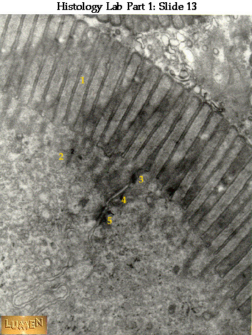 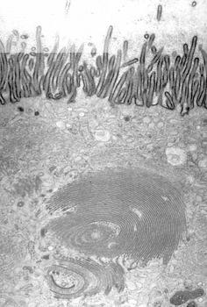 striated border brush border
- Cilia – hair-like surface projections of cells involved in transport
- Glycocalyx – thin extracellular layer consisting of protein glycoprotein and sugar residues; stains PAS positive; can act as enzyme, CAM or for cell recognition

Basal surface

Basal invaginations or folds – greatly enhance surface area; folded membrane with ions pumps + mitochondria form basal labyrinth in kidney tubules.

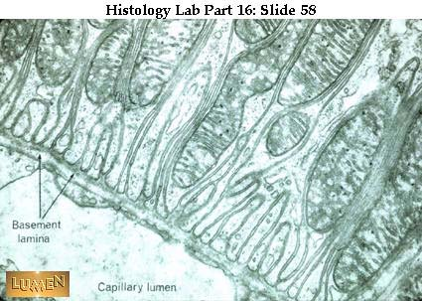

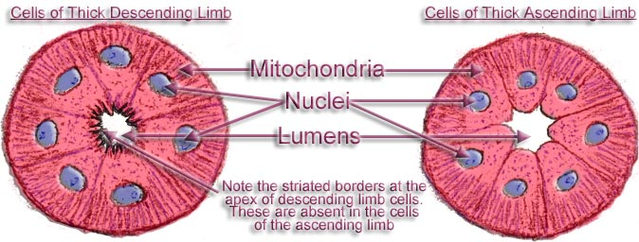

Note the striation of basal parts of the cells = basal labyrinth
Epithelial tissues are physically separated from underlying connective tissues by a basement membrane or basal lamina. The portion of an epithelial cell attached to the basement membrane is called its basal surface. The opposite side - facing the external environment, or lumen of a body cavity, is its apical surface. Basement membranes are composed of a special type of collagen and a substance called laminin (see below). The basement membrane helps epithelial cells orient themselves in relation to other tissues. After epithelial injury (e.g., an abrasion), the basement membrane serves as a scaffolding upon which new cells attach themselves during healing.
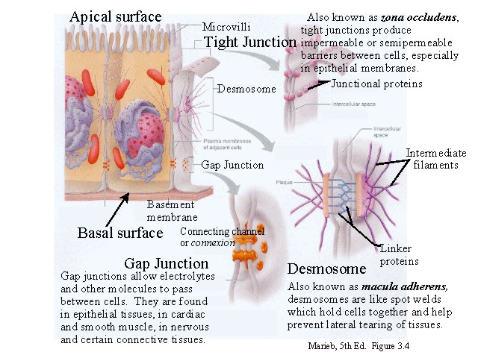

Cassification of epithelia

I. surface epithelium – is 1 or more layers of cells arranged into sheet;

 | According to number of layers | According to shape of cells in the outermost layer
surface epithelium |  simple layerd | – squamous
 |  | – cuboid
 |  | – columnar
 |  | – pseudostratified columnar
 |  stratified | – squamous non-cornified (non-keratinized)
 |  | – squamous cornified (keratinized)
 |  | – columnar
 |  | – transitional

SIMPLE EPITHELIA – only 1 (single) layer on basement membrane
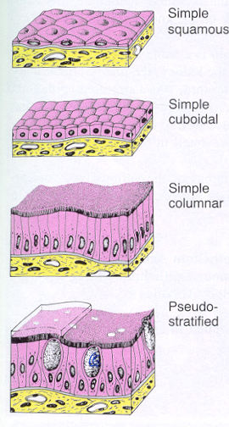 | Squamous – single layer of flattened thin cells with little cytoplasm and prominent nucleus. (In the smallest tubules and ducts of different organs, Henle´s loop or Bowman´s capsule in kidney) Endothelium – squamous epithelium in cardiovascular system. Mesothelium - squamous epithelium of mesodermal origin lining serous membranes and cavities.  Cuboidal - cell height, width and depth are the same, round centrally placed nucleus. (In renal tubules and small glanular ducts)  Columnar - cell height greater than width, nucleus elliptical or cigar shaped. (In the intestines, in the oviduct)  Pseudostratified – single layer but nuclei situated at different levels in the cell. All cells are in contact with the basement membrane, but not all cells reach the apical surface. Both conditions create the illusion of several cell layers. (In the respiratory passages – nasal cavity, larynx, trachea, bronchi)

STRATIFIED EPITHELIUM – consists of basal layer on basement membrane, several layers of polyhedral cells and surface layer. According to the shape of cells in this layer the epithelium is named (squamous, columnar, transitional)
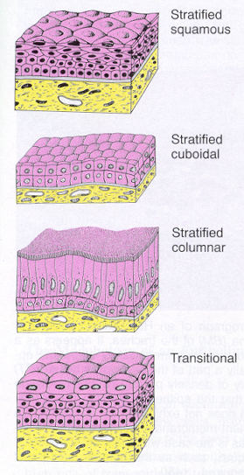 | Stratified squamous – resiting to mechanical influences (press) – non-keratinised (mouth cavity, vocal cords, vagina, anus) – keratinised (epidermis of the skin) – the cells are released continously from the surface  Is not described in human organism  Stratified columnar – 2 or more layers of cells, columnar cells form the upper layer (two-layered in ductus epididymis and ductus deferens, more-layered male urethra, conjunctive)  Transitional - stratified, top layer dome or umbrella shaped. (only in some urinary passages – renal pelvis, ureter and urinary bladder). Epithelium change the shape of cells and number of layers according to wall conditions of urinary passages – distansion or contraction.

Epithelia with special functions: resorptive, sensory, respiratory, myoepithelial cells

II. glandular epithelium – multicellular epithelial structures that specialize in synthesizing and secreting complex molecules.
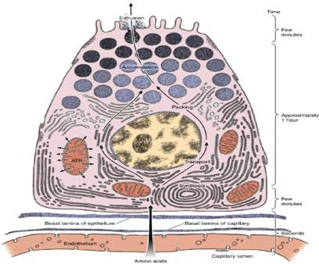 | Glandular cell  rough endoplasmic reticulum Golgi apparatus secretory granules nucleus with nucleoli

Classification of glands
GLANDular epithelium |  unicellular | Single cells in coverinrg epithelium – (Paneth cells, goblet cells, enteroendocrine cells, Leydig cells)
 |  multicellular | Accordin to mechanism of secretion endocrine exocrine – merocrine, apokrine,holocrine According to loclalization intraepithelial ⇔ extraepithelial According to arrangement of ducts simple ⇔ branched ⇔ compound According to type of secretory portions tubular⇔alveolar (acinar)⇔tuboalveolar According to product properties mucous ⇔ serous ⇔ mixed

According of mechanism of secretion
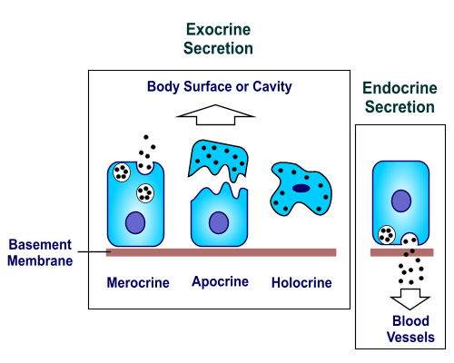 endocrine – glands withou ducts, product is released into the blood through the wall of capilareis exocrine – secretory cells of exocrine glands release their products into ducts in three different ways:
merocrine | apocrine | holocrine
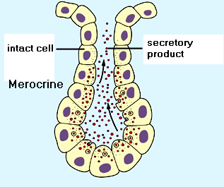 | 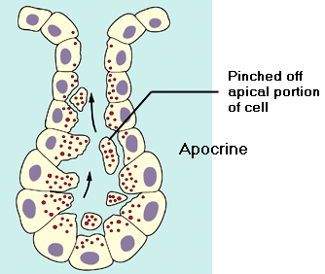 | 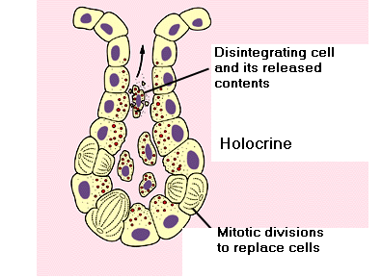
- membrane-bound secretory granules are moved to the apical surface where they coalesce with the membrane on to release the product. | - the apical portions of cells are pinched off and lost during the secretory process. | - secretory cell degenerates and as it breaks apart, the contents of the cell become the secretory product.

According to
type of secretory units | to product properties | simple | branched | compound
tubular | are usually mucous
alveolar (acinar) | are usually serous
tuboalveolar | mixed
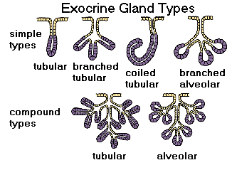
Secretory units
Serous acinus (alveolus) | Mucous tubule | Serous demilune (Giannuzzi)
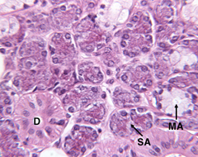 | 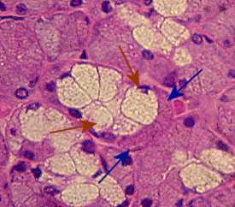 | 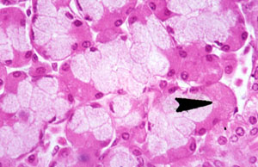

Functions of epithelia:
- Barrier: Epithelial tissue commonly functions as a covering or lining for organs and other tissues (e.g., skin, mucous membranes, pleural cavity, etc.). Epithelial cells serve as selective barriers between the environment and the internal structures of the body. They protect underlying tissues from drying, and from mechanical and chemical injury. Tight junctions between individual cells play an important role in the barrier function of epithelium. Some barrier epithelial cells have motile cilia that propel fluid or particulate matter over tissue surfaces (e.g., cells lining the bronchi).
- Absorption: Epithelial cells are found in those organs (e.g., intestine) which are involved in absorption of substances important for life. These cells often microvilli which increase cell surface area in order to facilitate absorption.
- 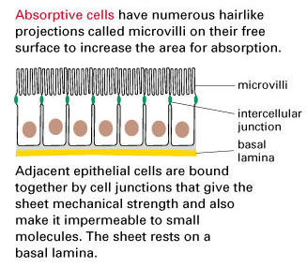
- Secretion: The secretory cells of endocrine and exocrine glands are epithelia.
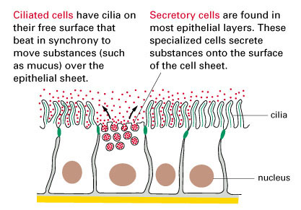

- Sensory: Many of the more complex sensory receptors of the nervous system are derived from specialized epithelia called neuroepithelia (e.g., the rods and cones of the retina, olfactory receptors of the nose, taste receptors on the tongue, etc.). Sensory receptors function by converting mechanical, chemical, or electromagnetic signals from the environment into nerve impulses which can be processed by the nervous system.
- Contractility: Some very specialized epithelial cells (myoepithelia) contain the contractile proteins myosin and actin similar to muscle. Myoepithelia are associated with the ducts of sweat, salivary, lacrimal, amd mammary glands and assist in the secretory process.
Origin: Epithelial tissues are derived from all three primary germ cell layers.
- Ectoderm: The epithelial cells of the skin and oral cavity (epidermis) are derived from ectoderm. Epithelial cells covering the cornea and lens, as well as sensory receptors of the eyes, ears, and nose, are also ectodermal in origin.
- Mesoderm: The epithelial lining of blood vessels (endothelium) is derived from mesoderm. The epithelial lining of the pleural and peritoneal cavities (mesothelium) also originate from mesodermal cells.
- Endoderm: The epithelial lining of the respiratory system and digestive tracts - as well as the functional cells (parenchyma) of the liver, pancreas, gallbladder, thyroid, and parathyroid, are derived from endoderm.

Protocol
Simple squamous  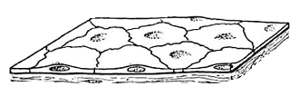 | 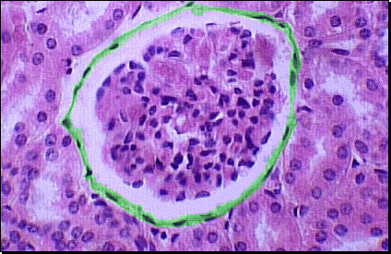
Simple cuboidal  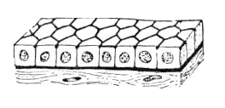 | 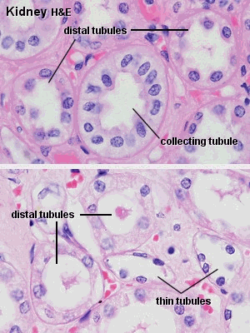
Simple columnar  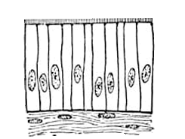 | 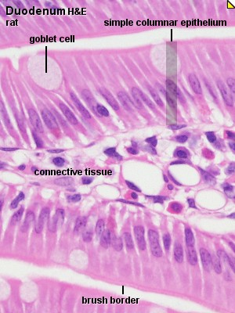
Pseudostratified columnar with cilia  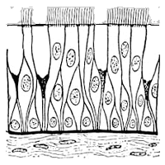 | 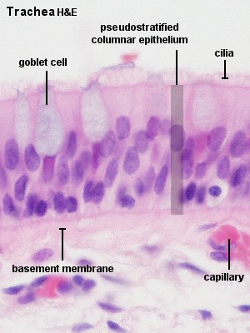
Stratified squamous  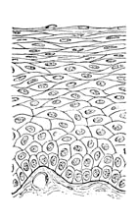 | 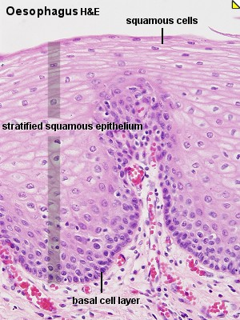
Transitional  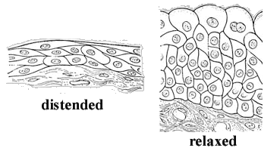 | 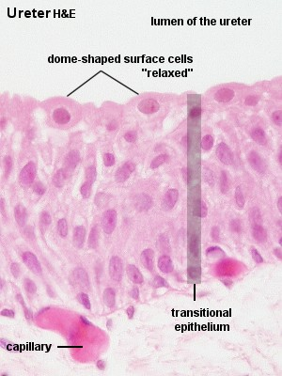
 | 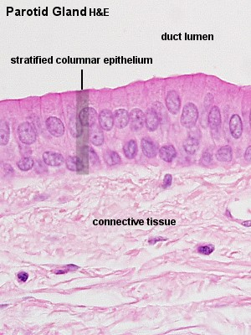
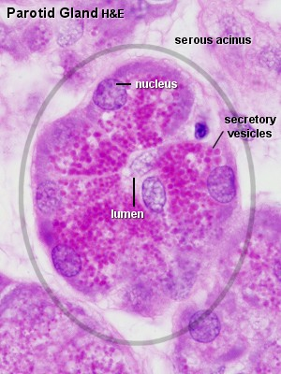 | 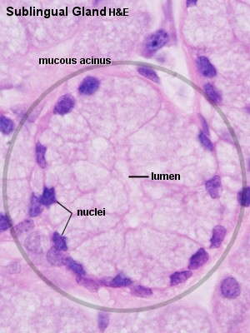
Serous acinus Mucous tubule

Appendix: atlas
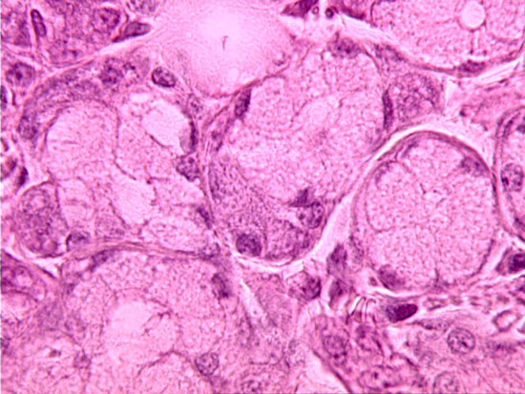 | Parotid gland:  serous acini
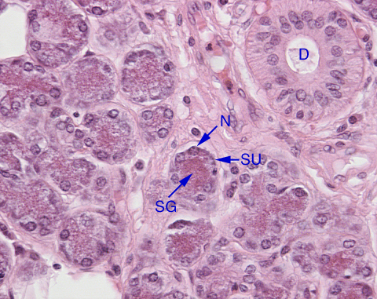 | Parotid gland:  SU – serous acinus D - striated duct SG – secretory granules N – nucleus of serous cell
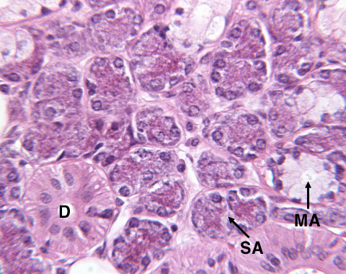 | Submandibular gland:  SA – serous acini MA – mucous tubuli D – striated duct
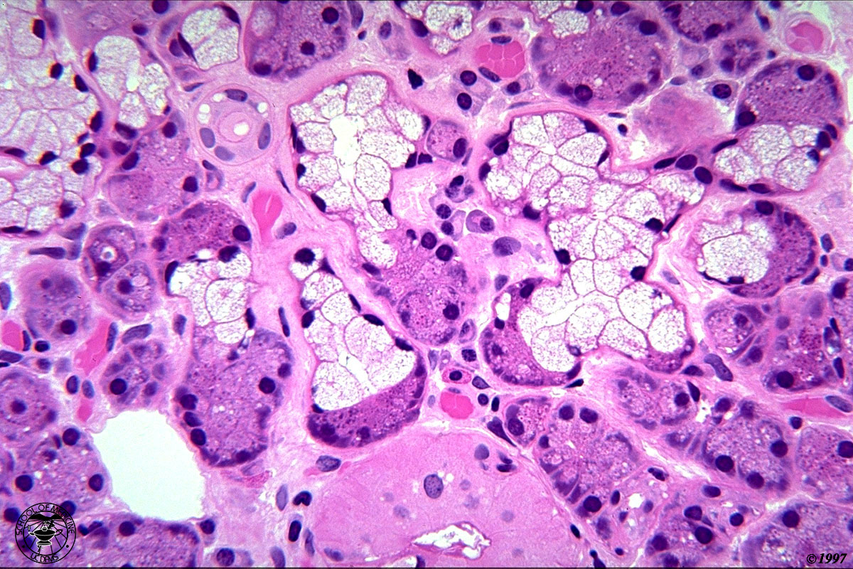 | Submandibular gland:  serous demilunes

