EXPRESSIVE CREATING AND PLAYING OF PRE-SCHOOL CHILDREN

Marie Bajnarová

Abstract
Expressive creation provides space for children to express themselves through both the actual creation and also a debate. For children to be enable to express themselves creatively in the artefacts, they must be tuned onto an idea and should also learn and know certain rules of how to use art tools and equipment. The author of this thesis is solving art work of children in the pre-school age. This thesis points out how expressive work and playing of children plays an important role in the development of these pre-schoolers.

Keywords
Child of pre-school age, expressive creation, games, child's artistic expression, art activities

1. Introduction
Expressive creation means an artistic activity in which human emotional states are expressed through singing, movement, artistic means and sound. This allows an individual to authentically project his experience in a creative way onto an expressive artifact. In expressive art work there are: the expression (concentration and attention devoted to the process of creation), communication (sharing one's experience in expressive speech) and the form (variations of works, art technique).
Expressive creation is important for the development of a child's personality, It contributes to a better self-image and gives one some kind of new internal energy. The expression that is evident in a child's drawing is individual, unique, original and also predicates some kind of power of expression. Works of expressive creations reveal through its contents, form and expression. After this artistic activity a discursive finish-off should be done. Children should be taught a cultivated speech and reveal and name the different symbols in their artefacts.
This text focuses on spontaneous artistic expression of the preschoolers. By 'spontaneous artistic expression' we mean a creative activity that is not directly or intentionally encouraged or stimulated by another person. It is about an impulse which arises from the internal needs of a person who decides to creatively and artisticaly respond to external and internal stimulus. According to Roesell (2003, p. 48) a spontaneous expression is related to the artist's relationship to reality and that is why this artistic form does not require a true presentation nor to respect proportions nor precision regarding details, it is about expressing the artist's essence. This is also about being able to reach one's deep feelings and experiences. At this moment, the preschooler authentically devotes himself into his own perceptions and the art form. A spontaneous creation is about the artist focusing primarily on capturing his current mental state, impressions, feelings and moods, thoughts or his attitudes. The artist is mainly focused on what he is experiencing while drawing his creation. This is an experience which expresses his current state of mind. I can declare that a spontaneous artistic expression allows his creators to further develop his personality. Through this authentic expression the creator reveals himself, opens up to the world and most of all gets to know himself. This unique creative process even enables the artist to express his symbolism.

2. Expressive creation of pre-schoolers
We view the results of children's art expression formations not only as an expression of the child's personality, but also as a whole complex of displayed symbols and the emotions one feels from the artifact. An artistic expression here shall be construed as an expression relating to a child depicting his relationship to reality where we can see extensive psychological processes and experiences of the little artist. Children's emotions in each art activity are as important as the perception of the artistic process.
We can see emotions in the creations in the above examples (see Fig. 1). The differences in the manner of interpretation of a fairy tale are recognizable. The first two drawings are painted by children who were happy while painting their creation and the actual painting process was filling them, they successfully communicated exactly what they were portraying and had joy from this creative activity. Most children, while they are drawing or painting, are relaxed and during this process are able to use word reflection regarding their art work. Some children however may experience anxiety or other negative emotions and due to these can lose control during their art process. This negative mental state can lead the child to a point where he crosses his own creative borders and begins to express himself expressively in his creation. The two children's well-being and satisfaction is reflected and is visible at first sight in the top drawings. On the other hand negative emotions are reflected in the lower two creations. These expressive paintings were painted by children who did not like the fairy tale, they were blocked and closed within themselves and prior to the creation as well as during the process of creating these paintings they were working with disgust.

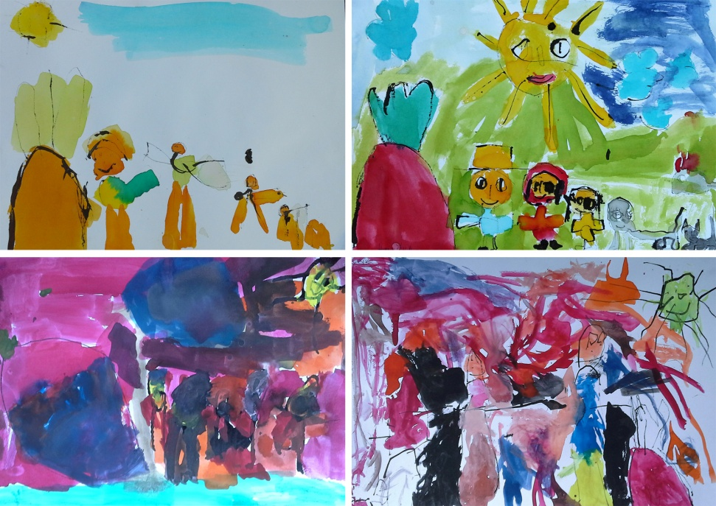Fig.1 „The Tale of Red Beetroot”, mixed media, painting watercolors and ink drawing, children 3 to 5 years, 2014, A4

An expression can be described as a non-random outward manifestation of every person who is underpinned by a deliberate or automatic decision to express himself. Slavík (2001, p. 96) sees the inestimable advantage of expression in the fact that it allows us to lead a continuous passage from the impressive spontaneous expression of human behavior through the typical artistic manifestations of expressiveness all the way to intentional behavior. Expressive creation is an art activity for children, stemming mainly from self-satisfaction. It usually captures the emotional tuning of the creator, his attitude to different people, emotional ties to his surroundings, it portrays himself and also his self-confidence. A spontaneous child's activity represents a valve of his internal ideas that the child cannot verbally express, therefore he must express himself through his artistic creation. The child expresses his feelings, ideas and thoughts freely through an artistic activity. The child cannot be forced into expressive creation and games. The child should create forms only for himself while monitoring his own hidden goals (Read, 1967, p. 147).

2.1. Art games for pre-schoolers
For small children it is quite natural that their content is playing. A game is the best form of preparation for future life situations. The game which is considered to use the highest amount of concentration is drawing. It is also drawing or painting which differs from other games in the way that it leaves behind permanent prints and that of a child's creations which express his personal childlike expressions (Uždil, 2004, p. 103). Children's art expressions are based on playful doodling where at that moment of time the child is happy and feels a pleasing feeling of the fine movement, rhythm and movement (see Fig. 2). Doodling or freehand drawing challenges the child to play another game, which is more complicated for the child. In time doodling gradually changes to drawing of familiar things. At this stage a game ceases to be just a game and becomes a serious attempt to show the abilities of the small author (Uždil, 2004, p. 18).

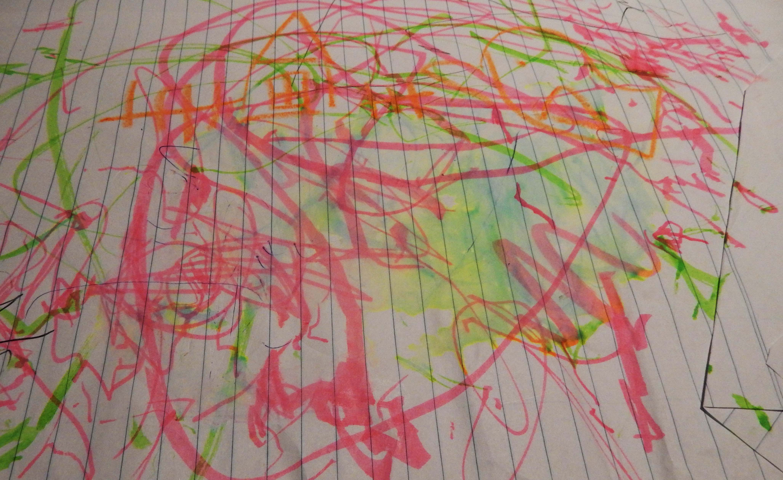
Fig. 2 „Untitled”, playful doodling, mixed media and drawing, Charlotte, 2 years, 2014, A4

According to Slavík (1994, p. 4), expressive creation and games belong to the most serious cognitive and creative activities. In this process of creation the child's "I am" opens a gate to all the events, which, although under limited control still induces (self-) knowledge (see Fig. 3).

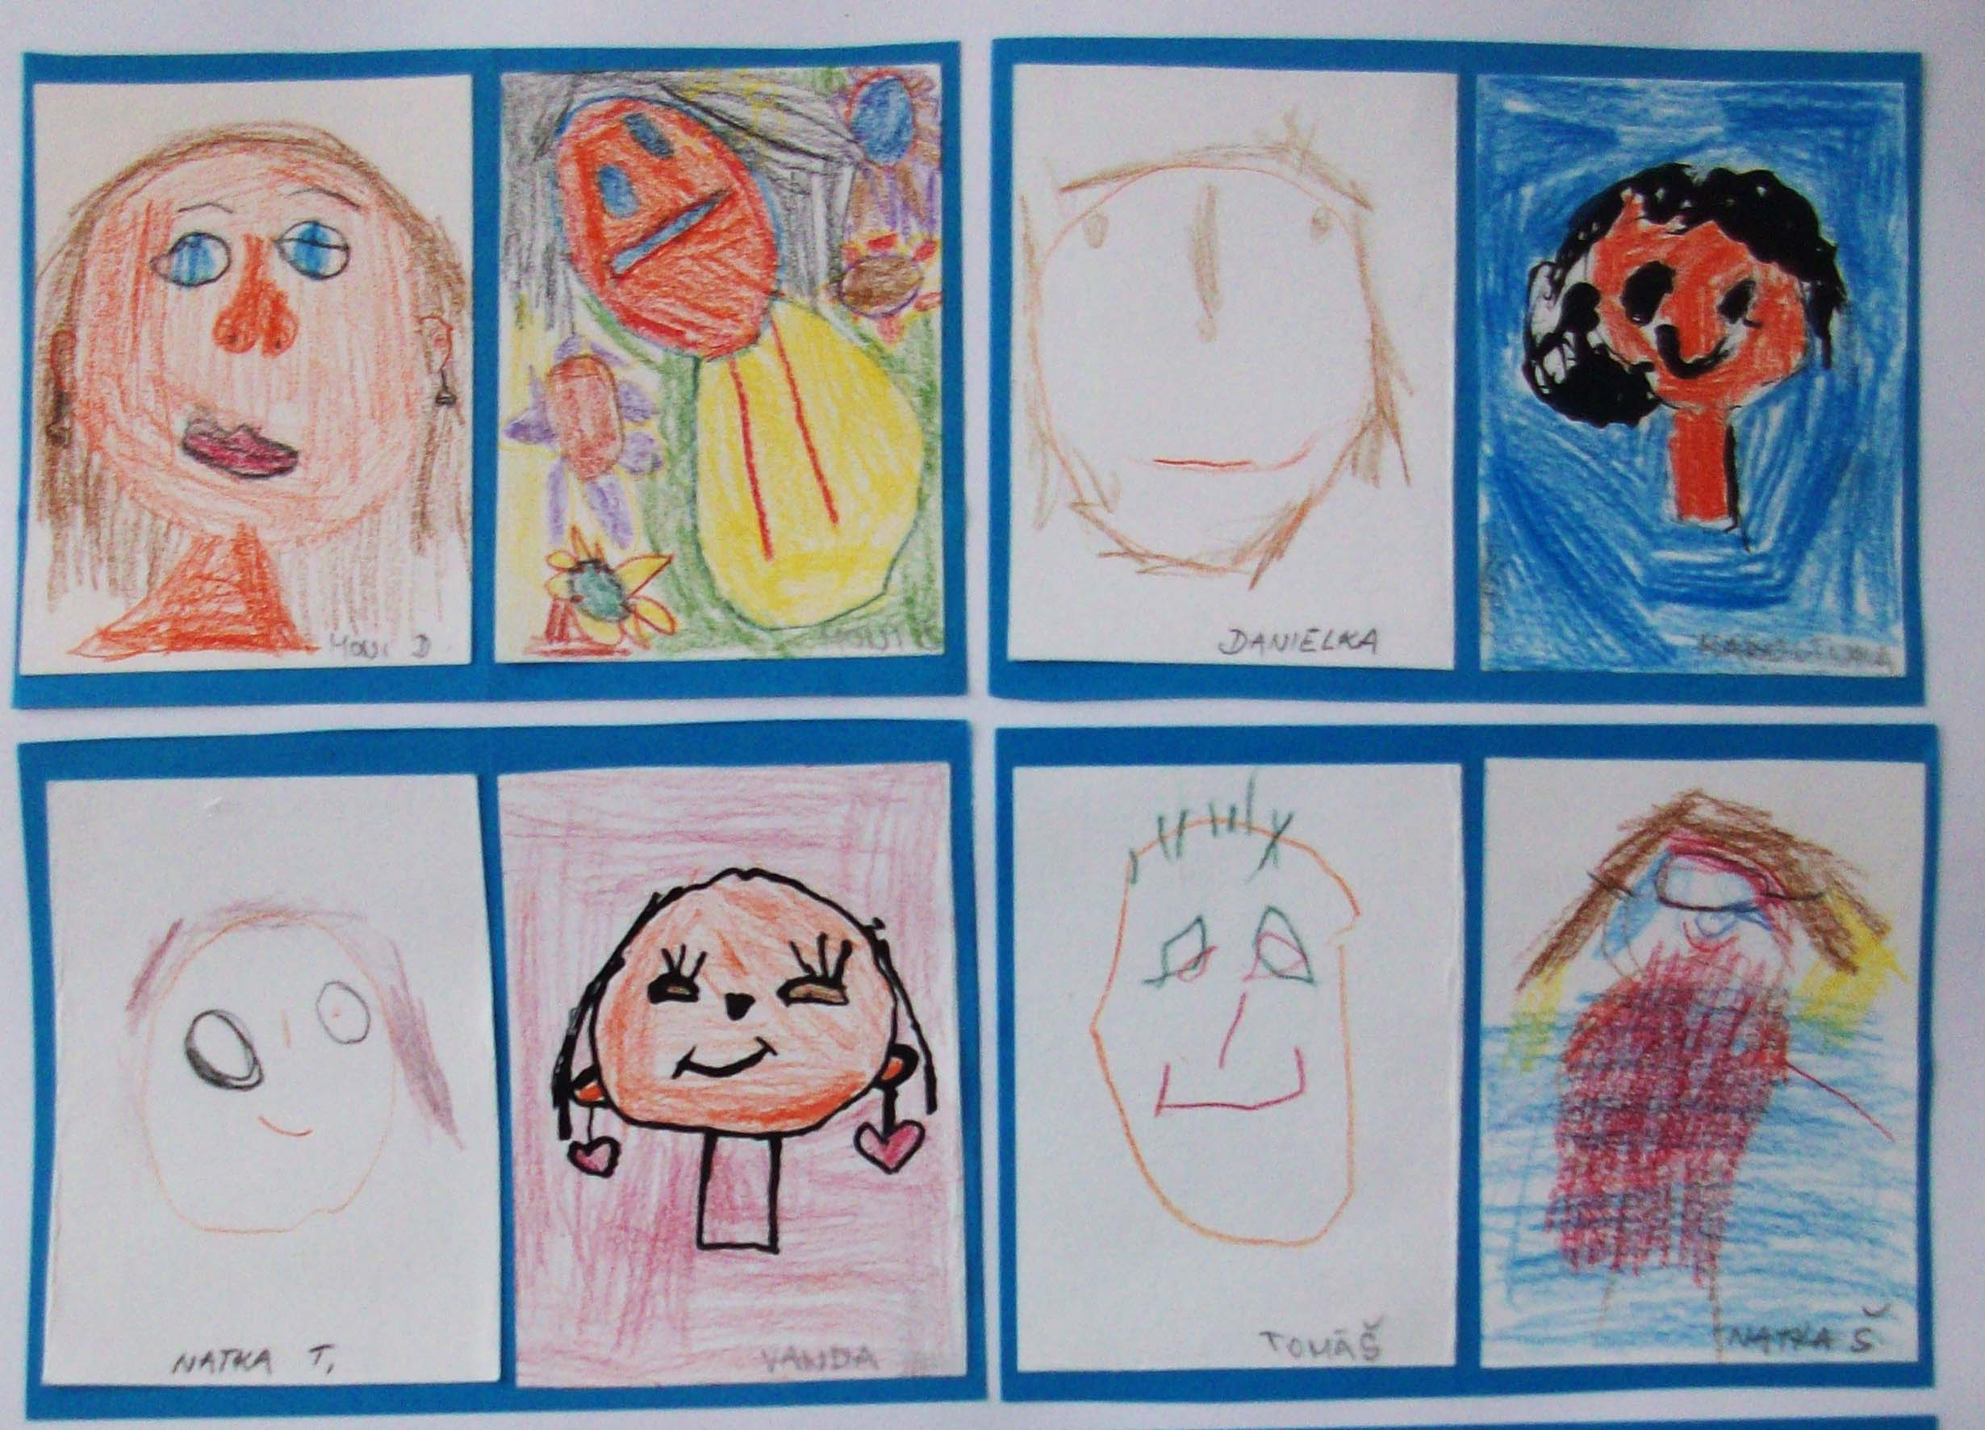
Fig. 3 „Self-portrait”, drawing and ink drawing, children 3 to 5 years, 2014, A4

Expressive formation associated with games is a means of understanding and experiencing. In art games the child's expression and creative activity is manifested and it is also where the child's understanding of the world and the amount of knowledge about his immediate surroundings is reflected. Slavíková (Slavíková, Slavík, Hazuková, 2003, p. 74) represent the first stage of the rise of creative activity, which can be regarded as an expression and a child's game. This stage countinues around the time from birth to 5 years, where it culminates. Creative elements are random and immature. The child is not able to distinguish his ideas from reality. This stage is called pre-creative and is divided into two developmental stages:
1. Period of sensorimotor games (from birth to the age of 3): A child builds his creativity on sensory experience which still has flaws. It is some kind of a beginning of the first ascent of creativity, artistic expression and games (see Fig. 4).
2. Period of imitating games (3 to 6 years): Child begins to build on his ideas, which are a generalization of sensory experience. This period is a critical phase of pre-creative activity and is important for the creative activity in older school age (see Fig. 5).
A drawing and painting process inherently belongs to the activity that shows the perception of the world and the person himself. Studying these drawings we can find out what kind of a life the artist lives and what kind of an inner life he has. Children´s symbolic images in the drawings show us some kind of communication, the artist talks to us through these. A child acquires art skills which he can play, explore and experiment with. At the same time he experiences a haptic contact with materials and tools. Art games are very beneficial since they help the child get rid of shyness in front of strange artistic resources. Later on these artistic resources become an inspiration for the child so he can spontaneously create his art work without any limitations. Art games should awaken creative power within small children.

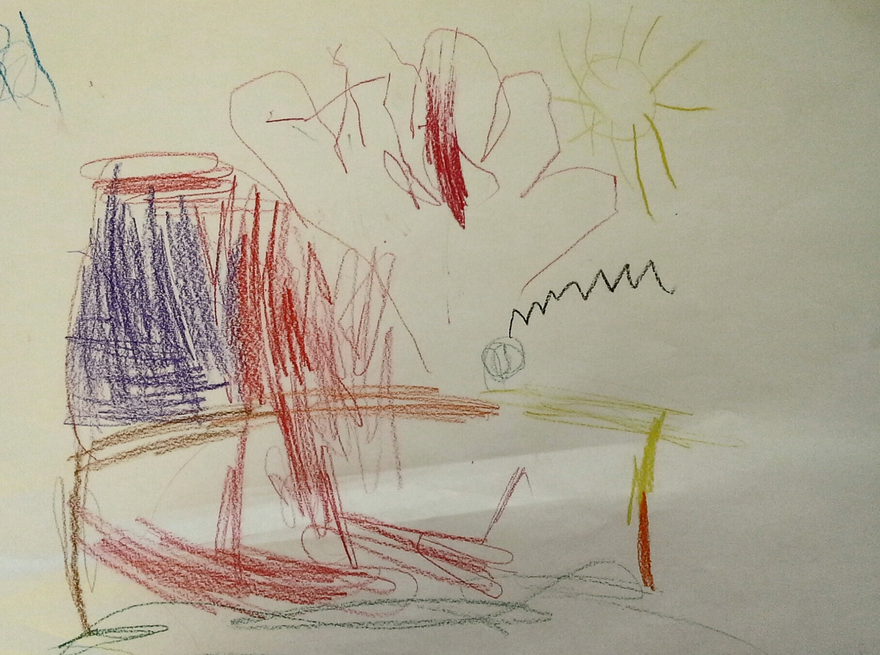
Fig. 4 „My house”, drawing, boy, 3 years, 2014, A4

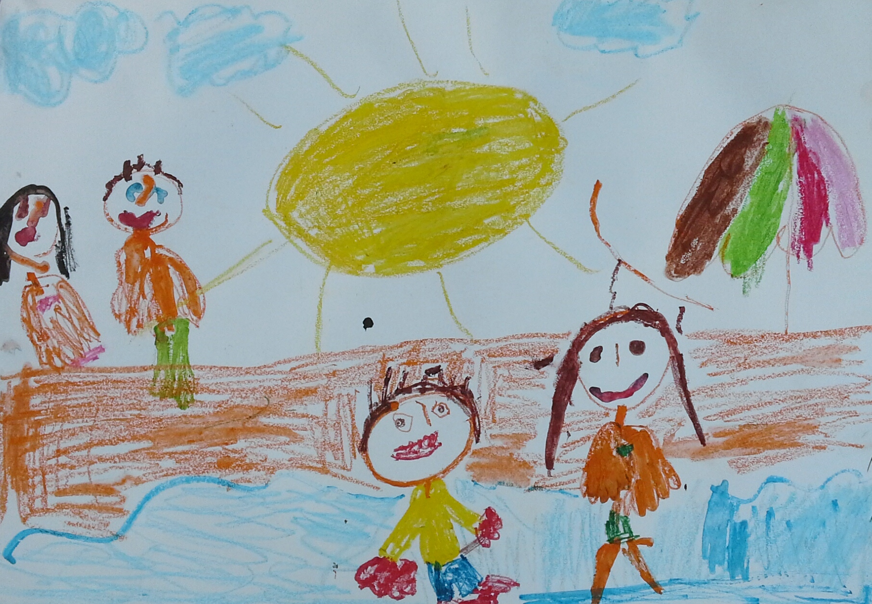
Fig. 5 „My family”, mixed media, drawing and painting, Daniel, 4 years, 2014, A4
3. Conclusion
Whether a child plays with toys, other children or with art media, he will always apply his imagination. A child's penchant for playing begins to appear around the age of 8 to 11 months. From the adult's perspective the child's playing appears as a mere game, yet the child means his playing seriously as this gives him joy, fun, cognition, as well as learning, care and responsibility. The child is truly immersed in his playing and if we disturb him, he will become angry. The child's game is important work for him. The function of the game is some kind of future preparation for later life's demands. A child plays, even when he is sick since it helps him to get well and restore his strength and also to relax and overcome social demands. The game reflects free manifestation of the child, his creativity, fantasy and imagination and artistic abilities. The game is attractive for the child only if it takes place in the child's imaginary world, where the child behaves and plays only „by pretending“. The game is also one of the auto-cultivating activities with the mentally-hygienic and collective function.

Sources
1. Uždil J., Lines, scribbles, dummies and Cars: creative expression and psychological life of the child. Prague 2004, p. 128 .
2. SLAVÍKOVÁ V., SLAVÍK J., HAZUKOVÁ H., Artistic witchcraft: aftefiletics for pre-schoolers and younger school children. Prague 2000, p. 179 .
3. SLAVÍK J., Art experience, experience art I .: Theory and Practice artephiletics. Prague 2001, p. 265 .
4. SLAVÍK J., Chapters in Art Education II. (experience, dialogue, concept). Prague 1994, p. 37 .
5. READ H., Education through art. Praha 1967, p. 228 .
6. ROESELOVA V., Methodology of art education. Prague 2003, p. 200.

Contact
Mgr. BcA. Marie Bajnarová
Masaryk University, Faculty of Education, Department of Art
Poříčí 7, 603 00 Brno
Czech Republic
e-mail: marie.bajnarová@seznam.cz
tel.: +420734738138

