Case #10. A Tale of Two Solar Farms
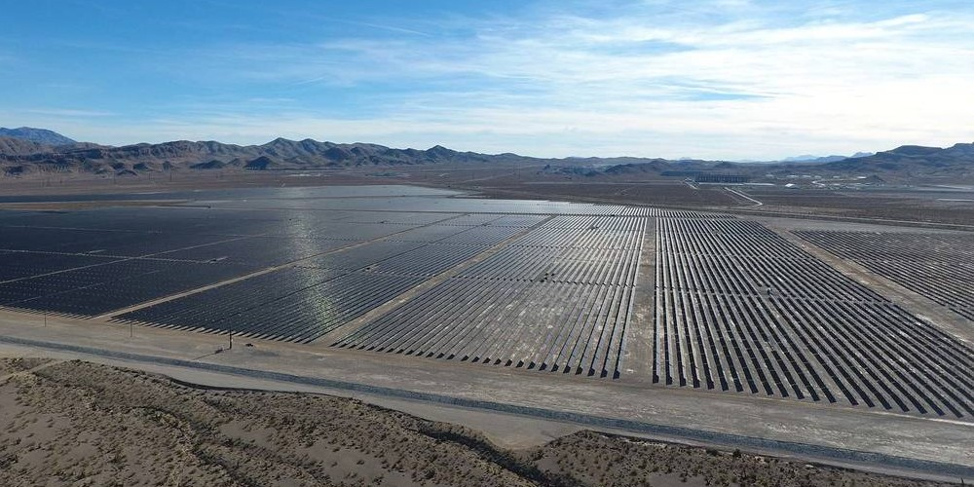
https://www.powermag.com/feds-approve-largest-u-s-solar-project/
Gemini: A Successful Project
A Nevada installation that would be the largest solar power project in U.S. history was approved by the U.S. Department of the Interior on May 11, 2020 in the last year of the Trump Administration. The estimated $1 billion, 690-MW Gemini solar photovoltaic electric generating facility is sited on 7,000 acres about 30 miles northeast of Las Vegas.
Interior Secretary David L. Bernhardt signed the Record of Decision (ROD) (authorization) that paves the way for California–based Solar Partners XI to build the facility. Solar Partners, a consortium that includes NV Energy, a subsidiary of Warren Buffett’s Berkshire Hathaway Energy, first announced its intention for the project in July 2017, saying it would work with the federal Bureau of Land Management (BLM) on the project, which will use federal land (Figure 1).
The project will include four large lithium-ion batteries capable of storing up to 380 megawatts (MW) of solar energy for up to four hours.
The ROD approves a right-of-way grant for the project, along with authorizing 34.5-kV overhead and underground collector lines, a 2-acre operation and maintenance facility, three substations, internal access roads, access roads along generation tie-lines, a perimeter road, perimeter fencing, water storage tanks for fire protection, drainage control features, a potential on-site water well or a new water pipeline, and improvements to the existing NV Energy facilities to support grid interconnection.
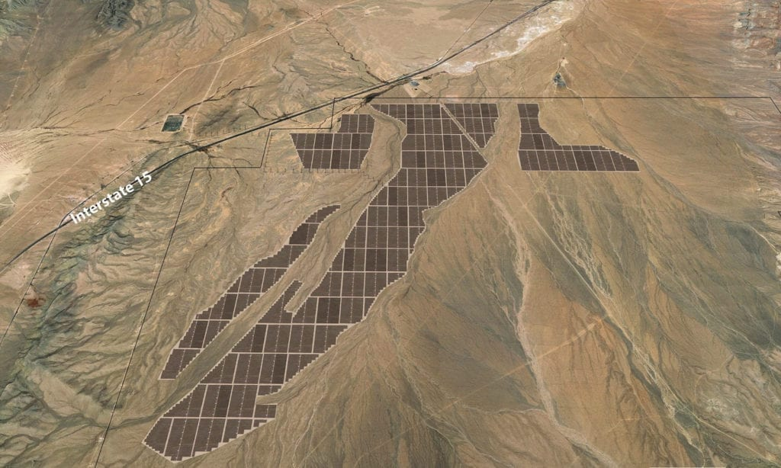1. The planned Gemini solar and battery storage site in Nevada, about 30 miles outside Las Vegas, is shown on Google Maps. Courtesy: Arevia Power and Quinbrook Infrastructure Partners
“This action is about getting Americans back to work, strengthening communities and promoting investment in American energy,” said Casey Hammond, an Interior Dept. official, in a news release. “Domestic energy production on Federal lands remains fundamental to our national security.”
Bernhardt, noting the damage to the U.S. economy caused by the COVID-19 pandemic, said, “Our economic resurgence will rely on getting America back to work, and this project delivers on that objective.”
David Scaysbrook, co-founder and managing partner of Quinbrook Infrastructure Partners, one of the developers of the project, in an email to POWER wrote, “We are very pleased to have reached a satisfying and final seal of approval from the Department of the Interior and the Bureau of Land Management so that we can now take Gemini forward with confidence. This final decision officially clears the pathway for Quinbrook, and our development partners at Arevia, to accelerate completion of detailed project designs and procurement plans for one of the world’s largest renewables projects ever undertaken. Gemini offers the opportunity to showcase, at an unprecedented scale, what we believe to be one of the most promising technological advances in coupling battery storage to utility-scale solar power to produce low-cost renewable energy over the long term. Gemini will benefit all Nevadans by supporting jobs, stimulating the local economy and capturing the state’s abundant solar resources to deliver low-cost, renewable power to NV Energy customers.”

Project Was Delayed
Government sign-off on the installation had been delayed for months. The BLM earlier missed two deadlines to approve Gemini, in part due to an extended environmental review that included a look at the project’s impact on historical areas, including a railroad camp on the Moapa River Indian Reservation, and the Old Spanish National Historic Trail, used by early settlers moving through the area from the 1830s to the 1860s.
The BLM and Solar Partners XI in Monday’s news release said the groups have “developed measures to avoid, minimize and mitigate impacts to other resources including, but not limited to, visual resources, cultural and tribal resources, recreation access and air quality.”
NV Energy already had negotiated a 25-year power purchase agreement rate of $38.44/MWh for the project. NV Energy in December 2019 secured approval from the Public Utilities Commission of Nevada (PUCN) for about 1.20 GW of new solar projects, including Gemini, along with 590 MW of energy storage capacity.
The solar power industry was quick to praise Monday’s approval. “Despite the challenges of the coronarivus, we’re pleased to see that Nevada will soon be home to one of the biggest solar projects in the world,” said Abigail Ross Hopper, president and CEO of the Solar Energy Industries Association. “The solar industry is resilient and a project like this one will bring jobs and private investment to the state when we need it most. We appreciate the work the Trump administration has done to make this historic project a reality.”
The Gemini project marks the third time the Trump administration’s BLM has approved a solar power project on federal lands. The agency approved an 80-MW project in Wyoming in June 2018, as well as a 550-MW solar farm near Joshua Tree National Park in California in November 2018.

Gemini Tortoise Relocation Plan
Opponents of the Gemini project have said they don’t think the installation’s benefits outweigh its environmental impact, arguing over the past few years that it will disrupt a desert ecosystem of flora and fauna about 30 miles northeast of Las Vegas. Primergy has repeatedly said it has “invested significant resources” to minimize risks, including a partnership with biologists to create a Desert Tortoise Relocation Plan that “tracks, cares for and will safely reintroduce the protected species back into their natural habitat once construction is complete.”
Environmentalist Group Opposition
Conservationists say clean energy shouldn’t come at the cost of damaging the environment or threatening endangered species. The Sierra Club, which describes itself as “a relentless advocate for the decarbonization of the electric grid via renewable energy sources,” is one of several environmental groups opposing the plant.
While the Sierra Club supports utility-scale clean energy, their expansion “must be done with care to avoid impacts to imperiled wildlife and their habitats,” among other considerations, said Karimah Schoenhut, an attorney with the Oakland, Calif.-based group.

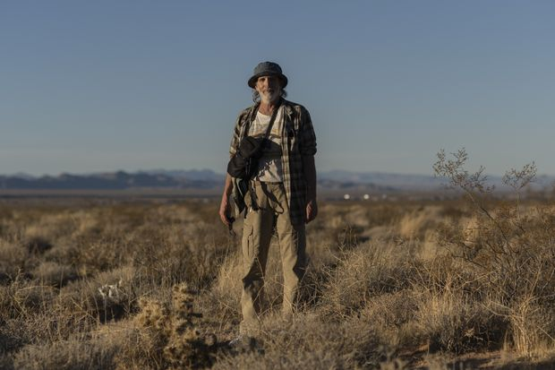

Co-founder of Basin and Range Watch Kevin Emmerich walks near the site of the Gemini Solar Project.
Kevin Emmerich, co-founder of the Nevada-based Basin and Range Watch environmental group, is a longtime supporter of solar energy. “It’s something you have to do,” he said.
Mr. Emmerich also believes big solar projects represent a threat to a desert landscape he has worked for decades to protect. In particular, he worries about the impact on the threatened desert tortoise, a reclusive creature whose shrinking habitat is imperiled by development, according to federal studies. An estimated 1,000 desert tortoises inhabit the Gemini site.
Desert tortoises will be able to rest in a manmade shelter along this fence on the boundary of the Gemini Solar Project. Laura Cunningham, a co-founder with her husband of Basin and Range Watch, warned that the project will harm prime habitat for the threatened species.
Mr. Emmerich and his wife in late February 2021 stood dejectedly outside a newly erected fence at the Gemini site as survey crews roamed the desert in all-terrain vehicles, with tortoise biologists in tow.
“They will tear up every tortoise burrow,” Mr. Emmerich said.

Native American Tribal power
Gemini drew also drew opposition from the Moapa Band of Paiutes, whose Native American reservation sits next to the proposed solar plant along Interstate 15 about 35 miles east of Las Vegas.
“This is a clear environmental justice issue that cannot go unaddressed,” the tribe said in an Oct. 10, 2019, letter to Bureau of Land Management officials, citing impacts including noise, dust and damage to its ancestral homeland.
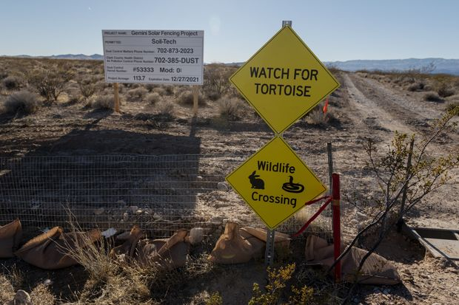

Signs alert visitors to desert tortoises and other wildlife at an entrance to the approved Gemini Solar Project site northeast of Las Vegas.
Tribal members say they support solar power, noting that they allowed a 250-megawatt facility to be built on their lands in 2017.
The Interior Department in May 2020 approved the project anyway, stipulating Arevia Power would have to take mitigation measures such as relocating tortoises to new habitat. In all, a U.S. Fish and Wildlife Service report estimates 15,390 of the threatened turtles stand to lose nearly 70,000 acres of habitat in solar projects planned for the Southwestern deserts. “It is difficult to assess how desert tortoise populations will respond because of the long generation time of the species,” the report said.
In his statement, Mr. Graf said Arevia intends to work with federal agencies to protect both the tortoises and native plants at this and other projects and that they will have “far less impact” on the desert than off-road vehicle use.
Primergy has said the project’s construction will minimize impact to the area, with narrow road corridors to the construction site, and “building appropriately spaced, raised rows of solar modules to ensure nearly 80% of the land on site remains open to the sky.”
Ty Daul, CEO of Primergy declared. “Through Gemini, Primergy has pioneered a holistic approach to responsible project development that considers complete ecosystem management, collaborative partnerships with local and community stakeholders and undertakes careful due diligence in supply chain and equipment selection. This ensures the company procures responsibly, minimizes environmental impact and delivers lasting community benefits across jobs, training and ongoing education in the benefits of large-scale clean energy infrastructure.”

Battle Born: A Failed Project

The following is an excerpt of an article entitled, “Solar Power’s Land Grab Hits a Snag: Environmentalists,” By Jim Carlton The Wall Street Journal June 4, 2021

https://www.wsj.com/articles/solar-powers-land-grab-hits-a-snag-environmentalists-11622816381?mod=trending_now_news_4

Mojave Desert residents say they support clean energy, but not giant projects, citing threat to tortoises and views
Many residents in the Mojave Desert are dead set against a planned solar plant atop the Mormon Mesa, which overlooks this valley 50 miles northeast of Las Vegas. Slated to be the biggest solar plant in the U.S., the Battle Born Solar Project by California-based Arevia Power would carpet 14 square miles—the equivalent of 7,000 football fields—with more than a million solar panels 10 to 20 feet tall. It would be capable of producing 850 megawatts of electricity, or roughly one-tenth of Nevada’s current capacity.
“It will destroy this land forever,” said one local resident after riding her bicycle on the 600-foot high mesa.
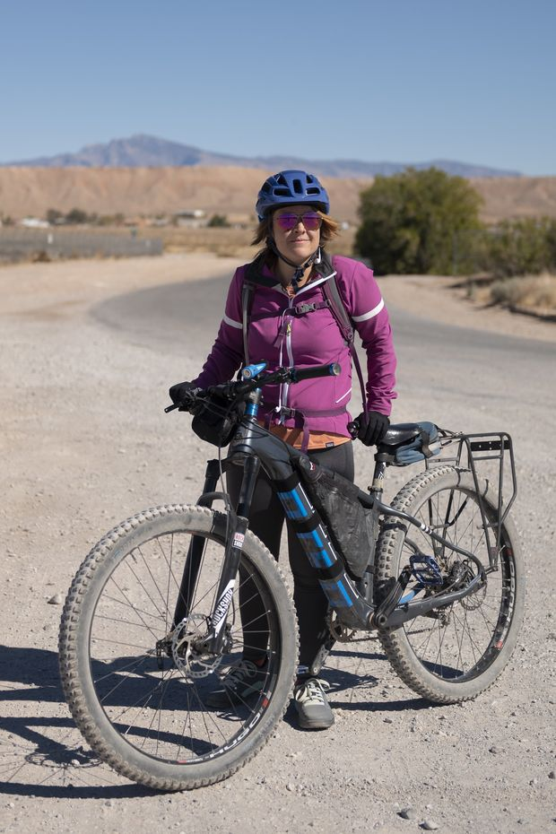
Across the U.S., more than 800 utility-scale solar projects are under contract to generate nearly 70,000 megawatts of new capacity, enough to power more than 11 million homes. More than half this capacity is being planned for the American Southwest, with its abundance of sunshine and open land.
These large projects are increasingly drawing opposition from environmental activists and local residents who say they are ardent supporters of clean energy. Their objections range from a desire to keep the land unspoiled to protection for endangered species to concerns that their views would no longer be as beautiful.
Unlike past fights between polluting industries and environmentalists, this one pits people who say they want more renewable power against companies that want to generate it. It threatens to significantly slow efforts by the Biden Administration and businesses to fight climate change by reducing America’s carbon emissions.

Tortoise habitat
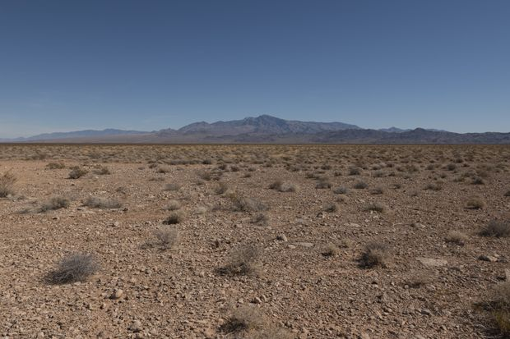

Desert vegetation on Mormon Mesa, where Arevia Power wants to build the Battle Born Solar Project on land owned by the U.S. Bureau of Land Management.
Solar-industry executives say they construct their projects responsibly and that building them fast can help combat climate change. “Responsibly developing solar and storage projects on public lands delivers tremendous benefits to the region, state and everyone wanting to preserve this valuable ecosystem,” Ricardo Graf, managing partner of Arevia, said in a written statement.
A spokesman for the Bureau of Land Management (BLM), which oversees public land where 81 applications for solar plants are pending, said the agency works with residents, interest groups and other affected parties “to develop mitigations which allow solar projects while protecting resources.”
The BLM is charged under the Energy Act of 2020 with permitting at least 25,000 megawatts of renewable energy capacity by 2025, but spokesman Richard Packer said some projects would get approved faster than others. The agency now has 6,900 megawatts in operation, enough to power 1.1 million homes.
Recently, Nevada has gone all in on solar development. On Earth Day of 2019, Gov. Steve Sisolak, a Democrat, signed a bill to increase Nevada’s renewable energy portfolio to 50% by 2030—one of the most ambitious targets in the nation.
Over the past five years, more than 50 solar plants have been built in Nevada with generating capacity of about 1,000 megawatts.
Both the Gemini and Battle Born projects had been in the offing under different companies since 2007, but didn’t gain momentum until the current push for clean energy. Gemini was put on a regulatory fast track.
About 15 miles to the east, the roughly 10,000 residents of the three main Moapa Valley towns—Overton, Logandale and Moapa—are determined to avoid a similar fate for Battle Born.
Founded in the 19th century as an outpost of Mormon settlers, the valley in recent decades has become home to a mix of commuters, retirees and tourism businesses. The valley went through a slump 10 years ago, following the 2007-09 recession and closure of nearby boating facilities amid falling levels at Lake Mead.
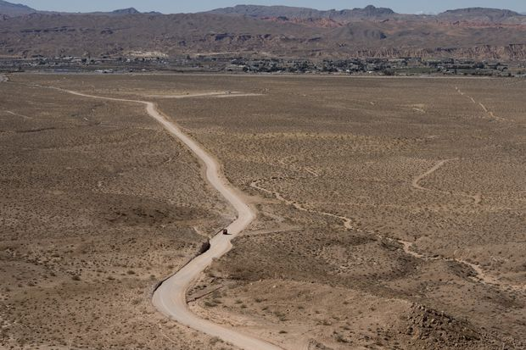

A driver on an all-terrain vehicle approaches Mormon Mesa, a popular recreation area.
But since then, it has been on the rebound, with the Mormon Mesa drawing four-wheelers, bicyclists and skydivers onto its plateau of yucca and creosote. The mesa is filled with Native American artifacts and features a 1,500-foot trench called the Double Negative, created in 1969 by artist Michael Heizer as one of the world’s largest pieces of land art.
Kyle Grimes is one of relatively few local residents who publicly support Battle Born, as well as Gemini, which he says are needed “just to get away from the fossil fuel.” But the business consultant said he would like to see Battle Born moved off areas of the mesa where people recreate.

Facebook campaign
More common are the local residents who formed a group called Save Our Mesa and began campaigning against the site on Facebook, in sign-waving protests and at a public meeting held at a community center in Overton last October. Among their other concerns: more dust and hotter temperatures from the solar operation, as well as destruction of the mesa and the tourism industry it supports. “We don’t want to be the guinea pigs,” Lisa Childs, co-founder of the Save Our Mesa citizens group, said in the meeting.
Mr. Graf told the overflowing room of about 200 people it was still early in the process but that Battle Born would be built in an environmentally friendly way and that benefits to the community would include more than 1,000 jobs, mostly in the construction.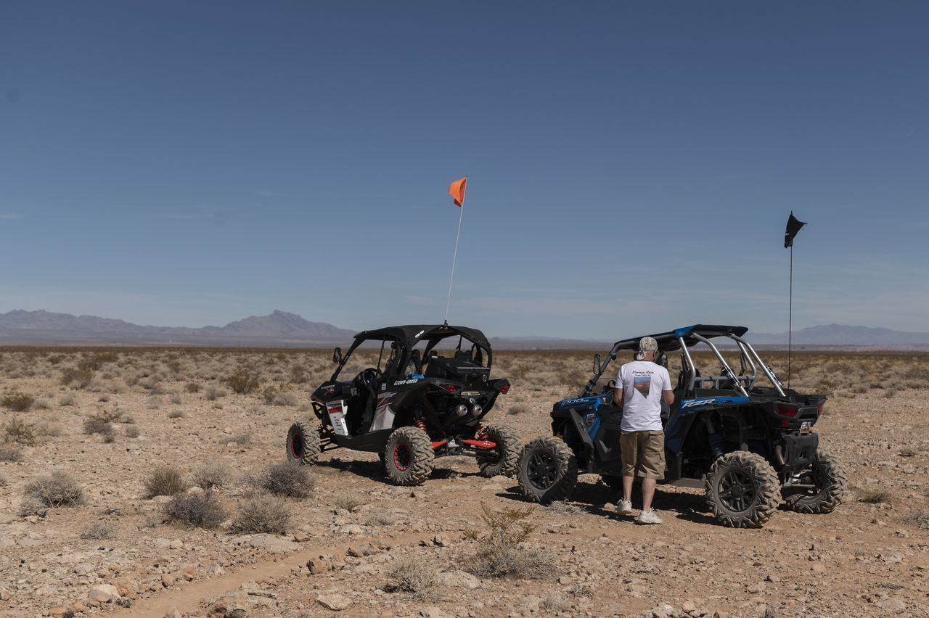

Supporters of Save our Mesa, a local group co-founded by Lisa Childs to fight the proposed Battle Born Solar Project, prepare to ride their all-terrain vehicles on Mormon Mesa.
Mr. Graf challenged the concerns on dust, heat and economic harm—saying the plant’s footprint would take up less than a tenth of the mesa’s 200 square mile area. “We are just beginning the public portion of the permitting process and feel that through open, considered dialogue with all stakeholders, we can find common ground,” Mr. Graf said.
On a mild February morning in 2021, Ms. Childs and other project opponents headed up to Mormon Mesa in their gasoline-powered all-terrain vehicles to inspect favorite overlooks that they fear will be forever marred.
“Once it’s done,” said Ms. Childs, with her engine switched off, “it can’t be undone.”
Project Cancellation
In July 2021, it was announced that the Battle Born Solar Project– what would have been the largest solar farm in the US – was canceled because nearby residents said it would be an eyesore.
California-based Arevia Power and Solar Partners VII LLC withdrew their application with the Bureau of Land Management (BLM) last week in the face of opposition from Save Our Mesa.
The group, which is made up of residents, environmentalists, and others, feels that the solar farm would hinder hiking, camping, driving off-highway vehicles, and horseback riding and deter tourists from visiting artist Michael Heizer’s environmental sculpture, “Double Negative” (1969).
Arevia noted that “the arrays would have been set back and not visible from the valley below. The company had estimated the project would create 2,600 jobs and provide daytime energy needs to 500,000 homes.”
Kirsten Cannon, a BLM spokesperson, said that the project did not have high priority.
The Battle Born project rated as low priority both in the initial ranking and after the proponents provided additional information and requested reconsideration.

Save Our Mesa’s objections
One Save Our Mesa supporter said, “ I’m not against renewable energy, I’m just against losing this beauty.”
In a blog posted on July 24, 2021 on Save Our Mesa’s website, a post called “In our own words,” We have been called a whining NIMBY (not in my backyard) group, well this is mostly true because this project IS literally IN our backyard! The Battle Born Solar Project is being proposed to be built 8000’ from our homes and 2/3 of Manhattan can fit in its footprint!”
A company spokesperson wrote in an email:
“[The companies] withdrew the application for the Battle Born Project to relocate it to a more optimal site with better proximity to transmission. Several sites are under consideration.
And the BLM clearly wasn’t overly excited about the Battle Born solar farm’s proposed location.
So it appears as though this solar farm could eventually be located elsewhere. The need to transition to clean energy is urgent and non-negotiable, and Nevada is willing.”
Appeared in the June 5, 2021, print edition as 'Solar Power’s Land Grab Hits Snag: Environmentalists.'
ACTORS IN THE BATTLE BORN CASE
Arevia
Solar Energy Industries Association
Save Our Mesa
Nevada Governor
US Government Structure:
Biden Administration
-Interior Department
-U.S. Fish and Wildlife Service
-Bureau of Land Management (BLM)

CASE QUESTIONS:
  - (4) Summarize the power situation Arevia faced that led to its withdrawal. Contrast it with the situation the Gemini project faced and the decisions Solar Partners and its partners made to achieve approval. (maximum words: 100)

  - (2) Were there any signals in the Gemini case and the early stages of the Battle Born case that should have indicated to Arevia that their proposal was unlikely to succeed? (maximum words: 80)

  - (4) Diagram a best case scenario that would result in Arevia gaining approval of the Battle Born project at some future time? Be sure to include actions Arevia can undertake to make approval more probable.

  - (1.5) What public policy model do you think will best describe how the Bureau of Land Management came to the decision to oppose Battle Born? Explain your choice (maximum words: 30)

  - (3.5) What is your estimate of the likelihood of Arevia achieving future approval, i.e., what is likely to preempt your best case scenario (maximum words: 50)

