Case#12. Is Beef Sustainable in the Face of Climate Change

This case is based on the condensation of 4 articles:

Europe proposes pollution clampdown for industry, livestock farms
By Kate Abnett, Reuters, April 5, 2022

…(In early April 2022), Brussels proposed an upgrade of EU rules covering pollution from 30,000 industrial facilities, including power plants, waste incineration sites, landfills and cement factories, plus 20,000 livestock farms. The rules oblige countries to only grant permits to facilities that meet standards on waste disposal, and emission limits for polluting gases such as sulphur dioxide and nitrogen oxides.
The rules add cattle farming to the regulation for the first time, while more pig and poultry farms would be included - meaning 43% of EU livestock emissions of the potent greenhouse gas methane would be covered.
In addition, Europe's roughly 850 sites for extracting industrial minerals - including nickel and lithium - would be added, plus large-scale battery factories, of which the EU hopes to build dozens to meet demand for electric vehicles.
Environmental law firm ClientEarth criticised the proposal for not setting a firm cap on total emissions from industries, as is done under the EU carbon market, the bloc's main tool for cutting CO2 emissions from power plants and industry.
The rules need to be negotiated by EU countries and the European Parliament, and would likely not apply to new sectors like livestockuntil 2027.
Operators whose installations breach the rules could face fines and have their permits suspended. Governments will also be obliged to ensure citizens can claim compensation for damages they suffer from breaches.

- The future of meat and dairy production in light of the European Green Deal
- 2022 March 4 esthinktank Written by Roberta Guevska
The Farm to Fork Strategy is the main stake of the EU’s Green Deal, aiming to make food systems fair, healthy and environmentally-friendly. In general, the scheme sets its sights on a grand makeover of the EU’s food systems to encourage more sustainable food production and turn the EU into a global pioneer of a food system that is beneficial to the climate. However, there are some concerns that come to mind.
To this day the EU’s Common Agricultural Policy (CAP) takes a considerable part of the EU budget. Whilst this is vital for the well-being and food supply of Europeans, it remains difficult to implement the above-mentioned Farm to Fork strategy and reach its goals with the way CAP works currently. Therefore, there is much to be done iin 2022 and beyond if we want to ensure that our food would be sustainably produced, and this is closely related to the transformation that livestock farming shall experience in the upcoming years.
The CAP as we know it today – goals and outcomes
Agriculture has always been a crucial part of each European Financial Framework – a cause of numerous disagreements, discussions, and compromises. Introduced in 1961 and constantly changing ever since – it accounted for 73% of the European Economic Community (EEC) budget in 1985 until reaching 37% in 2017. Nevertheless, a lot has happened since the eighties in the area of agriculture…
The 1985 Treaty of Rome included the following objectives stated in Article 39.1: “…to increase productivity through technical progress and the best use of the factors of production (such as labour); to ensure a fair standard of living for communities employed in agriculture; to stabilise markets; to secure the availability of supplies; and to enforce fair prices.” (Article 39 TFEU). Article 39.2 (TFEU) further explained some key factors that policy makers shall consider, like: the circumstances of each agricultural activity due to the social structure of agricultural communities and the inequalities between richer and poorer regions; the need to act gradually to allow agriculture sufficient time to adjust; and to remember that agriculture was heavily integrated in the wider economy. All in all, meat and dairy have been a huge part of the policy framework and have a central role in the life of Europeans to this day…
For this to happen, the whole system of livestock farming shall undergo a massive turnover towards sustainability and contribute with its actions to the objectives set by the EC… Although environmental rules have become more stringent resulting in companies and farmers already achieving great progress in reducing GHG emissions from the EU livestock sector below 6% of the EU’s total GHG emissions…
Meat and dairy production in the EU – Overview
The effects of animal agriculture on air pollution can be divided into six main sectors: transport, buildings (residential, commercial, institutional), energy generation, manufacturing, agriculture, and waste… Food systems are largely responsible for emitting three greenhouse gases: Methane (CH4), Nitrous oxide (N2O), and Carbon dioxide (CO2). In this aspect, agriculture emits over 55% of non-CO2 greenhouse gas emissions.
− Methane is relatively short-lived in the atmosphere, breaking down after about 12 years.
− Nitrous oxide is around 265 times greater than carbon dioxide, and long-lived, though not emitted in very high quantities.
− Carbon dioxide is the ‘primary’ global greenhouse gas. Unless sequestrated, it accumulates in the atmosphere where it can stay for hundreds of years.
− Agricultural activities cover emissions from enteric fermentation, manure application and management, synthetic fertilizers, rice cultivation, crop residues, and biomass burning. Agricultural activities also involve energy use and transport, but emissions from these activities are often not included in statistics as part of agricultural sector emissions. Certain supply chain assessment methods do include other sources of emissions.
− Land use and land-use change relate to how food systems activities affect the land’s status as either a source of emissions or a sink. For instance, the conversion of forests into croplands will lead to emissions, while well-managed grasslands have the ability to store carbon.
− Supply chain and consumption, including activities such as transport, processing, packaging, retail, cooking, wastage, and so on.
A life-cycle assessment from 2003 estimated that food as a final consumer good was responsible for around 30% of the EU’s total contribution to global warming, with the contribution of meat products estimated at 4-12% of the total (European Commission, 2020).
Finally, the future of food systems, and the role of animal production therein, will be a significant determinant of the climate trajectory not only in the EU but globally. It has been calculated that even if all non–food system greenhouse gas emissions were immediately ended and would be net-zero from 2020 to 2100, emissions from the current food system alone would likely exceed the 1.5°C warming limit between 2051 and 2063 (Ritchie & Rover, 2021).
Future of the EU livestock. What is to be expected? – Challenges and Opportunities
The physical and financial scale of EU livestock production means that it has far-reaching environmental, economic, and social consequences. Livestock production is an important part of the economy and vitality in many regions including some marginal rural areas. Its social importance extends beyond employment – many of the valued landscapes and cuisines of the EU have evolved along with livestock production…
Europeans consume large quantities of animal products per capita. The protein of animal origin covers over 50% of the total protein intake of European diets and EU27 per capita consumption is more than twice the world average. Each European consumed circa 69.5 kilograms of meat, expressed in retail weight equivalent, and 236 kilograms of milk. Meat consumption is expected to decline further by 2030. EU-wide average figures mask significant national disparities, for both meat and milk, in terms of current consumption and trends over time. This heterogeneity can be illustrated by noting that the annual consumption per capita varies for meat from 34 kilograms in Bulgaria to 62 kilograms in Luxembourg, for milk from 115 kilograms in Cyprus to 353 kilograms in Finland. Since 2011, there have been significant drops in meat consumption in Italy (-8 kg), Germany (-10 kg), and Belgium (-26 kg) but smaller changes in France over the same period, although there has been a shift from red meat to poultry meat (Pushkarev, 2021).
To translate Green Deal goals into concrete targets for 2030: reaching 25% of agricultural land under organic farming, reducing by 50% the use and risk of pesticides, reducing by at least 20% the use of fertilisers and by 50% the sales of antimicrobials used for farmed animals and aquaculture.
In conclusion, it is a fact that meat and dairy production plays a great role in the EU’s economy and its transition has a key role in accomplishing the Farm to Fork Strategy’s goals. Having said that, animal farming should evolve to provide a bigger number of goods and services, and not be completely reliant on the final production.
https://esthinktank.com/2022/03/04/the-future-of-meat-and-dairy-production-in-light-of-the-european-green-deal/

- The European Livestock and Meat Trades Union (UECBV)

uecbv.eu
The European Livestock and Meat Trades Union (UECBV) is the EU voice of national federations representing livestock markets, livestock traders (cattle, horses, sheep, pigs), meat traders (beef, horse meat, sheep meat, pig meat), and the meat industry (slaughterhouses, cutting plants, meat preparation plants).
UECBV counts 50 national or regional federations in 24 out of the 27 Member States of the European Union, but also in Japan, Norway, Switzerland and Ukraine. In total, some 20,000 firms of all sizes and over 230,000 jobs are represented within the UECBV and its national and international federations.
UECBV provides its member federations with an acute knowledge on the EU policies related to their interest and makes sure that their voice is always taken into account at EU level.
UECBV secretariat coordinates the work of its experts through sections and committees tackling meat industry, international trade and livestock issues.
When required, an EU meat sector expert working group can draft a position paper on key issues which, once approved, are communicated to European and international decision-makers aiming at shaping legislative and non-legislative developments impacting on the industry.
UECBV is an active member of the EU advisory groups. UECBV addresses the EU meat sector interests through eight themes: agriculture, health and consumers, trade, industry and EU funded research projects, climate change and environment, competition, social affairs and customs union, indirect taxation.
UECBV is a member of the EU civil dialogue groups on:
- Common Agricultural Policy (CAP)
- Livestock Products
- Quality of Agricultural Products
- Environment
- Advisory group of the food chain and animal health
- Promotion
- Rural development

- The EU Beef Industry Response: European Roundtable for Beef Sustainability (ERBS)

The European Roundtable for Beef Sustainability (ERBS) is a multi-stakeholder organisation focused on European beef sustainability from farm to fork.
The ERBS unites and coordinates sustainability programmes around a common agenda to deliver measurable and positive impact within the beef value chain. We are aligned to the principles of the Global Roundtable for Sustainable Beef (GRSB) and other major international bodies.

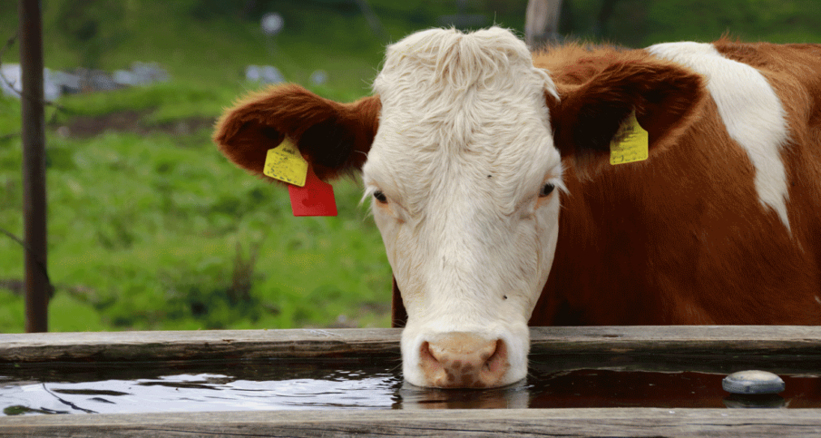
The ERBS believes it can achieve a world in which all aspects of the beef value chain are environmentally sound, socially responsible and economically viable. It sees its mission as ensuring that all aspects of the beef value chain are recognised for delivering measurable positive impacts and continuous improvement towards key sustainability priorities.

The ERBS is open to farmers, allied industries, companies in Processing, retail and food service, and “civil society organizations” (i.e., NGOs) wishing to “constructively collaborate with partners in the beef industry on aligned sustainable practices.”
For details on ERBS operations, see https://saiplatform.org/erbs/
In 2019, the beef industry ran a public relations campaign, arguing that meat and farmed animals are wrongly blamed for the climate crisis without considering their benefits for society.
Billboards appeared this week in Brussels metro stations together with a social media campaign #meatthefacts. The adverts were funded by European Livestock Voice, which is backed by organisations representing EU farmers, foie gras producers and the fur and leather industry.
“We believe this campaign is necessary in order to address misinformation,” said a spokesperson for Livestock Voice. The group said they want people “to think about the whole picture and all the consequences that simplistic speeches calling … for a ‘drastic reduction of livestock’ could have on Europe’s rural areas and on society in general.”
The campaign group says the current debate around meat and livestock has been one-sided, and that livestock’s contribution to biodiversity, bioenergy and the rural economy has been overlooked. “An EU without livestock would not only lose locally produced food, but also essential habitats and biodiversity. It would also mean increased fires, lack of natural fertiliser and green energy, and a rural exodus,” it says.

ACTORS IN THE CASE
The European Livestock and Meat Trades Union (UECBV)
European Roundtable for Beef Sustainability (ERBS)
European Livestock Voice

European Commission
European States with a significant beef industry
European States without a significant beef industry

European consumers

European environmental NGOs

Media

CASE QUESTIONS

- (1) If you were European Livestock and Meat Trades Union (UECBV) what would be (a) the most important issue, and (b) the most important actor (other than the European Commission) you would monitor as you seek to influence European Commission policy and decision-making regarding livestock and greenhouse gas emissions Format: I’d monitor______ because__________.
(maximum words: 80)

- (3) Summarize the power situation that UECBV faces in the case (maximum 100 words)
- (3) Diagram your most likely scenario on how livestock policy and decision-making regarding greenhouse gas emissions will unfold in the EU (without active intervention on your part).
- (1) What public policy model do you think will best describe how the European Commission will make policy and decision-making regarding livestock and greenhouse gas emissions. Explain your choice (maximum words: 30 words)
- (5) Given your power summary, scenario and public policy models, as UECBV, what will be your strategy going forward to maximize the possibility that the European Commission will make policy and decision-making regarding livestock and greenhouse gas emissions acceptable to your membership? (maximum words: 150)
- (2) In your view, what would the European Livestock industry have to do to meet a standard of “creating shared value” as defined in Module 4? (maximum words: 80)

Appendix A. Beef and Deforestation

“Getting to zero—what’s the beef?”

By George Tyler, Social Europe, 3 December 2021
https://socialeurope.eu/getting-to-zero-whats-the-beef

Most livestock land will have to be repurposed as carbon sinks to remove the huge global emissions related to food production.
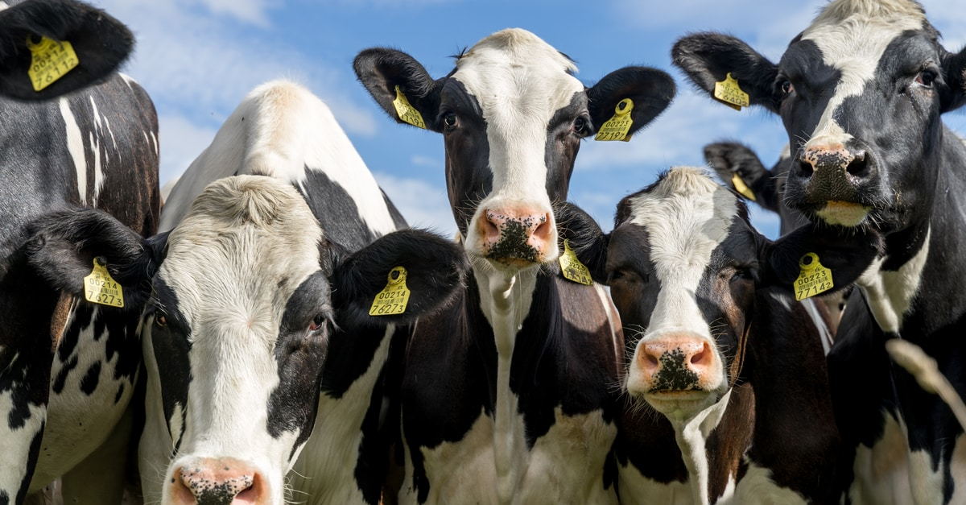Land earmarked for cattle—as these Fresians in Estonia—needs to revert to C0₂ absorption (Ingrid Pakats / shutterstock.com)
The COP26 debates often ignored the cow in the room—the biggest challenge of all. Greenhouse gases (GHG) from food and agriculture comprise a third of global emissions. Success in stemming climate change hinges emphatically on reducing food-chain emissions to zero. That can only occur with dietary changes, accompanied by repurposing as carbon sinks most agricultural lands feeding beef and dairy cattle.
Achieving zero emissions from all sectors, except food, is potentially amenable to technology. Replacing fossil fuels in long-distance air and marine travel, production of cement clinker and some chemical and industrial processes will be challenging. But the associated research and development is advancing and eliminating emissions without sacrificing quality of life appears technically feasible.
Volkswagen, for instance, is powering its huge new car-carrier vessels with waste and residual vegetable oils. Maersk has ordered eight giant ships, each holding 16,000 containers, to be fuelled with carbon-neutral methanol. Steel at the largest electricity consumer in Colorado (arc furnaces at Evraz Rocky Mountain Steel) is being produced with solar energy. And Deutsche Bahn is experimenting with French hydrogen-fuelled locomotives and lithium-ion batteries to replace diesel.
The food chain is different, however. Fossil fuels account for only 20 per cent of sector emissions. And most food-chain emissions—from crop fertilisation, ploughing, rice paddies, animals burping methane and the like—can only be marginally attenuated. Improved manure management, planting more nitrogen-fixing legumes and switching to green fertiliser from solar-electrolysis hydrogen are promising. But burping by beef and dairy cattle alone accounts for 8 per cent of global GHG emissions (with mitigation hinging on exotic R&D options, such as seaweed feed additives).
Food-chain (>26 per cent) and non-food agricultural uses (>5 per cent), such as textiles, sum to 31-34 per cent of global GHG emissions. They still account for a quarter of net emissions after adjusting for estimated emission offsets (photosynthesis and land carbon fluxes) that capture atmospheric GHG. That 25 per cent is a huge impediment to zero emissions.
The first step is to identify foods high in emissions—overwhelmingly animal products.
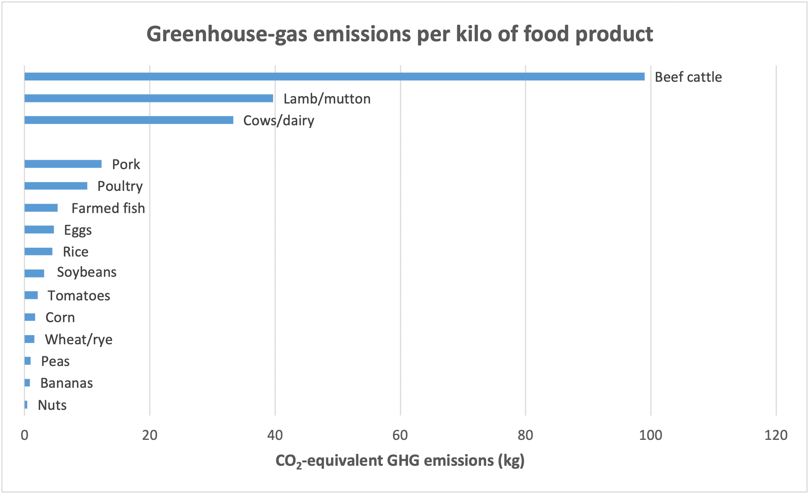Source: Poore and Nemecek and Ritchie and Roser
Meat is not an indispensable source of protein, as more than a billion vegetarians worldwide attest. Fish and vegetables such as peas already supply 63 per cent of global proteins / amino acids. Protein substitutes for milk, other dairy and meat are rapidly gaining market acceptance.
As sources of protein / amino acids, vegetables are far more environmentally sustainable. These data are the scientific basis for appeals to reduce meat and dairy consumption. (A spinoff benefit is reducing the spread of bacterial resistance in humans by corralling antibiotic use in animals.)
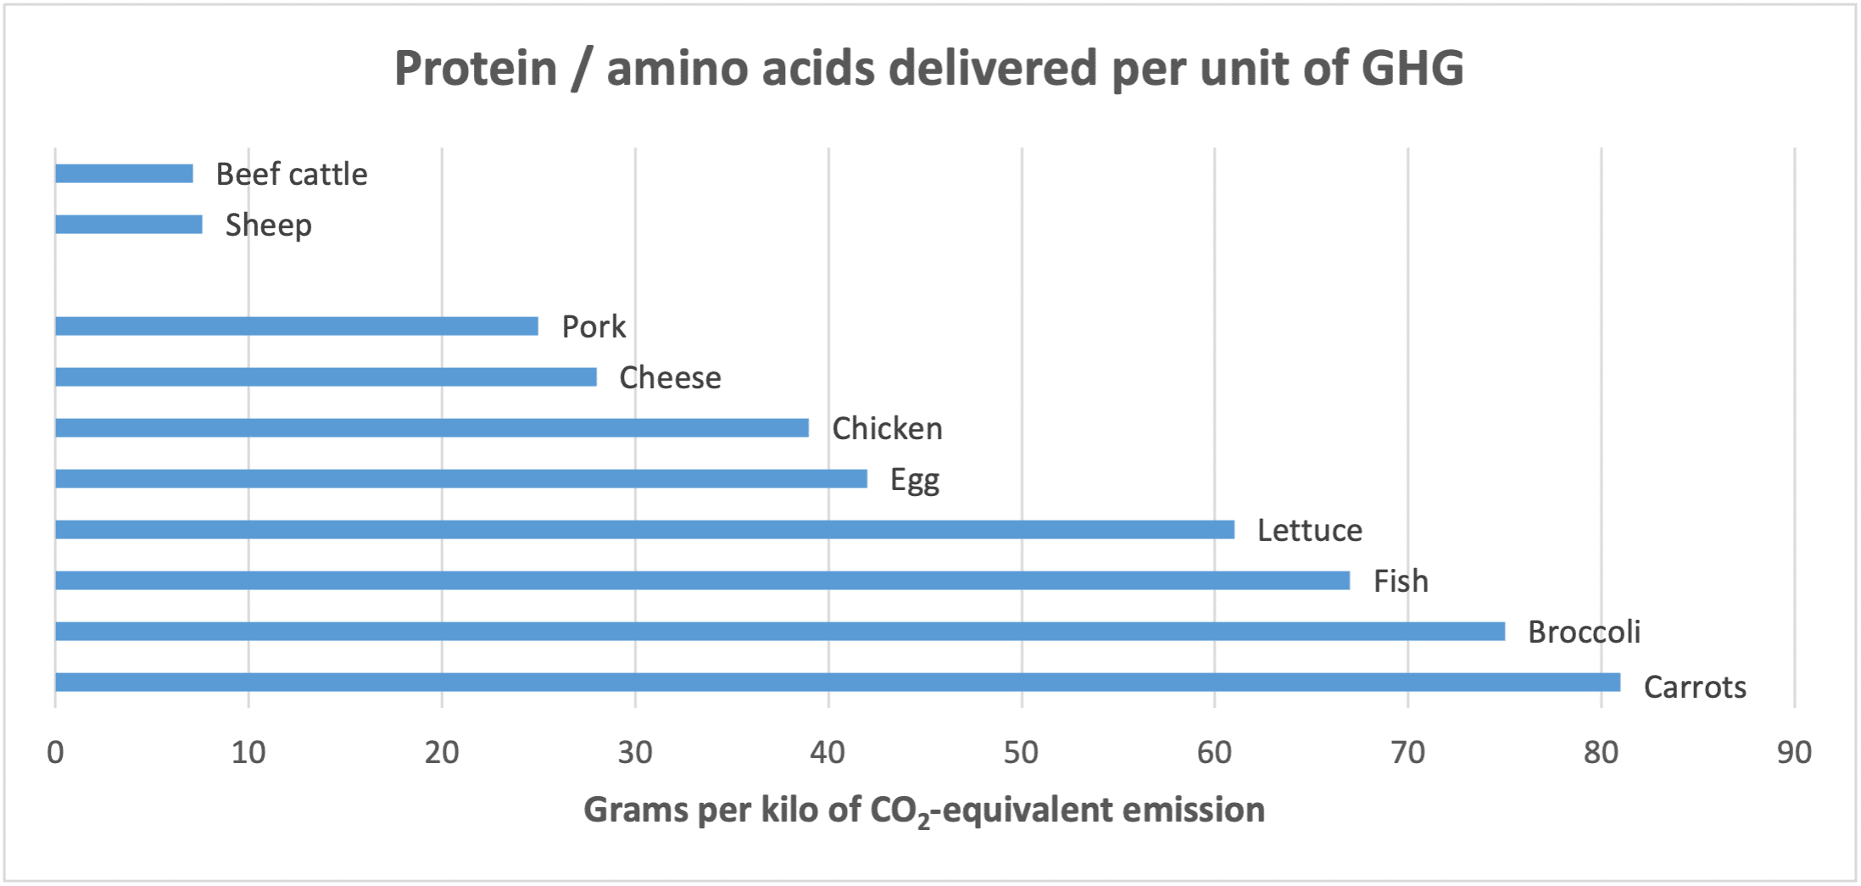Source: Gonzalez, Frostell and Carlsson-Kanyama
Switching to low-emission foods alone will not however eliminate food and agriculture’s 25 per cent global net share. If all consumers worldwide excluded beef and cow products from their diets, this would eliminate only 9 per cent of emissions.
The gap can be largely closed with a second policy—repurposing as carbon sinks pastures and lands cultivating feed for large ruminants. Cattle and cows, for instance, eat about 25 pounds daily, their land requirements far exceeding that for smaller ruminants—sheep (4.5 pounds/day) and goats (2-4 pounds)—as well as fish, pork, poultry and plants.
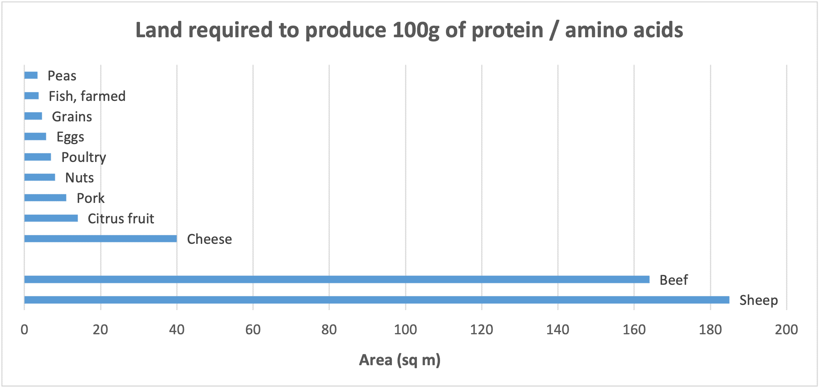Source: Ritchie and Roser
Livestock pastures and cropland cultivating animal feed occupy 77 per cent of global agricultural land, with about three-quarters of that acreage devoted just to cattle and cows. Scientists calculate that allowing all livestock lands to revert to carbon sinks would result in the sequestration of 8.1 gigatons of GHG annually over the next 100 years. Converting the share devoted just to cattle and cows would sequester up to 6 gigatons annually, comparable to 12 per cent of global emissions. In combination with dietary substitution of plants and poultry for cattle and cows, that would close much of the food-chain emissions gap.
True, cultivation of the substitute low-emissions foods would add 2-3 percentage points to land-cropping requirements and thus to global emissions. Additional emissions reductions are however feasible from promising agricultural R&D and from cessation of deforestation in the Amazon, Indonesia and elsewhere associated with cattle (cleared for pastures and feed cultivation). Deforestation for cattle alone adds 3.4 per cent to annual GHG emissions.
Central to this environmentally beneficient scenario is purging most large-ruminant food products from diets; that is an environmental sine qua non. At the same time, selective accommodation is appropriate regarding some meat or dairy products and for the 500 million pastoralists and smallholders worldwide who depend on livestock for their survival, income and assets. Moreover, religious considerations are important, particularly in south Asia.
In the European Union, reforms to the Common Agriculture Policy set for 2023, just adopted by the Council of the EU, will likely shrink herd size. The CAP could complement those reforms with voluntary purchases of current cattle pastures to create publicly-owned carbon reserves. Safeguards could include animal censuses to ensure herds do shrink. Financed with meat taxes, such land purchases would ease (and perhaps accelerate) the transition of cattle owners and dairy farmers to other pursuits while creating new national parks and forests.
The same concept could be adopted in the United States if opposition can be overcome from Republican politicians seeking partisan advantage by embracing beef and from the meat and dairy industry. Reducing herds could be facilitated by creating carbon reserves, financed entirely by reallocating the annual $38 billion federal meat-and-dairy subsidy. Moreover, displaced cattle and dairy workers could be included in the American Jobs Plan of the president, Joe Biden, otherwise providing support for former fossil-fuel-industry workers. Occupational transition for the combined two million workers could include training to enhance re-employment, along with support for their communities.
A model is the 1977 expansion of California’s Redwood National Park, where Congress provided hefty income support over 6-11 years for displaced loggers. That model today could be funded in part by diverting the government’s annual $20 billion fossil-fuel subsidy.
Reducing food-chain and agricultural emissions to zero is a huge challenge for a global industry with tens of millions of workers, 500 million pastoralists and herders, and nearly eight billion fickle consumers. Pivotal will be sweeping mitigation policies, including switching government and World Bank subsides from cattle to small-animal husbandry. Moreover, consumers need encouragement to remove large ruminants from diets—a goal taxes and R&D on benign substitutes for beef and cows can facilitate.
As COP26 and the recent report by the Intergovernmental Panel on Climate Change make clear, inaction is not an option. Without prompt reforms, the globe is certain to replay the Pliocene era of 3-5 million years ago—melted ice caps flooding the planet, with seas 82 feet higher, and relocation of 190-630 million flooded inhabitants.

Appendix B. Environmentalists bewildered by EU approach to meat consumption and Farm to Fork
By Sustainability Times on December 9, 2020
Animal rights advocates and environmentalists across Europe have been left scratching their heads after news broke of a ‘Beefatarian’ campaign for which the European Union has set aside over €3 million to target consumers in Belgium, France, Germany, Portugal, and Spain. Of course, the new clip celebrating, and even promoting, the consumption of red meat is just the tip of the iceberg in the controversies associated with the EU’s Farm to Fork (F2F) strategy, which is intended to make Europe’s food system healthy as well as sustainable for the planet.
The F2F strategy, published earlier this year, outlines many crucial areas for the bloc to address, such as the promotion of agroecology and sustainable consumption – notably including the need to move towards less (and more sustainably produced) meat. In this light, the European Commission’s ongoing funding of campaigns to boost meat consumption seems to be undermining its own food policy, while also forcing the citizens of Europe to wonder whether they can really trust the Commission’s approach to implementing effective nutritional and environmental policies.

Beef between environmentalists and the Commission
Just a few weeks after the pro-beef campaign was unveiled, 26 non-governmental European organizations addressed a letter to international institutions, in particular the European Union, broaching the very same subject. Their missive underlined the extent to which food production influences the rate of climate-altering emissions.
Signed by groups including Slow Food, Humane Society International, and the Climate Action Network, the letter reads: “Energy, fossil fuels, transport and industry tend to dominate climate discussions and actions. However, the food system generates around 26% of global greenhouse gas (GHG) emissions. Around 75% of agriculture’s emissions are produced by livestock, including the production of feed for livestock and the associated land use changes. In contrast to this, global meat and dairy production provides only 37% of our protein and 18% of our calories.”
The sector’s footprint is indeed massive. The agriculture sector accounted for roughly 10 percent of the EU’s total greenhouse gas emissions in 2015, and nitrogen pollution costs the EU as much as €320 billion each year. Addressing UN Secretary-General António Guterres and European Commission president Ursula von der Leyen, among other leaders, the NGOs decry industrial meat production which emits more climate-altering gases than the entire transport system, as well as devastating the soil, polluting groundwater, and exhausting water resources.
The European Union’s consumption of meat and dairy is already 70% greater than the WHO recommendation, and twice the global average. Campaign groups insist that if our consumption continues to grow at this rate, the “system will collapse.”

Should Europe put a label on it?
The new beefatarian campaign could turn out to be just one of several ways in which the EU knowingly or unwittingly promotes unsustainable meat consumption, with the ongoing debate surrounding front-of-pack food labelling featuring candidates which stand accused of pushing consumers towards eating more meat instead of less – essentially offering misleading nutritional guidance which is also bad for the planet. Here again, the F2F strategy, which enshrines the Commission’s commitment to considering a harmonized front-of-pack labeling (FOPL) system for the whole of the EU, finds itself front and center.
One of the leading candidates under consideration by the Commission, the French traffic light-style Nutri-Score, has raised questions among environmental campaigners over whether it promotes meat consumption. In determining grades for food products, Nutri-Score is designed to see meats receive “greener” scores because their protein content leads Nutri-Score’s algorithm to consider them healthy, regardless of whether or not they have been produced by factory farming. As a result, in France, Belgium, Spain, and most recently Germany, activists are contending with policy choices that may both directly (via the beefatarian advertising campaign) and indirectly (via the Nutri-Score food label) push consumers toward the very meat consumption they are trying to reduce.
Nutri-Score’s controversial algorithm is also under fire for its impact on other key elements of European diets, notably the Mediterranean culinary traditions prevalent in Italy, Spain, and other southern EU countries. Notably, long celebrated ‘Mediterranean diets’ have recently attracted renewed scientific attention for their environmental sustainability as well as their contributions to human health. By encouraging the consumption of fruits, vegetables, cereals, and legumes, with only occasional servings of red meat, these food traditions and their small footprints have been held up by the UN’s Food and Agriculture Organization (FAO) as a model for a “sustainable diet” worldwide.
These decisions, though they may seem esoteric, add up to a big impact on the planet. If dietary shifts can indeed “contribute up to a fifth of the mitigation needed to meet” the Paris Agreement’s target of keeping global warming below 2°C, grassroots activists are fighting a key battle in advocating for a shift away from unsustainable eating and towards slow, mindful consumption.

More battles still to come
Consumer advertising and food labels are just two of the many heated debates the Commission will need to navigate as it pushes ahead with F2F. The concept of “new breeding techniques” or mutagenesis has also been included in the document, despite the European Court of Justice ruling on genetically modified organisms. Agriculture experts also state that the F2F strategy’s pesticide reduction targets of 50% are too low to reverse the unprecedented pollinator extinction rates the EU is currently seeing, with 12 wild bee species now critically endangered.
Given the over €1 trillion that will be poured into the European Green Deal over the next several years, including the F2F and Biodiversity Strategies, the efficacy of the EU’s approach is of great import for the 447 million people who live in the European Union. While the F2F strategy was drawn up to instate a Europe-wide sustainable food system, flawed implementation threatens to drastically undermine what could otherwise be decisive European action on climate change through the food industry and agriculture.

