Case #8. Nuclear Power Industry: Friends and Enemies

The Appendices provide background on nuclear power

Nuclear Power in the European Union
- The EU depends on nuclear power for one-quarter of its electricity, and a higher proportion of base-load power. Nuclear provides half of low-carbon electricity.
- Very different energy policies pertain across the continent and even within the EU, but attention is now being given to an EU Energy Union.
- A substantial degree of transmission interconnection exists in western Europe, but much more investment is needed.
- Electricity markets are a key to the future of reliable generation capacity, including nuclear.
- EU states split on classifying nuclear energy as 'green'
"It's too risky, too slow and too expensive," Germany says — while other EU members have pushed for the bloc to classify nuclear power as eco-friendly for investors.
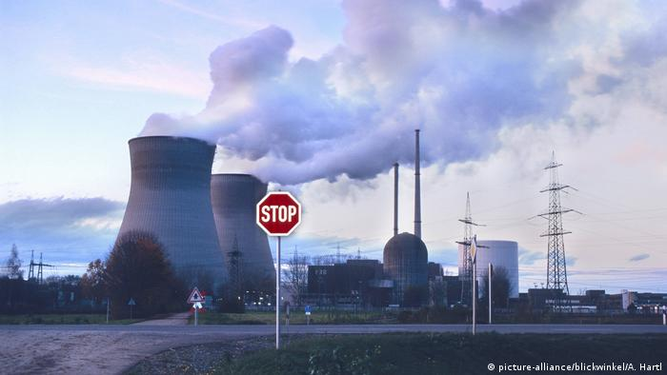
Germany was set to complete its nuclear phaseout by 2022, but then Russia invaded Ukraine.
This past Fall, Germany, Luxembourg, Portugal, Denmark and Austria spoke out against the classification of nuclear energy as a climate-friendly source of power.
The five countries issued a statement on the sidelines of the UN climate summit in Glasgow, COP26. It came as the European Commission was working on a so-called EU taxonomy, in which it lists what the bloc considers as "environmentally sustainable economic activities."
Some other EU countries, led by France, were seeking to add modern forms of nuclear energy to that list. France, in particular, voiced plans to use nuclear energy as part of its efforts to phase out fossil fuel plants that are significant sources of greenhouse gas emissions.
"The current decade will be crucial for our common path toward climate neutrality and an economic system that respects the limits of our planet," Germany, Luxembourg, Portugal, Denmark and Austria said in their statement.
Therefore, it is crucial to have an EU taxonomy that considers the sustainability of a form of energy "throughout its life cycle," the signatories added, referring to the radioactive waste generated by nuclear power use.
They also warned that the classification could risk diverting EU funds from renewable energies such as wind and solar power.
"Nuclear power cannot be a solution in the climate crisis,'' said German Environment Minister Svenja Schulze. "It is too risky, too slow and too expensive for the crucial decade in the fight against climate change," she added.
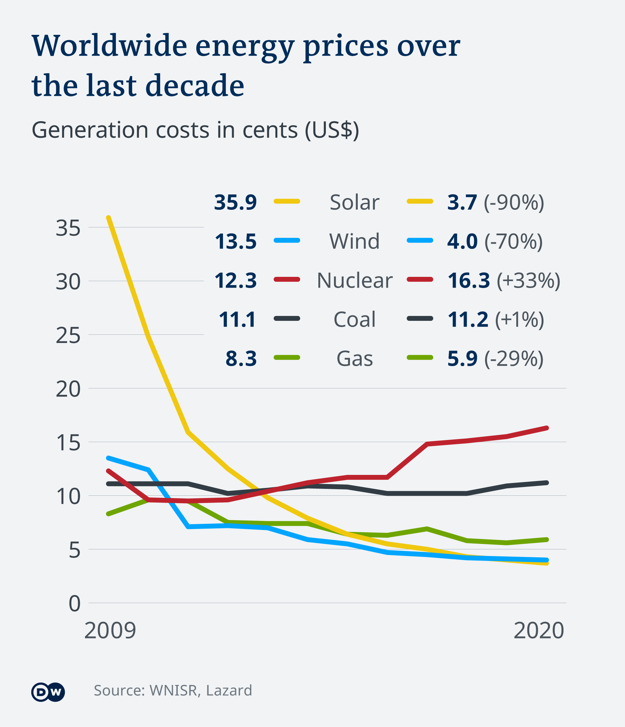
In the past decade, renewable energy prices have significantly dropped, compared to nuclear energy
Austria's environment minister, Leonore Gewessler, also backed Germany's stance, saying, "Just because something is not quite so bad doesn't mean it's good."

What about the countries supporting nuclear energy?
France, Poland, Hungary and the Czech Republic have called on the European Commission to classify nuclear power plants and nuclear waste storage facilities as "green." They also want the taxonomy to include natural gas-fired power plants.
This past fall, France announced that it would start building its first new nuclear reactors in decades to meet its promises to reduce carbon emissions. "If we want to pay for our energy at reasonable rates and not depend on foreign countries, we must both continue to save energy and invest in the production of carbon-free energy on our soil," said French President Emmanuel Macron.
Compiled by the European Commission, the classification system is a list of "environmentally sustainable economic activities." The Commission said the list should "create security for investors, protect private investors from greenwashing, help companies to become more climate-friendly, mitigate market fragmentation and help shift investments where they are most needed."
If the European Commission in Brussels classifies nuclear power as "sustainable" in the legal text, it will count as a direct recommendation to financial markets to invest in nuclear plants.
In April 2020, the European Commission's scientific body, the Joint Research Centre, released a report that found that nuclear power is a safe, low-carbon energy source comparable to wind and hydropower in terms of its contribution to climate change.
Still, many environmentalists oppose nuclear power, citing the risk of nuclear meltdowns and the difficulty of properly disposing of nuclear waste.
FORATOM, the Voice of the Nuclear Energy Industry in Europe
FORATOM is the Brussels-based trade association for the nuclear energy industry in Europe. FORATOM acts as the voice of the European nuclear industry in energy policy discussions with EU Institutions and other key stakeholders. The membership of FORATOM is made up of 15 national nuclear associations representing nearly 3,000 firms.
FORATOM supports the European Nuclear Society (ENS), a Learned Society that brings nuclear societies and professionals in Europe together, allowing them to exchange knowledge and experience about nuclear science and technology. ENS promotes the development of nuclear science and technology and the understanding of peaceful nuclear applications. Founded in 1975, ENS is the largest society for nuclear science, research and industry in Europe.
The Society’s membership includes national nuclear societies from 20 countries in Europe plus Israel. Another crucial component of that membership are its Corporate Members, representing key stakeholders which are partners for nuclear technology and research in Europe.
ENS connects its members with the principle aim of fostering and coordinating their activities on an international level. In relation to this, the society encourages the networking of scientists and engineers between different countries and organises meetings devoted to scientific and technical matters and to the communication on nuclear applications.
ENS comprises more than 12,000 professionals from the academic world, research centres, industry and authorities: people who voluntary commit themselves to generate ideas and to take up responsibilities, who have the enthusiasm to get things done and the curiosity to learn from colleagues and from people outside the network
One major initiative of ENS is called, “Nuclear for Climate.” It circulates a position paper entitled, “Net Zero Needs Nuclear.”
The Russian Invasion of the Ukraine and the Future of Nuclear Power
On February 24, 2022, Russia invaded the Ukraine. On February 27, Germany signaled a U-turn in key energy policies, floating the possibility of extending the life-spans of coal and even nuclear plants to cut dependency on Russian gas, part of a broad political rethink following Russia's invasion of Ukraine.
Europe's top economy has been under pressure from other Western nations to become less dependent on Russian gas, but its plans to phase out coal-fired power plants by 2030 and to shut its nuclear power plants by end-2022 had left it with few options.
In a landmark speech, Chancellor Olaf Scholz spelled out a more radical path to ensure Germany will be able to meet rising energy supply and diversify away from Russian gas, which accounts for half of Germany's energy needs.
"The events of the past few days have shown us that responsible, forward-looking energy policy is decisive not only for our economy and the environment. It is also decisive for our security," Scholz told lawmakers in a special Bundestag session called to address the Ukraine crisis.
"We must change course to overcome our dependence on imports from individual energy suppliers," he said. This will include building two liquefied natural gas (LNG) terminals, one in Brunsbuettel and one in Wilhelmshaven, and raising its natural gas reserves.
Earlier in the week, Germany halted the $11 billion Nord Stream 2 Baltic Sea gas pipeline project, Europe's most divisive energy project after Russia formally recognised two breakaway regions in eastern Ukraine. Nord Stream 2 is now considered dead by most analysts.
As of the date of this case, the price of natural gas in Europe has almost doubled from pre-war levels.
ACTORS IN THE CASE
FORATOM
EUROPEAN NUCLEAR SOCIETY
EUROPEAN COMMISSSION (EC)
EC’S Joint Research Centre
EUROPEAN PARLIAMENT
4 PRO-NUCLEAR COUNTRIES
5 ANTI-NUCLEAR COUNTRIES
Antinuclear environmental NGOs
NOTE: YOU MAY CHOOSE TO REFERENCE CURRENT EVENTS AS THEY ARE UNFOLDING IN THE EU ECONOMIES, THE UKRAINE AND THE INTERNATIONAL ENVIRONMENT IN ANSWERING THE QUESTIONS BELOW.
CASE QUESTIONS:
- (7) With the actors identified above, draw a power diagram for the case, following the examples shown in Exhibit 8.1, 8.2 AND 8.3,

Please review “How to Structure an Easily Readable Power Diagram” before drawing your power diagram. Exhibits 8.1, 8.2 and 8.3 are good diagrams except they do not follow my advice in the “How to…” regarding centering the government agencies, bracketing by supporters and opponents of the focal company.
2. (4) Summarize what your power diagram tells you about the power situation that nuclear power advocates, whether advocating for big or small nuclear power plants, face in the case (Summary means summary! Do not simply repeat what is in your diagram. Summarize key elements, leading to a concluding sentence about position, positive or negative, of (a) big nuclear power plant advocates, and (b) small nuclear power plant advocates, i.e., a “summary” of your summary in power terms.) (maximum 150 words)
3. (4) Referencing where appropriate your foregoing power analysis, is there a viable strategy for(a) big nuclear power plant advocates, and (b) small nuclear power plant advocates to prevail? If yes, explain. If not, explain why not. (maximum 75 words for each a and b.)

Appendix A
In February 2022, the European Commission labeled nuclear and gas as sustainable. Anti-nuclear power critics immediately called the step "greenwashing" and say it could threaten the bloc's bid to become climate-neutral by 2050.
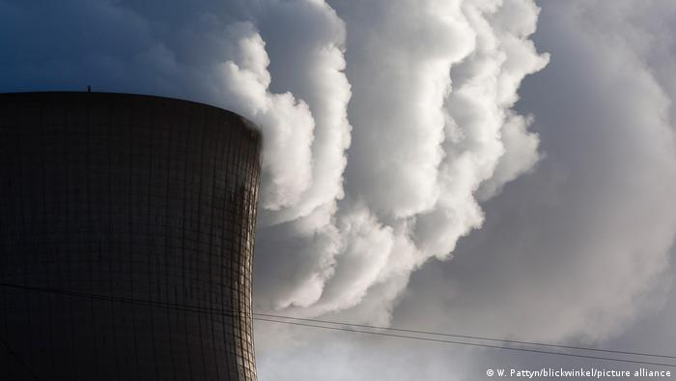
Nuclear energy is criticized by environmentalists, among other reasons due to very large water use
European Commission chief Ursula von der Leyen cannot repeat often enough how close stepping up climate action is to her heart.
She described the European Green Deal as "Europe's man on the moon moment." She has called climate neutrality "our European destiny." And she solemnly proclaimed that no effort will be spared for Europe to become the world's first continent with net-zero emissions.
But as often, the devil is in the detail. The big question is how exactly the European Union intends to achieve its goals.
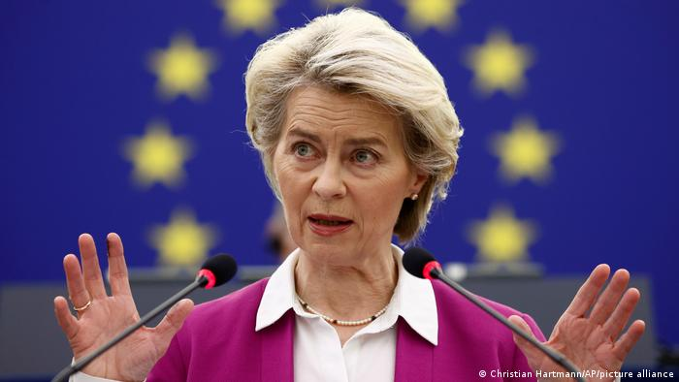
European Commission President Ursula von der Leyen paints herself as a friend of the climate
The Green Deal taxonomy is "a classification system, establishing a list of environmentally sustainable economic activities," according to the European Commission. This taxonomy could be described as the EU's green investment rulebook, intended to serve the goal of allowing the continent to become climate neutral by 2050.
In its proposal, the EU Commission stated that certain strings remained attached. For example, gas plants could only be considered green if the facility switched to low-carbon or renewable gases, such as biomass or hydrogen produced with renewable energy, by 2035.
Nuclear power plants would be deemed green if the sites can manage to safely dispose of radioactive waste. So far, worldwide, no permanent disposal site, has gone into operation though.
At a news conference in Brussels, Mairead McGuinness, the EU commissioner responsible for financial services, said her institution was not guilty of "greenwashing," as gas and nuclear were labeled as "transitional" energy sources in the taxonomy. "Our credibility is still strong," McGuinness added.
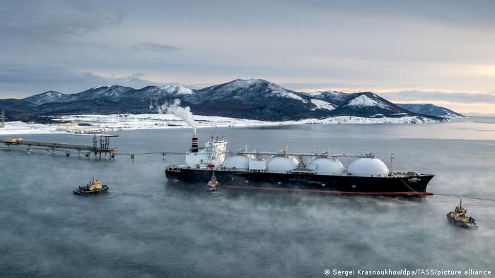
Natural gas can be liquified, allowing it to be shipped relatively easily via tanker
Environmental organizations most certainly see this critically, saying the proposal could jeopardize the EU's aim to reach climate neutrality by 2050. The Climate Action Network Europe wrote that the EU Commission "sacrifices the scientific integrity of the taxonomy on the altar of fossil gas and nuclear lobbies" and failed to "reorient financial flows towards genuinely climate-positive investments."
And it's not just climate activists: Also a group of experts critical of nuclear power advising the EU on the matter had announced how they are worried about "the environmental impacts that may result," for example the consequences of a nuclear accident. Building new nuclear plants would also take too long to contribute to the 2050 neutrality goals, they believe.
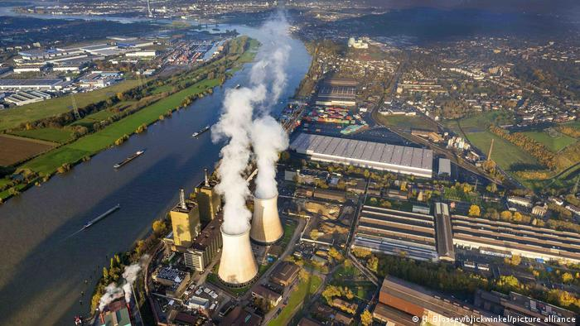
Germany has opted to use gas as a bridge away from more polluting fossil fuels and toward zero-carbon energy sources

Germany pro-gas, France pro-nuclear
France wants to invest in new nuclear power plants, particularly in new generation, so-called small modular reactors.
Energy expert Nicolas Mazzucchi, who works for the Foundation of Strategic Research think tank in Paris, supports the French government's plans. "These reactors can be produced on an industrial level at factories, as automated as possible, to make it cheaper and guarantee quality," Mazzucchi told DW.
Germany, however, has argued against nuclear power — also unsurprisingly, as it decided to shut down all its nuclear power plants by the end of 2022 following the Fukushima disaster in 2011. Denmark, Austria and Luxembourg share this view, highlighting the controversial point of where to safely store highly radioactive nuclear waste.

France: Is nuclear energy green?
In a letter to the European Commission, Germany's current governing coalition has clearly said that gas is needed as an interim energy source until enough renewables are available.
To avoid a clash with its EU neighbor France, German Chancellor Olaf Scholz downplayed the importance of the taxonomy at an EU leaders' meeting last year, saying the debate was "completely overrated."
Georg Zachmann, a senior fellow at the Brussels-based Bruegel think tank, has been following the EU's energy and climate policy for years. He said that, in the end, he was relatively sure no decision would be taken by the European Commission in Brussels to prevent France, for example, from investing in and building new nuclear reactors.
The European Commission is keen to have the taxonomy viewed as the "gold standard" for guiding private investment toward measures that help fight climate change.
But in Zachmann's view, no investor would be interested in nuclear or gas if the EU "invested political capital" in getting member states to substantially expand their renewable energy production. "We know that onshore wind and solar power are not very costly in most European countries," he pointed out.

What happens next?
The European Commission's taxonomy proposal will now be reviewed by the 27 EU member states and by the European Parliament.
Because the European Commission opted for a “delegated act,” a type of fast-track legislative procedure, only a total of 20 EU countries, or a majority of EU lawmakers at the European Parliament, would be able to reject it.
While EU states are not likely to turn down the taxonomy, a win in the European Parliament is not yet certain. Parliamentarians from across the political spectrum have expressed anger over the inclusion of fossil gas and nuclear power in the EU taxonomy.
Green lawmaker Rasmus Andresen said he was "disappointed" by the proposal, adding that the Green parliamentary fraction would fight hard to gather a majority against the taxonomy.
German Social Democrat Joachim Schuster told DW he thought it possible that the European Parliament could vote against the act.
And even if lawmakers were to support it, there was another threat looming: Austria and Luxembourg threatened to sue the European Commission over the taxonomy rules.

Appendix B. Is Nuclear Power Part of the Climate Solution?

Investing in the next generation of nuclear reactors could give the world an important tool for reducing carbon emissions.
By Gernot Wagner Wall Street Journal Jan. 7, 2022

Most reactors now operating were built in the 1970s, and many in the U.S. and Europe are being closed. Worldwide, 450 reactors generate 10% of the total electricity consumed today, down from more than 15% in 2005, thanks to a rapid global build-out of power capacity that has largely left nuclear behind.
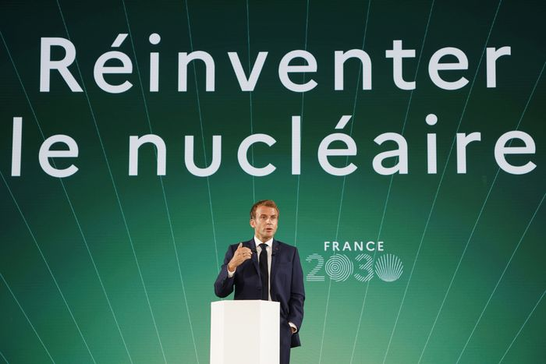

French President Emmanuel Macron at the presentation of the ‘France 2030’ investment plan, which includes funding for research and development of nuclear power, Paris, Oct. 12, 2021.
Photo: Ludovic Marin/Pool Photo/Associated Press
The level of carbon emissions generated by nuclear power is on par with solar and wind, especially when considering the complete life cycle of a plant. Both solar and wind produce entirely carbon-free electricity once they are up and running, but they require a significant carbon investment up front. Solar panels rely on metals that need to be mined, and the average wind turbine is now large enough to contain around 200 tons of steel or more. It will eventually be possible to produce this steel without generating carbon emissions, but not yet.
Nuclear power’s biggest environmental challenge is the waste it produces, which requires thousands or tens of thousands of years of safe storage. But there isn’t a lot of it: All of the nuclear waste produced in the U.S. since the 1950s adds up to about 85,000 tons of material. Compare that with the tens of billions of tons of carbon dioxide that would have been produced had that electricity come from fossil fuels instead.
In November 2021, the U.S. Congress passed an infrastructure package that earmarked $2.5 billion for research and development of new nuclear technologies. It also included $6 billion in subsidies to keep existing nuclear plants running longer.
In France, as part of a massive push to “reindustrialize,” the government will spend $1.13 billion on nuclear power R&D by 2030. The focus is on developing a new generation of small modular reactors (SMRs) to replace parts of the existing fleet that supplies around 70% of the country’s electricity.
The Netherlands’ new coalition government sees nuclear power as a “complement” to solar, wind and geothermal energy in the country’s low-carbon energy mix. The Dutch are extending the life of one nuclear plant and taking steps to build two new reactors, putting $566 million toward that goal. And just last week, in a controversial move, the European Union proposed classifying nuclear as a “green” energy source for funding purposes, “to facilitate the transition toward a predominantly renewable-based future.”
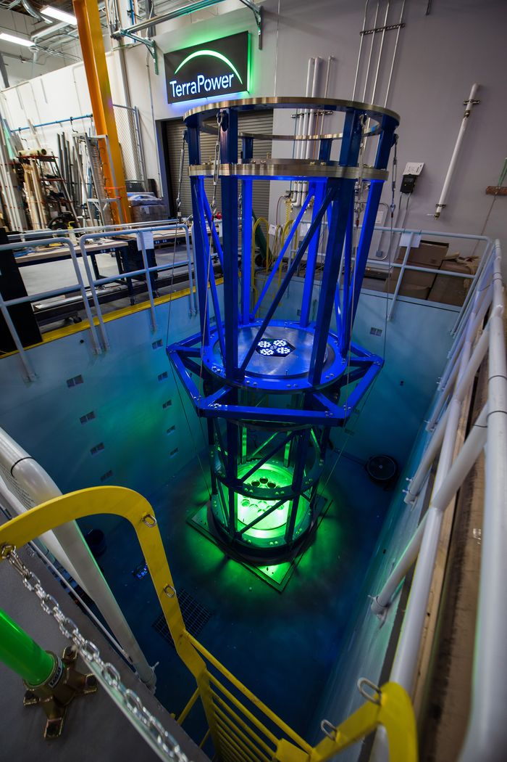

A fuel-handling test facility at TerraPower, the nuclear energy company founded by Bill Gates.
The most consequential story of a country with second thoughts about nuclear energy is Germany, Europe’s industrial powerhouse. Before 2011, nuclear power accounted for about 25% of Germany’s electricity production. The country had not built a new reactor since the late 1980s, influenced by the Chernobyl nuclear accident in the Soviet Union in 1986, but it planned to operate most of its reactors through the 2030s.
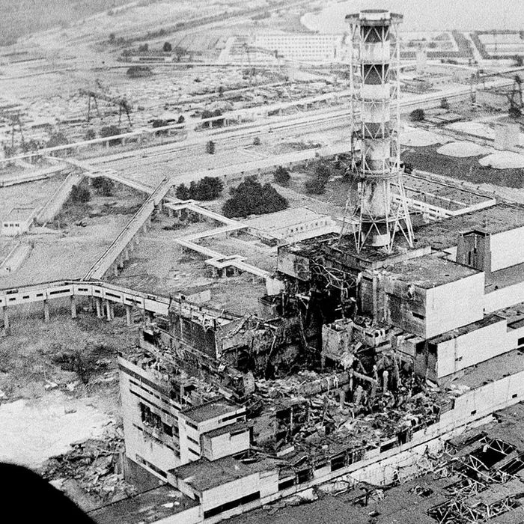

The Chernobyl nuclear reactor days after it was destroyed by an accident on April 26, 1986.
Photo: ASSOCIATED PRESS
Then came the Fukushima nuclear accident on March 11, 2011, triggered by the most powerful earthquake ever recorded in Japan. In the wake of the accident, Japan’s decision to shut down its nuclear plants instead of phasing out coal.
Nuclear power has also stagnated in the West because of its high cost, which is partly related to safety measures. While solar and wind have been getting cheaper, nuclear power has been getting more expensive. The U.S. is building only two new reactors at the moment, both outside Augusta, Ga., at a combined cost of over $28 billion, roughly double the original projection. France is currently building only one reactor, which will go on line later this year; it has cost $21.5 billion, instead of the originally budgeted $3.9 billion, and is a decade behind schedule. The U.K. has two reactors currently under construction at a total cost of $30 billion, dwarfing the country’s $516 million investment in research and development on small modular reactors.
SMRs and other new technologies are the nuclear industry’s big hope. One focus of research is using new fissile materials such as thorium, which is more abundant, produces less waste and has no direct military applications. Other technologies look to using existing nuclear waste as a fuel source. Turning away from massive reactors toward SMRs might, at first, increase costs per unit of energy produced. But it would open financing models unavailable to large reactors, allowing costs to come down, with reactors following a uniform design instead of being designed one by one. Building many small reactors also allows for learning-by-doing, a model actively pursued by China at home and as part of its Belt and Road Initiative abroad.
None of these new technologies is sure to be economically competitive. Some of the more experimental technologies, like China’s thorium reactors, might yet pay off. TerraPower, a venture founded by Bill Gates, has been working on natrium reactors for over a decade and recently added a molten-salt design to the mix, which could make a real difference if it works out. The point is to try. Like solar and wind, nuclear energy could climb the learning curve and slide down the cost curve with the right financial backing.
Nuclear power comes with risks. So does a warming planet. The high cost of nuclear power today says little about where things might stand in a few decades, when the world should be well on its way to powering its grids with low-carbon technologies alone. For reasons of both energy security and climate change, governments in the West, China and beyond should continue to invest in nuclear research and development.
—Dr. Wagner teaches climate economics at Columbia Business School (on leave from New York University). He writes the Risky Climate column for Bloomberg Green and is the author of “Geoengineering: The Gamble” (Polity Press, 2021).

Appendix C. U.K. Backs Giant Nuclear Plant
The British government said it would acquire a 50 percent stake in the new power project and buy out China’s investment.
- https://www.nytimes.com/2022/11/29/business/uk-nuclear-plant-china.html?smid=nytcore-ios-share&referringSource=articleShare
- By Stanley Reed New York Times Nov. 29, 2022

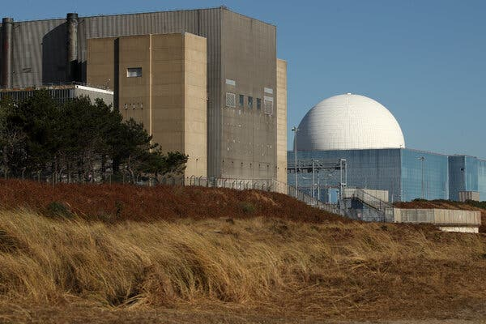
The Sizewell B nuclear power station in Sizewell, England. A new plant is expected to take a decade to become operational.Credit...Chris Radburn/Agence France-Presse — Getty Images

In late November 2022, the British government threw its weight behind nuclear power, saying it will back a major new generating plant on the coast of the North Sea northeast of London.
The government said it would invest 700 million pounds ($839 million) for a 50 percent stake in the plant, known as Sizewell C. EDF, the French state utility, which will construct the plant, will hold the rest.
The deal squeezes out a Chinese state-owned company, China General Nuclear, which had owned 20 percent of the project. CGN received an undisclosed sum for its share, reflecting its value and representing a commercial return on development work to date, the British government said.
The deal amounts to another blow to Britain’s once warm business relationship with China. Britain courted Chinese investment over the last two decades, and the agreement to invest in Sizewell C was a centerpiece of a visit to London in 2015 by President Xi Jinping of China with the British prime minister at the time, David Cameron. Relations, though, soured over Beijing’s crackdown on Hong Kong and other developments.
The British government is now wary of Chinese involvement in sensitive areas like nuclear power and telecommunications, worrying that the presence of Chinese companies could lead to security risks.
Daily business updates The latest coverage of business, markets and the economy, sent by email each weekday. Get it sent to your inbox.
On Monday, Prime Minister Rishi Sunak underscored this shift, saying the “golden era” in relations with China was over. Britain has for some time been maneuvering to end Chinese involvement at Sizewell C.
The British government and EDF, which has reduced its share to 50 percent from 80 percent, also want to attract investors to the project, which is expected to cost £20 billion or more. A stake held by a company controlled by the Chinese government might have complicated that task.
China General Nuclear continues to be an investor in the only major British nuclear power station under construction, at Hinkley Point in southwest England. It also has long-held plans to build a Chinese-designed plant at some point at Bradwell, not far from London. That proposal, given the shift away from Beijing, now seems highly unlikely.
Britain is clearly going in a different direction now, but one that could also prove complex. Jeremy Hunt, Britain’s chancellor of the Exchequer, said in a statement that the government’s decision “represents the biggest step on our journey to energy independence.”
The government wants to boost the amount of electricity generated from nuclear power and other sources like wind in order to reduce dependence on natural gas, now the largest source of power, whose volatility has pushed up electricity prices. However, construction has not yet begun at Sizewell C, and it will require a decade or more to make a difference.
The government’s plan is to attract capital to the nuclear industry from asset management firms and other financial market players. To make the investment attractive, the government would allow developers to recover costs from bill payers as the projects progressed.
The government portrayed Sizewell C as the first of a “pipeline” of new nuclear plants that would “enable the delivery of clean, safe electricity over the decades to come.” The plant would provide enough power for about six million homes, the government said.
Analysts, though, said the announcement on Tuesday might be only a step on what could be a long and fraught journey. The recent experience of building nuclear plants in Western Europe has been plagued by long delays and cost overruns. Hinkley Point C, similar in design to Sizewell C and being constructed by EDF, is years behind schedule.
“Expect severe delays, significant cost overruns and a serious lack of skilled workers,” said Franck Gbaguidi, a senior analyst at Eurasia Group, a political risk firm.
EDF has said it would leverage that experience and the trained work force at Hinkley Point to reduce costs at Sizewell C. Mr. Gbaguidi, however, said EDF might struggle because it was “currently overwhelmed with existing and planned projects in France.”
Indeed, major problems at EDF’s nuclear stations in France have reduced their power output at a time when they are needed to buffer the effects of Russia’s cutoff of gas to Europe.
It may help that nuclear power, long shunned by environmentalists and investors because of the toxic waste the plants produce and the risks of catastrophic accidents, is enjoying something of a revival in Europe. Despite their problems, nuclear plants are a route to generating large amounts of emissions-free electric power.
Still, the British government is facing increasing concerns about having sufficient electric power in the future. Britain’s nuclear plants, which produced about 16 percent of its electricity over the last year, are gradually being shut down because of age.
Stanley Reed has been writing from London for The Times since 2012 on energy, the environment and the Middle East. Before that he was London bureau chief for BusinessWeek magazine.

