Exhibit 11.2. Scenarios separated by Short Run, Medium Run and Long Run in a case involving contract workers at a Czech Foxconn facility

a. Short Run:
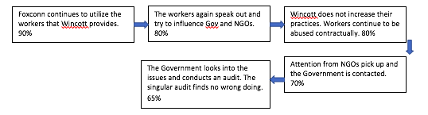

b. Medium Run:

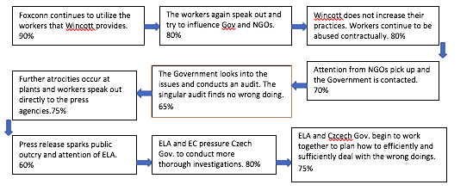

c. Long Run (2023):

