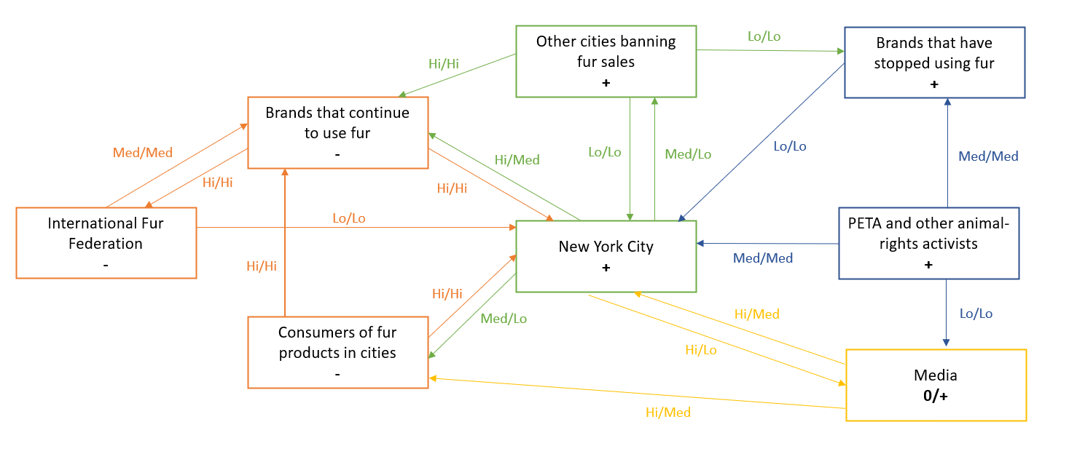
Exhibit 8.1. Power diagram for a Case involving fur retailers (on the left) vs. NGOs (on the right) trying to stop the sale of fur in New York City and other cities (center)

2. (4) Summarize what your power diagram tells you about the International Fur Federation (IFF)’s situation in the case in less than 150 words (Summary means summary! Do not simply repeat what is in your diagram. Summarize key elements, leading to a concluding statement about position, positive or negative, of the IFF, i.e., a “summary” of your summary in power terms.)
IFF has no or just low influence on NY as it’s a representative organization and has no influence on customers. Instead, brands have power over NY, because of their tax payments. But NY also has power over brands as a ban influences their sales and business model. The most influential opponent of the ban are customers. They’re potential voters and represent bargaining power for NY.
Among supporters PETA and Media are influential to NY as they have public awareness. Public opinion is an important source of power since PETA and Media base their influence/power on it. Moreover, society could also influence consumers.
Overall IFF has a weak position. Their power depends on the brands selling fur. Moreover, supporters basing their power on societies interests are highly influential and therefore weaken the IFFs position especially since they have also potential power over consumers, which are a powerful party opposite NY. Excellent 5/5

