Simple scenario (Budgets) ERP Microsoft Dynamics NAV 2018
Created by : Jaromír Skorkovský
Date : 9.12.2020
For : MPH_AOPR
Database : MS Dynamics NAV 2018 W1

- We have to create real data to compare it to data in the budget
- So we have to compare actual and expected (budget) data posted on the account number 8320 cost of Consulting services (or a similar one in its neighborhood such as 8310 or 8330).
- The working date should be setup so that new posted G/L entries will be unique in our budgeted period. We have below the last G/L entry 24.1.2019, so set the new WD to 1.4.2019.
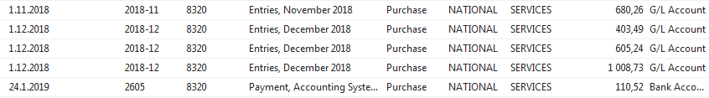
- Create one Purchase order with two lines- A different dimension value should mark every line. In our case Department= ADM and SALES. In our example, we show only the purchase line. The supplier could be, for instance, 10000. To enter dimension value to every line, go to icon Line->Dimension and enter Department =ADM for the first line and Department =SALES for the second one. Below we show the only setup for the first purchase order line
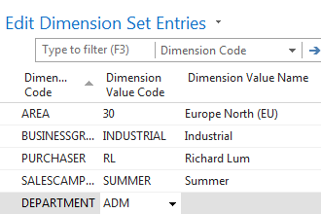

- Purchase order lines look like :
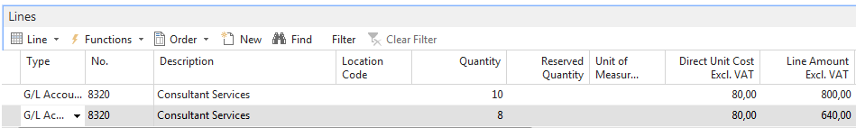

- Post this Purchase order by use of F9
See G/L entries ->Financial Management->General Ledger->Archive->History->G/L registers and go to the last record and use icon General ledger entries in the upper left corner of the screen.
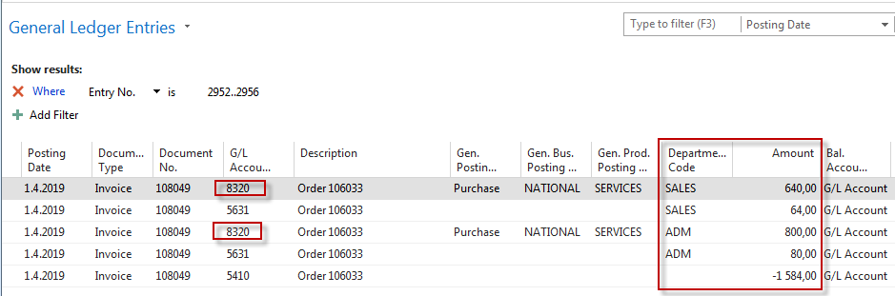
- Go to General Ledger->Lists->G/L Budgets ->Icon Edit Budget and use a cursor to the account number 8320. For the chosen date 1.4.2018, we will get :
Use the three-dot button to go to these lines and enter figures and department values as follows
So the amount in the budget will be 900 and posted by us was 640 for department dimension value =ADM. For the other dimension value= SALES the actual posted amount is 640, and our budget is 700. To see the total budget amount for both dimension value 1600, you must close and open the budget window to refresh the data

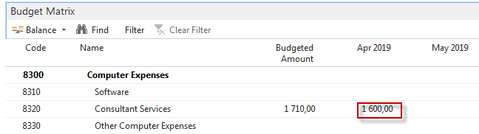

One possibility to see % deviation you have to use icon G/L Balance/Budget. In the newest versions of databases, it could be a different name, and TU will explain.
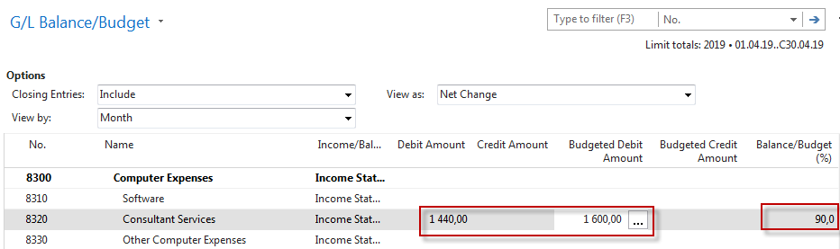

- We can also see the result using the accounting schedule (we went through last week). Find Accounting Schedule and create a new one (icon New). Enter manually Budget SW and Description and Default Column by use of a mouse or F4->Budganalysis
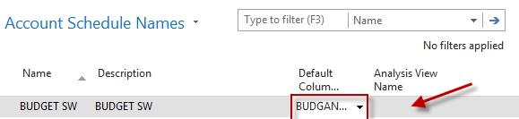

- Open Analysis View Name and use Advanced->enter New and ad data to the following window. After push icon UPDATE. This action will automatically upgrade fields such as last Date Updates and Last Entry number.
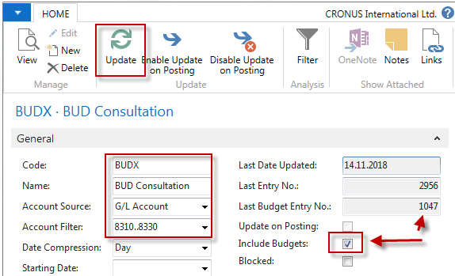

- You will get this line in the accounting schedule window
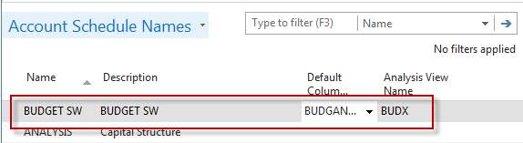
- Now use icon EDIT Accounting Schedule and enter by use of icon Add G/L Accounts account 8320. So simple design of the report structure has been created.
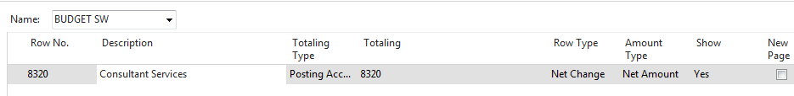
By use of icon Overview, you will finally get this result
