Simple scenario Accounting Schedules MS NAV 2020
Created by : Jaromír Skorkovský
Date : 23.11.2020

Reason : Orientation in the MS Dynamics NAV 2020 Material helping to understand basic discount principles and one primary type of financial reporting (accounting schedules)
For : MPH_AOPR, winter term 2020

Used database : MS Dynamics NAV 2018w1

Used abbreviations : Q=question, G/L=General Ledger, Simple Scenario = SS,
PWP=Power-Point
Accompanying material: PWP-Accounting Schedules

- A useful tool to create new financial reports used for economic analysis without programming. This tool complements standard mighty reporting system (hundreds of reports)

- Basic financial reporting is provided by running user-defined reports called Account Schedules. Besides hundreds of predefined and existing reports, it is a fundamental tool to access vital importance data. All these reports use as resource data. General Ledger Entries are created automatically by posting various documents (e.g., Sales and Purchase orders) by key F9. You can also calculate different parameters, such as IRR, ROI, and many more.

- Go to menu Financial Management ->General Ledger ->Reporting & Analysis ->Analysis & Reporting. There you can see Account Schedules.

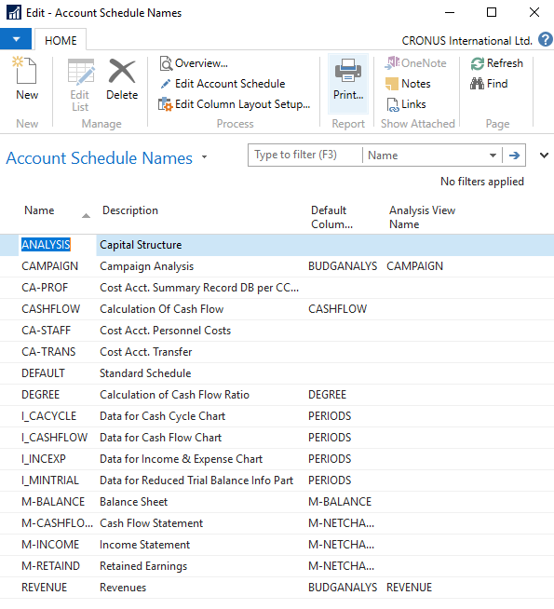

- In this form, go to the field Name in the header and find analysis (one of many). You see a template of the report created by somebody who already made this Accounting schedule in the demo database. To see data, go to the icon Edit Account Schedule and push this icon. There you see all G/L accounts used in this report. The tutor will explain the structure. Then you make the icon Overview to see data. The design of the Account schedule uses data taken from G/L entries based on the initial setup of matrix lines and columns:

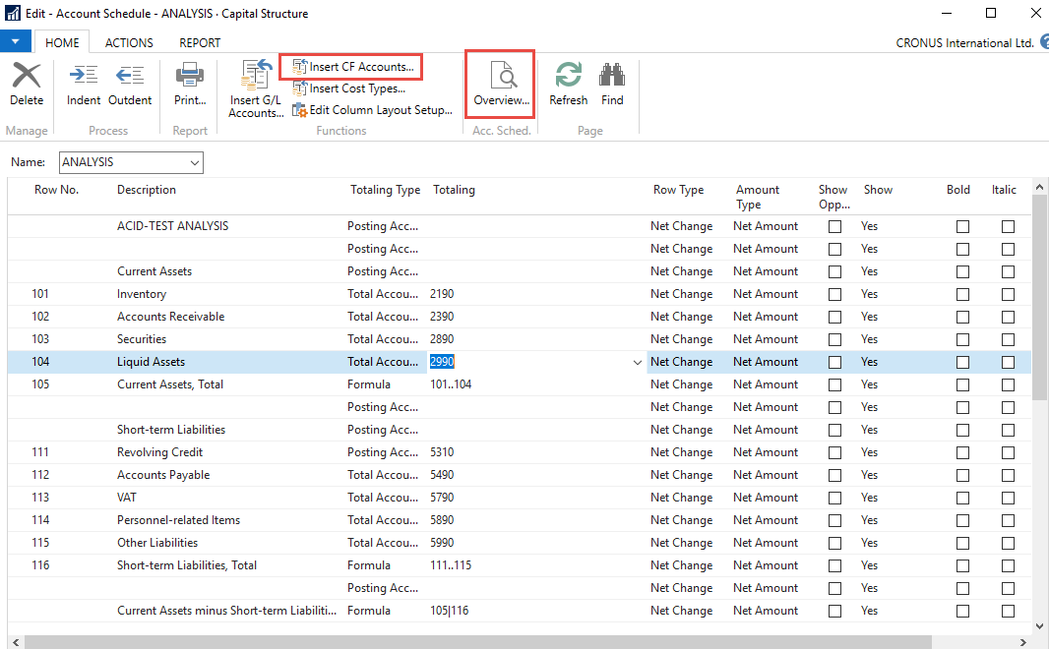

As you can see in the above form in Row No, we do have variables (entered when created manually). In our case, we do have 101,102 and so on. In the totaling column, we can see accounts.

And to see real data, you can also change periods by related fields (by date, dimension filters such as Department, a project of G/L budget filter). The Dates window from to may be different on the Autumn 2020 course.

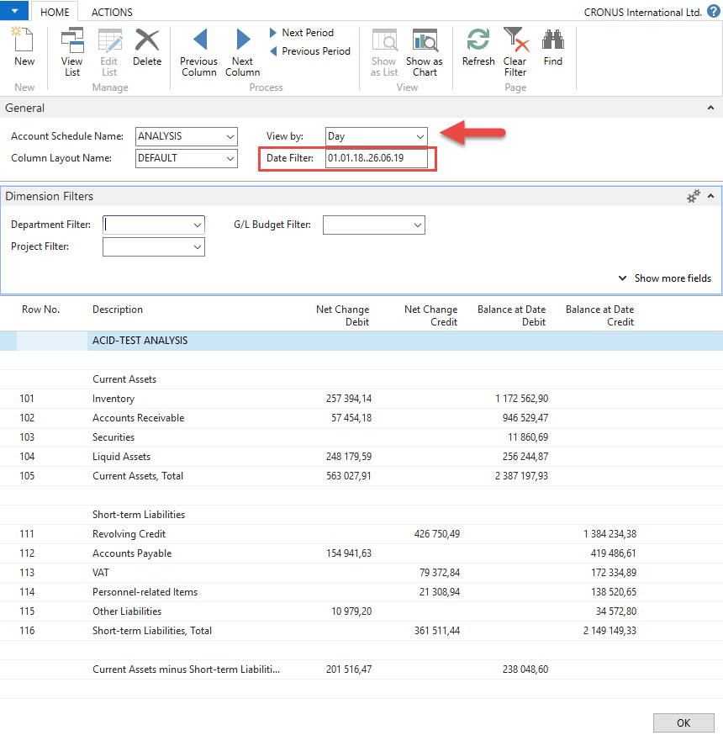

- If you change Default Column layout Name to BUDGANAL (Budget Analysis), you close and open it again by Overview; you will get the different data overview. You have to have some data in a budget matrix.

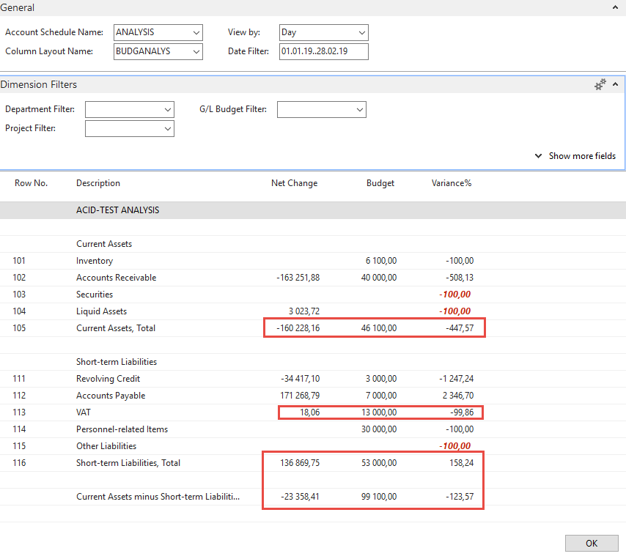

- Let´s create your analysis!! Go to the Name field and in the list enter a new analysis name (e.g., TEST), as you can see below.

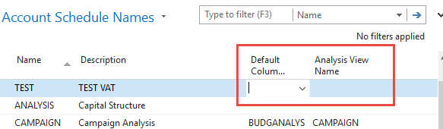

And enter Default column layout = DEFAULT! By use of mouse or F4 to see and chose this possibility.

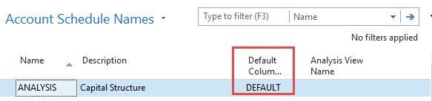

- With the help of F4 from the field Default column layout (see above) and by use of Advanced, you will get this form after the creation of a new line by Ctrl-N or icon=NEW:

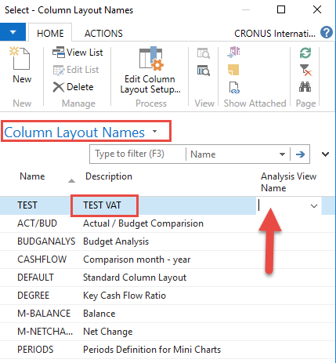

Next, you have to Create Analysis View Name. Use the F4 and Advanced button and the icon New. Enter VAT accounts From-To (5600-5790), G/L accounts used for VAT posting, dimensions (Area and Department), and use icon Update. It will create a subset of data used in our Accounting schedule. The last entry numbers are visible in the form below. The first picture is before Update and the second one after.

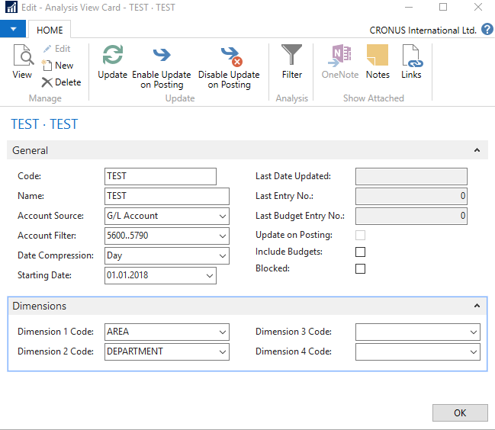

After the Update you will get :

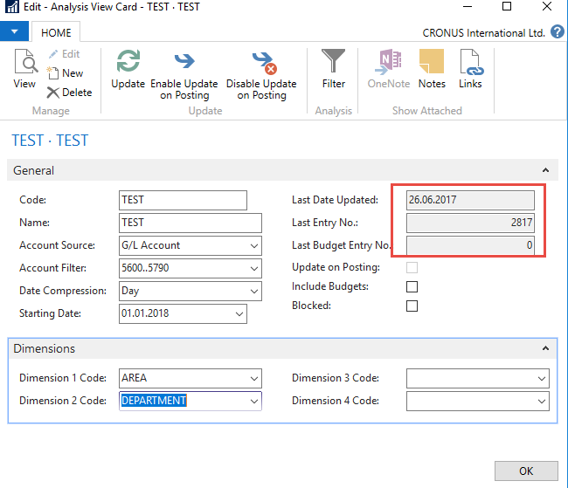

Finally, you will get this and use the layout of column=Default. Anyhow, this was already presented.

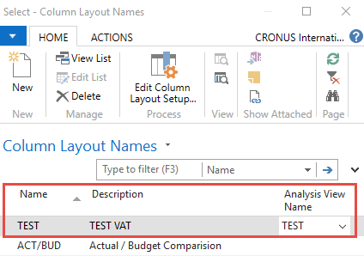

Go to Account Schedule Names, choose the TEST, and Edit Account Schedule icon. Then use icon create and enter two VAT account for purchase and two for sales and formulas as shown in the following form (use G/L account icon) and modify the first column manually to chosen variable names IN 10, IN 25….). These are, in fact, variables that may be used in the calculation.

To enter new lines with description, use right-click and New line!

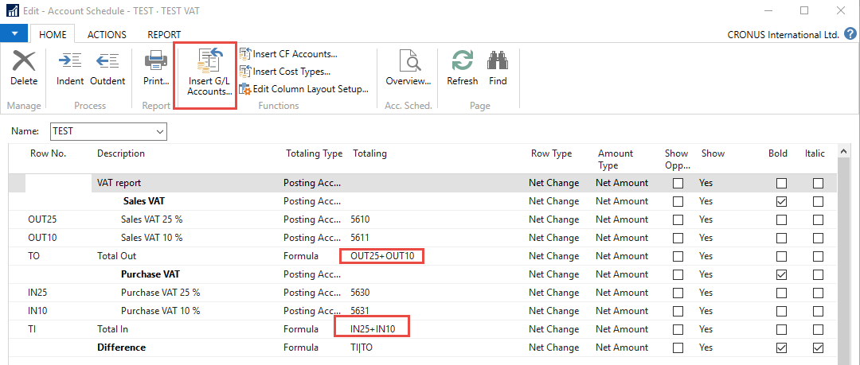

And you will get (after using icon Overview)

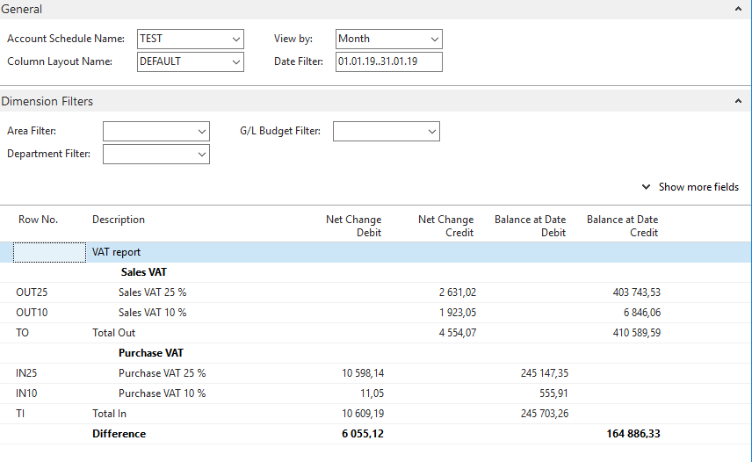

Next example related to budget creation with Dimension use, G/L entries creation, and accounting schedule to see how actual and budgeted amount fit together (also used for South African clients)

- Create a new G/L account using an icon new from the Chart of account window and the icon's indent chart with this name. The number of the G/L account will be 8350 and name Artificial Intelligence Consultation. General Posting Type=Purchase, General Business Posting Group=National, General Production Posting Group=Services

Before adding a new G/L account

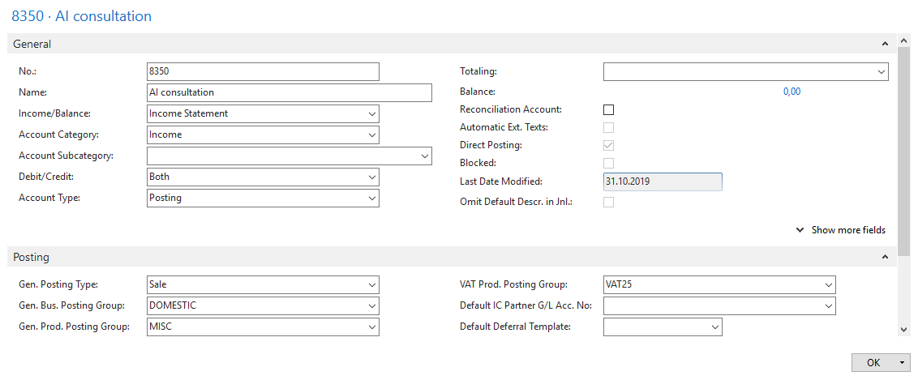

You must indent created Account by the icon above Chart of Account

After adding an indenting a new G/L account :

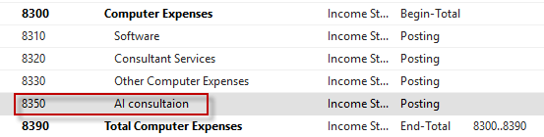

Create a new budget 2020:

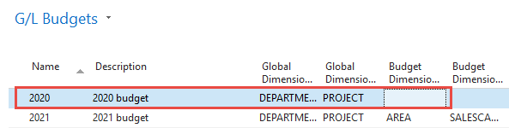

You have enter data into budget 2020. So open the budget, and before a check, the working date is 26.2.2020, Use the icon Edit Budget. In Filters, remove data From-To, if any. To enter data, use the tree-dots button and afterward icon New.

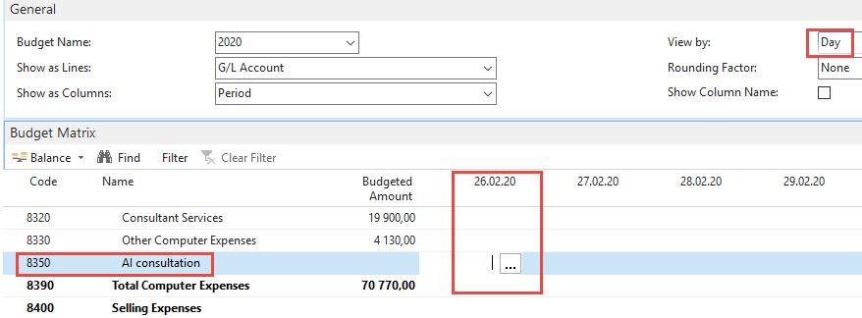.

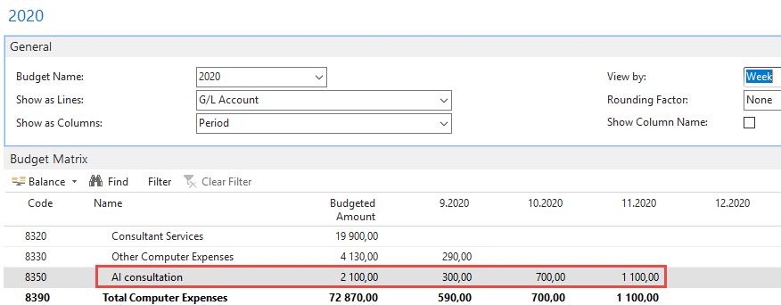

- The next step will be purchasing services, meaning two Purchase Order lines, and every line assigned to different dimension values (Department=SALES and Department=ADM). Use Purchase Invoice instead of Purchase Order. Vendor=10000. Be careful about the working date (remember it). It is crucial for the next example of the following steps. Mind you, that type of purchase line will be G/L Account (the one we just created). For the Sales dimension value, this will be 1 hour and 180 GBP per hour. The second line for Dimension value ADM will be 1 hour and 60 GBP. To assign dimension values, use icon Line and icon Dimension and icon New to add Dimension Department. Post it by F9. Below you can first see two purchase lines and then assign one of the two values to them. In our case, this will be Department=SALES. Mind you, that document was created on 26.2.2020.

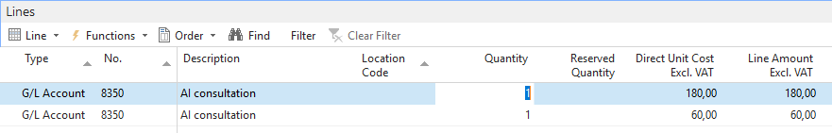

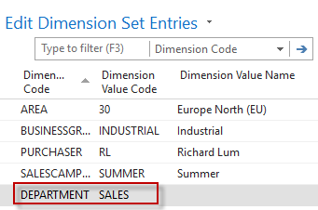

- Please change the date to 6.3.2020 and create a new purchase order with two lines, as we have done previously. For ADM dimension, the value will be 500 GBP, and for the Sales dimension, the amount will be 200 GDP

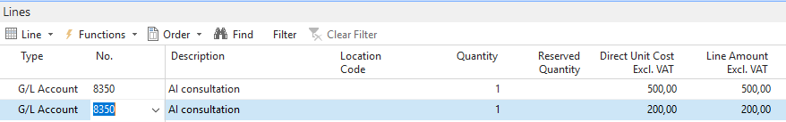

After posting the purchase invoice, you can see General Ledger Entries. In NAV 2018 w1 we will use different dates (26.2.2020, 6.3.2020, and 14.3.2020

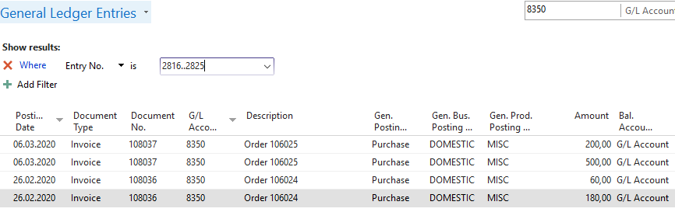

- We have to create a new Account schedule to see differences between budgeted and actual (real amounts). Go to Account schedule area and use NEW:

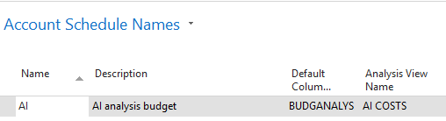

We enter New name=AI and already predefined Default Column=BUDGETANALYS. Then we enter a brand new name for Analysis View Name, and the card will be as follows (parallelly follow the creation of this card and its Update done by a tutor.

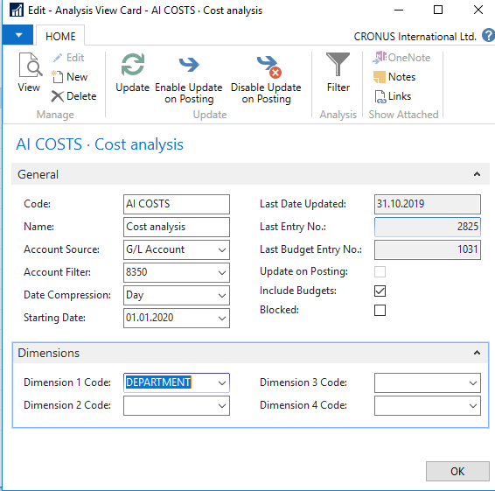

Now, we have to add a new line into our new Accounting schedule AI by use of Edit icon and Insert G/L accounts

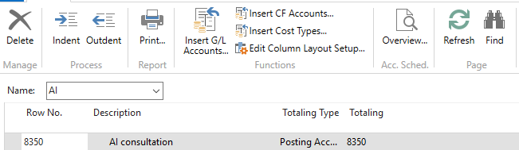

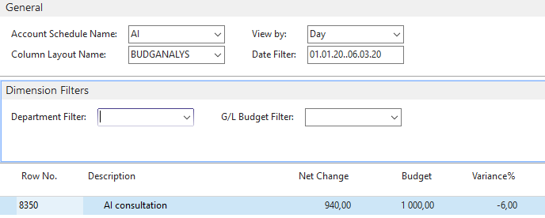

And then enter filter for chosen dimension Department values (ADM or SALES)

