Simple scenario Customer Relationship Management MS Dynamics NAV 2018w1
Created by : Jaromír Skorkovský
Date : 30.11.2020 or 7.12.2020

Reason: Orientation in the MS Dynamics NAV 2019 Material helping to understand basic CRM principles
For : MPH_AOPR

Used database : MS Dynamics NAV 2019 W1 (British one) – RTS

Used abbreviations : Q=question, G/L=General Ledger, Simple Scenario = SS,
PWP=Power-Point. PO-Purchase Order
Accompanying material: Introduction MS Dynamics CRM NAV RTC 20201130

- Simple task: orientation in the MS Dynamics NAV part oriented to CRM. It means relationships between business partner cards (Vendors and Customer) and its Contact Cards.
- We do have two types of Contact Cards (Company Cards – Bold ones and Person Cards)

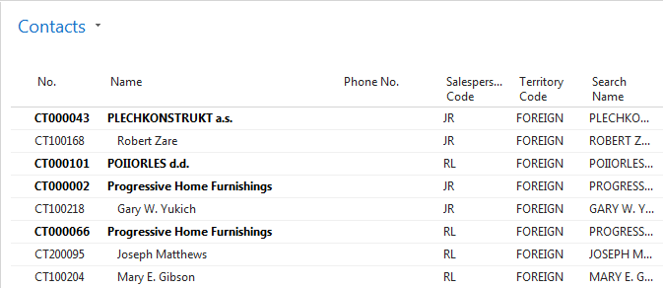

- To see Interactions related to these Contact Cards, use a relevant icon or key combination Ctrl-F7.
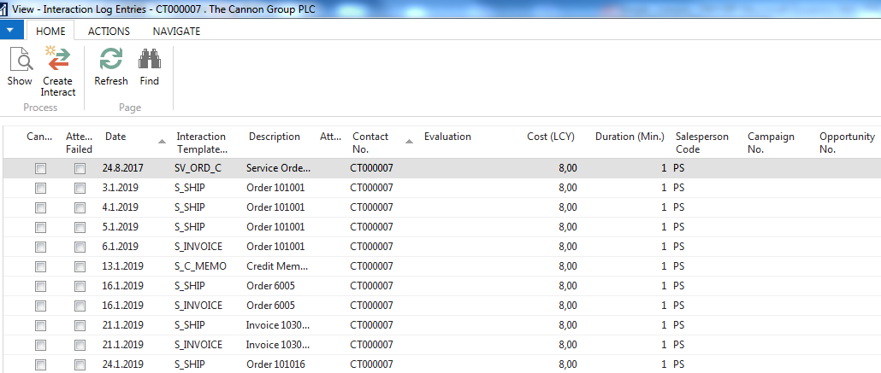

- Interaction (Telephone calls, meetings,…) –see interaction Groups from searching window
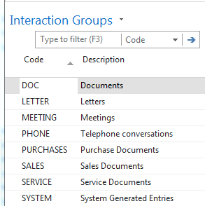

- It the lower part of the contact card, you can see the profile (Tutor will explain more in detail)
Profile of the person
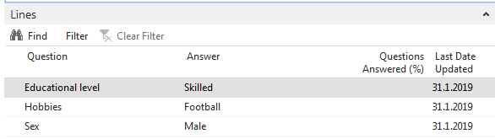

Profile of the company

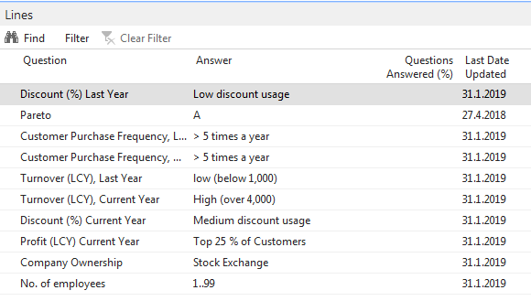

- Create a new Contact Card and then create from there new Customer card by use of the template
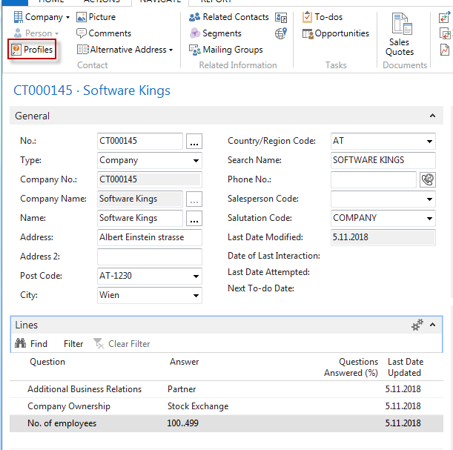

moreover, person contact working for model company Software Kings
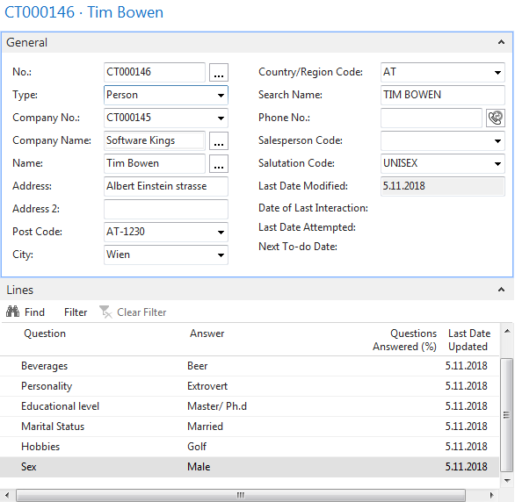

the template will be found here and Create as a Customer:
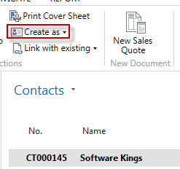

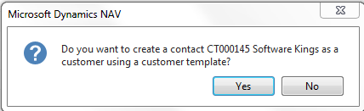

You can also create a template for the Austrian company. In our case, the British company has a subsidiary in Vienna. Click on chosen template 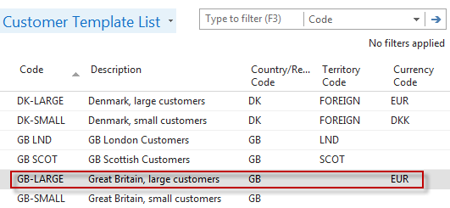
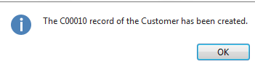
Create new interaction for Tim Bowen (just created contact) using the wizard (e.g., incoming telephone call). The tutor will explain more in detail the sequence of actions.
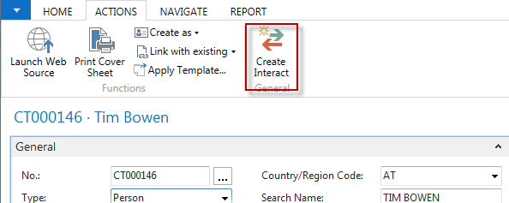
Go and see how to set up questionnaires (profile) ->Sales->Sales and Marketing->Administration->Profile->Setup
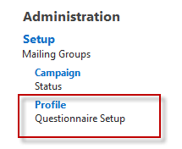

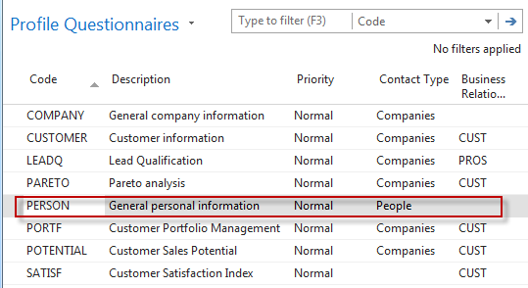
Go there and add some new properties
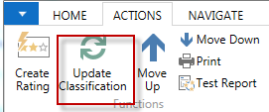
By use of Update Classification, you will find an actual quantity of all contacts related to properties named in the questionnaire
Go to Opportunity list by the searching window (see Sales Cycle and other vital fields in the Opportunity lines). Choose one of them (Status = In progress:
The tutor explains the primary meanings of these fields
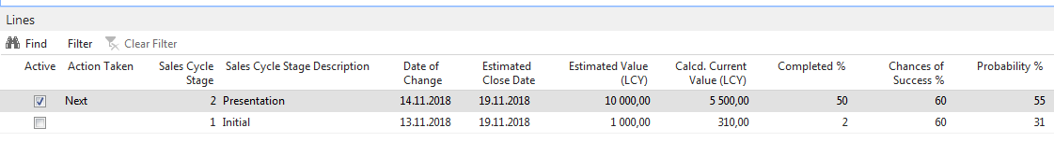

Create a new opportunity by use of the wizard.
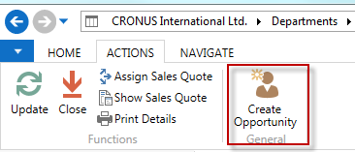
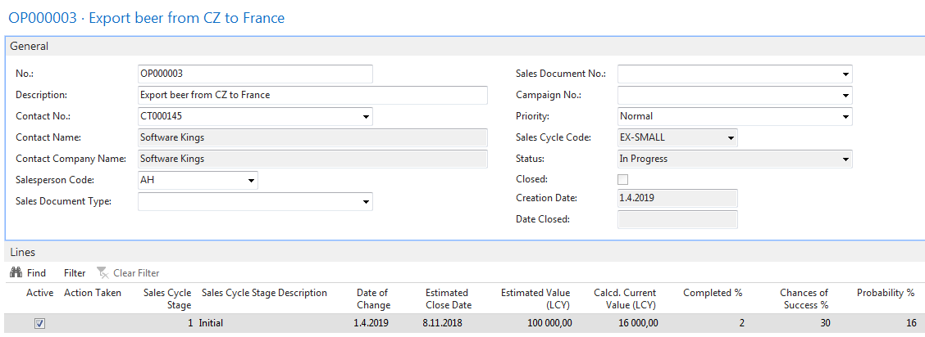

Let's set up a new profile called Pareto based on Sales figures :

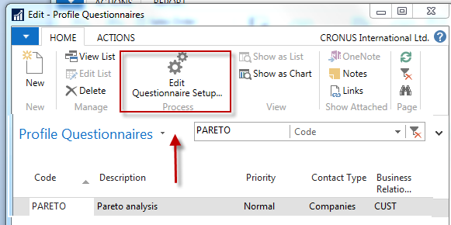

Before you enter data into the second form, you must specify the Details of the Question. Use icon: Question Details?

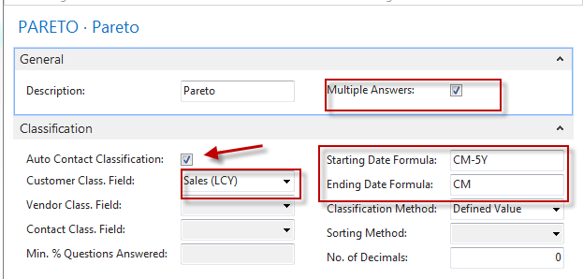
Date Formula CM-5Y means the Current month – 5 years. CM stands for Current Month.
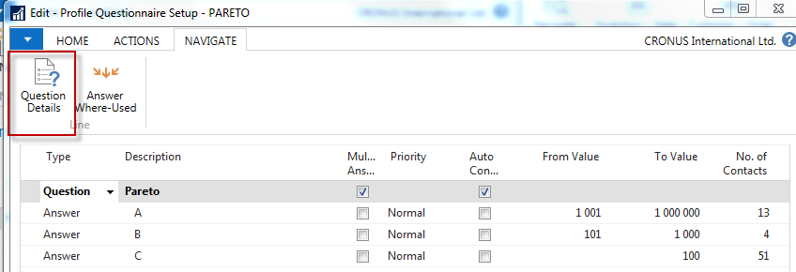

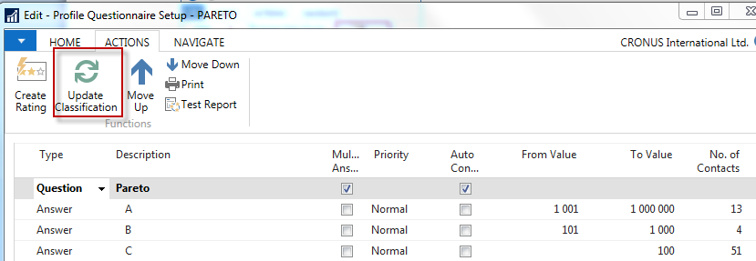

See the customers' profile of contact cards, and you will see that A, B, or C codes classify most of them. Click on the calculated field No. of Contacts. We have chosen code B in our example. So you can see that we do have four contacts
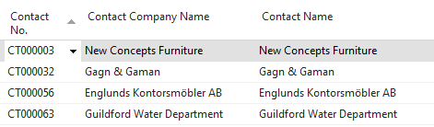
From one chosen contact, click od Contact number->Advanced->Edit, and you will get

