Simple scenario (Discounts) ERP Microsoft Dynamics NAV 2018w1
Created by : Jaromír Skorkovský
Date : 11.11.2020
For : MPH_AOPR and BPH_EPS1
Database : MS Dynamics NAV 2018w1
Keys : Ctrl-N=New, F4=Look-up, Ctrl-F7-entries, F7-statistics, F9-post
Shorthands : G/L General Ledger, TO-Transfer Order
Tutor-TU
- Find Customer card and customer with code 10000.
- On the Toolbar, you will see in the Navigation section three icons. Directly from the list of items
- The similar area with slightly different icon names you can access from BAR about item card see second picture below
From the list
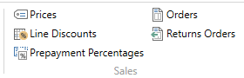
From the card
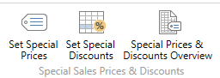
Prices=Set Special prices, Line discount =Set Special Discounts

- Open icon Prices and enter this window Customer (it should be already there) and enter item 1964-W. The standard Unit price from the item card is supposed to be 292.
- Enter 3 pcs and enter a new price for this quantity and a higher amount of 290 and 5 for 280.
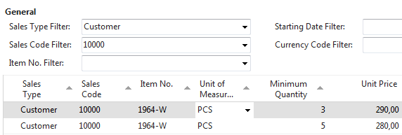

Confirm by OK and go to the icon Line Discount and enter different quantity and % values, as shown below.
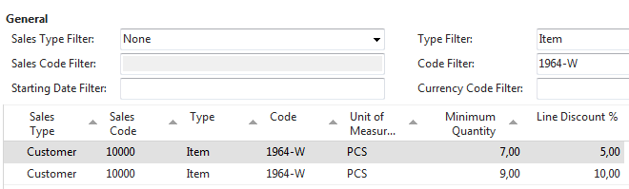
Be aware that this is only to show how ERP NAV 2018w1 can calculate discounts.
Pcs | Unit Price | % | Final unit price | Total
1 | 292,00 | 0,00 | 292,00 | 292,00
3 | 290,00 | 0,00 | 290,00 | 870,00
5 | 280,00 | 0,00 | 280,00 | 1 400,00
7 | 280,00 | 7,00 | 260,40 | 1 822,80
9 | 280,00 | 9,00 | 252 | 2268

Create Sales Order with several lines. Our example in a typical business situation is pointless.
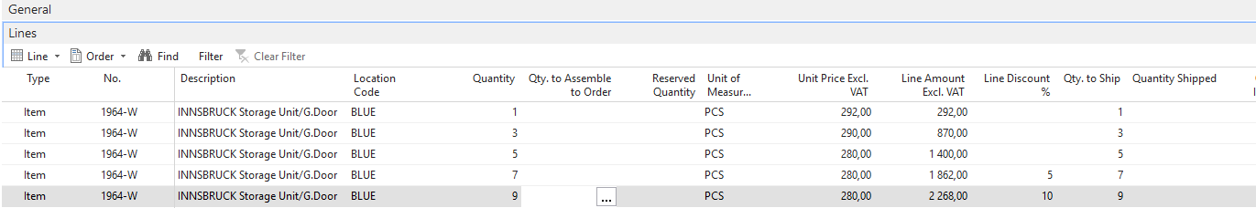
After posting the created Sales order, you can go to General Ledger->Archive->G/L Registers
Below you see printed posted SO = Sales Invoice
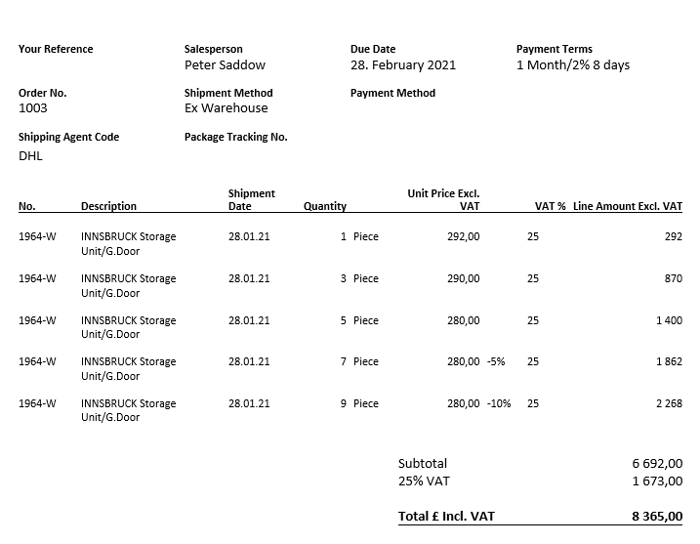
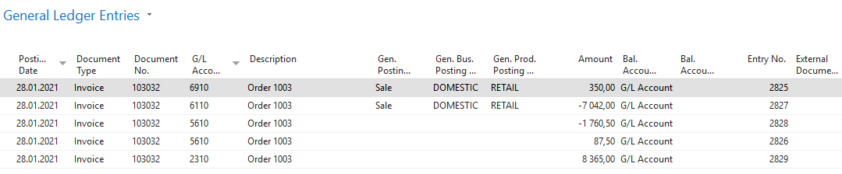
- Go back to the Customer 10000 and in the Tool area find and use icon Invoice Discount to set this type of discount

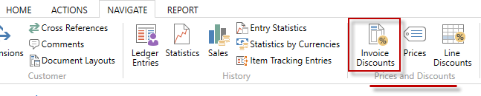

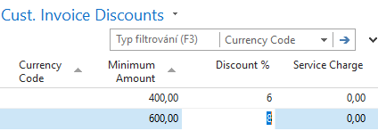
The meaning of setup is straightforward. If the total amount related to the created Sales Order will be higher than the set limits, the customer will get a setup % discount for this document.
- Please create a new Sales Order with Customer 10000 in its header with enough quantity of the item
1964-W to exceed the set limit for invoice discount. See only Sales Order lines

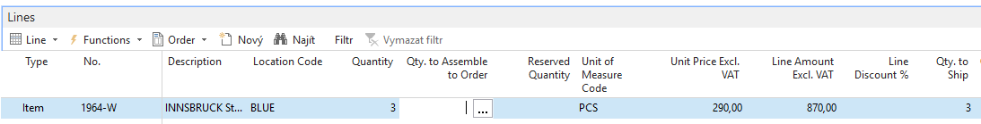
There is only a Price discount applied but not an Invoice discount, which has to be activated by the selling person manually. Before calculating an Invoice, see discount Statistics of this Sales Order by use of key F7. You could see that the filed Invoice Discount is empty so far.

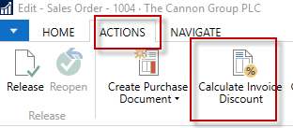
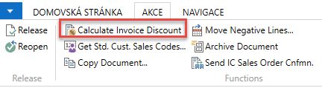

When using the icon Calculate Invoice Discount, you will see calculated Invoice Discount using the Statistics window, or you can see this field with the show column (right mouse click on the line description area. Czech word Přidat means Add
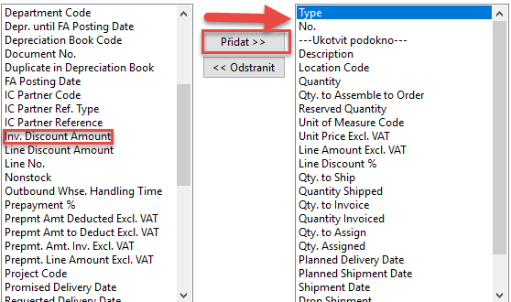

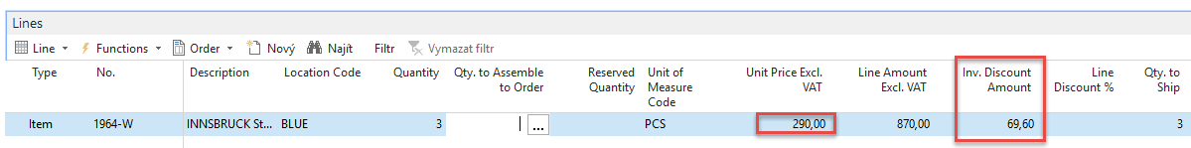
Statistics F7 will show total amount 870 British pounds and 870 x 0.92 =800,4 and 870-800,4=69,60.
If you change the number of items to 7 pcs to get at least some % discount um the line and you will recalculate Invoice Discount, you will get

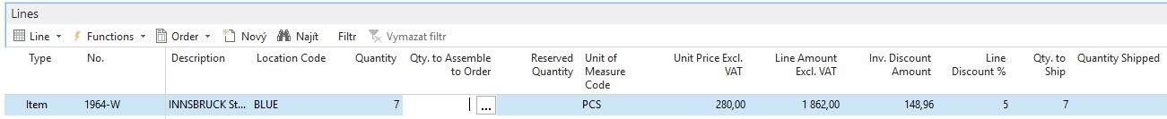

Post Sales Order by use of key F9 and see General register and General Ledger Entries. Financial Management->General Ledger->Archive ->History->G/L Register and last line and upper left corner icon General Ledger

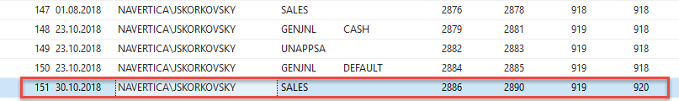

General Ledger Entries looks like

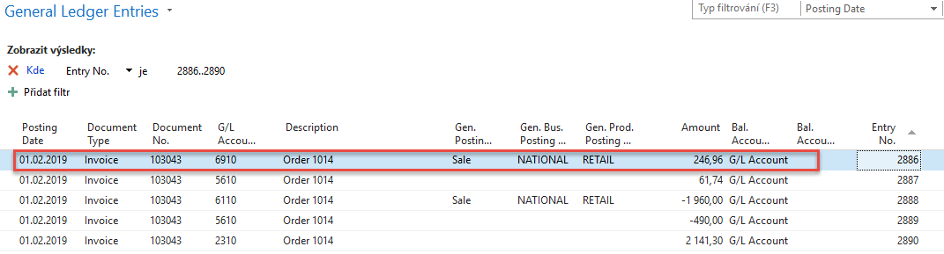

The new set price was 290. Total is 1960, and after a 5% line discount, we have got 1960*0,95=1862. And after the Invoice Discount of 8% is applied, we have got 1862*0,92=1713,04. If we get the posted document from G/L Register via Customer Ledger Entries->Navigate, we will get:
