A simple scenario (Payment–General Journal) ERP Microsoft Dynamics NAV 2018w1
Created by : Jaromír Skorkovský
Date : 29.10.2020
For : MPH_AOPR
Database : MS Dynamics NAV 2018 W1
Keys : Ctrl-N=New, F4=Look-up, Ctrl-F7-entries, F7-statistics, F9-post
Related file : PWP related to Payment and General Jorunal
Shorthand : G/L General Ledger, TO-Transfer Order. SO-Sales Order, PO-Purchase Order
Tutor-TU

Main menu-> Financial Management-> General Ledger -> Tasks-> General Journals

Enter the Type Payment into the Document Type field. Account Type = Customer and Account number =10000. TU will explain that a real account number related to the Customer is hidden behind a code 10000. Enter the Bank Account (balancing account) and NBL bank code into fields Balanced Account Type and Balance Account Number. NBL bank represents Bank Card, and from there, you could see the real bank account number.

Move the cursor to field description area, and use by right mouse click an option Find column and move from left part a field Applies-to Doc. No. to the correct location and then run it up close the position to Bal.Account No. It is set up of working, and it is not related to the knowledge of the General Journal's primary use. See the red arrow above.

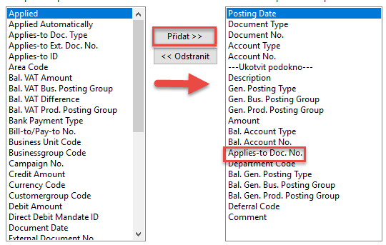
Comment (Přidat=ADD) Move the cursor to this field, and a new form will open.

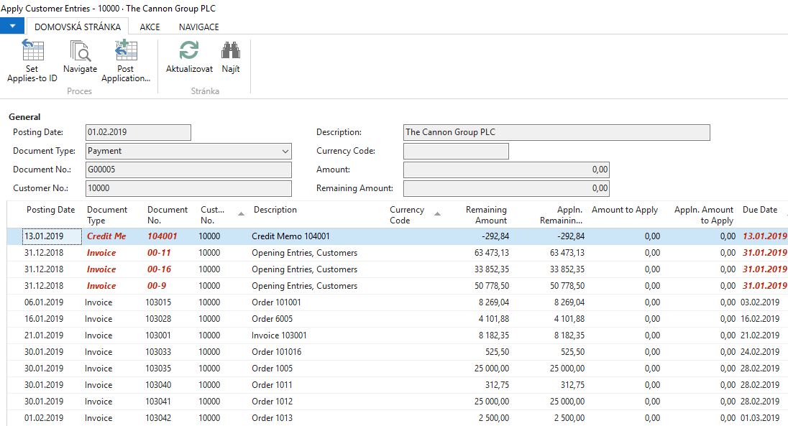

All these invoices (entries) are open (see the related field), which means that they are not applied by payment. Choose one of them and use the OK button to confirm your choice, and You will get the general journal filled with all the necessary data.

The amount will appear in line with a minus, which means that the amount will look after the registration of the credit side. Post it by the key F9 (or the appropriate icon).

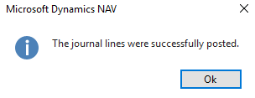

To see the impact of just processed payment see General Ledger->Archive->History->G/L Registers and go to the first line

and on the upper left corner of the BAR, you will see icon General Ledger. Use it, and you will get this form

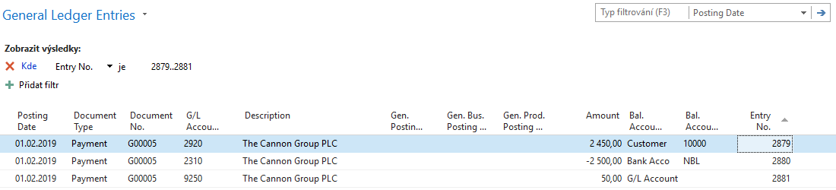

Let's find our Customer list via the searching window. From there, go to our Customer 10000 and go to Customer ledger entries by use of crucial combination Ctrl-F7 or appropriate icon above.

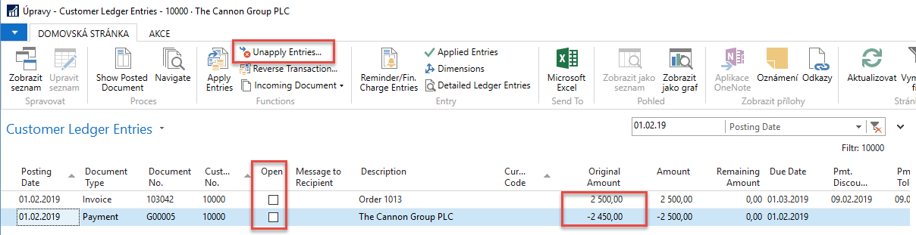

Be aware of applied filter -> the reason that only two entries are visible. Notice that both entries are closed. As a matter of training, we will look for any reason (TU will explain) to Unapply these entries using icon Unapply.

You will get (confirmation that Unapply happens )
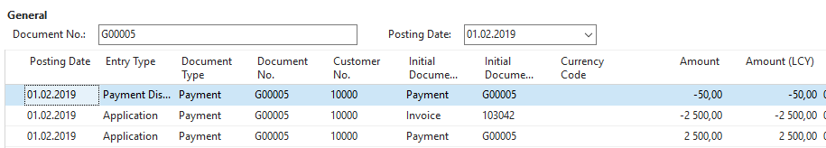

Here you have to confirm it by the Unapply icon. (ANO=YES=OK)

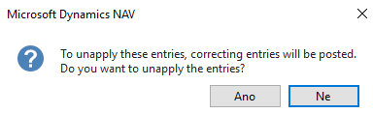

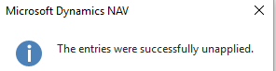

You will get the following entries
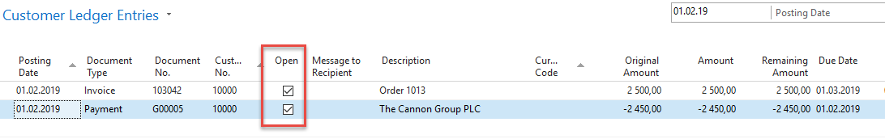

The next task will be applying our open payment to another open invoice from this window (Customer Ledger entries one) by use of the icon Set Apply-to ID

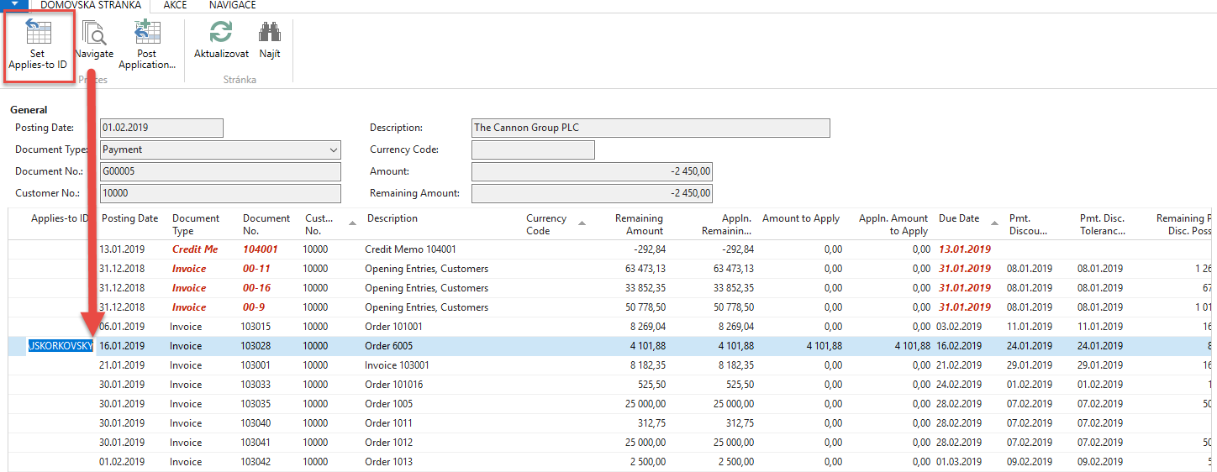

Post it by icon Post Application

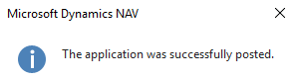

and you will get:

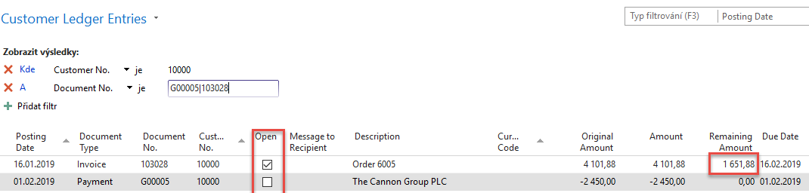

Go back to General Journal and enter this data (we will use sending payment to Vendor now)

By use of icon Applied entries, which is a different way to access open entries – in our case opened Vendor Ledger entries) go to the window—repeat operation, which we have already done.

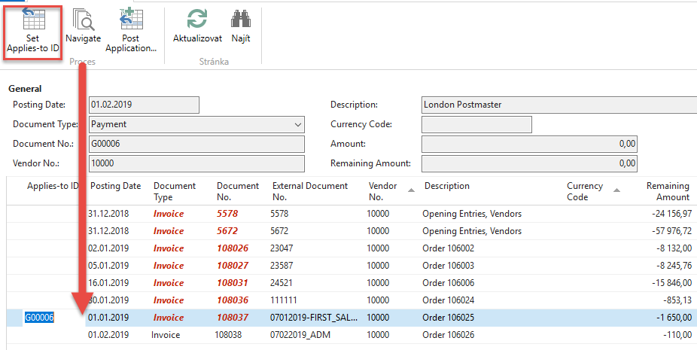

and confirm by button OK.

You will get:

Post it by F9 and go again to General Ledger->Archive->History ->G/L Registers and go to the last line
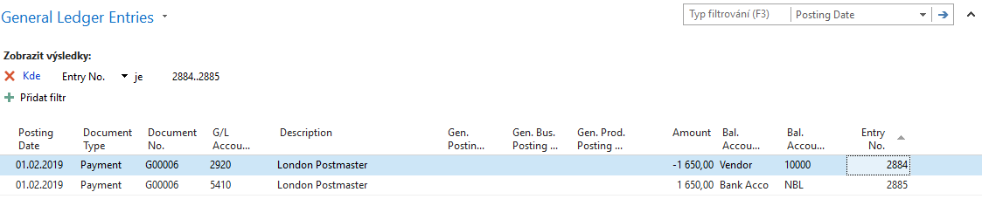

Now we will manually transfer an amount from one account to another account. We enter both G/L Journal sides and post them by F9.
General Ledger->Archive->History->G/L Register
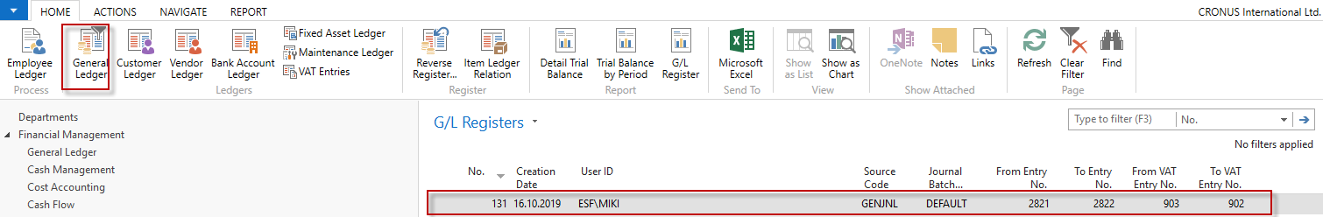
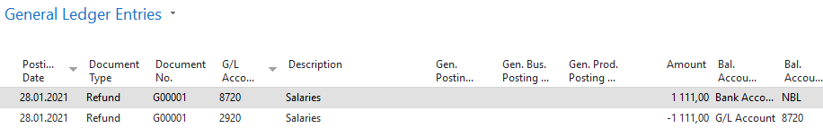
You may reverse this transaction if, for instance incorrect amount was used. Use Reverse Transaction and then Reverse icon.
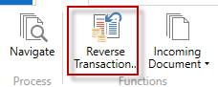
The result will be as follows
