DTEDI Schedule – Spring 2021
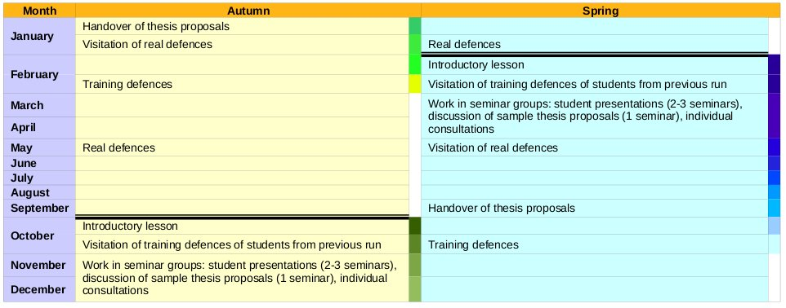
Zoom: https://cesnet.zoom.us/j/97961673356

Introductory lesson:
- 18. 3. 2021 12:00 – 14:00
- Introduction, motivation, DTEDI content, thesis proposal guideline, …
- Formal requirements (Ada Nazarejová)
- Assignment to seminar groups
- Schedule of the semester, plan of students introductory presentations

Training defenses of students from previous semester:
- You are welcome to attend training defenses of your colleagues from previous run and became a member of “scientific committee” for this moment.
- Schedule:
  - 13. 05. 2021 12:00 – 14:00, online: Canceled
  - 20. 05. 2021 12:00 – 14:00, online: Presentation of Iris Kicko, Eva Šmijáková, Lukáš Daubner

Work in seminar groups
- Student presentations: Introduction to research topics. 20 min. of presentation + 10 min. of discussion. The goal is to present your research area and PhD activities to the general public.
- Discussion of sample thesis proposals.
- Individual consultations. At any time.
- Schedule:
  - 08. 04. 2021 12:00 – 14:00, online: Presentation of Rudolf W., Matěj L., Milan P.
  - 15. 04. 2021 12:00 – 14:00, online: Presentation of Vojtěch B., Lukáš G., Egon S.
  - 22. 04. 2021 12:00 – 14:00, online: Presentation of Filip P., Petra N., Dávid L.
  - 29. 04. 2021 12:00 – 14:00, online: Presentation of Jiří V., Michal Š., David K.
  - 06. 05. 2021 12:00 – 14:00, online: Presentation of Michal P., Johana V.

Attendance at real defenses
- 06/2021 (will be specified)
- Schedule: https://is.muni.cz/auth/noticeboard/FI/ds/statni-doktorske-zkousky-cerven-2021/

Handover of your thesis proposal
- September 2021

Your training defenses
- will be specified

Enrolled students:

1. | 433392 | Brůža, Vojtěch
2. | 325217 | Grolig, Lukáš
3. | 433409 | Kuťák, David
4. | 242528 | Lang, Matěj
5. | 422640 | Lupták, Dávid
6. | 423909 | Němcová, Petra
7. | 379389 | Pajtinka, Michal
8. | 459197 | Patnaik, Milan
9. | 433705 | Pokrývka, Filip
10. | 501885 | Stemle, Egon
11. | 422237 | Štefánik, Michal | opak
12. | 422802 | Vahala, Jiří
13. | 478857 | Virtanen, Anu Johanna
14. | 396340 | Wittner, Rudolf

