Class II.
Feedback I.

- Basic rules of cavity preparations are :
Name three basic rules

- What does it mean „cavosurface“ margin ?

- Conventional preparation of Clas II. cavity for amalgam consist of two cavities – name them:

- What is isthmus?

- Describe th walls:
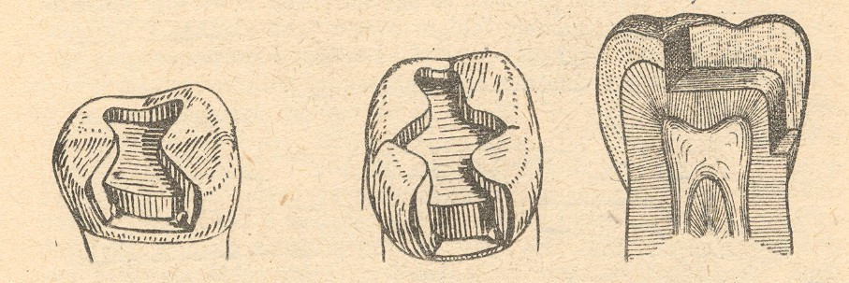

- Which of them are pulpal walls?

- Where the base is placed?

8. Cavosurface margin – class II.:
- occlusal cavity¨
- proximal cavity

- Which rules must be fullfilled for correct preparation og gingival wall?

- Retention for amalgam in class II.

- Resistance for amalgam in class II.

- What are matrices?

- What is the purpose of wooden wedges?

- What do we check before the condensation of amalgam?

- Which instruments do we use for preparation of class II?

15 Which filling instruments do we use for making the class II. fillings?

