1. Discuss: *group discussion, plenary fdbk 5+10 min/100*
2. How important are plants for humans?
3. Some plants are under threat. What is the reason?

a) Everything comes to plants in the end. Provisioning: Food, medicine, fuel, construction, clothing,

Culture: spiritual, recreational, aesthetic, inspirational, educational

Supporting: soil formation, nutrient cycling, primary production

b) Now plants are **under threat**. They're under threat **because of changing climate**. And they are also under threat because they are sharing a planet with **people** like us. And people like us want to do things that destroy plants, and their habitats. And whether that's **because of food production**, or because of the **introduction of alien plants** into places that they really oughtn't to be, or because of **habitats being used for other purposes** -- all these things are meaning that **plants have to adapt, or die, or move**. And plants sometimes find it rather difficult to move because there might be cities and other things in the way.

1. Listen to the talk about one project to save plants, and complete the table below <https://www.ted.com/talks/jonathan_drori_why_we_re_storing_billions_of_seeds?language=en#t-305421> (1:28-end) 15/85

|  |  |  |
| --- | --- | --- |
| 1 | the way of saving plants | by storing seeds |
| 2 | species most under threat | Dry land species |
| 3 | no of countries in the project | 50 |
| 4 | no of cooperating institutions in the project | 120 |
| 5 | the temperature at which the seeds are stored | -20 C |
| 6 | the time for which these seeds are undoubtedly capable of germinating | Hundreds of years |
| 7 | collected plants seeds in the world-wide scale | 3 billion, 10% |
| 8 | the country running a similar project | Norway (Svalbard) |
| 9 | the area in the USA under restoration | Tall grass prairie |
| 10 | average cost of training | 2,800 dollars per species |

1. Here are the stages of the process of collecting seeds for the Millennium project (in chronological order).

Use time connectors (some are given in the table) and change the noun phrases below into full sentences that would make up one coherent text.*10/70*

first, initially, first of all, then, next, later, afterwards, after that, after…, at the next stage, finally, eventually, in the end, at the end of…, following that, subsequently

* Getting permission from land owners or managers
* Organizing seed collection expeditions
* Identifying and assessing seeds before collecting them
* Choosing appropriate seed collection techniques
* Recording seed data – records of where samples were collected
* Shipping seeds to a seed bank

E.g: First, Kew Gardens scientists have to get permission from landowners or land managers to collect seeds. …

1. Below there are more adverbs of sequence. Categorize them into adverbs for
2. preceding actions: before…, prior to…, before that
3. simultaneous actions: meanwhile, simultaneously, at the same time, at this point

meanwhile, simultaneously, before…, at the same time, prior to…, before that, when, at this point

*5/60*

1. Look at the definitions describing anatomic parts of a plant and label the picture. *10/55*

|  |  |
| --- | --- |
| lateral root | extend horizontally from the primary root |
| taproot | main part of a plant through which water and minerals are absorbed, usually in the ground |
| reproductive shoot | a shoot bearing a flower |
| vegetative shoot | a shoot not specialized for reproduction |
| node | a part of a stem that normally bears a leaf |
| internode | section between two nodes |
| axillary bud | growing from the place where a leaf/shoot is connected to a stem |
| terminal bud | bud ending in a shoot |
| blade | flat part of a leaf |
| petiole | connects the flat part of a leaf with the main part of a plant |
| stem | main part of a plant from which leaves and flowers grow |
| root system | the part of a plant in the ground |
| shoot system | the part of a plant above the ground |

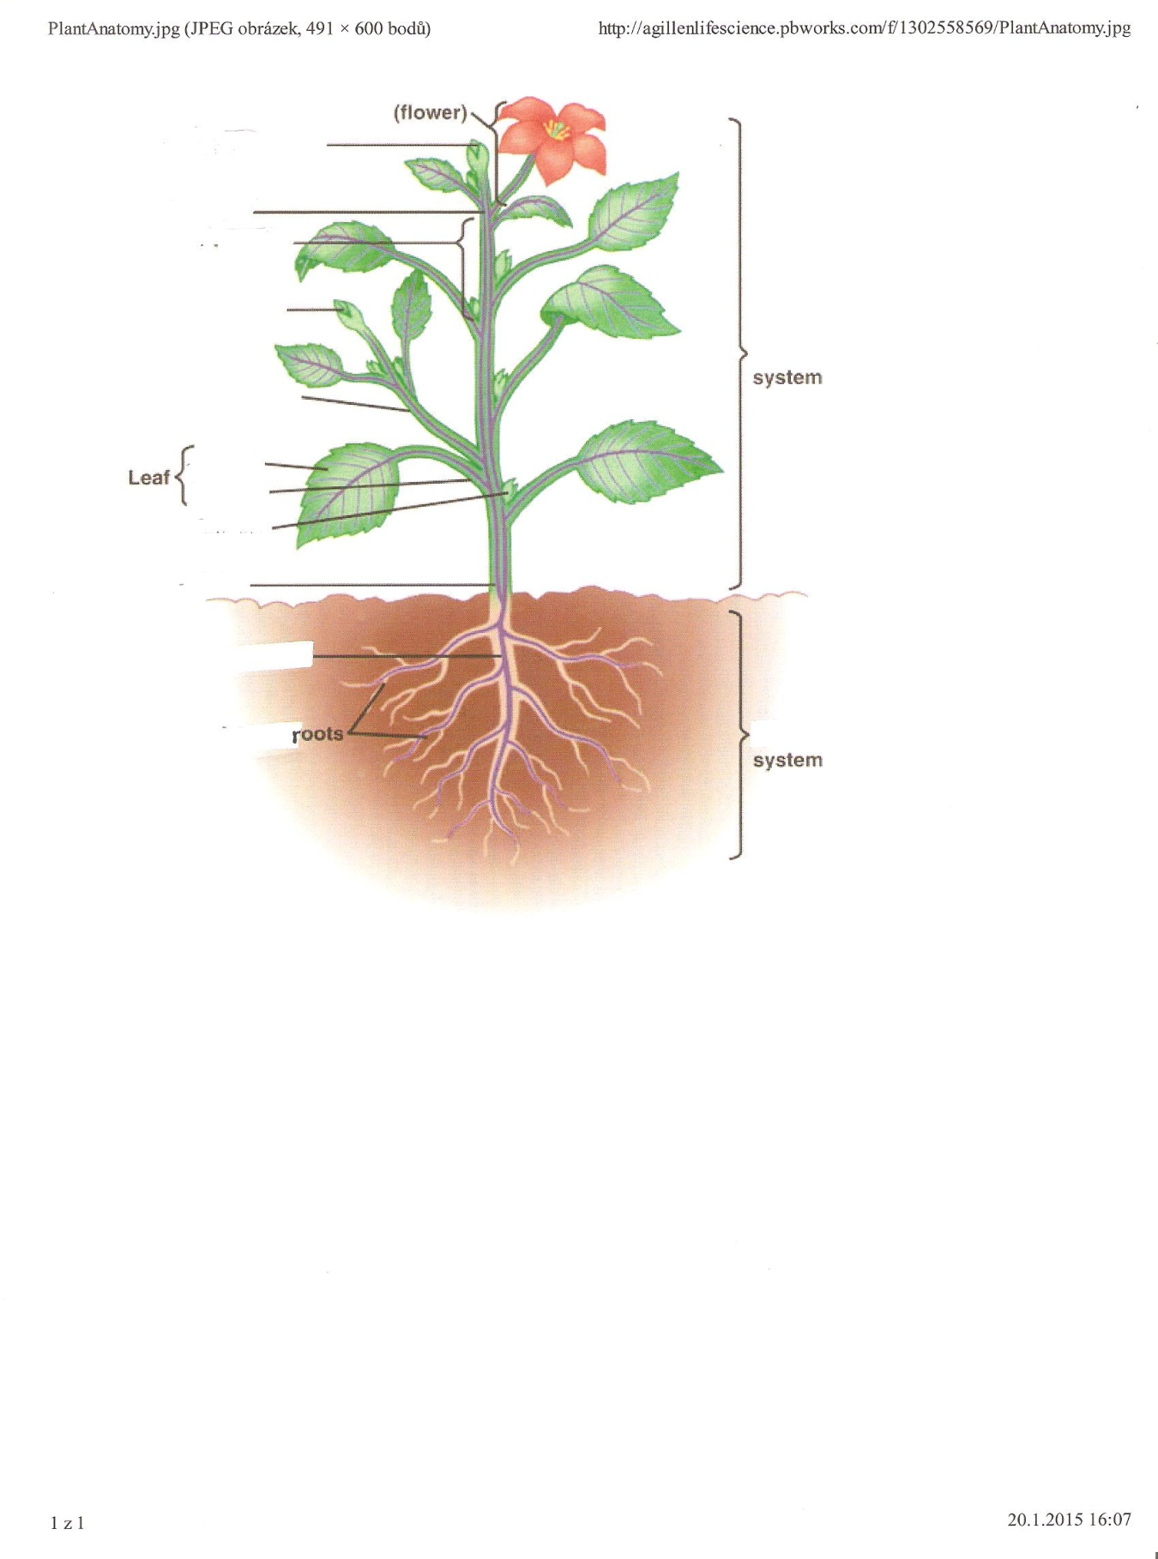

1. Complete the text about the plant life cycle with suitable adverbs of sequence from ex.4 and 5. *Try not to use the same adverbs more than once 5+5fdbk/45*

Like all living things, plants too have a life cycle. The flowering plant life cycle begins with a seed.

_**First/initially/to start with/ to begin with/ in the beginning_____,** the seed is sown. __**After**___ some time it will germinate and a tiny, immature plant called a seedling will grow. The tiny roots will work their way down, and _**simultaneously/ at the same time__** the tiny stem will work its way up. With sunlight and water, this seedling will grow larger and more mature. The stem and root will grow longer, and new leaves will appear on the plant. _**When___** roots and leaves develop, buds will form and, _**subsequently/ following that/afterwards ____,** the plant will start flowering. _**Next**__, the flower is pollinated and fertilized. Once fertilized, the flowers will begin developing seeds. Some plants protect the seeds inside the fruit that houses the seeds until they are ready. __**When**_ the fruit is rape, the plant will use all kinds of techniques to let the seeds disperse. For some plants, this means dropping fruit onto the ground to rot or be eaten by animals. Other plants release their seeds in unique ways, such as being blown by wind or by sticking to animal fur.

_**At this point/then__** the cycle begins again, with a small seed finding its way into the ground. This seed will sprout and grow into a new plant that looks exactly like its parent plant. When this seed begins to grow, the cycle will start over again.

1. Text organization: look at the text above again and try to divide it into 3 parts: introduction, main body, closing**. *3ss+5fdbk/35***
2. Read the text about photosynthesis process and put the paragraphs into a correct order (take into account: types of sentences typical for introductions/ main body/ ending - general/specific information, summarising, logical connections, coherence markers, etc.). ***3 min, ask them to read the answers and give reasons for such decisions: analyse logical connections within a text: 5min (7/27)***

*2. a The cells near the top are called palisade cells and inside, these cells are full of green blobs called chloroplasts. These contain a green pigment called chlorophyll, which gives the plant its green colour, but more importantly, it captures energy from the sun. Carbon dioxide enters the leaf through holes in the lower surface, called stomata. But this is only half the story.*

*4. b So, during photosynthesis oxygen is given as the life-sustaining gaseous component of the atmosphere, while glucose is transported to all parts of the plant and used for growth.*

1. *c The two main ingredients for plant growth are carbon dioxide and water. Carbon dioxide and water chemically combine to become actual stuff the plants are made from. This chemical reaction is called photosynthesis, and the leaf is where photosynthesis takes place.*
2. *d The cells on plant roots grow into long hairs which stick out into the soil, giving the plant a big surface area for soaking up water. Water travels up the stem to the leaves in tubes called xylem. Once in the leaf, the water passes into the cells and enters the chloroplasts. Here it meets the carbon dioxide. Carbon dioxide and water react to form glucose and oxygen. Glucose diffuses out of the chloroplasts and is transported to all parts of the plant, aiding its growth, and the oxygen diffuses out of the plant through stomata.*
3. Now listen to the recording and check your answer. *The first three stages will be given*

<https://www.youtube.com/watch?v=ErF1ks5qL_Q&t=8s> seen on 7 July, 2017 *(0:00- 1:57) put no on the slide next to the text in ss version for fdbk, 3m/20*

1. Some process descriptions have no sequence adverbs, but instead give information on **what** happens *(typical use of verbs of movement: passes, transports, diffuses, enters,…),* **where** it happens, **how** (usu worded with “by…”) and what is its purpose (**why**). Read through the text in 8 again and find two examples of each function. *in pairs, finally in fdbk show the T’s notes, 10 min/17*
2. Look at the graph below and describe the process of pollination, and fertilization.

***Assign as homework. Tell them to remember about an intro and a summing up sentence. In the next lesson - visualize and read your text from the key for comparison***

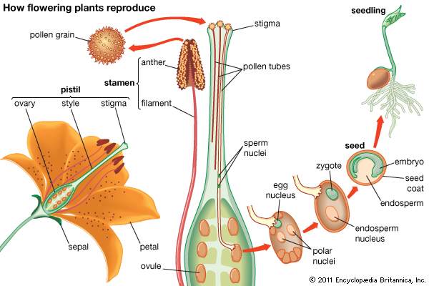

Pollination7 is a very important part of the life cycle of a flowering plant8. It is part of the sexual reproduction process of flowering plants, which results in seeds that will grow into new plants.

Plants have gametes, which contain half the normal number of chromosomes9 for that plant species10. Male gametes are found inside tiny pollen11 grains on the anthers12 of flowers. Female gametes are found in the ovules13 of a flower. Pollination is the process that brings these male and female gametes together. Pollen can’t get from the anthers to the ovules on its own, so pollination relies on other things to move the pollen. The wind or animals, especially insects and birds, pick up pollen from the male anthers and carry it to the female stigma14.

Only after pollination, when pollen has landed on the stigma of a suitable flower of the same species, can a chain of events happen that ends in the making of seeds. A pollen grain on the stigma grows a tiny tube, all the way down the style18 to the ovary19. This pollen tube carries a male gamete20 to meet a female gamete in an ovule21. In a process called fertilisation22, the two gametes join and their chromosomes combine, so that the fertilised cell contains a normal complement of chromosomes, with some from each parent flower.

The fertilised ovule goes on to form a seed23, which contains a food store and an embryo24 that will later grow into a new plant. The ovary develops into a fruit to protect the seed. Some flowers, such as avocados, only have one ovule in their ovary, so their fruit only has one seed. Many flowers, such as kiwifruit, have lots of ovules in their ovary, so their fruit contains many seeds. <https://www.sciencelearn.org.nz/resources/77-pollination-and-fertilisation>

1. Grammar revision: look at the sentences from ex. 6. – future tenses revision: will/going to/pr.continuous *remaining time (cca 7 min)*

-What time do underlined parts refer to?

With sunlight and water, this seeding will grow larger and more mature.

Before roots and leaves develop, buds will form.

-Can we say these sentences with “going to” or present continuous for future references?

-Give examples of sentences with these two structures to show the difference in meaning.

Now carry on with the activities from the grammar handout. (coud be any grammar book) *again, assign as homework*

Additional material: video: <https://www.youtube.com/watch?v=pFaBpVoQD4E&t=191s>, <http://theseedsite.co.uk/leafshapes.html>, <http://theseedsite.co.uk/flowershapes.html>

Sources:

[www.kew.org/discover/videos/beyond-gardens-millennium-seed-bank-partnership](http://www.kew.org/discover/videos/beyond-gardens-millennium-seed-bank-partnership), seen November 22, 2015

<http://sciencing.com> (adapted), visited July 5, 2017

<https://www.youtube.com/watch?v=ErF1ks5qL_Q&t=8s> (adapted), visited July 5, 2017

Macmillan Vocabulary Practice Series – Science CD-ROM

<http://w3.dwm.ks.edu.tw/bio/activelearner>

<http://en.wikipedia.org>

<http://phschool.com/science/biology_place/biocoach/photosynth/intro.html>

<http://dictionary.reference.com>