Giving away tests, discussing problems – 15 minutes/100
- Read the names of animals in the box below. Think about their similarities and differences.

bird
cow
crab
dog
elephant
fish
kangaroo
ladybug
lion
monkey
mosquito
mouse
spider
turtle
whale
frog

- On a separate piece of paper, divide the animals into categories. You may use as many categories as you wish. Share your way of classification with the rest of the group.
E.g.: Because of (according to/ due to/ as far as/ when considering) …, we can divide (classify/ group/ categorize/ etc.) these animals into …
Ten minutes, in fdbk after the ss answers have been given show them your way (below); 10 min/85
Because of locomotion techniques, we can divide these animals into:
- those that fly: bird, ladybug, mosquito,
- those that walk/run: cow, dog, elephant, kangaroo, lion, monkey, mouse, spider
- those that walk and swim: crab, turtle, frog
- those that swim: fish, whale
According to their morphological features we can classify them into:
- mammals: cow, dog, elephant, kangaroo, lion, monkey, mouse, whale
- birds
- fish
- insects: mosquito, ladybug
- reptiles: turtle
- amphibians: frog

- Read the text below and check how animals are classified there. Give short descriptions of the categories. Vertebrates – have a backbone, invertebrates – have no backbone.
Ind, compare in pairs, fdb plenary, 5/75
ANIMAL LIFE
Animal life on Earth is very diverse. There are more different kinds of animals than plants. Scientists have identified and named more than 1.8 million species of animals. They believe there are still millions more to identify in the future.
There are two main groups of animals: vertebrates and invertebrates. Vertebrates are animals that have a backbone. A backbone is a line of bones that goes down the middle of the animal’s back. It supports the animal and protects the spinal cord, which is an important group of nerves that sends messages between the brain and the rest of the body. Every vertebrate also has a head with a skull that surrounds and protects the brain. Fish, snakes, birds, and monkeys are all vertebrates.
Invertebrates are animals that do not have backbones, such as worms and spiders. About 95 percent of all animals are invertebrates. Many of them have a hard protecting covering such as a shell. Invertebrates can live anywhere, but most, like the starfish and the crab, live in the ocean.
Human activities, such as deforestation, and environmental changes, such as global warming, are dangerous for animals as well as plants. Many animal species are losing their habitats. Some are endangered, others are already extinct. Many biologists and environmentalists think these changes in animal life are a clear warning about the future health of our planet.
(from: Wharton, J. (2009) Academic Encounters – The Natural World, CUP)

- Read the last paragraph again and find words that mean: ind, another 5m (3+2fdbk)/70
- cutting down large areas of trees - deforestation
- natural environment of a plant or an animal - habitat
- at risk of no longer existing - endangered
- no longer in existence - extinct

- Words c and d in point 4 describe a conservation status. Here are some more words. Put them in order from the least concerned to extinct. Pair/ group work, 5m/65
extinct in the wild –vulnerable – endangered – critically endangered – near threatened
least concern - _near threatened_ - _vulnerable_ - _endangered_ - _ critically endangered _ - _extinct in the wild_ - extinct

- Definition 4b relates to a habitat. Look at the descriptions a-e and decide which habitats from those listed below (in bold and italics) they describe. Pairs, 10m/60 in fdbk make sure you clarify the meaning

- The zone of the seashore between high- and low-water marks, or the zone near a lake shore with rooted vegetation – littoral
- The region of the earth between the Tropic of Cancer and the Arctic Circle, and between the Tropic of Capricorn and the Antarctic Circle – temperate
- The region of the earth that surrounds the equator, from 23.5 degrees north to 23.5 degrees south – tropical
- An area where a freshwater river meets the ocean, resulting in fluctuations in salinity – estuarine
- Any water in a sea that is neither close to the bottom nor near the shore – pelagic
tundra, coniferous forest, deciduous forest, pelagic, desert, mountains, estuarine, reef, littoral, savannah, swamp, rainforest, coastal, tropical, lakes and ponds, sea bed, temperate, urban, farmland, wildflower meadow, taiga, grassland, marsh, parkland, rivers and streams

- Which habitats are shown in the pictures? Pairs again, in fdbk double check they understand the words, 5m/50
Tropical grassland (savannah), deciduous forest, coniferous forest, sea bed
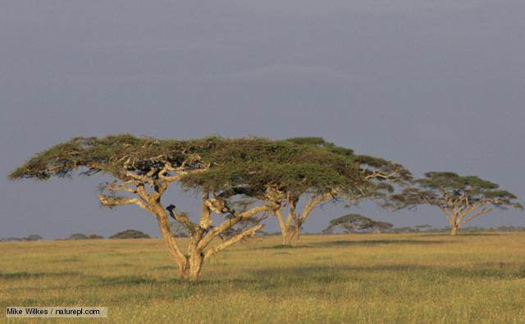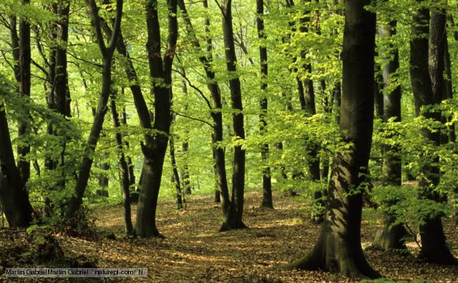
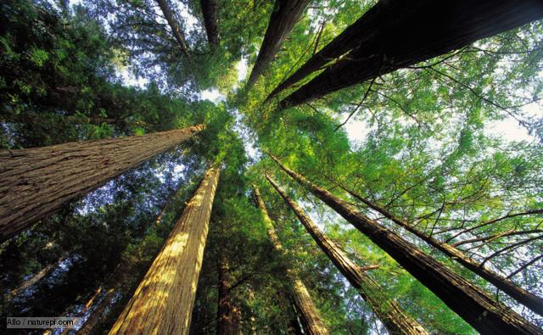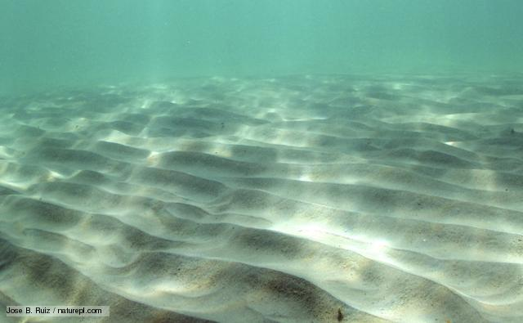
http://www.bbc.co.uk/nature/habitats
- Now classify all these habitats into following three categories: pairs, clarify the meaning if needed in fdbk, 10m/45
TERRESTRIAL HABITATS | FRESHWATER HABITATS | MARINE HABITATS
coastal, coniferous f, deciduous f, rainforest, desert, grassland, farmland, mountains, parkland, Taiga, Tundra, wildflower meadow, urban | swamp, marsh, lakes and ponds, rivers and streams, littoral | estuaries, reefs, sea bed, pelagic, littoral

- Which of the habitats do the following animals live in? speculate in pairs/groups, try to get more specific answer than the above three groups division, have the pix of the three animals ready to show on a slide, tell them to get the clues from the pix – 5m/35

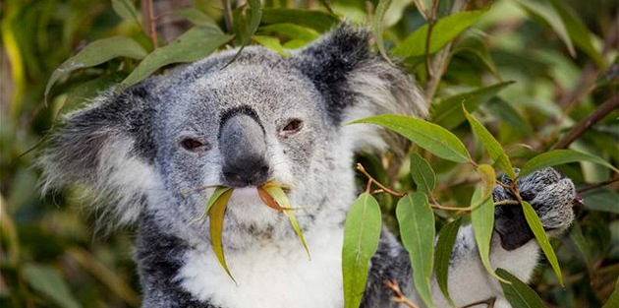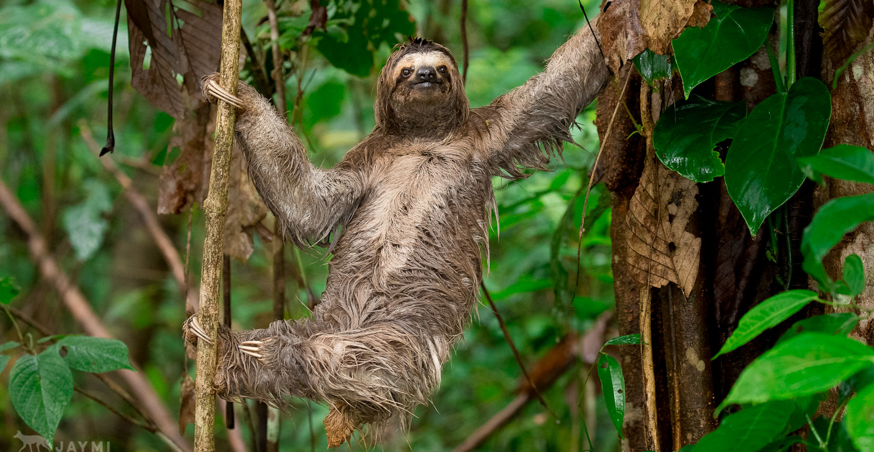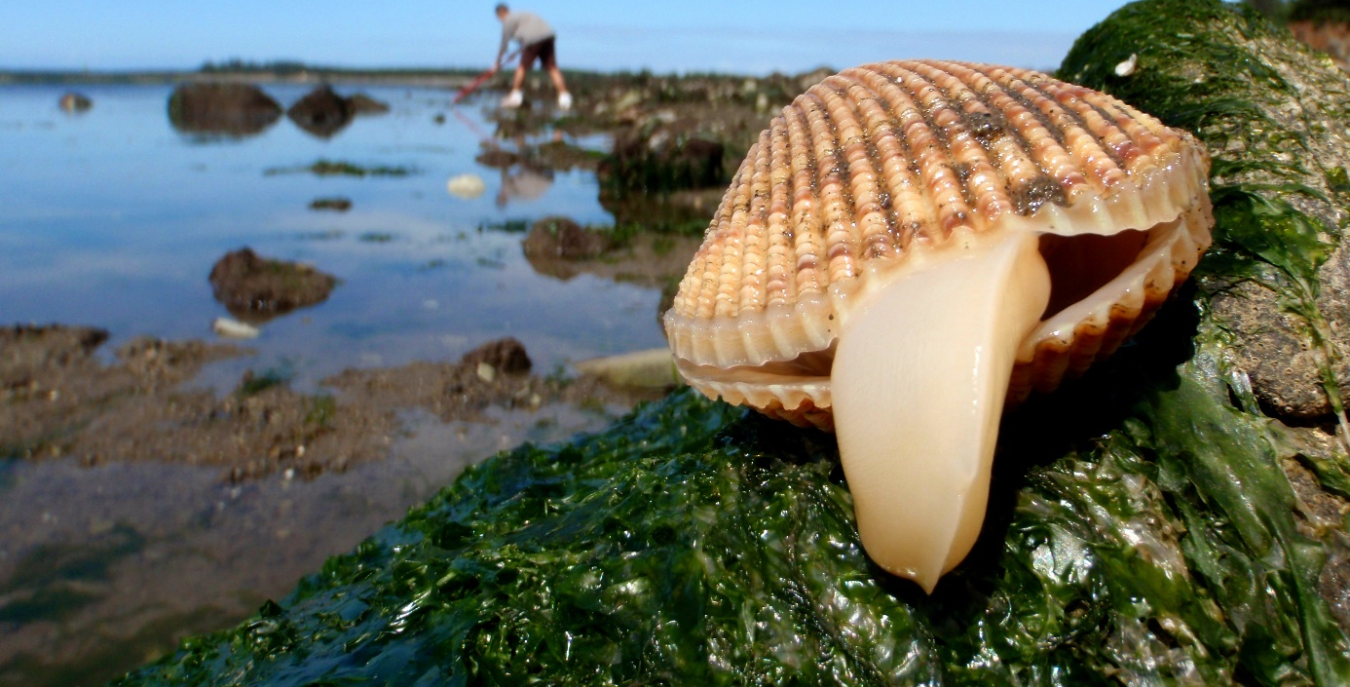

koala - ter: eucalypt forest sloth- ter: rainforest clams- marine: intertidal

- Group work (of 4) All the words below relate to animal reproduction techniques. Organize the words in a diagram, classifying animals according to this criterion. Give them cards, ss can get up (1 from each group), compare their ideas w/ those of other groups, after fdbk they sketch the diagram to their handouts – 10m/30
oviparous viviparous ovoviviparous marsupials placental sexual hermaphroditism asexual external fertilization internal fertilization

REPRODUCTION

ASEXUAL SEXUAL

HERMAPHRODITISM EXTERNAL FERTILIZATION INTERNAL FERTILIZATION
(self-fertilization)

OVIPAROUS OVOVIVIPAROUS VIVIPAROUS
(egg-laying) (producing eggs that are hatched within the body) (giving live birth)

MARSUPIALS PLACENTAL
(pouched animals)

- Which category do the animals from 9. fall into? +ask them to give examples of animals with the remaining repr.techniques, 3m/20
Koala – marsupial, sloth – placental, clams - hermaphrodites
- Behaviour. Match definitions below with their terms pairs/ groups, 5m /17
Terms: territorial, scansorial, omnivore, cursorial, herbivore, carnivore, saltatorial, folivore, natatorial, diurnal, frugivore, granivore, nocturnal, crepuscular, hibernating, solitary, colonial
Definitions:

- adapted for leaping - saltatorial
- specialized for swimming - natatorial
- eating plants – herbivore/herbivorous
- eating everything - omnivore
- active in the daytime - diurnal
- capable of climbing - scansorial
- living in big groups - colonial
- active in the night-time - nocturnal
- feeding on leaves - folivore
- active in twilight - crepuscular
- feeding on grains - granivore
- feeding on meat - carnivore
- in a dormant state in winter - hibernating
- capable of running - cursorial
- living alone or in pairs - solitary
- eating fruits - frugivore
- defending certain territory - territorial

Now classify the items into these four categories:
SOCIAL BEHAVIOUR | LOCOMOTION | ACTIVITY PATTERN | FOOD HABITS
Solitary, colonial, territorial | scansorial, saltatorial, natatorial, cursorial | diurnal, nocturnal, crepuscular, hibernating | Herbivore, carnivore, omnivore, folivore, granivore, frugivore

- In groups of 4-5, choose an animal and present it to the rest of the class (in 5 minutes). Give information on its: tell them the pix will be provided – show on slides from google images, 2min explaining the task +10min for preparation:12/12
- taxonomy (use English, not Latin terms)
- geographical range, habitat
- lifespan, behaviour: activity pattern, locomotion, social behaviour, food habits
- reproduction: techniques, no of offspring, parental investment
- conservation status

When presenting, remember to speak loudly, clearly, TO the audience, and to use vocabulary which you understand well, your audience is able to understand, or which you are able to explain well.
Remember to have an introductory sentence in the beginning:

Let us introduce/present a … to you.
We would like to present a … to you today.
What we would like to talk about today is …
What you can see in the picture is …
… are very interesting/ specific/ etc. animals.

And a final statement in the end:
This is all about …, we hope you have enjoyed it.
And that’s the end of our presentation, thank you for your attention.
To end our presentation, we want to thank you for listening, and hope you found it interesting and informative.
View via OHP the animal that the ss present, if the groups are big, make it a group work.

NOT MANAGE TO DO ALL IN ONE LESSON! Carry on with delivery, fdbk, and grammar in the next lesson 20 min delivery + 5 min fdbk + 5 min a general fdbk on speaking in the public based on their mistakes/strong points

- GRAMMAR REVISION: ADJECTIVES. Look at different ways of forming adjectives in English. Explain the homework, do w/the class a few examples
- Write a few examples appearing in today’s lesson into each category. Give as homework if running out of time
adjective endings
-ed | -ing | -ous | -able | -al
adapted  specialized | feeding  eating  living | deciduous  coniferous  omnivorous | capable | colonial  diurnal  natatorial  external  placental
Now choose one word from each category and make a sentence with it.

- Carry on with exercises on adjectives from the two grammar handouts in IS (adjectives-nouns: word formation, so vs such)

Sources:
Ex.1-3: Wharton, Jennifer (2009) Academic Encounters, the Natural World; CUP
http://www.bbc.co.uk/nature/habitats
handout: Mammals by Hana Němcová, based on: http://animaldiversity.ummz.umich.edu/site/accounts/information/Mammalia.html, http://www.britannica.com/, www.wikipedia.com, http://www.youtube.com www.bbc.co.uk http://www.oxforddictionaries.com/

