MINIMALISTIC SIMULATION OF POPULATION AGING’S IMPLICATIONS IN THE SLOVAK REPUBLIC

Zdeněk Rosenberg, Masaryk University

Abstract
The main goal of the paper is to present transparent simulation of population's aging fiscal implications in the Slovak republic. The simulation uses projection of population aging and briefly analyses some of its aspects. It uses the number of people of each age and average government’s expenditures related to citizen of every year of age to calculate total expenditures for every year from present till 2050. The needed level of productivity of labor growth sufficient to balance budget in long run is calculated.

Keywords: Aging – Pension system – Fiscal policy – Labor productivity – Simulation

JEL Classification: C63, H55, H68
AMS Classification: 68U20

- iNTRODUCTION
This paper presents a simulation of the budget implications of population aging in the Slovak Republic using author’s own approach. In contrast to usual overlapping generation model (OLG) this approach is simpler and very transparent. For the purpose of the simulation a population projection by The World Bank is used along with fiscal indicators from recent years. The core of this simulation is simple vector product. For every year of the simulation the government’s simplified age related expenditures are calculated using the number of citizens of each age group and the age related expenditures of average citizen of that specific age cohort which is five years long. The simulation shows the total expenditures of every fifth year under the assumption that the structure of expenditures will stay the same as it was in the year 2010 which is a starting year of the simulation.

- Population projection and data
Figure 1 shows a sharp drop of the percentage share of 16-65 years old. The minimum of 58.7% is reached only at the end of the simulation. The oldest age group’s share is at its maximum of 26.4% at that moment. From 2030 on over half of those older than 20 will be also older than 50, whilst it is 40.5% in 2010. The majority of those over 20 will be over 55 in 2050 whilst it is 31.2% in 2010. This fact may worth noting because it is very likely to shift the preferences of median voter.
FIGURE 1: Projections of Slovak republic’s main age groups share of population
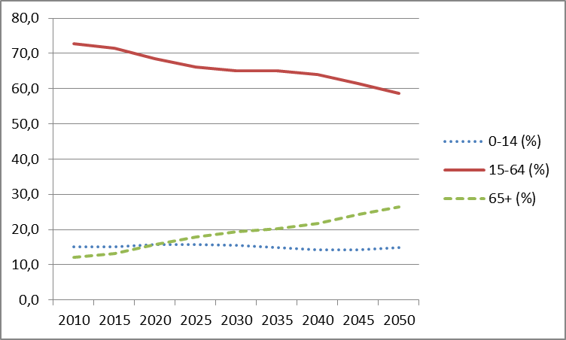
Source: World Bank.
In Figure 2 the slow declining trend of Slovak population is apparent. In contrast to this the rising number of those over 65 is shown along with the estimated number of employed population. This estimate was calculated by using the employment rates for age groups of five years from pre-crisis year 2008 as provided by Eurostat in [2] combined with the number of people in each age group from the projection.
The simulation uses the government’s expenditures related to the average citizen of every age group as is shown in Figure 3. All prices are in current Euros. There is no inflation in the simulation so when pensions do not change in time they are actually inflation adjusted.
Expenditures consist of costs of every level of education as provided by World Bank in [8], unemployment costs and pensions. Average unemployment monthly benefit of 307 Euro and average monthly state pension of 399 Euro are used. The enrollment rate of secondary education is currently 92% of the population and for tertiary education it is 52% as provided by World Bank. The five years of primary, eight years of secondary and three years of tertiary education are used in the simulation to compensate for those who drop out.

FIGURE 2: Total population, number of employed and those over 65 (in thousands)
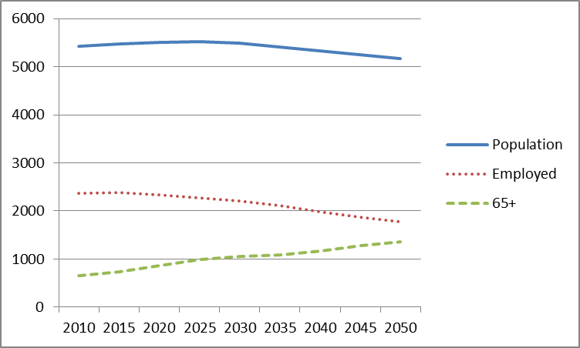
Source: World Bank, Eurostat, author’s calculations.
Education cost, unemployment and state pensions of average citizen are shown in Figure 3. Unemployment is distributed to age groups using data form 2008 so the simulation’s results are not disturbed by the current crisis.
FIGURE 3: Age related expenditures per citizen (in Euros)
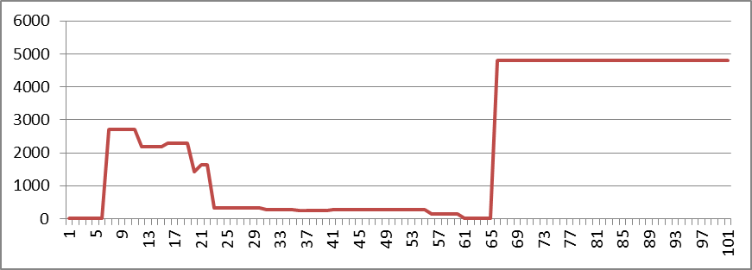
Source: International Labour Organization, Sociálna Poisťovňa, World Bank.
- Results
The rise in state pensions caused by population aging cannot be compensated by lower public spending on education as is clear form Figure 4.

FIGURE 4: Selected expenditures (in thousands of Euros)
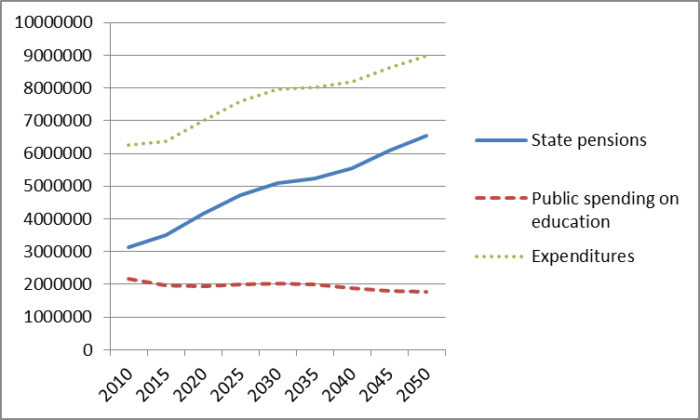
Source: World Bank, Eurostat, author’s calculations.
Slovak Republic relies heavily on indirect taxation and so calculating the effect of aging on overall finances directly would require a detailed enquiry into the source of money paid on indirect taxes another approach was needed. The balanced budget of the government’s age related revenues and expenditures have been chosen as a starting point for the simulation. Using the number of employed citizens and total age related expenditures it was calculated that to achieve balanced budget in 2010 average employed citizen must have paid 2651 Euro. This allows the simulation to answer two key questions. What would the deficit be if nothing happened to ease the impact of aging and how much more must employed citizens pay to achieve balanced budget in the long run.
The deficits were calculated using total age related expenditures and the assumption that employed citizens would have to pay the same taxes as in the beginning of the simulation for the rest of it. As is clear from the Figure 5 the deficits will grow steeply and reach as high as 6.5% GDP. This is for the situation with no growth and it is equal to 33.2% of the whole government revenues form starting year. The cumulated deficit from every year of the simulation would reach 122.5% GDP. Using the age related expenditures, number of employed population and the taxation needed to balance this part of budged it was calculated that the growth in productivity of labor of 1.64% a year would be sufficient to balance budget at the most problematic end of period.

Because of the much shorter simulation period and different role of direct taxation which led to new method of establishing the deficit in this paper it is not possible to make direct comparison to the results obtained by similar simulation in Rosenberg (2014). In that study Czech economy was analyzed for the period of 2013 to 2100 and much higher deficit of 11.6 % GDP in the worst year 2060 was found. Also the accumulated deficit was much higher but the growth of productivity sufficient for balanced budget was below one percent a year.

FIGURE 5: Deficits and revenues (in thousands of Euros)
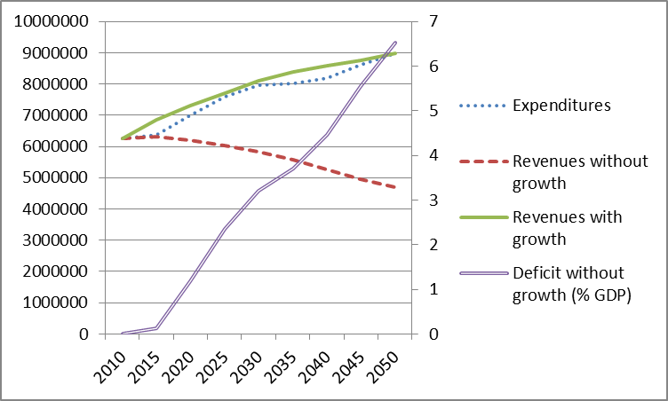
Source: Author’s calculations.

- conclusions

The goal of the simulation was to provide an insight into the dynamics of what is likely to happen and not to provide exact numbers
- The deficit of state pensions accumulated over a whole period is over 120% GDP and is still growing. Labor productivity and economic growth are a top priority in dealing with an aging population. With its second pillar of the pension system, which is mandatory since 2005, and the popularity of the growth fund the Slovaks are clearly expecting favorable levels of growth.
- Even modest growth of productivity of labor of 1.64% a year can make the current system sustainable.
- Even though the absolute income of the seniors would not drop with the growth mentioned above, the relative would drop dramatically if it was not for the successful second pillar. Further analysis of the larger economic growth’s impact on the possibility of rising state pensions is needed.

Acknowledgements: This work was supported by Specific research project at ESF MU.

References
- Babecký, J., and Dybczak, K.: The Impact of Population Ageing of the Czech Economy
(working paper ČNB), 2009. [online] WWW: <https://www.cnb.cz/miranda2/export/sites/www.cnb.cz/en/research/research_publications/cnb_wp/download/cnbwp_2009_01.pdf>
- Eurostat. Employment rates by sex, age and nationality.[online] WWW: <http://appsso.eurostat.ec.europa.eu/nui/show.do?dataset=lfsa_ergan&lang=en>
- International Labour Organization. Unemployment 3B. [online] WWW: <http://laborsta.ilo.org/STP/guest>
- Ministry of finance of the Slovak republic. Public Administration Budget. [online] WWW: <http://www.finance.gov.sk/Default.aspx?CatID=6958>
- Rosenberg, Z.: Minimalistic Simulation of Population's Aging Fiscal Implications and the Role of Productivity of Labor. In Pavel Jedlička. Hradec Economic Days 2014. 1. vyd. Hradec Králové: Gaudeamus, 2014. s. 256-262, 7 s. ISBN 978-80-7435-370-3.
- Sociálna poisťovňa. Priemerná výška dávky v nezamestnanosti. [online] WWW: <http://www.socpoist.sk/priemerna-vyska-davky-v-nezamestnanosti/1663s>
- Sociálna poisťovňa. Priemerná výška vyplácaných dôchodkov (v mesiacoch). [online] WWW: <http://www.socpoist.sk/646/1614s>
- World Bank. Country statistic. Slovak republic.[online] WWW: <http://data.worldbank.org/country/slovak-republic>
- World Bank. Population projection.[online] WWW: <http://siteresources.worldbank.org/EXTHNPSTATS/Resources/3237117-1319036514658/SVK_POP.XLS>

Author’s address
Ing. Zdeněk Rosenberg
Faculty of Economics and Administration, Department of Economics, Masaryk University
Lipová 41a 602 00, Brno Czech Republic
email: zdenek.rosenberg@econ.muni.cz

For the explanation of the OLG approach, precise description of all used parameters and equations see Babecký, Dybczak (2009).
The number 307 is average of values from years 2011, 2012 and 2013 and the 399 is average pension as calculated in February 2014 by Sociálna Poisťovňa in [6] and [7]. This slightly higher numbers are used deliberately because pensions and unemployment benefit do not rise in the simulation even when the productivity of labor does.
This is much more than 887 Euro form the income taxation and capital gains on one employed as is the current situation as provided by Ministry of finance of the Slovak republic.

