The Banking System of the Czech Republic as a Cybernetic System
- a Unit Step Response Analysis

František Kalouda¹
¹ Masaryk University
Faculty of Economics and Administration, Department of Finance
Lipová 41a, 602 00 Brno, Czech Republic
E-mail: kalouda@econ.muni.cz

Abstract: The aim of this paper is to further describe and analyze the behavior of Czech banking as a cybernetic system.
Studying the Czech Republic's banking system using cybernetic methodology has to date given essentialy unambiguous results as regards its static charakteristics (transfer function). It si principially a linear system, which further analysis to some extent simplifies. From a methodological point of view, in order to consider appropriate control interventions, the dynamical charakteristics – i.e. the step response – of the behavior of the system crucial.
Here the situation is less clear – the unit step responses of different perionds are not identical. The preliminary results of this paper provide solution of this problem.

Keywords: banking system – cybernetics – market interest rate – unit step response
JEL codes: C67, E58, G21, G28

1 Introduction
Previous analyses of the behavior of the banking system in the Czech Republic have focused on processes for controlling the commercial rate (market interest rate) by using the discount rate. The cybernetic approach depicts these processes as the result of the relationships between the central bank (Czech National Bank) as the control element and the system of commercial banks as the controlled system.
The behavior of the Czech Republic’s banking system as a whole is directed towards identifying its static and dynamical qualities. The results achieved so far have been theoretically and practically remarkable. And this is in spite of the fact, or perhaps because of it, that in the formulation of these results both theoretical and practical ambiguities have appeared.
A concise overview of the existing results of the study of the behavior of the Czech banking system in the given area can be summarized in the two points below:
- Linearity of the Czech Republic’s banking system (results of the analysis of the static function of the banking system)
The commercial banks themselves essentially behave as a linear system. The
quantity of existing non-linearities identified is so small that linearization is not associated with any significant problems (Kalouda, 2014b). Despite some undoubtedly interesting constituent ambiguities in the sources (Švarc et al., 2011; Kalouda, 2014a; Balátě, 2004), the linearity of the Czech Republic’s banking system can be regarded as a fact.
- Dynamical properties of the Czech Republic’s banking system - step function response of the banking system
The step function response of commercial banks, as it has been analyzed to date, leads us to the interim conclusion that, from a dynamic point of view, commercial banks can be perceived as a second-order static oscillating system (Kalouda, 2014b). Nevertheless, the available data does not rule out a tendency to start oscillation with a potential risk of destabilizing the system (Kalouda, 2014a; Kalouda, 2014b).

It is clear that the risks of the system oscillating into an unstable regime (or into system behavior on the threshold of instability - Švarc et al., 2011) are too large to be ignored. The transitional characteristics of the Czech banking system in its different periods are, after all, not identical to each other, which evokes a risk that the stability of the system may be lost. This is why this paper is devoted to examining in detail the dynamical behavior of the banking system in the Czech Republic in different periods.
2 Methodology and Data
Methodology
In this paper we understand the study of the behavior of the banking system in the Czech Republic primarily to be the study of communication and control within the relevant system. Therefore it is appropriate to test in the given context the application of the methodological tool of a theoretical discipline which in the conditions of main-stream economics in the Czech Republic has so far only been used for such purpose to a limited extent. This theoretical discipline is “cybernetics …. as the science of general laws concerning the origin, transfer and processing of information in complex systems and on the general laws for governing such systems.” (Kubík et al. 1982).
Of the various methodological tools of cybernetics (more accurately technical cybernetics), the following in particular shall be used for studying the dynamical properties of the banking system in the Czech Republic (in short, for identifying systems):
- theory of the step function response (Švarc, 2003; Kubík et al. 1982; Fikar and
Mikeš, 1999), with a special focus on
- interpretation of the meaning of poles and zeros of the transfer of the studied system (Švarc et al., 2011; Balátě, 2004; Houpis and Sheldon, 2014).

The area in which we are applying these methodological tools is usually designated as economic cybernetics (Švarc et al., 2011). We shall respect this convention.
Aside from the above, the methodological apparatus of this paper also comprises a description and the standard analytical synthetic procedures.
The effect of the discount rate on market interest rates is studied on the assumption of ceteris paribus. The subsequent extension to include the effects of specifically chosen elements of the material surroundings of the analyzed system has not been ruled out.
Model Specification
The real-life object which we shall be modelling in this paper is the banking system of the Czech Republic. We shall model the processes of managing the price of capital at a business level (commercial rate) through the use of the discount rate. The model for this real-life system is the step function response, which is one of the deterministic methods for identifying systems (Fikar and Mikeš, 1999).
This is a relatively simple model, based on the assumption that the requirement for the linearity of the modelled system is met (Švarc et al., 2011). The relative simplicity of the model used does not prevent it from being used for primary identification, for acquiring the indicative characteristics of the analyzed system (Fikar and Mikeš, 1999).
Data
This paper draws on freely available output data published by the Czech National Bank (CNB) at http://www.cnb.cz/cs/financni_trhy/penezni_trh/pribor/rok_form.jsp, and at http://www.cnb.cz/cnb/STAT.ARADY_PKG.STROM_DRILL?p_strid=0&p_lang=CS, to which we link here (to save space). This data is taken from the period 31/01/2004 until 30/09/2013. The values of the variable discount rate and commercial rate are monitored. See Figure 1 Commercial rate = f (discount rate).

Figure 1 Commercial rate as a function of the discount rate
Source: Author’s own work
At any given time, we are only analyzing in the sources those reactions of the system that are usually considered, i.e. the reactions to a rise in the discount rate. From Figure 1 it is clear that meaningful data appears in the following periodic intervals:
• 1st interval – 31/07/2004 – 31/12/2004,
- 2nd interval – 30/09/2005 – 30/06/2006,
- 3rd interval – 31/08/2006 – 30/04/2007,
- 4th interval – 31/07/2007 – 31/10/2007, and finally
- 5th interval – 31/12/2007 – 30/06/2008.

3 Results and Discussion
Zeros and poles of the transfer function
The dynamical properties of the studied system, in our case the banking system of the Czech Republic, are perfectly described by the distribution of the poles and zeros of the given system. However, when first trying to identify a system it is not necessary to know the transfer in the form of the distribution of its poles and zeros. Knowledge of the distribution of poles and zeros in the complex plane of the system transfer can be substituted by using the correlation between the step function response and the distribution of the poles and zeros.
Zeros and poles may be theoretically
- real,
- complex (always complexly associated), and even
- purely imaginary (Švarc et al., 2011).

Rules for interpreting the position of poles of transfers in a complex plane
The results acquired from the model and the related discussions are presented in the text below in the order corresponding to the above-stated intervals. By presenting the research results in this manner, they can be integrated into the time contexts of the modelled process (the modelled real-life object). In this context, we are especially interested in the future status of the deciding parameter of the modelled system, i.e. the course of the commercial rate over time.
The poles of the transfer have a special importance in this connection. From their position in relation to the imaginary axis of the complex plane of the system transfer, it is possible to deduce the course of the time response of such system, as well as its behavior.
The result of work on the primary sources contains an immediately successive overview of the results of the positioning of the poles for the course of the time response and the behavior of the analyzed system. In effect, it involves elementary rules for interpreting the position of poles in the complex plane of a transfer with respect to the behavior of the given system:
- The further the poles are from the imaginary axis, the more the transition process is damped (Balátě, 2004) and thereby also becomes shorter (Švarc et al., 2011);
- If the real pole is at least six times further to left than the complex pole, its effect on the time response of the system is negligible, and the time response is designated as “typical”;
- The shift of the real pole towards the right along the negative semi-axis generally means a smaller overshoot of the step function response;
- If the real pole comes closer to the level of the complex poles (but is constantly to the left of their level), the first maximum step function response is smaller than the maximum value of the overshoot; the largest overshoot may appear in the form of a second or subsequent maximum,
- If the real pole is situated at the same level as the complex poles, no overshoot of the time response will appear; together with a minor rippling of the time response, it indicates a “critically damped situation”;
- If the real pole is located to the right of the level of the complex poles, the time response is “over-damped” (Houpis and Sheldon, 2014);
- In the initial time phases of the time response, deviations can appear on the “opposite” (Švarc et al., 2011) or “wrong” (Balátě, 2004) side; the time response thus acquires temporarily negative values. This indicates a system with a non-minimum phase (Švarc et al., 2011), or a non-minimum dynamical system (Balátě, 2004). The stability of the system is defined however by the position of the poles (Houpis and Sheldon, 2014) and is not connected with the designation of the non-minimum phase (non-minimum dynamical system).

Typical Time Response (Step Function Response)
The effect of the position of the poles of transfer on the course of the studied system’s time response (in the form of so-called “typical” step function responses) is set out in Figure 2 below.
Here the poles are marked with a cross. Complex or complexly associated poles are labelled as p₁ and p₂. The real pole of transfer, which has a decisive significance for the character of the time response and thereby for the behavior of the system, is labelled as p₃. The time response itself is labelled c(t).
This is again an illustration, in its own way, of the modelled situation and even on an ideal plane. The real course of the step function response for the specific application (in the given case of the banking system of the Czech Republic) may in the details naturally differ from this ideal. Moreover, assessing the level of its conformity with the ideal or typical course of the time response is to a certain extent inevitably subjective.
From this it follows that estimates for the position of the poles from known real time response may also be subjective. The same applies to the final result of an expert assessment of the specific form of a time response – i.e. the behavior or actual status of the modelled system.
If we wanted to find an analogy for this procedure, an example is provided in medicine by the problem of “reading” the graphic outputs of an ECG examination.

Figure 2 Time response (step function response) as a function of the real pole location
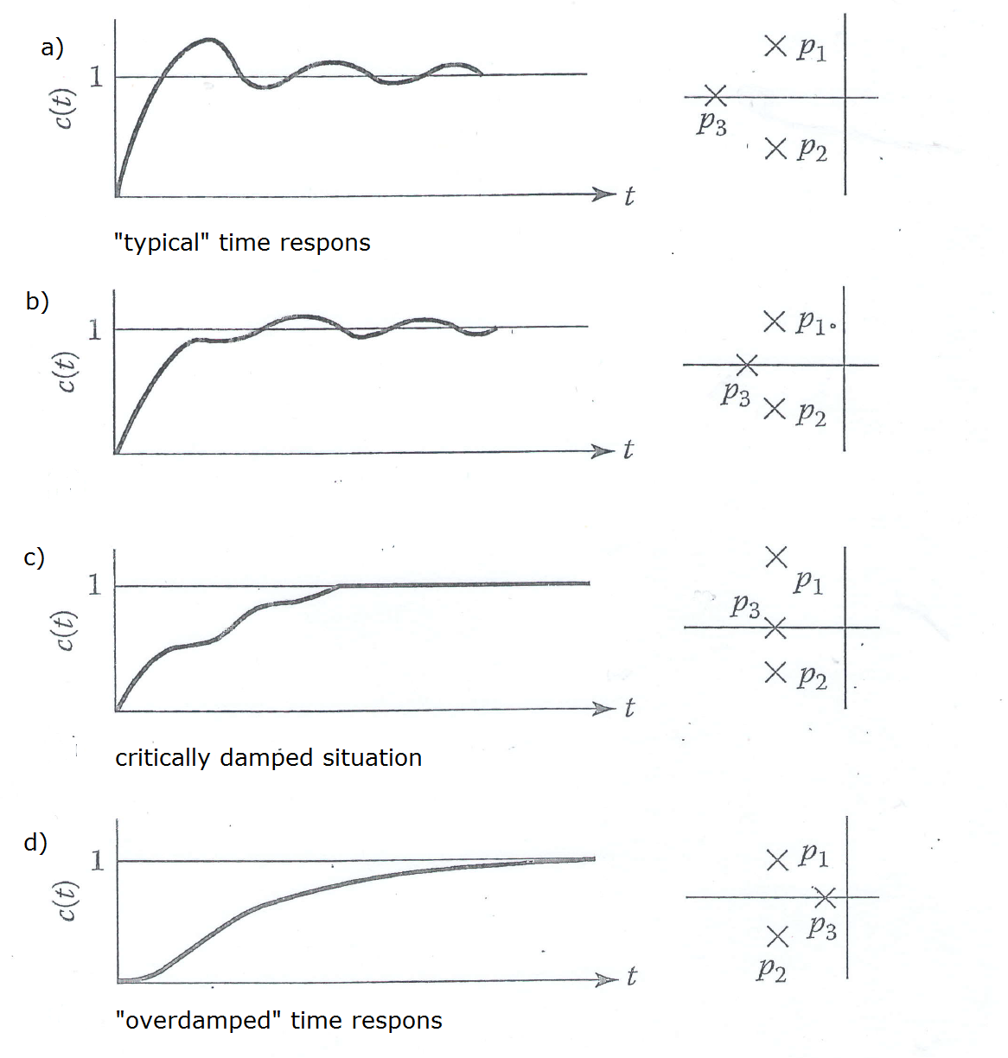

Source: Adapted from Houpis, C.H., Sheldon, S.N. (2014). Linear Control System Analysis and Design with MATLAB, sixth ed. New York: CRC Press, p. 341, Figure 13.4
These typical time responses will be compared to further measured real step function responses of the Czech banking system and by analogy we will formulate a conclusion as to the state and behavior of this system, and perhaps make some forecasts.

Time Response 1st interval (31/07/2004 – 31/12/2004)
The corresponding step function response is illustrated in Figure 3.
Figure 3 - Time Response 1st interval
Remark: Refracted curve shows real data.
The smooth curve is an approximation of the real data to polynomial function.

Source: Author’s own work

In this case it is possible to deduce the “typical” course of a response time. However, the system of commercial banks is unable to process any regulatory intervention. The time response lacks sufficient length, which can be interpreted as evidence of the premature regulatory intervention of the central bank in the form of reducing the discount rate.

Time Response 2nd interval – 30/09/2005 – 30/06/2006
The corresponding step function response is illustrated in Figure 4.
Figure 4 - Time Response 2nd interval
Source: Author’s own work
In this case we can also point to a “typical” course of time response. The central bank waited a sufficient time before further increasing its discount rate – the period for the “run-in” of the step function response seems adequate. The problem is the evident inclination of the banking system towards a loss of stability. A subsequent increase in the discount rate may have a stabilizing effect. The indication of the behavior type “system with non-minimum phases” is not, however, connected with stability.

Time Response 3rd interval – 31/08/2006 – 30/04/2007
The corresponding step function response is illustrated in Figure 5.

Figure 5 - Time Response 3rd interval
Source: Author’s own work
The regulatory intervention of the central bank in this example caused greater damping of the system (see the course of the time response in Figure 1 graph c), where the real pole is shifting towards the right); nevertheless, this did not benefit the system in terms of stability. The system is clearly heading towards oscillation.
The first-signal response is clear – to dampen the system still further, with the objective being to restore its stability.

Time Response 4th interval – 31/07/2007 – 31/10/2007
The corresponding step function response is illustrated in Figure 6.
The additional raising of the discount rate now meant that the system is damped to a critical extent. This is a clear signal that further corrections aimed at limiting the dynamics of the system are no longer desirable. The central bank proceeded along this course regardless, and repeated increases in the discount rate followed.

Figure 6 - Time Response 4th interval
Source: Author’s own work
The raising of the discount rate brought about the desired stabilizing effect on the system. The price is high, however: the system shows clear signs of over-damping, from which we can conclude that identical measures in a similar vein will no longer be effective – the system will not in effect be able to respond. Nonetheless, after a relatively short period of time the central bank began a new series of raising the discount rate.

Time Response 5th interval – 31/12/2007 – 30/06/2008
The corresponding step function response is illustrated in Figure 7.

Figure 7 - Time Response 5th interval
Source: Author’s own work
The latest series of increases push the system into a chaotic state. What is more, the behavior type “system with non-minimum phases” again becomes apparent, which fortunately has no bearing on the stability of the system. The next step of the central bank can be predicted – a reduction of the discount rate, ultimately even a series of such control interventions. The final effect will be devastating, however – the discount rate will lose its regulatory potential.

4 Conclusions
The general conclusion for the central bank is devastating. Their series of regulatory measures lead to a situation in which the regulatory tool, i.e. the discount rate, stopped having any effect.
The question is whether or not, in the course of the monitored time interval, any other (partial objectives) of the central bank were achieved. In every case their interventions lead to a situation in which the system (originally clearly linear) began to show the clear non-linearity of a type of hysteresis.
In addition, previous analyses raise the suspicion that the reactions of the central bank were being “dragged along” in the wake of the actual development of the price of capital (at the level of commercial rates): see the second analyzed interval.
There has been no exhaustive discussion about how the position of the poles and zeros of the transfer of the particular system effects behavior. The application of theories for solving differential equations is another possible direction that analysis might take in future.

Acknowledgments
This paper was written with support from the project OP Education for Competitiveness, Science and Scientists for the Education of a Modern Society (OPVK Věda a vědci pro vzdělanost moderní společnosti) (CZ.1.07/2.3.00/35.0005).

References
Allen, R.G. (1971). Matematická ekonomie, Prague: ACADEMIA.
Balátě, J. (2004): AUTOMATICKÉ ŘÍZENÍ, Prague: BEN.
Fikar, M., Mikleš, J. (1999). Identifikácia systémov, Bratislava: STU Bratislava.
http://www.cnb.cz/cs/financni_trhy/penezni_trh/pribor/rok_form.jsp
http://www.cnb.cz/cnb/STAT.ARADY_PKG.STROM_DRILL?p_strid=0&p_lang=CS
Houpis, C.H., Sheldon, S.N. (2014). Linear Control System Analysis and Design with MATLAB, sixth ed. New York: CRC Press
Kalouda, F. (2014a). Cost of Capital Management by Central Bank as a Cybernetic Model. In: Jdlička, M., ed., Hradecké ekonomické dny 2014. Hradec Králové, Czech Republic: Gaudeamus, Univerzita Hradec králové, pp. 428-434.
Kalouda, F. (2014b). The Impact of Discount Rate on Commercial Rates in the Czech Republic: The Cybernetic Approach. In: Deev, O., Kajurová, V., Krajíček, J., ed., European Financial System 2014. Brno, ČR: Masaryk University, pp. 307-313.
Kubík, S., Kotek, Z., Strejc, V., Štecha, J. (1982). Teorie automatického řízení I, Lineární a nelineární systémy, Praha: SNTL.
Švarc, I. (2003). Teorie automatického řízení, Brno: FS VUT.
Švarc, I., Matoušek, R., Šeda, M., Vítečková, M. (2011). Automatické řízení, 2nd ed. Brno: CERM.

