7. Practical application of genre analysis in the classroom
In this part of the workshop, we are going to analyse some of the texts from the discipline that you teach. Before we begin, we need to get to know some important tools.
An introduction to AntConc
Discuss the following questions with a partner.
- What is a corpus?
- Have you ever used one?
- Do you know of any which are used to better understand academic writing?
- Have you heard of AntConc? Do you know what it does?
- Can you think of any ways in which concordance software programmes can help you analyse specific genres?

Key information
The following information has been adapted from ‘A guide to using AntConc’.
A Concordance is a list of target words extracted from a given text, or set of texts, often presented in such a way as to indicate the context in which the word is used. This format of presenting information is called ‘KWIC’: Key Word In Context. Concordance software can usually extract and present other types of information too, e.g. identifying the words that most commonly appear near a target word (its ‘common collocates’).

AntConc is a freeware concordance program developed by Prof. Laurence Anthony, Director of the Centre for English Language Education, Waseda University (Japan).
The AntConc programme is available from http://www.antlab.sci.waseda.ac.jp/software.html
You can either download it onto your computer or run it from the website.

Getting started with AntConc
Today we are going to look at how to analyse texts using AntConc. But before we analyse a set of texts, let’s open AntConc.
You can open it directly from the website or save it on to your computer or memory stick. You choose! http://www.antlab.sci.waseda.ac.jp/software.html
Before you carry out a detailed analysis of your discipline-specific texts, let’s work with just one text so we can get to know what we can do with the programme.
Step 1: Choose one text. Save this text as .txt (I will show you how to do this, if you are unsure).
- Open the AntConc programme. You should now have the AntConc window (see below). You can reposition, resize or maximize the window in the normal way.
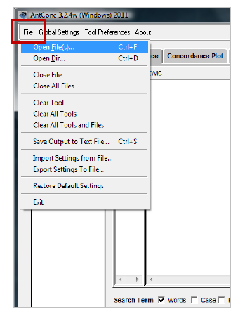
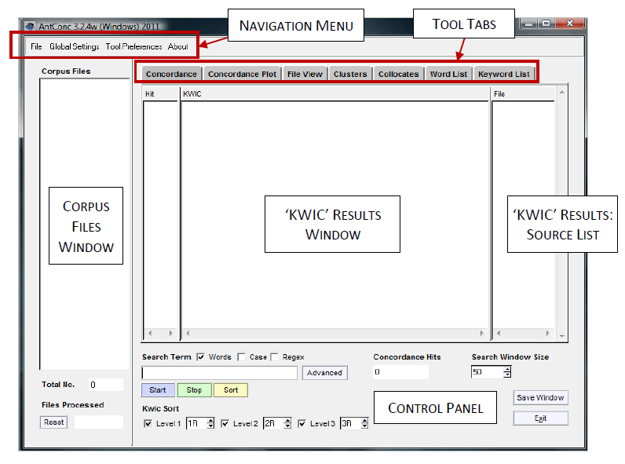
Load a file
- Select ‘Open File(s)’ from the ‘File’ menu.
- Select the file
- Click the ‘Open’ Files button. The chosen
Files are now listed in the ‘Corpus Files’
Panel on the left side of the AntConc window.
The ‘Total No’ box under the panel shows
how many files you have selected.
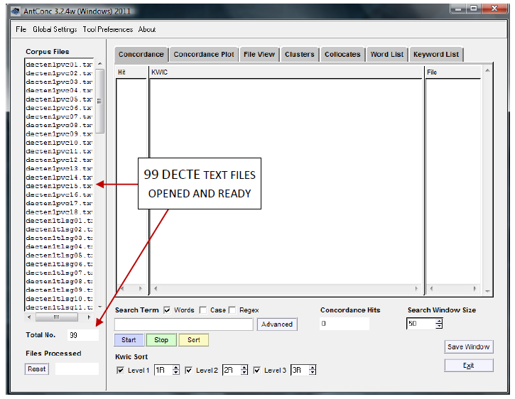
Concordance
To create a concordance, first make sure the ‘Concordance’ Tool Tab is selected. (The Tool Tabs are located at the top of the AntConc window. When the Concordance tool is selected, the results window and control panel will look as they do in the screenshot above.)

- To run a simple concordance using a single search term, enter the term in the search box on the left-hand side of the control panel, and click ‘Start’. For example, entering canny in the search box will generate a list of all occurrences of that word form in the interview text files you have chosen to search (see first screenshot on the next page).

- The results will appear as a list in the KWIC results window, showing the word in the context in which it appears in the text. The interview in which each result can be found is indicated by the file name in the ‘File’ source list window to the right of the KWIC results window. The total number of results is indicated in the ‘Concordance Hits’ box in the control panel.

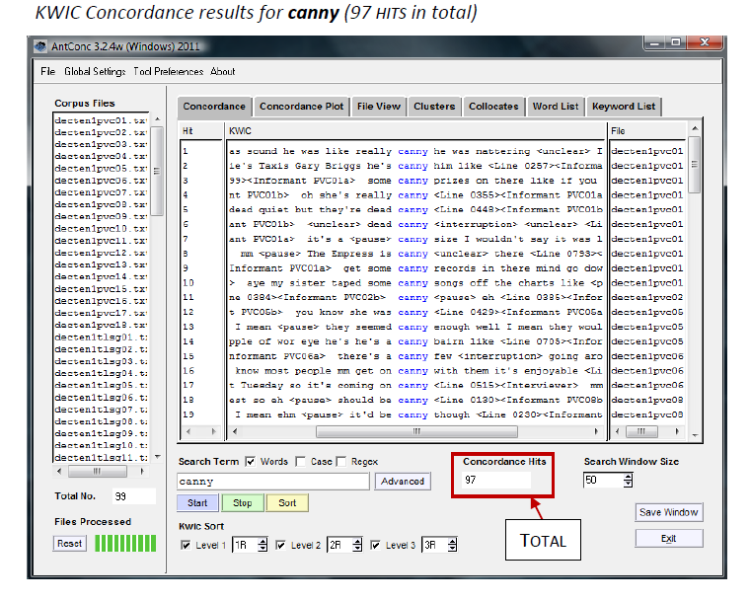
You can select ‘File View’ to see the wider context of the first result in the Canny results list.

Collocates
To generate a list of the most common collocates of a search word, first click the ‘Collocates’ Tool Tab at the top of AntConc window.
When generating a collocation list, it is a good idea to have AntConc set to ignore any tags in the text (e.g. those that identify line numbers or speakers). To do this, click ‘Global Settings’ in the navigation menu at the top of the AntConc window. In the resulting window, choose ‘Tag Settings’ from the menu on the left-hand side. By default, ‘Show Tags’ will be selected. Select ‘Hide Tags’ instead, and click ‘Apply’.

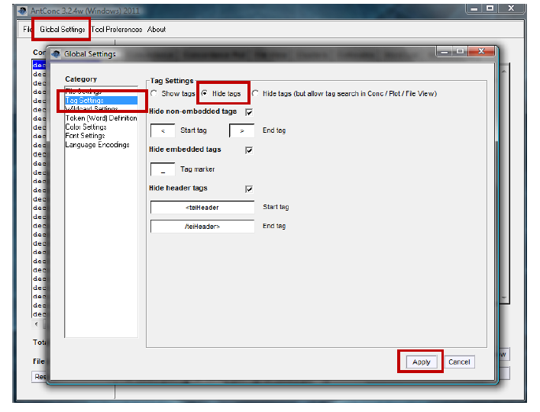

Next, choose the span of words that you wish to include by altering the ‘Word Span’ settings in the control panel, e.g. setting ‘From’ to ‘5L’, and ‘To’ to ‘5R’ will search for collocates in a span of five words to the left and five to the right of the key word.
Now enter your search term in the search box, and click ‘Start’. In the latest version of AntConc (3.2.4), a message will appear telling you that the program must first generate a word list. Click ‘OK’. When the word list has been generated, the program will automatically return to the ‘Collocates’ tool and generate your collocate list.
The Collocates window lists words by the frequency with which they appear in the contexts centred on your search term (see the collocates list for canny, below). The list also indicates the frequency with which the collocates occur to the left or right of the key word. (By default, the ‘Stat’ column records a ‘Mutual Information’ score, which is a measure of the probability that the collocate and key word occur near each other, relative to how many times they each occur in total.)

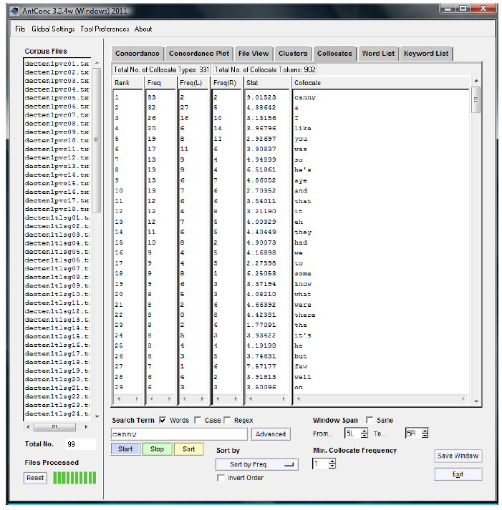

Saving results

To save one of your results windows, select ‘File’ in the navigation menu at the top of the AntConc window. Then select ‘Save Output to Text File’ — OR — press CTRL+S.

So far, you have had a very brief introduction to AntConc. From what you have seen:

Discuss with a partner.
- How do you think you could use AntConc in the classroom?
- Do you think you could introduce students to it? How could students use it?

PRACTICAL ASSIGNMENT
You are now going to carry out your own genre analysis of a set of texts of your choice.
Step 1:
Choose a set of texts (between 3 and 5) of your choice (preferably ones that you could use with your students). All of the texts need to relate to the same genre and be on the same topic.

Or choose 3-5 journal articles which relate to a specific discipline and topic from Google Scholar:
- http://scholar.google.co.uk/

Alternatively, you could examine 3-5 newspaper articles from:
- http://www.theguardian.com/uk (broadsheet)
- http://www.mirror.co.uk/ (tabloid)
Again these need to be on the same topic.

Step 2:
Deconstruct the genre
Having seen how genres are unpacked using different strategies, I would like you deconstruct your texts to find out their most salient features. Think about:
- Context
- Structure
- Language

- Can you think of any other areas you can/should explore?

Before you begin to deconstruct the genre:
- Discuss how you are going to work out the key features.
- Can you use any of the materials that have already been given to you?
- Can you use AntConc? How? For what?

I would recommend you also make a discipline-specific word list with 10-20 of the most frequent words. Remember to use the AWL highlighter to remove any words that belong to the AWL: http://www.nottingham.ac.uk/alzsh3/acvocab/awlhighlighter.htm
Step 3:
Deconstructing the genre (Exercises for students)
Having deconstructed the genre yourself, can you think of any exercises you could create for your students to make them consciously aware of the salient features of your genre/text type?
Discuss with a partner.

Prepare to give a short presentation about your findings and any advice you can give to your colleagues

Step 4:
Reconstructing the genre
What exercises could you carry out with your students to help them reconstruct the genre and gain ownership of it?

Step 5:
Reformulation
Reformulation is one of the strategies you could use at the ‘reconstruction’ phase. It can help students clearly identify the similarities and differences in their own writing. Although reformulation is traditionally carried out with the reformulators being native speakers, today you are going to be the reformulators.

You will be given a short text which has been written by an international student. You are the reformulator. As the reformulator, you should read the guidelines below and re-write the student text according to the guidelines.

Reformulation Guidelines
What is reformulation?
Reformulation is a mistake correction technique used on the output (more typically written) of language learners. The technique requires the students to reflect on their own writing and ‘notice the gap’ between their current written output and that of a native speaker. This technique aims to help students develop their writing (in this case) or speaking skills.

Your role
Your role in this task is to be the reformulator.

Reformulation Guidelines
As the reformulator, you are required to:

- Read the non-native speaker’s writing

- Ensure you have understood the message and ideas of the writer and then

- Rewrite it in a way which is more natural to a native speaker.
It is important that you:
- preserve the student’s original ideas and that you do not add any of your own
- do not completely change the order of sentences and paragraphs unless the structure needs to be revised.

Reformulation in practice
In order for you to see how your reformulated writing is going to aid learners, please read the steps below which explain how this technique is typically used in the classroom.

Step 1: The students complete the first draft of an essay.

Step 2: This first draft is given to the reformulator who reformulates what they have written according to the Reformulation Guidelines.

Step 3: The teacher in the next class distributes a non-native version of the text together with the reformulated version (the version you have written). The students note down the similarities and differences between the two versions and discuss as a class. The students also discuss the reasons for the similarities and differences and the overall effect of the changes.

Step 4: Taking into account the class discussion, the students then re-write their first draft.

Step 5: The teacher then gives them very brief and generic feedback on the final draft.

Step 6: Once the students have read their feedback, the students will be given a model response to the essay title so they can compare it to their own.

Texts to reformulate

The following paragraphs are main-body paragraphs which have been extracted from undergraduate and postgraduate essays.

Before you begin to reformulate a paragraph, discuss:
- How is a main body paragraph typically structured?
- What problems do students have with main body paragraphs?

Considering the structure and typical issues, reformulate one of the paragraphs below.

Text 1

There are two factors affecting the country, on the one hand, the decrease of birth rate and the other hand the high life expectation. People having less babies and individuals living longer than they should. A Population with more ageing people means that there will be more expenses going toward pensions and health care. As the countries’ populations’ age, working class working adult will have to pay more tax because more money will be taken from their salary and be transferred to the elderly people. For example according to my research i was able to know that the public pension spending in Japan will have to increase from 8.7% of GDP to 14.3% in 2030 and to 20.2% in 2050. Jackson, R. and Howe, N., (2008).

Text 2
But according to Jackson (2002) the greatest impact is in terms of financial cost. In Europe for instance the benefits are high and people retire fairly early. Jackson says that The European Commission (EC) and the Organization for Economic Co-operation and development (OECD) estimate that spending on pensions and health benefits for the elderly in a classic developed country will increase from 11 to 18 % of the GDP during the next fifty years. The pay as you go system, used by developed countries to support retirees is no longer efficient. The number of young people was much higher than the number of retired people, and therefore it was affordable to pay retirees with the contributions of the workforce. Jackson (2002, p 44) says that “there will be just two working ageing adults for every elder in the developed world”.

