- Current key issues in teaching writing in an EAP context
& possible solutions
We are now going to focus on some of the current key issues in academic writing classrooms found at HE institutions throughout the UK and in your country.
Before we begin

Write a list of some of the key issues that you have in your own academic writing classrooms.
_________________________________________________________________________________________________________________________________________________________________________________________________________________________________
How do you overcome these issues? Discuss with a partner.

Here are the 10 most common key issues in teaching writing in HE institutions throughout the UK:
- Students have different linguistic levels
- Learners are studying different disciplines
- Deciding which approach to academic writing to follow (different learning preferences)
- Students don’t use enough academic vocabulary
- Students write in an informal way (looks more like spoken English)
- Students don’t plan before they write, therefore, their writing is not structured and confusing to read

- Students don’t use the correct punctuation
- Students make lots of spelling mistakes
- Their writing is littered with grammar mistakes
- Students don’t reference other author’s ideas (not something they are used to doing)
With a partner
- Look through each problem and discuss how serious it is.
- Do your students have the same issues?
- How do you overcome these issues? Or How could you overcome these issues?
Problems & possible solutions
The solutions below could help solve some of the problems above. The possible solutions below are not exhaustive. Please add your own ideas to them.
Please note the solutions below match the problems above e.g. Problem 1 = Solution 1.

- This is an institutional issue and although you can suggest dividing the students up according to their linguistic levels, often because of timetabling, this issue cannot be rectified. That said:

- How could you help the lower levelled students?
- In what ways could the higher levelled students help the lower levelled ones?

- Try to find out the types of assessments each discipline is expected to write and adopt the most popular types (e.g. essay, report, critical review) into the scheme of work.

With a partner, discuss:
- Choosing the right approach to academic writing for your students.
- What are the current approaches used to teach academic writing in your country?
- Can you name any other approaches which you have read about?
- Which approach do you use and why?

Most popular approaches to teaching Academic Writing in the UK
General EAP
- Focus: general linguistic & cognitive needs of non-native speakers (Benesch 2001, Leki & Carson 2004).

- Aim: what is taught & learnt helps ss with writing across the curriculum (Leki & Carson 1994).
- Materials: study skills.
- Issue: Pre-determined, non-discipline specific materials.

Academic Literacies
- Focus: diverse writing practices in HE (Lea & Street 1998).
- Aim: address literacy from cultural & social perspective and contemplate issue of identity & power relationships.
- Materials: Limited availability & time for preparation.
- Issue: No practical suggestions of integration (Wingate & Tribble 2012).

Genre-based approaches
- Focus: Explore genres students are required to write. Awareness that variations exist in different contexts of writing.

- Aim: to provide a contextual framework.
- Pedagogic approach: Genre-informed pedagogic framework (Tribble & Wingate forthcoming).
- Role of teacher: guide & support the learners (Vygotskian scaffolding).
The Teaching-Learning Model
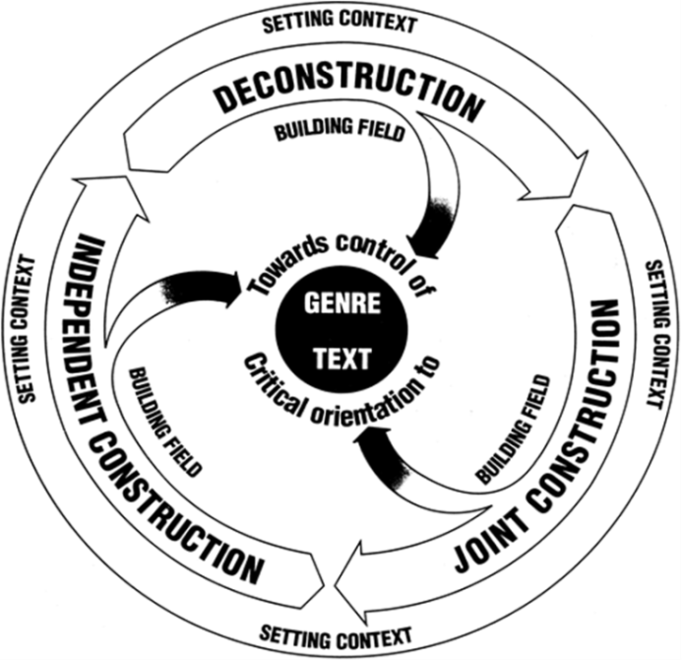
(Rothery and Stenglin 1994:8 cited in Martin 2000:19)

- Introduce students to the Academic Word List (AWL).
With a partner, discuss:
- What is the AWL?
- How could it benefit your students?
- Do you make your students aware of it in your classrooms?
- How could you/do you incorporate it into your materials?

Typically I make my students aware of it in the first class. In subsequent lessons, I start the class by looking at some of the words from one of the sublists. Below is an exercise, which takes approximately 10-15 minutes which I frequently carry out as a warm-up activity.

AWL – Warm-up

How well do you know the following words from Sublist 10 from the AWL?

1 = I don’t know this word
2 = I have seen or heard this word before, but I am not sure of the meaning
3 = I understand this word when I see it or hear it in a sentence, but I don’t know how to use it in my speaking and writing
4 = I know this word and can use it in my own speaking and writing

Look at the words below. Use the scale to score each word.

___adjacent
___albeit
___ forthcoming
___persist
___reluctance
___compile
___invoke
___levy
___ongoing
___nonetheless
___whereby
___notwithstanding

Look at the words with your partner. If your partner has a 1, 2 or 3 and you know the word, give a definition of the word and try to use it in context so that your partner can better understand this word. Once you have helped your partner, ask your partner to help you.

http://www.englishvocabularyexercises.com/AWL/id30.htm

- It is important to show students the linguistic differences between written vs spoken English.
You can do this by carrying out the following exercise.

Written or spoken text?
Look at the following texts and decide if they are written or spoken.
Text 1
Uhm, I think the sessions were very useful because we did specific work on specific themes, like, for example, uhm, how to use linking words, when to use them with like with examples and uhm and I think compared to the normal EAP classes this was more detailed, and more focused on well, specific themes.
Text 2
I bought the above iron from The Electrical Store in Newford on 10 October. On using it
for the first time, I found that the temperature control was faulty; it was not possible to set it for any temperature apart from the highest (cotton).

Text 3
It is evident that the financial crisis is having a negative impact on the environment in many developing countries.
Text 4
Ok, well, I can see a girl and a dog. Er the dog is black and has a long ears. Hhhm, I think it’s an old English sheep dog. The girl is, I think, about 10 years old.

What are the differences?
Spoken language production | Written language production
Let’s focus on Text 1 and Text 3 in more detail.
Complete the table.
 | Text 1 (Spoken) | Text 3 (Written)
What is this text? How do you know?
Register
(Give examples)
Purpose
Language (Vocabulary) used
Cohesive? How?
Sentence level (complexity, length, etc.)

- Factor essay planning into the scheme of work.
Two exercises I find work well with my students:
- I show students an essay plan template with things they could/should include. I then give students an essay title and ask them to plan the essay using the essay plan template.
- Alternatively, I show students an essay and ask them to complete the essay plan based on the contents of the essay.

- It is important to address the use of the colon and semi-colon as these are punctuation devices students often incorrectly use. Find a good academic grammar book e.g. Writing Academic English (Oshima & Hogue) and work through the exercises. Then ask the students to write sentences using these punctuation devices in context.

- Tell students to use an English spell checker.
- What else could you do in class?
- Grammar mistakes will and often occur. The mistakes could be individual to a specific student or the whole class could benefit from going over the mistakes.

Often, once I have taken in a draft essay or piece of writing, I will write create a hand-out with the most common mistakes in context and give these out in class. I then ask students to correct the mistakes. Students can learn from other student’s mistakes.

- It is important to highlight the severity of plagiarism and its consequences. This should be done early on in the course.
It is important to carry out exercises which focus on quoting and paraphrasing and common mistakes.
- Are there any particular exercises that you find work well?
- Why do students often struggle with paraphrasing?

Future consideration
The key is to anticipate the problems and address the possible solutions before they come up. You should always factor reoccurring problems into the scheme of work or your lesson plans.
List of references
- Benesch, S. (2001). Critical English for academic purposes: Theory, politics and practice. Maywah, NJ: Erlbaum.
- Lea, M. R., & Street, B. (1998). ‘Student Writing in Higher Education: An Academic Literacies approach’ in Studies in Higher Education 23/2:157-172.
- Leki, I., & Carson, J. (1994). ‘Students’ perceptions of EAP writing instruction and writing needs across the discipline’ in TESOL Quarterly 28/1:81-101.
- Rothery, J. & Stenglin, M. (1994). Writing a Book Review. A unit of work for Junior Secondary English (Write it Right Resources for Literacy and Learning). Sydney: Metropolitan East Disadvantaged Schools Program.
- Tribble, C. & Wingate, U. (forthcoming). ‘From text to corpus-a genre-based approach to academic literacy’ in System.
- Wingate, U. & Tribble, C. (2012). ‘The Best of Both Worlds? Towards an EAP/Academic Literacies Writing Pedagogy’ in Studies in Higher Education 37/5:481-495.

