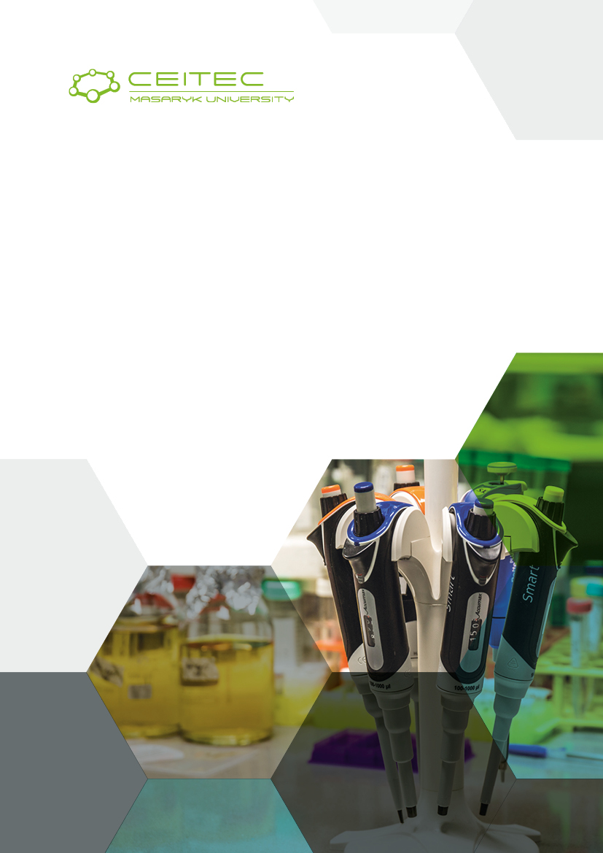
Gender Equality Plan: Sustainability Plan
Eliška Handlířová
March 2019
Version | 2019-03-28
Authors | E. Handlířová, Director’s Office
Consulted with | -
Admin Meeting | To be presented in March/April 2019
Management | To be presented in March/April 2019
Director’s Board | To be presented in May 2019
Type of Document | Activity Plan
Key Words | Gender Equality, LIBRA, HR Award
Reported Period | -
Sensitive Document | NO

LIBRA is ending by the end of March 2019. The consortium will have implemented all tasks and fulfilled all deliverables of the project. However, impact of the activities still need to be evaluated in a mid- and long-term perspective. Some of the LIBRA activities have been just kicked-off and need further implementations or corrections, and other issues have not been tackled yet. This document provides information on future steps in order to sustain and further develop (extend) the LIBRA achievements at CEITEC MU.

Coordination of GE Activities | Eliška Handlířová, Head of Director’s Office (LIBRA coordinator at CEITEC MU, HR Award coordinator at CEITEC MU)
Dedication of Human Resources | The LIBRA GEP team will continue even in extended way. CEITEC MU starts implementation of the HR Excellence in Research Award – Action Plan (2018-2023). The GEP for 2019+ will be prepared and implemented by the HR Award Working Group.
Members of the HR Working Group | - Eliška Handlířová (Head of Director’s Office, GEP team member)  - Nikola Kostlánová (Scientific Secretary, GEP team member)  - Andrea Dvořáková (Head of HR Department, GEP team member)  - Kateřina Ornerová (Head of Strategy and Science Dept., GEP team member)  - Martina Pokorná (Deputy Director for Administrative Matters, new member)  - Ester Jarour (PhD School Manager, Strategy and Science Dept., new member, upon invitation)  - Olga Křížová (PhD School Manager, Strategy and Science Dept., new member, upon invitation)  - Miroslav Haman (Head of Operations Dept., new member, upon invitation)
Highest Official Responsible Person(s) | - Eliška Handlířová (Head of Director’s Office, member of the management of the Institute)  - Martina Pokorná (Deputy Director for Administrative Matters, member of the management of the Institute)
Actions of LIBRA GEP To Be Continued | - 1.1.4 Applying job announcement guidelines – more templates will be changed to be more inclusive (using gender language decoder, etc.)  - 1.2.1 Institutional website revision – ongoing revision of using gender-sensitive language, proper images, etc.  - 1.2.3 Presentation of “family cases” – we will continue with interviews with our employees  - 1.2.4 Gender-inclusive PR material – all PR materials are now reviewed also in respect to be gender-inclusive  - 1.2.5 Proactively identify and contact potential female candidates for leading positions  - 1.2.7 Promote transparency of recruitment practices – website on Work at CEITEC MU will be available, including information on our recruitment procedure and rules  - 1.3.2 Recruitment policy/guidelines – will be implemented  - 1.3.4 List of interview questions, 1.3.5 Interview report forms, 1.3.6 Communication policy for communication with candidates and committee members – will be used also in the future  - 1.3.7 WLB brochure – will be offered to employees and updated if needed  - 1.4.1 Monitoring gender balance at each stage of recruitment process – will be implemented also in the future  - 2.1.2 Gender bias workshop – we aim to organize trainings for researchers with similar topics (if we have grants for that)  - 2.2.2 Pilot career development program for postdocs – format to be specified  - 2.3.2 Mentoring program – format to be specified  - 2.4.3 Seminars for PhD students and postdocs about available opportunities in non-academic sectors and 3.2.3 WLB lectures for researchers – to be continued  - 2.5.2 LIBRA Gender Handbook – still waiting for that...  - 3.1.3 WLB Module and 3.2.4 WLB Policy – to be available to employees and updated regularly  - 3.3.4 Sick days, 3.3.6 Nappy changing, breastfeeding, milk pumping, 3.3.12 Emergency leaves, 3.3.13 Personal return plans, 5.2.1 Exit interviews – will continue  - Sex/Gender Dimension in Research – we want to be informed about current developments and raise awareness among our researchers (format to be decided)  - 5.1.1 Data analysis tools – to be further developed  - 5.3.1 Screening internal documents and communication for gender-sensitive language use – to be implemented also in the future
New Actions | - We aim to continue in actions started as a part of LIBRA/GEP. That will be the core.  - Formalisation of the Recruitment Policy in a form of Director’s Measure and accompanying Guidelines.  - Review and implementation of Gender Guidelines on Evaluation.  - Reports from HR agenda to the management will be defined and prepared (currently, there is no regular monitoring established). Thanks to LIBRA, we started e.g. collection of data from the recruitment procedures. Next step is to start analysing those data on regular basis (e.g. annually).  - When preparing grant applications (esp. projects such as Teaming, Twinning, ERA Chair and some national schemes), we plan to include budget for HR/GE related activities.
Formal Documents, Institutionalisation and Monitoring | - New GEP for 2019-2020 / HR Action Plan for 2018-2022 (GEP is an internal part of it).  - HR Working Group (regular meetings/minutes, status reports three times per year presented to the Management, annually to the Director’s Board).  - Standardized Reports to the Management containing gender disaggregated data (on staff, recruitment procedure, PhD School, representation of women, etc.).  - Internal Guidelines and Norms to be prepared and approved.
Internal Communication | - Internal Newsletter  - Website “Work at CEITEC MU”
Link to CEITEC MU Strategy and Policies | - There is a strong link with the Strategic Plan of CEITEC MU up to 2020 (LIBRA is directly mentioned).  - In the HR Strategy (formulated in 2018), the gender equality is included, including formulation of new GEP for 2019-2020.
Dissemination | - In case we are approached by a research institute or university, we share our experience. Typically, it is in a form of few hours of personal meeting (consultation) and sharing selected documents and information.  - CEITEC MU is willing to share gained knowledge giving public lectures.  - In past years, we were approached e.g. by Ministry of Education, Youth and Sports of Czech Republic, Brno University of Technology, Institute of Biophysics of the Academy of Sciences of Czech Republic, and others.

