PUBLICATIONS ON CEITEC WEBpages

How Publications Get Onto CEITEC Webpages
Publications are downloaded from the Web of Science database at least once every three months (this includes all publications with CEITEC affiliation). Each publication is manually matched to people at CEITEC (only people with CEITEC affiliation).
Matching with research groups is done automatically (based on contracts within research groups). If a person is employed in more than one research group, publications are added to all of these research groups.
Only Q1 and Q2 publications (quartile classification is based on the average JIF percentile value) in which the Research Group Leader is one of the co-authors are uploaded to the website.

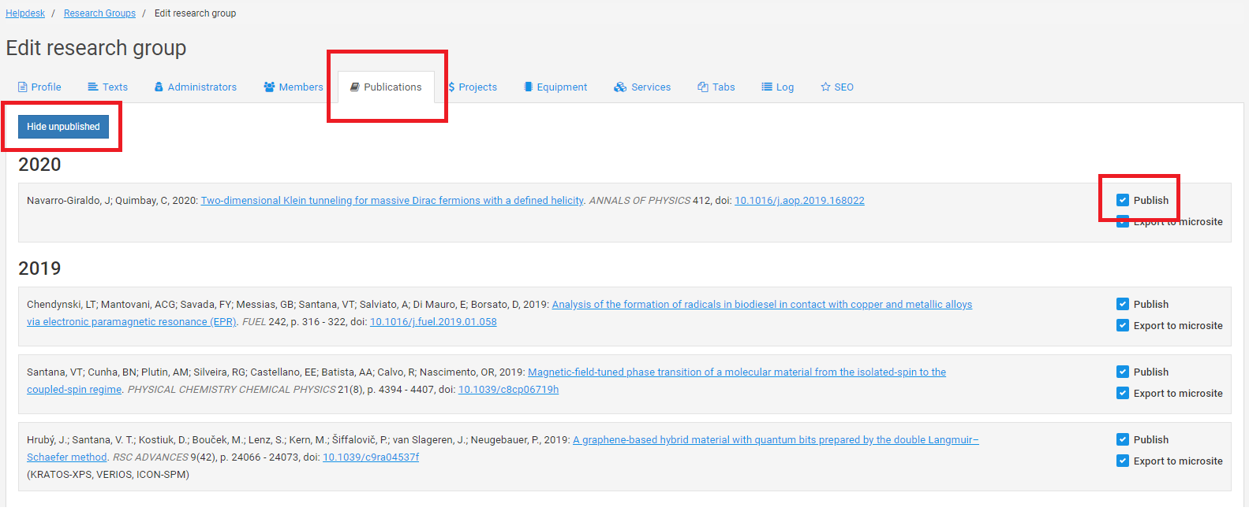
How to Hide and Sort Research Group Publications
All of the following functions are similar to your personal profile.
- For webpage administration, go to www.ceitec.eu and click on the pencil icon in the upper right-hand corner of the website. Then, log in with your MUNI identification number (UCO) and secondary password.
- When editing information about your research group, you can see the Publications tab (on the top navigation, it is the fifth tab – see the screenshot above, which is highlighted in a red rectangle).
- In this tab, a list of publications is displayed, and is sorted by year.
- You have the option to Publish (or unpublish, by unclicking the checkmark) all of the publications (for example, you might want to unpublish a publication if it is not connected to your research group, or you prefer not to promote certain publications). Please see the screenshot above, which is highlighted in a red rectangle.
- Another option is to sort the publications within each year, using the drag & drop option. You can use this option to sort the publications according to your own criteria. However, you cannot drop a publication into a different year, as it has already been predefined.
- You can also use the function, Hide unpublished (see the screenshot above, which is highlighted in a red rectangle), which will hide all publications that are already in system but have not been published by the Publisher yet.
Make sure to press Save after completing your work (otherwise, the changes won’t be saved). All changes will be reflected on the webpage immediately after saving (reloading the webpage is required).

How to Add Missing Publications
If a publication is missing on your research group profile on the CEITEC webpage, or if there is an error of information, please, contact Zdenka Pavlackova.

Zdenka Pavlackova, Ph.D.
Phone: | +420 54949 5114, +420 770 110 745
Email: | zdenka.pavlackova@ceitec.cz
Office: | Koliste 1965/13a, Brno, 602 00, office 401b

