Micro-teaching activities

There are various classrooms techniques which activate and engage students. Look at the following activities. Do you know/use any of them or can you guess for which purpose they may be used?

entry/exit ticket  think-pair-share  Switch it up!  board rotation  one-sentence summary  panel discussion | student pictures  imaginary “show and tell”  jigsaw reading  mind-mapping (concept mapping)  role-playing  harvesting

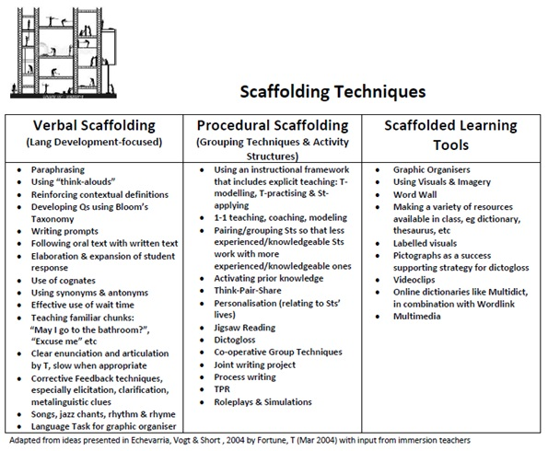https://sites.google.com/site/clil4umaincourse/module-8

