JOHARI WINDOW
(http://en.wikipedia.org/wiki/Johari_window)
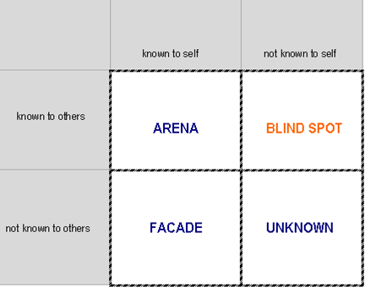

FEEDBACK GIVING & ACCEPTING
FEEDBACK GIVING  • GIVEN ON REQUEST  Feedback is effective when it is given on request. Both ends should agree with feedback giving.  • THE RIGHT TIME AND PLACE  Feedback giving needs at least basic privacy and adequate time – it should never be given in a hurry.  • DESCRIPTION NOT EVALUATION  Feedback describes what a person has done or said, it does not evaluate if it is right or wrong.  • BE CONCRFETE, NOT GENERAL  Concrete observed situation should be described, feedback does not generalise form the particular situation.  • CONSEQUENCES  Feedback summaries all reactions of the people involved and/or consequences of a person’s behaviour in the given situation.  • BALANCE  Positives and negatives should be in balance. | FEEDBACK ACCEPTING  • LISTEN ACTIVELY  It is important to listen carefully and remember (even take notes) the information.  • MAKE SURE YOU UNDERSTAND  Open questions or asking for more examples can help you to clarify unclear and vague information.  • DO NOT DEFEND YOURSELF  There is no need to explain why you have done certain thing the way you have.  • TAKE TIME FOR EVALUATION  It is important to take enough time to think about the information and analyse critically which areas are to be changed and why.  • SAY “THANK YOU”  Honest and well-given feedback is a useful gift that deserves acknowledgement, even if negatives prevailed.

