PAYMENTS BY FACULTY CREDIT CARD
- First things first: You must have a working contract with the university (Employment relationship, agreement..). If you teach at the faculty, you certainly have that kind of contract. If not, you will not be able to set up a travel order in INET! In this case, please set the meeting with HR Department.
- You need to create a travel order in INET - https://inet.muni.cz/ - (pic. 1) and send it to the approval proces. The number of travel order – form number (pic.2) should be fill in financial control form (Attachment of this email).

Picture number 1)

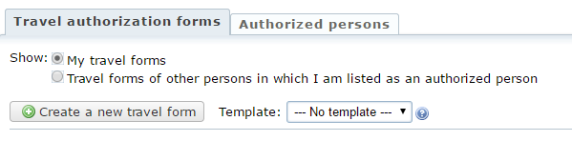
Picture number 2)
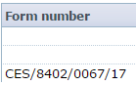

- Fill in financial control form - The form must be signed by the secretary (Lenka Bartošková) and the grant administrator.
- Then you come to my office to make a payment on my PC - when you have everything done, send me an email and we will set the date for the meeting.
- For faster processing, send me a link to the payment gate of the conference.
- Please keep in mind that after your return you will have to hand over all the documents related to your travel (bills , confirmation of conference attendance, bus tickets, conference fees - including this payment, etc.) at the cash desk office – you are responsible for providing all these documents!

