Odkaz: https://www.online.muni.cz/en/science/10300-success-in-nature-method-ranking-helps-to-analyse-cells

Success in Nature: Method ranking helps to analyse cells
science
5 March 2018
Martina Fojtů, eng Jana Doleželová
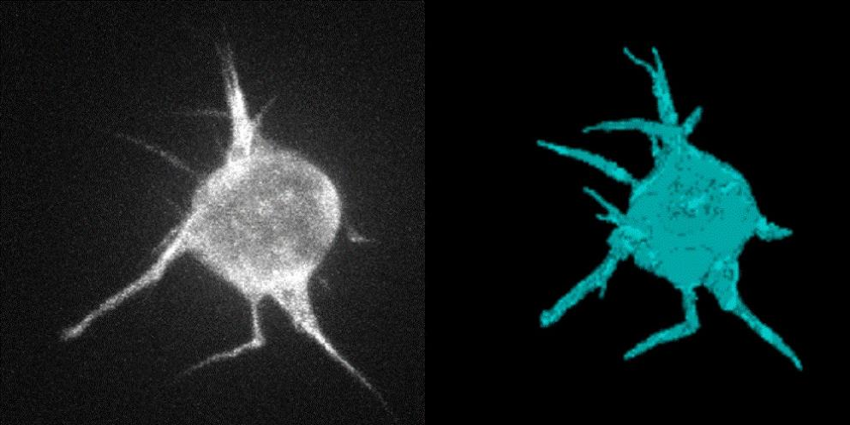
Foto: www.celltrackingchallenge.net
Modern laboratory devices provide researchers with new alternatives; however, they also produce a huge amount of image data that needs to be assessed.
A team of IT experts from Masaryk University made it all the way to the printed version of the Nature Methods journal as their paper, and the research that went into it, makes life much easier for their colleagues who study biology. The paper shows an easier way of choosing the best method of analysing image data obtained with optical microscopes.
Modern laboratory devices provide researchers with new alternatives; however, they also produce a huge amount of image data that needs to be assessed. Manual calculation is no longer possible and has been replaced by complex algorithms, necessitating the assistance of IT specialists. Experts from the Centre for Biomedical Image Analysis at the MU Faculty of Informatics have been studying descriptions of cell behaviour and images of cell movement and changes of movement for years. The recently published paper is a result of about five years of research in cooperation with their colleagues from abroad.
The research provides a comparison of different algorithms used for different types of tasks and cells and is a huge help for lab researchers. By reviewing the online overview at www.celltrackingchallenge.net, it is possible to identify which algorithm should be used first in a specific situation.
“We organised a benchmarking challenge of the individual methods, something like a competition for the existing approaches created by various institutions all over the world,” explains research group leader Michal Kozubek.
To compare the individual methods, the IT experts took data from biological studies and existing algorithms directly from international contributors. After applying each algorithm, they knew immediately whether it had performed better or worse than the others because they had the correct final results to compare it with. “What we came up with are rankings of methods, which we put together separately for different types of input data, for example, for different types of cells,” says Kozubek.
The rankings are now used by various groups of experts. Biologists use them as a guide when seeking the best analytical approach. “Our goal, however, wasn’t to find one universal method for all data sets, but something like a method kit for each individual problem that would work best with the given type of task,” adds Martin Maška, one of the team members.
In his opinion, it is important to realise that a combination of algorithms is sometimes useful when a single algorithm is not enough. IT specialists are another group of researchers that can gain valuable insights from the rankings. The existing overview can make life easier for those who are developing new approaches.
This IT research has had an impact on how scientists work all around the world, and not only because it was published in a prestigious journal: it is evident based on which scientists have already cited this and the preceding paper and where they work. Moreover, the publication of this paper should just be the beginning. The authors expect that the results of their research will now be available to more people who can use them in their own studies while they also plan to continue to expand the rankings with new results.

