Odkaz: https://www.southampton.ac.uk/maths/news/seminars/2019/02/08-pure-colloq-kral.page

Home>
Mathematical Sciences
>
Our news, events & seminars
>
Seminars
>

Pure Maths Colloquium - Analytic representations of large discrete structures - Prof Daniel Kráľ (Brno) Seminar
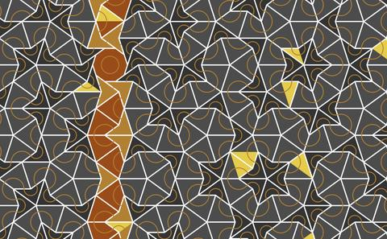
Time:
15:00 - 16:00
Date:
8 February 2019
Venue:
Building 54 (Mathematics), lecture room 10037 (10B), Highfield Campus, University of Southampton, SO17 1BJ
For more information regarding this seminar, please email Dr Jan Spakula at jan.spakula@soton.ac.uk .

Event details
Abstract: The theory of combinatorial limits aims to provide analytic models representing large graphs and other discrete structures. Such analytic models have found applications in various areas of computer science and mathematics, for example, in relation to the study of large networks in computer science. We will provide a brief introduction to this rapidly developing area of combinatorics and we will then focus on several questions motivated by problems from extremal combinatorics. In particular, we will disprove a conjecture of Lovasz, which was one of the two most cited conjectures in the area and which informally says that optimal solutions to extremal graph theory problems can be made asymptotically unique by introducing finitely many additional constraints.

Speaker information
Prof Daniel Kráľ, Masaryk University, Brno, Czech Republic; and Warwick University. Professor

