Free conference call – Skype
- In the first step, launch Google Chrome or Microsoft Edge (another is not supported)
- Then go to the web page: https://www.skype.com/cs/free-conference-call/
- Click on the button: „Vytvořit bezplatně schůzku“
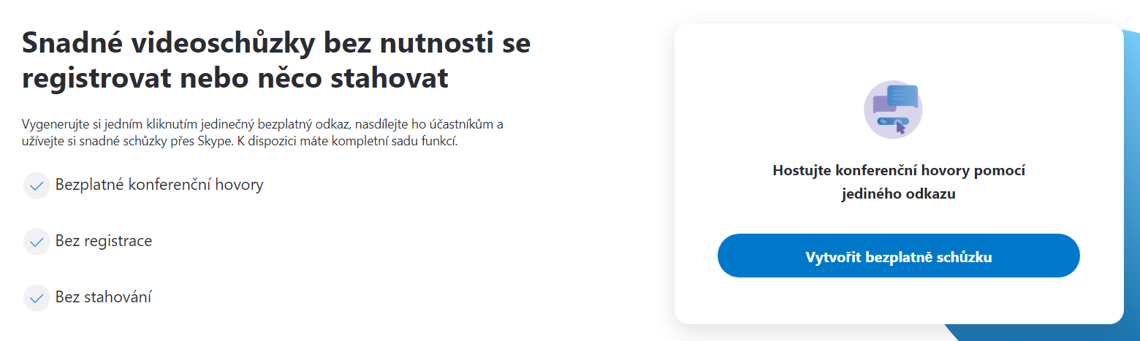
- Copy the link that will be used to join the meeting and choose „Začít hovor“
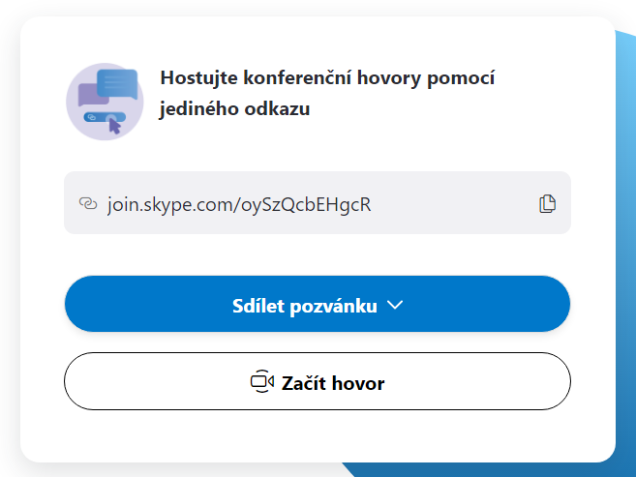
- In the next step, if we do not have or do not want to create a skype account, select the button „Připojit se jako host/Join as guest“ and then we fill in our name and choose „Připojit/Join“
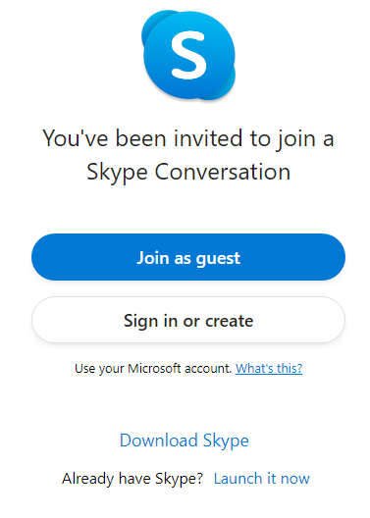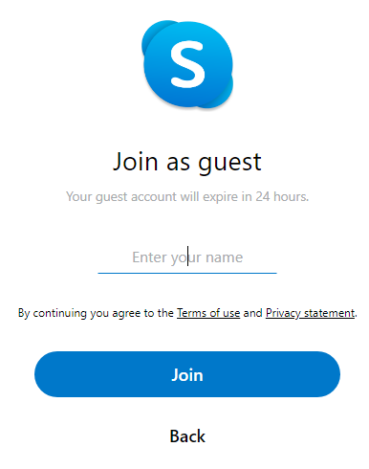
- In the next page, we can already chat with everyone who knows the link. If you want to start a video conference, select the button „Začít hovor“
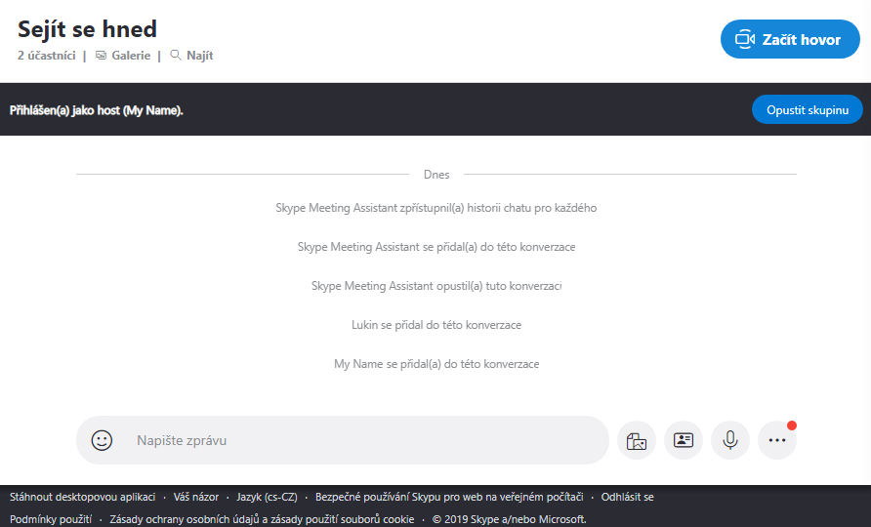
- When you click on „Začít hovor“ you'll see a page that verifies that microphone and camera are enabled on your computer (at least a microphone must be available, otherwise skype will not allow connection)
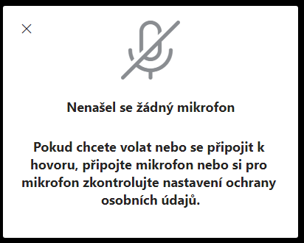
- If we have a microphone, just select „Začít hovor“. If we want others to see and hear us, we need to enable the camera and microphone
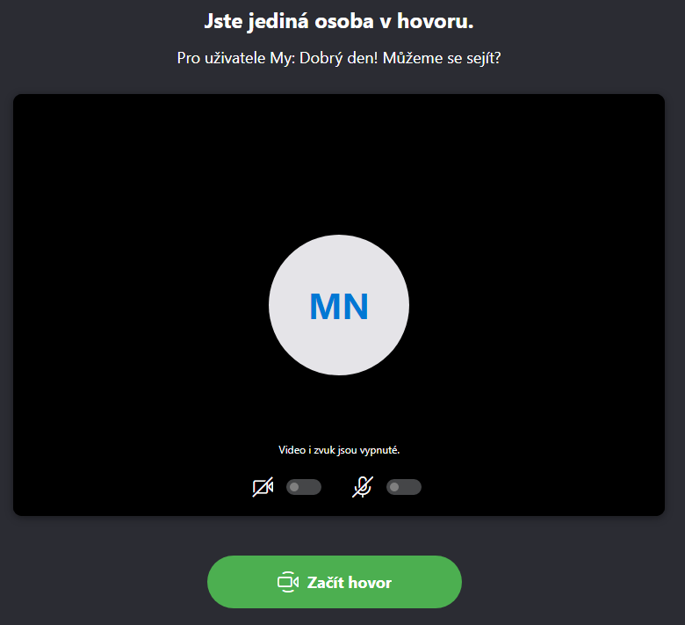
- When enabling the camera and microphone, the browser usually asks us if we really want to enable the device. In this case, we agree everything. It is important to read always all what we specifically allow.

Dodatečné informace
- If we have skype application, this meeting can be created directly in the application under the button „Schůzka“
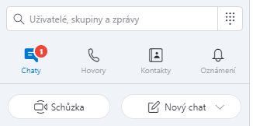
When we click on it, it generates the same link as through the web interface, we also have the option to enable or disable the camera and microphone and than click
„Zahájit hovor“
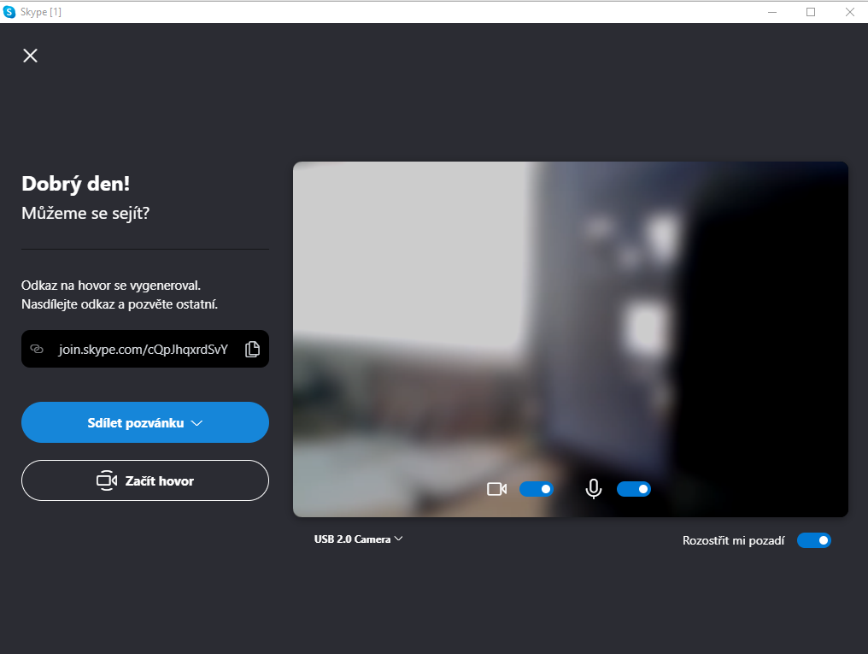
- The generated link is valid for 30 days for viewing the history, but for new meetings we recommend creating a new one.

