Press seminar for Czech students of journalism
organized by EPLO Prague ahead of the CZ Presidency

Brussels, 17 - 19 May 2022

English summary of the draft programme

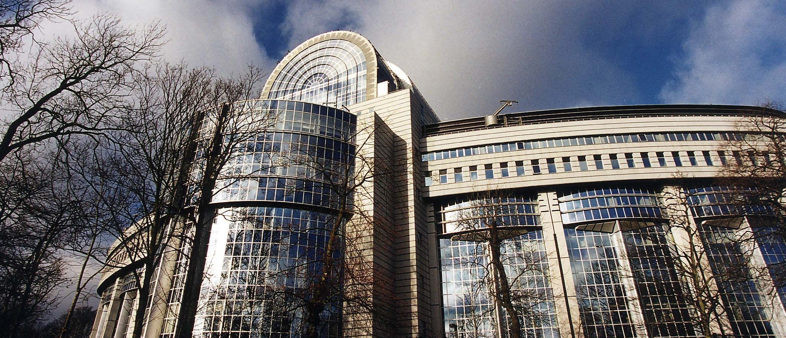

Tuesday, 17 May 2022

08:15 Arrival of the participants to Brussels airport (Flight at 6: 45)

09:30 Hotel + Accreditation in the European Parliament

11:00 Presentation of the EP press service, visiting press room and background for journalists

12.00 Lunch

13.00 Visit of POLITICO premises + short debate

14:00 Introduction to the EU institutional framework

16:00 Thematic roundtable with MEPs - theme according to the current political agenda

18: 00 End

Wednesday, 18 May 2022

9:00 Introduction to the role of the EP in the legislative process

11:00 AV facilities at disposal of journalists in the EP/AV website

12:00 Lunch with Brussels based Czech media representatives

14:00 Visit the House of European History

16:00 Meeting MEPs' in their offices - a background of the work of MEPs (participants divided into small groups, each group visits another MEP)

18:00 - 20.30 Working dinner with guest

Thursday, 19 May 2022

9:00 Meeting with the spokesperson and representatives of the Permanent Representation of the Czech Republic to the EU - Czech Presidency

11:00 European Parliament Plenary session from the tribune

12:00 Buffet lunch with Political group Press officers

12:40 Departure from Brussels airport

14:40 Flight to Prague

