Measure of the Director
of Central European Institute of Technology of Masaryk University
No. 6/2019

Amendment of Internal Budget Rules of CEITEC MU

(as amended, effective as of 1st January 2020)

Pursuant to Art. 7.2 f) of the Rules of Organization of the Central European Institute of Technology of Masaryk University (hereinafter the “Rules of Organization”), I hereby issue the following Measure:

Article 1

Subject Matter

This Measure determines the amendment of internal budget rules of CEITEC MU and also implements the corresponding amendment of Director’s Measure No. 6/2016 Internal Budget Rules of CEITEC MU (hereinafter the “Director’s Measure No. 6/2016”).

Article 2

Amendment of Director’s Measure No. 6/2016 Internal Budget Rules of CEITEC MU
- The wording “from the NPU subsidy funds“ in Art. 4.1 of Director’s Measure No. 6/2016 shall be changed to wording “from the resources stipulated in Art.2.2 a) - c)”.

- The wording “The Institute's contribution to the budgets of research groups consists of the basic contribution (paragraph 3), taking into consideration any deductions, if applicable (paragraph 4), increased or reduced depending on the performance-related criteria (paragraph 5)“ in Art. 4.2 of Director’s Measure No. 6/2016 shall be changed to wording “The Institute's contribution to the budgets of research groups consists of the general group-wide contribution (paragraph 3), taking into consideration any deductions, if applicable, (paragraph 4) and a performance-related part (paragraph 5)”.

- The wording “basic contribution“ in Art. 4.3 of Director’s Measure No. 6/2016 shall be changed to wording “general group-wide contribution” and the amount “CZK 1.4 million” shall be raised to “CZK 2 million CZK”.

- The wording “The basic contribution is reduced if the FTE of the relevant research group leader in that particular research group within the Institute is lower than 0.8 FTE. In such a case, the reduction is calculated as the multiple of the annual fixed amount of personnel costs determined as CZK 840,000 and the difference of the 0.8 FTE and the actual FTE of the research group leader as of 31 May of the current calendar year“ in Art. 4.4 of Director’s Measure No. 6/2016 shall be changed to wording “The general group-wide contribution consists of a fixed part amounting to CZK 1 million and a variable part amounting to CZK 1 million. If the head of the particular research group has a total workload lower than 0.8 FTE, the variable part shall be decreased. In such case, the decrease shall be determined according to the formula: CZK 1 million x (0.8 - current workload)/0.8. For the decreasing purposes, the total workload amount of the head of the research group valid as of 1 January of a calendar year shall be the decisive factor.”

- The wording “The provisions of the preceding paragraph shall not apply in the case of research groups whose leader has a lower FTE at CEITEC MU due to their engagement at another department of MU as a degree programme guarantor” in measure of Art. 4.5 of Director’s Measure No. 6/2016 shall be deleted. Instead of deleted Art. 4.5 of Director’s Measure No. 6/2016, a new paragraph 5 shall be added, reading as follows: “The performance-related part of the budget is allocated based on the scientific achievements according to the rules for the bonus contribution which forms an annex of this Measure.”.

- Points a) 1 – 3 and b) points 1 and 2 in Article 4.6. of Director’s Measure No. 6/2016 shall be deleted. The following points shall be renumbered accordingly.

- Art. 4.7 of Director’s Measure No. 6/2016, wording “The Director shall decide on use of resources deducted from the budgets of research groups or other worksites according to Article 4.5 b) and Articles 5.5 and 5.6“ shall be deleted.

- New paragraph 7, wording “Each scientific worksite may use, in addition to the worksite budget for covering of non-tax-deductible costs, in particular the representation costs, the amount of maximum CZK 10,000 from central non-grant resources”, shall be added to Art. 4 of Director’s Measure No. 6/2016.

- New paragraph 5, wording “If the head of the research group works as a rector, vice-rector, director or deputy director of a university/CEITEC institute, he/she may request determination of a budget for the period of his/her term in office in the amount of the average value of the group budget for the preceding three years or of the average value of all research groups during the current calendar year determined according to Art. 4.3 – 4.5 above. The head of research group may submit such request only once during his/her term in office and the set manner cannot be changed during the office execution period“ shall be added to Art. 5 of Director’s Measure No. 6/2016. The following paragraph shall be renumbered accordingly.

- The wording "A positive business result of the economic activity of the relevant site can be carried over to the next year and shall be used for the centralised creation of funds. The spending of the own resources created in this manner shall take place within the given site from the relevant funds" in Art. 9.5 of Director’s Measure No. 6/2016 shall be changed to wording "Income from the economic activity is primarily intended for covering of costs necessary for generating, securing and maintaining such income. The representation costs can amount only for a maximum of 2 % of the current year income. Higher using is possible only subject to prior approval by the director. A positive business result of the relevant site can be carried over to the next year and shall be used for the centralised creation of funds. The spending of the own resources created in this manner, with the purpose of supporting the main activity of the worksite, shall take place within the given site from resources allowing such spending, based on the nature of the expenses”.

- Art. 10.5 of Director’s Measure No. 6/2016, wording “The Finance Committee shall be informed on an ongoing basis of the budgetary measures pursuant to paragraphs 2 to 4 and presents its statements with respect to the information on the status of the budget spending submitted for discussion to the Director’s board“ shall be deleted.

- Art. 11.1 – 11.5 of Director’s Measure No. 6/2016 (Temporary Provisions) shall be deleted.

- New paragraph 1, wording “If, in the course of the preparation of the budget for 2020, the total budget of a research group drops by more than 20 % as a result of the procedure described in Art. 4 above, the budget amount shall be evened up if permitted by the budget possibilities.”, shall be added to Art. 11 of Director’s Measure No. 6/2016.

- New paragraph 2, wording “Joint scientific worksites according to Art. 3.8 are such worksites which would be considered as such by the current internal directives or agreements with different parts of MU or other institutions.”, shall be added to Art. 11 of Director’s Measure No. 6/2016.

- New paragraph 3, wording “If the provisions of Art. 5.5 apply to the head of the research group who started to work at any of the positions specified therein prior to the effectiveness date of this Measure, the starting time of the conditions set forth in the given provision shall be understood as the first month following the effectiveness date of this Measure”, shall be added to Art. 11 of Director’s Measure No. 6/2016.

- Art. 12.2 of Director’s Measure No. 6/2016 shall be deleted. The following paragraphs shall be renumbered accordingly.

- New Annex No. 1 – Methodology of Excellent Results Evaluation, which forms an annex of this Measure, shall be added to Director’s Measure No. 6/2016.

Article 3

Final Provisions
- The secretary of the Institute shall be responsible for the interpretation of this Measure.

- The Head of Director’s Office shall be responsible for issuance of complete wording of the Measure No. 6/2016 Internal Budget Rules of CEITEC MU, as resulting from Art. 5 hereof.

- The deputy director for administrative matters shall be responsible for the supervision over the compliance with this Measure.

- This Measure shall become valid as of the date of signature hereof.

- This Measure shall become effective as of 1 January 2020.

- This Measure shall apply adequately also to the preparation of the budget for 2020 taking place prior to the effectiveness date hereof.

Annexes: Annex No. 1 – Methodology of Excellent Results Evaluation

In Brno on 25th November, 2019 | Jiří Nantl  Director

Annex No. 1 – Methodology of Excellent Results Evaluations

The methodology of evaluation of excellent results specifies the process and evaluation criteria for research groups’ creative activity for the purpose of setting up their budget for the following year at the Central European Institute of Technology (hereinafter the “CEITEC MU”).

Article 1

Evaluated Results
- The evaluation includes all results that fully meet the following conditions:

- The result is marked as an article in an impacted journal (Jimp) according to the RIV methodology, recorded in this database in the year of evaluation processing and dedicated fully or partially to CEITEC MU in the institutional database of the Masaryk University is.muni.cz.
- The result is marked as type Article, Review or Letter according to the categorisation of the Web of Science database.
- The corresponding author presents in his/her result the affiliation with CEITEC MU and is, or was in the period of result creation, member of the particular research group at CEITEC MU.
- The head of the research group (the corresponding author of the result is a member of such research group) is a member of the team of authors and presents affiliation with CEITEC MU in his/her result.

Article 2

Evaluation Criteria
- R – Ranking
The R value can be determined in two ways:

- Calculation based on the ranking of the journal in which the article was published within the group of journals of the given category in the given year. The ranking R is expressed by the JIF Average Percentile in the Journal Citation Reports database.
- Calculation based on independent citations of this article – the R value is determined by the sum of all independent citations (citations from articles in which none of authors is a co-author of the evaluated i.e. cited article) for the given time period divided by number of years since the article publishing. The year of publishing can be omitted in the calculation if it lowers the average citation of the article.
Thus calculated real impact factor (RIF) of the article shall determine the real average percentile (RJIF). Evaluation according to RIF is calculated separately for each year. Supporting data for the RIF-based evaluation, i.e. the list of citations, is always supplied by the head of the research group to which article authors belong.

- OS – Output Score

Ranking is transferred to the Point score of the result by using the curve equation:

OS = 100*(1+EXP(-27))/(1+EXP(-27*(0,17-(100-E:E)/100)))

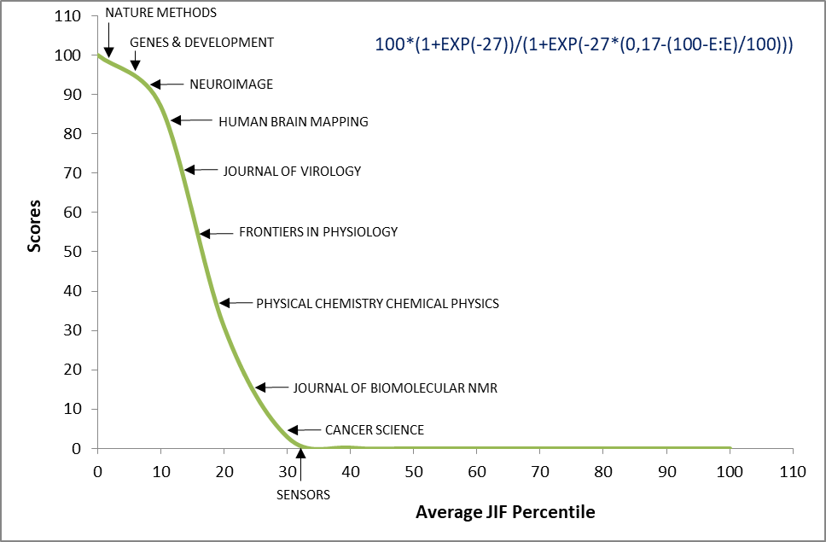

- S – Share
This criterion is determined by the affiliations of the head of the research group, or those of the corresponding author, if they are not the same person. If the head of the research group or the corresponding author of the result has a multiple affiliation specified, the share S is determined by the number of such affiliations. For the purpose of the evaluation, only unique affiliations to various institutions (including foreign institutions) of the author (head of the research group or corresponding author) with higher number of unique affiliations to various institutions among the considered authors shall be considered.

- D – Dedication/Share on the Result Credited to CEITEC MU
The value of share of CEITEC MU on the result can range between 0.01 – 1, depending on the data stated in the record on the given publication in the institutional database of Masaryk University is.muni.cz.

- FOS – Final Output Score
The final point evaluation of the result is calculated as follows:
FOS = OS*D/S

Article 4

Overall Evaluation of Research Group Point Score
- The point score of the given research group for the given year is calculated as the sum of the point scores of all results (not scored zero) included in the evaluation.

- For the purpose of setting up the budget of the research group, the final score represents the sum of final scores for the past three years - the year preceding the year of data processing and two preceding years.

- If the author of the given result is transferred to another research group during the evaluated period, the score of the given result remains to the original group.

Article 5

Final Provisions
- The Institute’s scientific secretary shall be responsible for the interpretation of this Methodology.

- The Institute’s scientific secretary shall be responsible for the ongoing updates of this Methodology.

- The head of the Strategy and Science Department shall be responsible for the supervision over the compliance with this Methodology.

