TRAINING
OCCUPATIONAL SAFETY, HEALTH PROTECTION AT WORK AND FIRE SECURITY

General Obligations
- To perform their work in such a way so as not to endanger their own health or the health of the others, to observe all applicable legal and other regulations and instructions of their supervisors in order to ensure occupational safety and health protection at work and to follow the prescribed work procedures. To prevent any careless conduct, negligence and wilful misconduct.
- In the course of their work, to always keep in mind the safety of their conduct and not to overestimate their capabilities.
- Not to launch into operation any machinery or devices, unless and until they have made sure that this will not endanger the life and health of their own or of any other persons.
- To refrain from any works for which they have not been trained and that require professional skills and competences.
- To refrain from the attendance of any machinery or devices for which they have not been trained or qualified.
- To attend the training courses organised by the employer in order to increase the occupational safety and health protection at work and to undergo all prescribed medical examinations.
- To keep their workplace and interior routes within the plant clean and tidy.
- To observe all traffic, safety and fire security signs installed within the plant and to abide all warning signs and agreed signals.
- To report immediately each work injury to the competent supervisor in order to ensure proper treatment and the execution of an injury record that is to be found in each first aid kit or that is to be obtained from the competent occupational safety and health protection officer.
- In the event of any health problems, sickness or taking of any medication, to report their health condition to their supervisor.
- To use adequate protection equipment and prescribed personal protection tools in the course of their work, to protect these tools and equipment against damage and to take care for their usual maintenance.
- To report immediately to their supervisor any defects and deficiencies that might endanger occupational safety and health of employees and to the best of their possibilities and qualification participate at their remedy

It is strictly prohibited:
- to breach the no smoking rule applicable at all worksites;
- to remove or damage any safety devices, covers or signs;
- to work without proper authorisation with any machinery equipment, electrical and other devices with which they are not familiar;
- to repair and clean any machinery and devices during their operation;
- to consume alcoholic drinks or not abuse additive substances at the employer´s workplaces and during his working hours also outside such workplaces, enter the employer s workplaces while under their influence;
- to smoke at workplaces.

Prior to the commencement of any new work, you must obtain instructions from your supervisor how to work safely. If you do not understand anything, ask your supervisor for explanation. He/she is obliged to provide you such explanation. Your direct supervisor will also provide you with personal protective equipment and tools before you enter your workplace and for each work that is assigned to you.

what to do in case of an accident at work

Safety signs
color | meaning | information
red | danger alarm | stop  shutdown  emergency, evacuate
 | fire fighting equipment | identification and location
yellow, orange | warning sign | be careful  take precautions  examine
blue | mantadory sign | specific behaviour or action  wear personal protective equipment
green | emergency escape, first-aid sign | door, exits, routes, equipment, facilities
 | no danger | return to normal

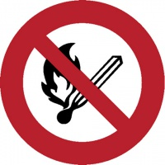 | 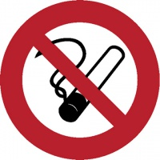 | 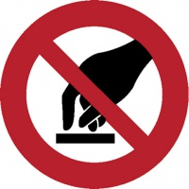 | 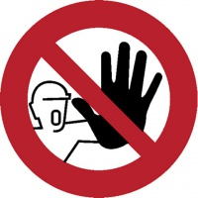 | 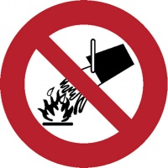 | 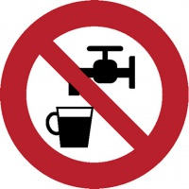
Smoking and naked flames forbidden | No smoking | Don´t touch | Unauthorised entry to this site is strictly forbidden | Water as extinguisher prohibited | Drinking of this water prohibited

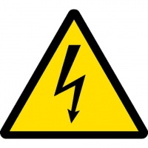 | 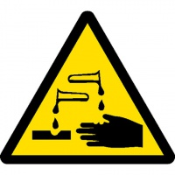 | 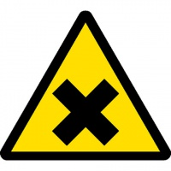 | 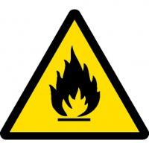 | 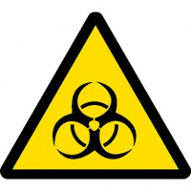 | 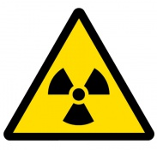
Warning of electrical shock hazard | Warning of corrosion hazard | Harmful or irritant material | Warning of fire hazard | Warning of biological hazard | Warning of ionising radiation hazard
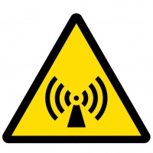 | 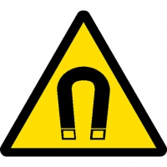 | 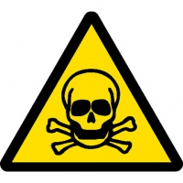 | 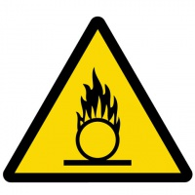 | 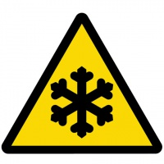 | 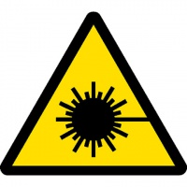
No- ionising radiation | Strong magnetic field | Toxic material | Nebezpečné oxidující látky | Loe temperature | Laser beam

 |  |  | 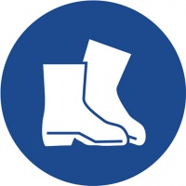
Eye protection must be wor | Safety gloves must be worn | Use protective wear | Protective footwear must be worn | Face protection must be worn

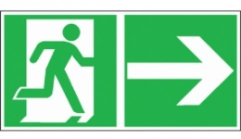 | 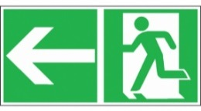 | 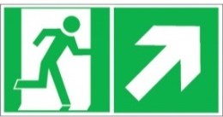 | 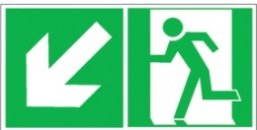
Emergency exit / escape route
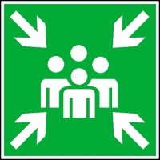 | 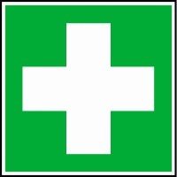 | 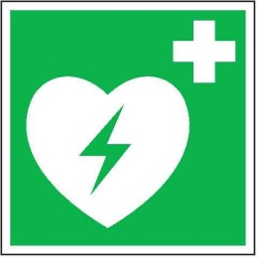 | 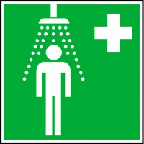 | 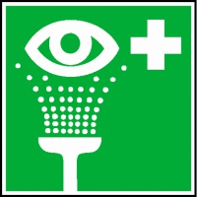
Meeting place | First-aid post | AED | Safety shower | Eyewash

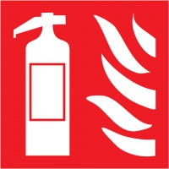 | 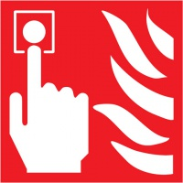 | 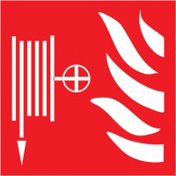
Fire extinguisher | Fire alarm call point | Fire hydrant | Ladder

Fire Security
Basic obligations arising from the Act on Fire Security:
- Each citizen is obliged to act so as not to cause any fire and so as to contribute, to the best of their capabilities, to proper fulfilment of tasks in the area of fire security, in particular by means of necessary personal and material assistance (e.g. transport vehicles for fighting fire and other natural disasters).
- Everyone who notices fire that he/she cannot extinguish by him/herself is obliged to immediately announce alarm or report the fire so that the fire brigade can intervene as soon as possible.
- In connection with extinguishing fire, everyone is obliged:
- to take any and all measures necessary for saving people;
- to extinguish the fire or take measures necessary for preventing its distribution;
- to report the identified fire at the prescribed place or to ensure its reporting;
- to provide personal assistance to the fire brigade upon the commander’s instruction.

In order to ensure fire security, everyone is obliged:
- to request from their direct supervisors instructions relating to fire risks in terms of operation, as well as instructions relating to the properties of substances and materials they work with;
- to take part in professional preparation (training courses) relating to fire security;
- to observe applicable regulations and instructions relating to occupational safety and prevention of undesired fire;
- to inform their supervisors or other competent employees - occupational safety and health protection officer and fire security officer – of any defects that might endanger the safety and to the best of their possibilities and qualification actively participate at their remedy;
- to respect the no smoking rule;
- not to work with pressure cylinders without adequate training;
- to store inflammable materials (chemicals, paints, oils, solvents) solely at the places dedicated for this purpose;
- to observe strict prohibition of using personal electrical, gas or other appliances, in particular those using open flame;
- not to carry out any repairs of electrical installations and appliances that may only be carried out by professionally qualified employees;
- not to obstruct with any materials the access to energy distribution devices, portable fire extinguishers and hydrants, escape routes and emergency exits;
- before leaving the workplace to disconnect any electrical appliances from the power supply network!

Theoretical instructions relating to portable fire extinguishers
Each fire can be successfully put out at the very beginning by a portable fire extinguisher; the instructions for use are specified on the label of the device. All fire extinguishers must be activated no sooner than at the immediate vicinity of the fire site.
- It is always necessary to put out fire in the direction of the wind (air draught)!
- The fire extinguishing media must always be sprayed from the bottom into the core of the fire, never into the flames!
- Fire must be put out with interruptions, step by step!
- When putting out fire indoors, always keep the door behind your back (to have a free escape route)!

How to use fire extinguishers:
- Pull out the safety seal
- Aim the hose
- Press the valve
- Extinguish the fire

Type of fire extinguisher | What it can be used on | Never use on
Water | Solid organic substances (paper, wood, textile), alcohols. | Live devices (with power on), acids, vegetable and animal fats and oils.
Powder | Inflammable solid substances, liquids, oils, gasoline, live devices (with power on) – universal fire extinguishing medium. | Light and inflammable alkaline metals.
Foam | Solid organic substances, gasoline, diesel oil, mineral oils and fats. | Live devices (with power on), light and inflammable alkaline metals.
Carbon dioxide | Live devices (with power on). | Inflammable powder, powdery substances.

General instructions
Everyone who notices a fire is obliged:
- to take any and all measures necessary for saving endangered people;
- if possible, to put out the fire or to take any measures necessary to prevent its distribution;
- if his/her powers or available tools and resources are insufficient to put out the fire, he/she is obliged to activate a fire alarm and inform the persons dwelling nearby of the fire;
- to immediately report the identified fire or ensure its reporting to your groupleader

Fire alarm is announced as follows:
- by means of an automatic electrical fire alarm sensor;
- by means of pressing the electrical fire alarm button;
- by means of shouting “FIRE – FIRE!”

Important contact:
OHS officer for Masaryk University | Ing. Michaela Jabůrková | bozp@ped.muni.cz; tel.: 549 49 5262

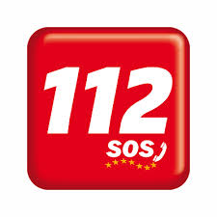

Evacuation is governed by the evacuation plan; all persons assemble at the determined place and wait for further instructions. Until the arrival of the fire brigade, the evacuation is managed by the competent head of the relevant building or his/her deputy. After the arrival of the fire brigade, everyone is obliged to follow the instructions of the fire brigade commander.
Each employee is obliged to exert their maximum efforts to put out the fire, thus protecting assets against damage.

I hereby confirm that I have been acquainted with the training occupational safety and health protection at work and fire security and that I have been duly informed of my obligations. I have read and understood this report.

Identification: «UCO»
Name and surname: «TitPred» «Jmeno» «Prijm»«TitZa»

In Brno, on

…………………………………
signature

