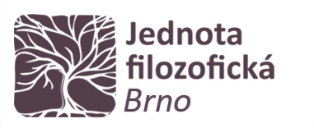

**Zoom**

**Pondělí 3. 10. 2022**

**16:00-17:40**

**3. října 2022**

**prof. David S. Luft**

**(Oregon State University)**

**Austrian Intellectual History and Central European Intellectual History**

aaaaaaaa

**Abstract**

My talk will address the problem of writing Central European intellectual history a century after the end of the First World War and the collapse of the Habsburg Monarchy, which is also the problem of how to think about this wider region and its linguistic and cultural complexity. I will describe the argument of my new book on Austrian intellectual history and explore the implications of my model of Austria for work on Central European intellectual history—not only under the Habsburg monarchs, but also in the century since they were at the heart of politics and culture in Central Europe. In my characterization of Central European intellectual history, I follow an understanding of the distinction between West and East Central Europe that grows out of the distinction between Cisleithanian and Transleithanian Austria [that is, předlitavsko and zalitavsko Rakousko]. Just as Cisleithanian Austria is the basis for my intellectual history of Austria, so the Leitha appears here as the western boundary of East Central Europe. Cisleithanian Austria the region I study in my new book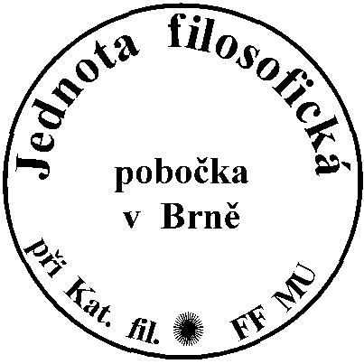.

Join Zoom Meeting

https://cesnet.zoom.us/j/93919453875?pwd=MjEwVWxYeklURlVqT29BSjY3OHZSUT09