# Aniseikonia correction with spectacle frame adaptation

## Introduction

If the patient has aniseikonia we can reduce it with spectacle lens shift according to below listed formula. So, called anisodistance spectacles is possible to use in case of monocular aphakia after cataract surgery. Currently anisometropia, respectively aniseikonia after cataract surgery is successfully solved by intraocular lenses.

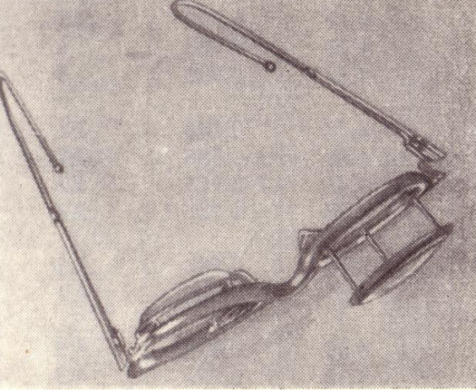

Picture 8.1: Anisodistance glasses (Polasek, 1974).

$β=1-∆d.{S´}_{B}$ S´B [D], d [mm] (25)

In case we decrease vertex distance in convex lenses we decrease the size of the retinal image. In case of concave lens is it opposite, i.e. decrease of vertex distance means increase of the size of the retinal image. This principal we can use for example with contact lens correction (Rutrle, 1993).

Size of the aniseikonia can be measured by so called eikonometers. Almost all projection or LCD optotypes contains so called hook test which can show size of the aniseikonia and further we can calculate change of the spectacle lens position to minimize aniseikonia.

## Goals

* Calculate sagittal position change of the spectacle lens in given magnification
* Calculate change of magnification by change from spectacle lens to contact lens

## Equipment

Spectacle frame, writing equipment, handy millimeter ruler or PD meter, calculator.

## Methods

### Calculate sagittal position change of the spectacle lens in given magnification

Measure given spectacle lens. We need the increase of magnification by 3 %. How many millimeters should we change and which direction to have aniseikonia spectacles?

### Calculate change of magnification by change from spectacle lens to contact lens

Given spectacle lens we would like to change for contact lens. How much will change size of retinal image with this correction?

## Results

### Calculate sagittal position change of the spectacle lens in given magnification

𝚫d =

### Calculate change of magnification by change from spectacle lens to contact lens

𝛃 =

## Discussion

We have to parameters which influence aniseikonia. One is own magnification of the spectacle lens and second one is position of the spectacle lens in front of the eye. If we multiply these two parameters we will get total magnification of the lens. This magnification we can use for elimination of aniseikonia. If we have percentage value we have to count two parameters together. Unfortunately for minimalization of the aniseikonia we have only lower potential, i.e. only 5-10 %.

## Conclusion, notes, comments

Which type of eikonometers do you know?

What is the size of the aniseikonia by monocular aphakia corrected with spectacle lens?

What is the size of the aniseikonia by monocular aphakia corrected with contact lens?