# Choice and recommendation of lenticular lens from the catalogue

## Introduction

Lenticular lenses are special spectacle lenses for high ametropia correction. They were used in times when we have no high index lenses. Currently lenticular lenses are replaced by high index lenses. Lenticular lenses are produces from glass or plastic. Optical and none optical zone can be polished or unpolished. The main disadvantage of the lenticular lens is reduction of the patient’s visual field and aesthetic conception.

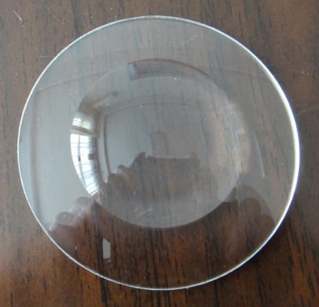

Picture 13.1: Convex lenticular lens (Benes et al., 2010).

## Goals

* For given spectacle frame choose and center proper lenticular lens from lens catalogue.
* For given patient release and evaluate prescription for optical aid.
* For given patient and prescription create financial plan for spectacles.

## Equipment

Actual book of VZP, catalogue of spectacle lens producer, writing equipment, calculator, PD meter.

## Methods

### For given spectacle frame choose and center proper lenticular lens from lens catalogue.

Your task is to choose proper spectacle frame for you colleague (student) from spectacle book and proper spectacle lens. Correction could be for lenticular lens. In the protocol you should note all measured parameters and data of selection including boxing system, PD of the patient, height of the centration, vertex distance, name of the frame and lens, type of antireflection coating. You should of course calculate and note decentration and chosen lens diameter.

### For given patient release and evaluate prescription for optical aid.

You should draw general prescription form into the protocol and fill in all important notes in it. Further you should financially evaluate the prescription.

### For given patient and prescription create financial plan for spectacles.

In this task you should create financial evaluation of the prescription for patient, i.e. you will sum price for the spectacle frame, spectacle lenses, for addition task as e.g. repair of the side, soldering etc. is. From this sum you will subtract price for the prescription and define payment for advance and payment of the rest of the issue.

## Results

### For given spectacle frame choose and center proper lenticular lens from lens catalogue.

### For given patient release and evaluate prescription for optical aid.

### For given patient and prescription create financial plan for spectacles.

## Discussion

If you will grind the shape of the lens with automatic grinding machine you should be careful not to lose the lens holder. Patient should get advice about the reduction of the lenses’ visual field. Spherical lenticular lens should be centered on pupil with natural head position. If we center aspheric lenticular lens we have to prefer put the lens cent on pupil in so called perpendicular view.

## Conclusion, notes, comments

Which types of lenticular lenses you know – material and type?

How does differ the price of lenticular and high index lens for the myopia -11 diopters?