Calculation of important point moving in prismatic lenses

Introduction
Prismatic lens bends the light beam to its base which is the thickest part of the lens. Oppositely the eye moves against the base. That is the reason why we have to adapt position of the lens main point of the prismatic lens. In practice we have to move the main point with few millimeters opposite the base. The size of the moving is related to prismatic value and vertex distance.
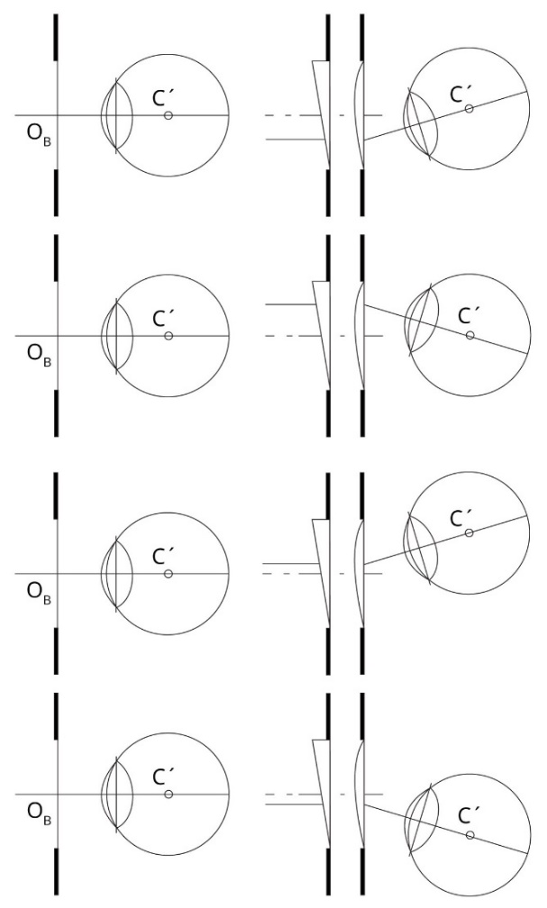
Picture 2.1: Moving of the main point in prismatic lens (C’= real eye’s rotation center, O = optical center of the eye, Rutrle 2001).

Goals
- Measure spectacle vertex distance
- Calculate size of the prismatic effect if we move the lens 10 mm from the center
- Calculate the final decentration of the main point for correct eye pair position if we have manufactured prismatic lens

Equipment
Spectacle frame, writing equipment, PD meter or millimeter rule, calculator.

Methods

Measure spectacle vertex distance
Put on the frame to patient’s head and measure vertex distance (distance from the back side of the lens to the front side of the cornea).

Calculate size of the prismatic effect if we move the lens 10 mm from the center
Calculate the size of the prismatic effect. From lens meter you will know the vertex power of the lens and decentration is 10 mm temporally. Use the Prentice formula.
$P= \frac{{S´}_{B }.d [mm]}{10}$ P [pD], d [mm], S´_{B} [D] (4)

Calculate the final decentration of the main point for correct eye pair position if we have manufactured prismatic lens
On the base of knowledge of the vertex distance (d) and given prismatic effect calculate the decentration (x).
$x=\frac{(d+13).P}{100}$ P [pD], d, x [mm] (5)

Results

Measure spectacle vertex distance
d =

Calculate size of the prismatic effect if we move the lens 10 mm from the center
P =

Calculate the final decentration of the main point for correct eye pair position if we have manufactured prismatic lens
x =

Discussion
Prismatic effect can be made by spectacle lens decentration of can be manufactured. During the manufacturing we use special prismatic circle or we can tilt the axis of the grinding machine. Prismatic lenses are used for heterophoria resp. strabismus correction. Some prismatic lenses with high prismatic effect have aberrations like distortion or color aberration.

Conclusion, notes, comments
Which is the value and direction of the main point moving of the prismatic lens in up listed case?

Which is the rule of the prismatic lens decentration in standard vertex distance 12 mm?

