**Conditional sentences**

There are four types of conditional sentences:

0 – The zero conditional

1 – The first conditional

2 – The second conditional

3 – The third conditional

It is also possible to mix the second and third conditional. Let’s look at each conditional to see how we use them.

**The Zero Conditional**

We use the zero conditional to talk about permanent truths, such as scientific facts, and general habits. The structure is simple:

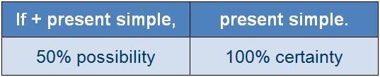

Here are some examples:

If you **heat** water to 100°, it **boils**.

If you **eat**a lot, you **put on** weight.

**The First Conditional**

We use the first conditional to talk about a realistic situation in the present or future. The structure of the first conditional is as follows:

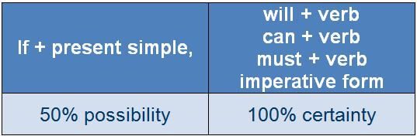

Here are some examples:

If you’**re** free later, we **can go** for a walk.

If they’**re** hungry, I’**ll make** some sandwiches.

If you’**re not** back by 5pm, **give** me a ring.

If he **studies** hard, he’**ll do** well in the exam.

If we **arrive**late, we **must get** a taxi.

He’**ll call** if he **needs** help.

**Take** a break if you’**re** tired.

**The Second Conditional**

We use the second conditional to talk about improbable or impossible situations in the present or future. Here is the structure:

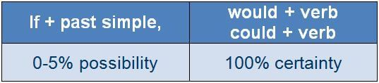

For example:

*If I****had****more time, I’****d exercise****more.*(But I don’t have more time so I don’t.)

*If I****were****rich, I’****d spend****all my time travelling.*(But I’m not rich so I can’t.)

*If she****saw****a snake, she’****d be****terrified.*

*If he****didn’t have to****work late, he****could go****out with his girlfriend.*

*What****would****you****do****if you****were****offered a job in Canada?*

*You****wouldn’t have to****walk everywhere if you****bought****a bike.*

A common expression used to give advice has the second conditional structure. The expression is ‘[If I were you](https://docs.google.com/spreadsheets/d/1oP8Wzz0eTsvN7mozfxMJ8QPpSIxCIeNvtoNpEcUwwx8/edit#gid=0&range=187:187), I’d..’, meaning ‘in your situation, this is what I would do’. For example:

A: I’ve got a headache.

B: **If I were you, I’d** take an aspirin.

A: I don’t understand this.

B: **If I were you, I’d** ask your teacher for help.

**The Third Conditional**

We use the third conditional to talk about impossible situations, as in the second conditional, in the past. We often use the third conditional to describe regrets. The structure is:

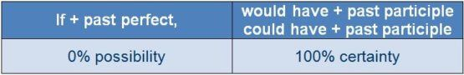

Here are some examples:

If we **had left** earlier, we **would have arrived** on time.

If you **hadn’t forgotten**her birthday, she **wouldn’t have been** upset.

If they **had booked** earlier, they **could have found** better seats.

**Mixed Conditionals**

It’s possible to combine the second and third conditional in one sentence when we want to make a hypothesis about the past that has a consequence in the present. In this case, the structure is:

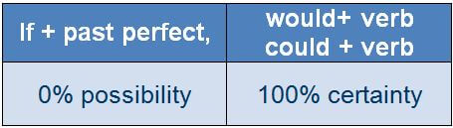

Here are some examples:

If you’**d studied** harder, you’**d be** at a higher level now.

We’**d be** lying on a beach now if we **hadn’t missed** the plane.

They’**d have**much more confidence if they **hadn’t lost** so many matches.

What **would** you **be** doing now if you **hadn’t decided** to study?

**Wish**

We use the **past tense** after wish: i wish I knew, I wish you were here…We use wish to say that something is not as we would like it to be:

I wish I didn´t have to work tomorrow.

I wish there weren´t so many people.

We use wish the **past perfect tense** after wish to say we are sorry something did not happen.

The weather was very cold, I wish it had been warmer.

I feel sick, I wish I hadn´t eaten so much.