**Cultures… described as …**

**Task 1** *Look at the pictures describing cultures (iceberg, waterlily, diamond and onion) and explain why these metaphors have been used:*

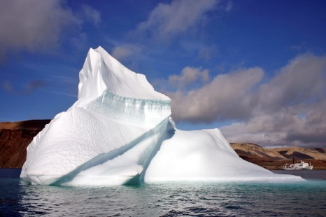

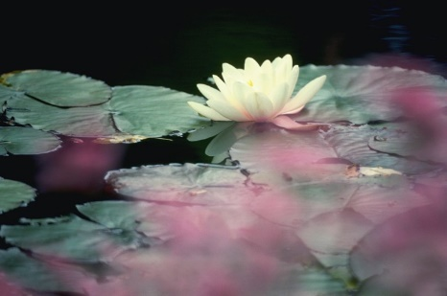

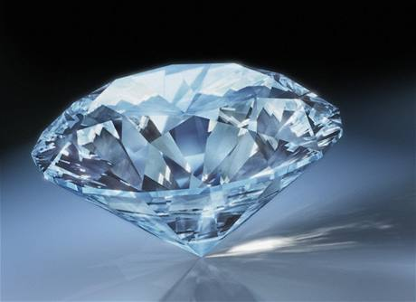

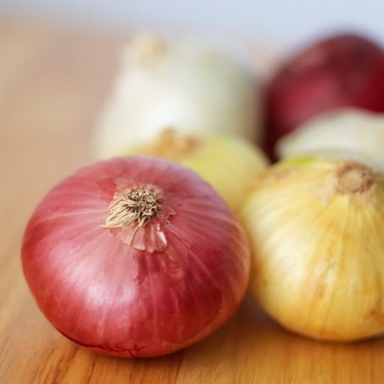

**Task 2** *Look at the two pictures of a queue and guess where (which country, culture) they have been taken. What does this say about those cultures?*

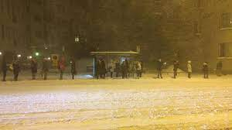 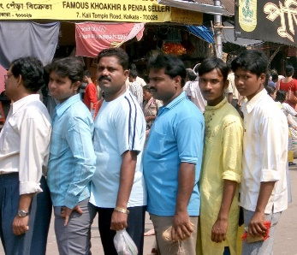

**Task 3** *What a queue would look like in your country/culture?*

**Task 4**

a) *Read the words below that are typical for certain cultures and can hardly be translated. Match them with their meanings.*

1. gründlichkeit a) ritual suicide
2. mañana b) complete absence of anything annoying
3. harakiri c) I am what I am because of who we all are
4. guanxi d) tomorrow as general future
5. savoir vivre e) relation network
6. ubuntu f) to be thorough

7) hygge g) a good life

*b) Can you identify the languages/cultures?*

*c) Can you think of any such word typical for your culture that would be difficult to translate to other languages?*

**Task 5** *Think of what you know about your country (Czechia/Slovakia/US...). If you were presenting your country to an Italian, what would you focus on?*

**Task 6** *Look at the cultural layers and name at least two symbols, heroes, rituals and values to the following cultural groups:*

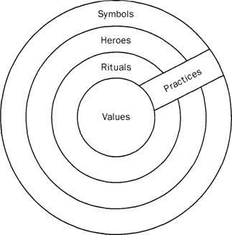

|  |  |  |  |  |  |
| --- | --- | --- | --- | --- | --- |
|  | Czechia | Slovakia | USA | Italy | global |
| symbols |  |  |  |  |  |
| heroes |  |  |  |  |  |
| rituals |  |  |  |  |  |
| values |  |  |  |  |  |

**Task 7** *Identify the following cultural symbols that you believe are relatable to global international audience.*

a) monument

b) place (landscape)

c) animal

d) story/legend/fairy-tale

e) piece of visual art

f) music/dance

g) hero

h) food

i) tradition