How do I record my feedback for Masaryk students?
- Go to www.mailvu.com
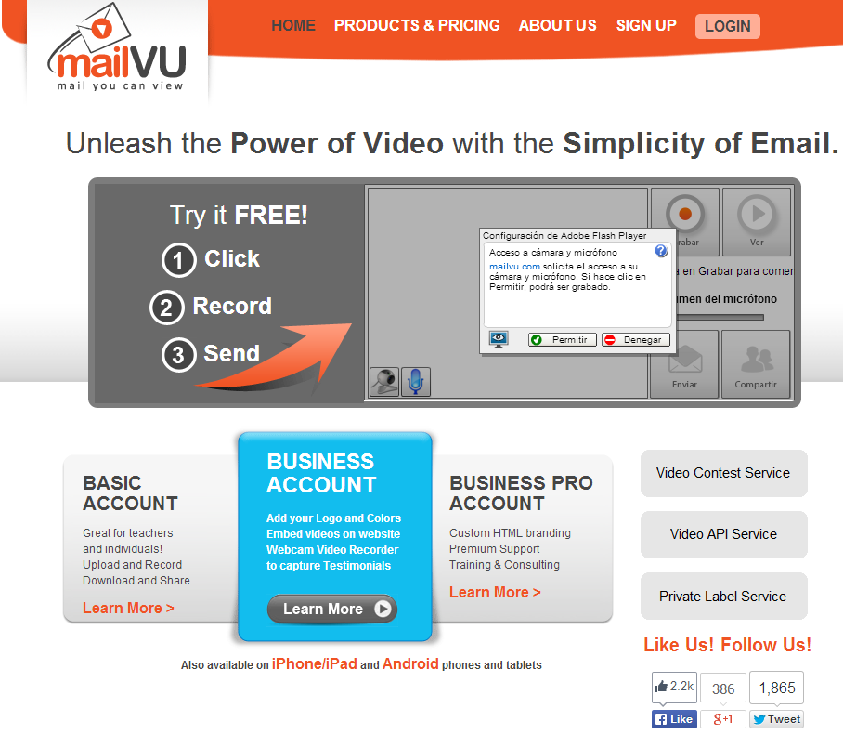
- Click on “Permitir” to allow your camera to record your reply.
- Your camera will be turned on and you’ll see yourself on the screen.

- Click on “Grabar” and the camera will start recording.
- Once you finish recording, click on “Stop”.
- You can preview the video by just clicking “Ver”.

- If you are not happy with the result, you can record the video as many times as you like. Once you are satisfied with your work, just click on “Compartir”
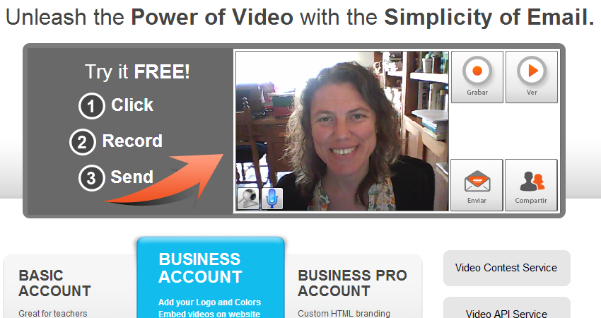
- A box will appear. Click on “Sí”
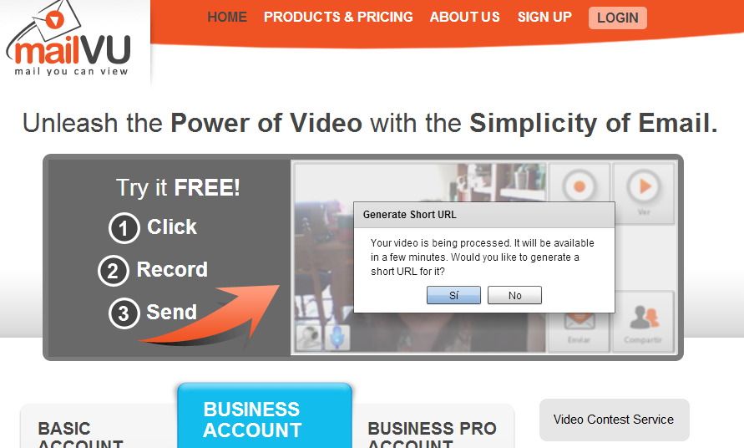
- Another box will appear that contains an URL. Click on “Copy to Clipboard”

- Open the discussion forum thread “ARGENTINIAN LINK: VIDEOS and upload your video there by simply pressing Ctrl + V.
THANK YOU VERY MUCH FOR PARTICIPATING IN THIS PROJECT!

