**How do I record my feedback for Masaryk students?**

1. Go to www.mailvu.com



1. Click on “Permitir” to allow your camera to record your reply.
2. Your camera will be turned on and you’ll see yourself on the screen.



1. Click on “Grabar” and the camera will start recording.
2. Once you finish recording, click on “Stop”.
3. You can preview the video by just clicking “Ver”.
4. If you are not happy with the result, you can record the video as many times as you like. Once you are satisfied with your work, just click on “Compartir”

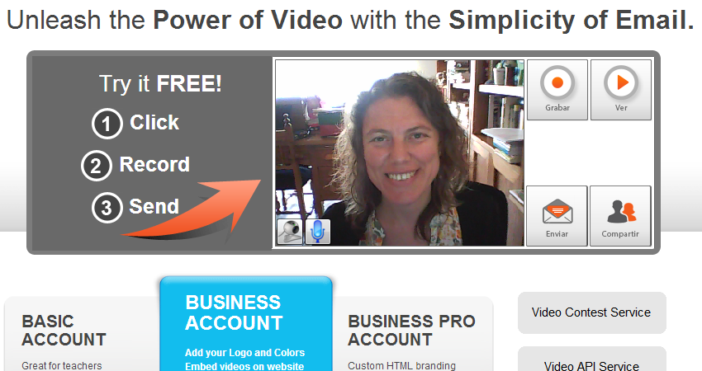

1. A box will appear. Click on “Sí”

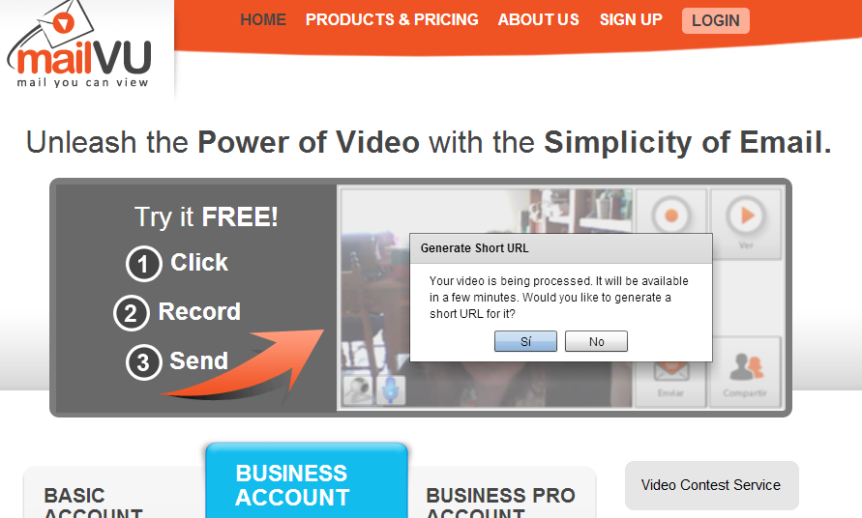

1. Another box will appear that contains an URL. Click on “Copy to Clipboard”



1. Open the discussion forum thread “ARGENTINIAN LINK: VIDEOS and upload your video there by simply pressing Ctrl + V.

**THANK YOU VERY MUCH FOR PARTICIPATING IN THIS PROJECT!**