Consumers Behaviour

Consumers’ motivation to rent instead of buy products

19/04/2023

Hugo Hemmerlin and Ombeline de Fougerolle

SUMMARY :

- Introduction

- The beginnings of the rental market

- The development of service or product rental

- Consumers' motivations

- Conclusion

- Sources

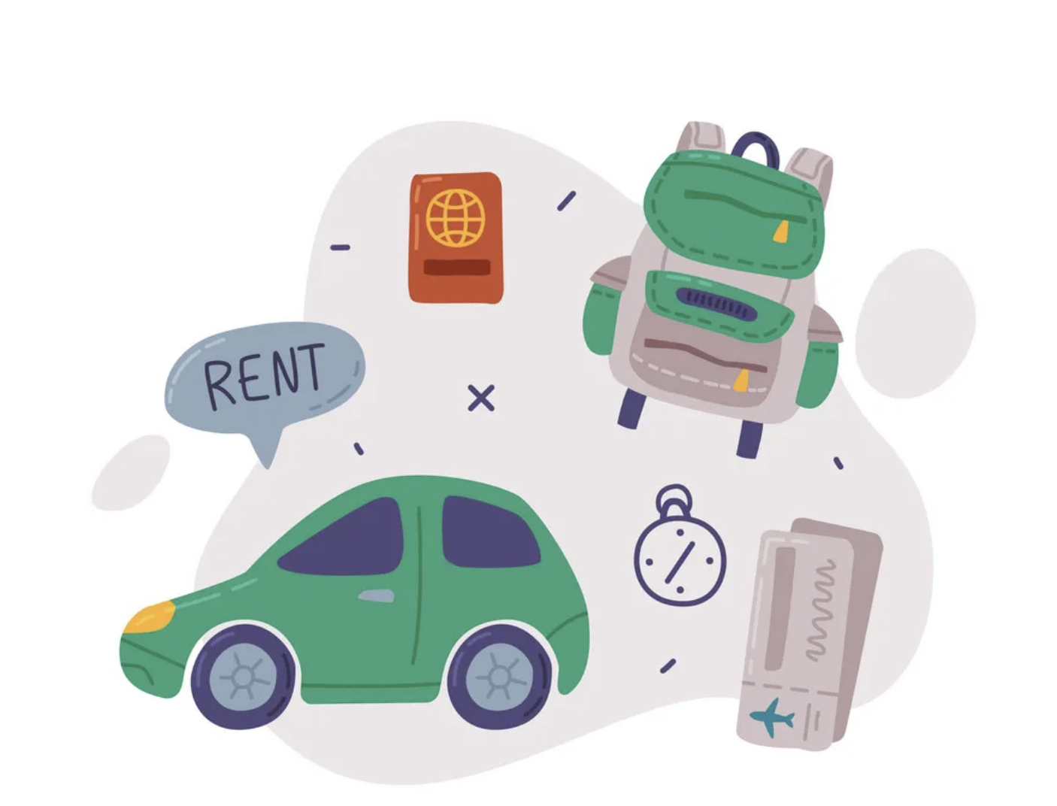
Introduction :
Access-based consumption is a recent development in the world of consumers. Instead of purchasing items, this tendency favors renting them, providing an alternative to the customary individual ownership and purchase. Formerly only seen in common consumer items like vehicles or apartments, this function is now included in a wide range of commodities, including apparel, DIY tools, and fitness equipment.
The rise of online rental marketplaces like Airbnb, Uber, and Rent the Runway has enabled this new method of consumption. These platforms provide a more flexible, cost-effective, and ecologically friendly way to consume goods and services that were previously challenging to obtain.
So what encourages customers to choose this access-based consumption strategy? Although the causes may differ greatly from person to person, it is possible to spot a few broad similarities. These themes include the desire for flexibility, financial savings, a smaller environmental impact, curiosity about new things and the desire to try them, or the preference for experiences over possessions.
We'll examine more closely the reasons why people choose to lease rather than buy in this essay. We will first look at the growth of the rental market globally, and then we will look at the consumers who participate in this sector.

I) The beginnings of the rental market :

The concept of lending an object or service to another person in exchange for money has existed since ancient Rome. In fact, most of the inhabitants of Rome lived in insulae (apartment buildings) often divided into rental apartments.
If we now study modern history, we can see that renting has become a real model in the world of commerce. Numerous companies developed to offer rental services in various fields, but more restricted than today, the rental of cars, tools, industrial equipment or real estate.We can take a few examples of pioneering companies in this market.

Concerning car rental, it is in 1918 in Chicago that the American company Hertz was founded. It became the first company in the world to rent cars and vans to individuals. It opened the modern rental market.
Shortly after, in 1923, in order to meet the high demand, especially in airports, Avis was created. This company allows the rental of a vehicle for vacations.

In the 1970s, the car rental industry grew, with the emergence of new companies. But it was in the 1980s that the rental market diversified to include real estate properties, with the rise of property management companies such as Equity Residential and Apartment Investment and Management Company.

Additionally after the 2000s, with the advent of the internet and online platforms, rental experienced a new wave of innovation and growth. Companies such as Airbnb, Uber, Rent the Runway, and Zipcar have paved the way for the ever-expanding consumer access and sharing economy around the world.
These companies have developed the rental of short-term housing, clothing or vehicles between individuals.

The company Rent the Runway, made polemics because it made the world of luxury fashion accessible by renting pieces from the biggest luxury brands such as Louis Vuitton or Dior Couture. While these pieces were intended for celebrities or very wealthy people.

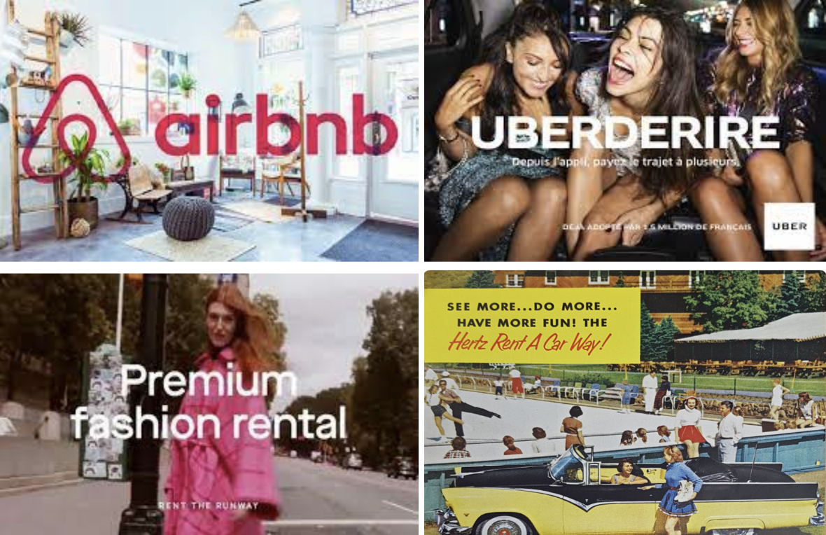

II) The development of service or product rental :

Overall, the entire equipment rental market has grown for over 20 years. It weighed in 2019 according to INSEE, more than 40 billion euros and all types of equipment is now present on the various sites: gardening tools or DIY, household appliances, sports equipment ... It is now almost possible to find everything on the various sites and rent any object between individuals.

The growth of the second-hand or rental market can be attributed to various factors, including economic and environmental considerations. As you mentioned, technological advancements have resulted in some products lasting for a long time, and their obsolescence can take years, making it more cost-effective to rent or lease an item rather than buying a new one.

Moreover, the rental or second-hand market provides consumers with access to a wide range of products and services that they may not have been able to afford otherwise. For example, renting high-end camera equipment for a one-time photo shoot or leasing a luxury car for a weekend getaway can provide consumers with the experience and access to products they may not be able to afford outright.

In addition, the rental or second-hand market can also provide a source of income for individuals who have items they no longer need or use. By renting or selling their items, they can earn extra income and reduce waste by extending the lifespan of the products.

Overall, the growth of the second-hand or rental market is a positive trend that benefits both consumers, renters and the environment.

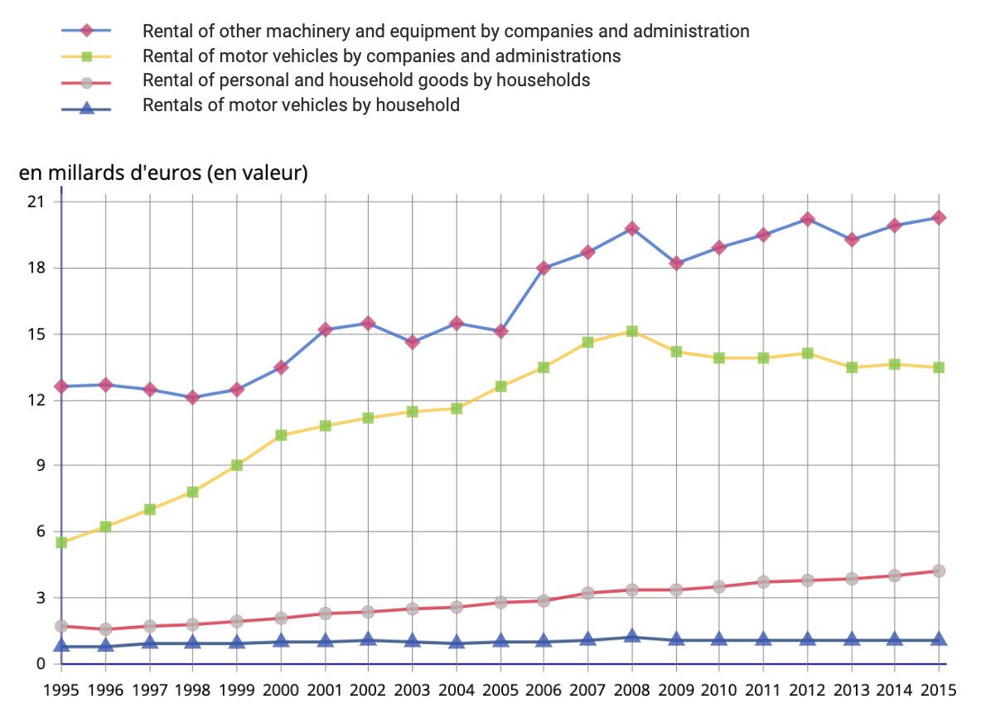

With the graph above, we can see that the rental service is used as well by professionals or administration as by individuals.
Because even if the professionals have higher expenses, for example concerning the renting of machines or equipment, in 2015, we count about 19 billion euro, compared to the expenses of the private individuals which is 4 billion euro.

III) Consumers' motivations

After studying the question and asking our friends and family, we found that today's consumers have several reasons for choosing to rent products rather than buy them, both for consumer goods and services.

We have therefore grouped the main reasons:

- The cost: indeed renting a good or a service can be cheaper than buying, especially if the use of the item is temporary or occasional. Renting can also allow consumers to benefit from high-end products or services that they could not afford to buy. For example, with Rent the Runway, which we discussed earlier.

- The flexibility: Renting offers consumers a great deal of flexibility, as they can choose to rent a product or service for a specific amount of time. This is especially beneficial for those who have one-time or temporary needs, or for those who are unsure of their long-term need. Renting can also allow you to try a product before you buy it, which can help you make a purchase decision.

- The space saving: Some people don't have enough space to store bulky items, such as sports equipment or home improvement tools. This allows consumers to use them without having to store or maintain them.

- And the environmental protection: In a generation that is increasingly concerned about the environment, renting can also be put forward. Indeed, this mode of consumption is considered more ecological than the purchase of products, because it reduces the production of waste and the consumption of natural resources. Rented products are often reused or recycled after use, which helps reduce environmental impact. And it reduces over-consumption and in some cases, the development of fast fashion, a very harmful environment for the planet.

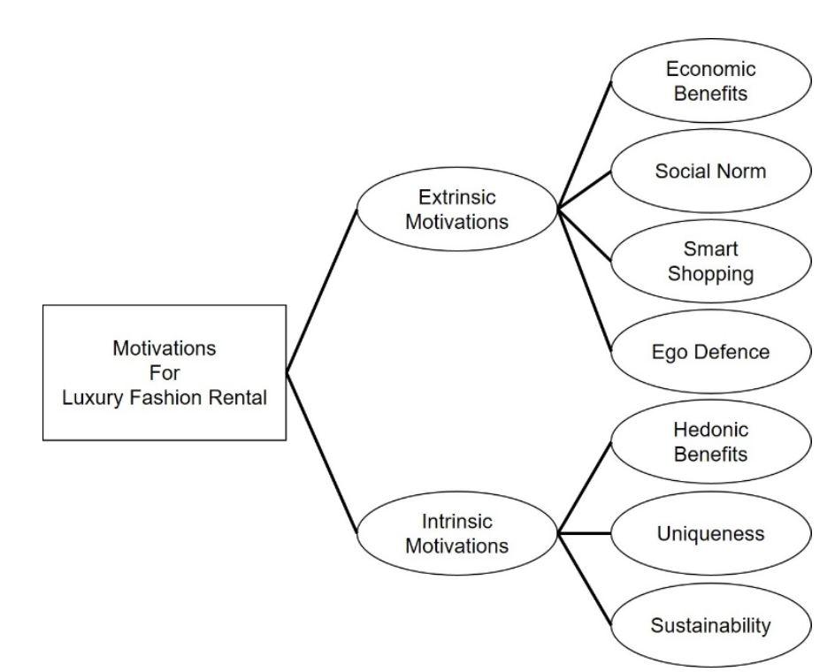

Example of the motivations of a typical consumer in a certain rental environment: Motivations for Luxury Fashion Rental

Conclusion :

In conclusion, thanks to our various surveys and in-depth research, we can see that for many years, the rental market has been developing on a large scale and is becoming one of the most profitable markets, both from a financial point of view and from an eco-responsible and environmentally friendly point of view. We have seen that several factors encourage consumers to like and use this mode of consumption.

However, it is important to note that the decision to buy or rent is influenced by each consumer's unique needs and preferences, as well as their financial situation. Indeed, this solution will be more used by students for example. As a result, rental companies must strive to meet their customers' specific needs.
This is accomplished by attempting to provide high-quality products and services at reasonable prices, while also ensuring customer satisfaction.

Renting can be a practical and beneficial alternative to buying because it provides flexibility, convenience, and significant economic and environmental benefits.

Sources :
- https://www.francebleu.fr/emissions/la-minute-conso/louer-plutot-que-posseder
- https://www.cairn.info/revue-management-et-avenir-2014-7-page-93.htm
- https://archipel.uqam.ca/11116/1/M15313.pdf
- https://www.earnest.com/blog/rent-vs-buy/

