Marketing 2

“Influencer Marketing Across Cultures”

Javier Diaz Celaya
Marcos Hernandez
Nicole Esperança
Xabi Zubiarrain
2022/2023

CONTENT

- Introduction…………………………………………………………………………………………… 3
- Problem statement………………………………………………………………………………… 4
- Objectives ………………………………………………………………………………………………6
- Literature review…………………………………………………………………………………… 7
- Methodology ………………………………………………………………………………………. 8
- Limitations…………………………………………………………………………………………… 9
- References…………………………………………………………………………………………… 11

Influencer Marketing Across Cultures

- Introduction
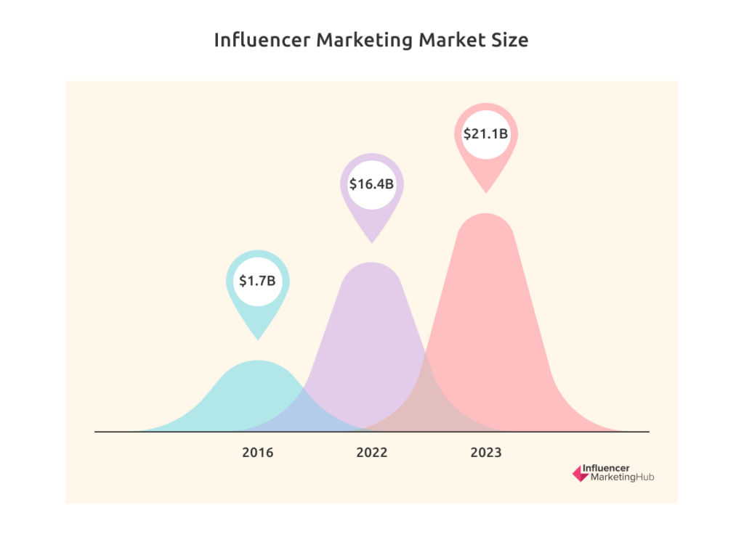
Influencer marketing has been a well-liked and successful strategy for firms to market their goods or services in recent years. This strategy entails working together with people who have a sizable following on social media sites to market brands or items to their audience. Influencer marketing has become more popular as a result of the growing significance of social media in consumers' lives and the diminishing efficacy of conventional advertising strategies. (Geyser, 2023)
Understanding how cultural differences may affect the efficacy of influencer marketing efforts is crucial as brands grow internationally. Marketing strategies must be regionally specific since cultural determinants like language, beliefs, and norms have a big impact on how audiences react to communications.
To learn how marketers might successfully apply this strategy in various cultural contexts, researchers are studying influencer marketing across cultures. Marketers can create more potent strategies for promoting their brands and products to international audiences by determining the elements that affect the effectiveness of influencer marketing initiatives in various geographical areas.
The results of this study could be very significant to marketing managers and specialists, especially those who are involved in creating and putting influencer marketing initiatives into action. Marketers may create more focused and successful programs that connect with consumers in various geographic areas by knowing the cultural elements that affect the effectiveness of influencer marketing.
Additionally, companies and organizations that operate internationally or have plans to do so may find this information to be useful. These companies can better position themselves for success in international markets by comprehending the subtle differences in influencer marketing across various cultural contexts.
In summary, this research on influencer marketing across cultures is important because it can help marketers develop more effective strategies for promoting brands and products to global audiences. The results of this research can be used by marketing managers and professionals to create more targeted and culturally sensitive campaigns, and can be valuable to businesses that operate in multiple countries or are planning to expand globally.

- Problem statement

As we already said in the introduction, in recent years, influencer marketing has become a popular marketing strategy for companies looking to reach new audiences and increase brand awareness. However, the effectiveness of influencer marketing can be affected by cultural differences between the influencer and their audience. As a result, companies may struggle to create effective influencer campaigns that resonate with audiences in different cultural contexts. This research proposal aims to explore how cultural differences affect the effectiveness of influencer marketing campaigns and identify strategies that companies can use to successfully adapt their influencer marketing strategies for different cultures.
The main problem that we have found is very relevant in a globalized economy where companies are expanding their business all over the world, and are increasingly using influencer marketing. The difficulty for companies is to understand the impact of their influencer marketing in different cultures. In this context, we made some questions to help us to identify the gaps in the existing literature and provide a basis for our research objectives and methodology:

- What is the current state of influencer marketing in different cultures?
The current state of influencer marketing varies across cultures. In some countries, such as the United States and the United Kingdom, influencer marketing has become a mainstream marketing strategy, with companies of all sizes using influencers to reach their target audiences. In other countries, such as Japan and South Korea, influencer marketing has been popular for many years, and companies have developed sophisticated influencer marketing campaigns that leverage the popularity of social media platforms. (Geyser, 2023)

- How do cultural differences affect the effectiveness of influencer marketing campaigns?
We have found some barriers that affect the effectiveness, such as language barriers, social norms and values, religion, beliefs, humor, entertainment… etc. (When Does Culture Matter in Marketing?, 2023)

- What are the key challenges that companies face when implementing cross-cultural influencer marketing campaigns?
As we already mentioned in the question above, there are many challenges that companies have to deal with. One of the biggest challenges that companies face when implementing cross-cultural influencer marketing campaigns is language barriers. Companies need to ensure that their influencers can communicate effectively with the target audience in their language, and that their messages are accurately translated and culturally appropriate. On the other hand, companies need to be aware of the cultural norms, values, and beliefs of the target audience, and ensure that their campaigns are appropriate and sensitive to these differences. (PGPEx, n.d.)

- What are the best practices for cross-cultural influencer marketing, and how can companies successfully adapt their strategies to different cultures?
The best practices for effective marketing can be, research and understand the target audience, work with local influencers, be mindful of cultural taboos and sensitivities and stay up to date on local laws and regulations. (“Cross-Cultural Marketing Best Practices,” n.d.)

- Objectives

At this point we are going to define the specific objectives for this study. As we already mentioned in the points before, the main problem of influencer marketing across culture are the different barriers that they have to overcome. So, based on the problem statement we discussed earlier, here are some potential objectives for our study on cross-cultural influencer marketing:
- To determine the cultural elements that affect influencer marketing initiatives success in various cultures and geographic areas.
- To investigate the differences in influencer selection, content creation, and engagement strategies used in cross-cultural influencer marketing campaigns.
- To evaluate the impact of cultural adaptation on the success of cross-cultural influencer marketing campaigns, including metrics such as engagement rates, conversions, and brand awareness.
- To create a framework that allows businesses to determine whether they are prepared for cross-cultural influencer marketing and to offer suggestions for effective implementation.
- To identify and analyze case studies of successful cross-cultural influencer marketing campaigns and extract insights and best practices that can be applied to other campaigns.
In order to try to achieve these objectives, here are some practises that companies can follow to successfully adapt their strategies to different cultures (“Cross-Cultural Marketing Best Practices,” n.d.):
- Research and understand the target audience: Companies should conduct research to gain a deep understanding of the target audience's cultural values, attitudes, and behaviors. This includes understanding their language, social norms, religious beliefs, and consumer habits. Companies can create marketing initiatives that resonate with their target demographic by studying them.
- Work with local influencers: Companies should work with influencers who are familiar with the target culture, speak the local language, and have a strong following in that region. Local influencers can help companies navigate cultural nuances and create campaigns that are authentic and relevant to the target audience.
- Customize content for each market: Companies should customize their influencer marketing content for each market to ensure that it is culturally appropriate and resonates with the target audience. This includes adapting the language, imagery, and messaging to match the local culture.
- Be mindful of cultural taboos and sensitivities: Companies should be aware of cultural taboos and sensitivities, such as religious beliefs and social norms, and ensure that their campaigns are respectful and sensitive to these differences. This may require adjustments to the messaging or visual elements of the campaign.
- Stay up to date on local laws and regulations: Companies should stay up to date on local laws and regulations governing influencer marketing in each market. This includes disclosure requirements, content restrictions, and other regulatory requirements.
By following these practices, companies can successfully adapt their influencer marketing strategies to different cultures and effectively engage target audiences around the world, overcoming the various barriers we have discussed above

- Literature review
Influencer marketing has become a popular strategy for brands looking to reach new audiences and build trust with consumers. However, when it comes to influencer marketing across cultures, there are unique challenges and considerations that brands must take into account. In this literature review, we will explore some of the key findings and insights from research on influencer marketing across cultures.
One study conducted by Lee, Kim, and Sung (2019) examined the impact of cultural congruity on consumer attitudes towards influencer marketing in South Korea. The study found that when there was a high level of cultural congruity between the influencer and the product being promoted, consumers were more likely to have positive attitudes towards the influencer and the brand. This suggests that brands need to carefully consider the cultural context in which they are operating when selecting influencers to partner with.
In a study by Han, Nguyen, and Lee (2020), the authors examined the role of cultural adaptation in influencer marketing campaigns targeting Asian Americans in the United States. They found that brands that adapted their messaging and creative elements to better align with Asian American cultural values and preferences were more successful in engaging this audience. This highlights the importance of understanding the cultural nuances of different subgroups within a larger culture when developing influencer marketing strategies.
In a study by Pauwels and Weiss (2020), the authors examined the effectiveness of influencer marketing in the United States and Japan. They found that while influencer marketing was effective in both countries, there were some differences in the types of influencers that were most effective. In the US, influencers who had a large following and were seen as trendsetters were more effective, while in Japan, influencers who had a smaller following but were seen as more knowledgeable about a particular topic were more effective.
Overall, these studies and insights highlight the importance of considering cultural factors when developing influencer marketing strategies. Brands that are able to understand the values, preferences, and behaviors of different cultural groups are more likely to be successful in engaging and influencing these audiences through influencer marketing.

5.Methodology
1. Qualitative research: It uses in-depth interviews or focus groups with marketers, influencers, and consumers from different cultures to identify the differences in influencer selection, content creation, and engagement strategies in cross-cultural influencer marketing campaigns.
We are analyzing the influencer market across different cultures, which is why in our interviews and focus groups we will focus on a younger audience, due to the fact that this generation is more susceptible to influencers. The people selected for this process will be between these age ranges:
1. Women between 18–22 years
2. Males between 18–22 years
The topic guide is gonna be a series of questions about the barriers that exist in influencer marketing. In this way we will be able to gather information about our problem.
To summarize, in the context of cross-cultural influencer marketing, qualitative research can help identify the cultural differences in consumer behavior and preferences, as well as the factors that influence the success of influencer marketing campaigns in different cultures.

2. Quantitative survey: Secondly, we would also like to implement this method. Conduct a survey with consumers from different cultures to evaluate the impact of cultural adaptation on the success of cross-cultural influencer marketing campaigns, including metrics such as engagement rates, conversions, and brand awareness.
In short, this methodology can be very useful for researchers who can use surveys to gather data from large samples of consumers from different cultures, and analyze this data to identify patterns, correlations, and trends. This data can then be used to evaluate the effectiveness of different cultural adaptation strategies and tactics, and to develop metrics for measuring the success of cross-cultural influencer marketing campaigns.

6. Limitations
Although it has many objectives and benefits for both people and companies, cross-cultural influencer marketing also has many limitations:
- Differences in values and beliefs: Influencer marketing campaigns may not be effective cross-culturally if the values and beliefs of the influencer's followers are significantly different from those of the target audience. For instance, a beauty brand that uses an influencer to promote their products in a conservative Muslim country where modesty is highly valued may not be effective. They can also have in legal and regulatory differences
- Different social media platforms: Different cultures may have different preferences for social media platforms, which can make it difficult to reach the desired audience through influencer marketing. One example is that a clothes brand that uses Instagram influencers to promote their products may not be as effective as Instagram because it is not as popular in Japan as other platforms such as LINE or Twitter.
- Influencer selection: It can be difficult to identify and select the influencers that are a good fit for a given culture, as the same influencer may not be equally effective in different cultural contexts. For example, a technology brand partnering with a popular influencer in the U.S. to promote its products in Siria may not be effective, as the same influencer may not be equally effective in different cultural contexts and may not have the same level of popularity or influence in Siria.

- References

- Geyser, W. (2023). The State of Influencer Marketing 2023: Benchmark Report. Influencer Marketing Hub. https://influencermarketinghub.com/influencer-marketing-benchmark-report/
- When Does Culture Matter in Marketing? (2023, March 29). Stanford Graduate School of Business. https://www.gsb.stanford.edu/insights/when-does-culture-matter-marketing
- PGPEx, I. S. (n.d.). How to Overcome the Major Challenges in Cross Cultural Communication. www.linkedin.com. https://www.linkedin.com/pulse/how-overcome-major-challenges-cross-cultural-iim-shillong-pgpex/
- The Ultimate Guide to Cross-Cultural Influencer Marketing. (n.d.). Influencer Marketing Hub.
- “Cross-Cultural Marketing Best Practices.” (n.d.). Interactive Advertising Bureau (IAB).
- DeepL Translate: The world’s most accurate translator. (n.d.-b). https://www.deepl.com/translator

