Consumer Behavior

“Consumer Behavior in Online Shopping”

Javier Diaz Celaya
Xabier Zubiarrain San Miguel
2022/2023

CONTENT

- Introduction……………………………………………………………………………….. 3
- Factors affecting Consumer Behavior in Online Shopping……………… 4
- Consumer Decision Making Process………………………………………………5
- Psychological Factors Affecting Consumer Behavior……………………..6
- Social and Cultural Factors Affecting Consumer Behavior………………7
- Marketing Implications……………………………………………………………….. 8
- Conclusion…………………………………………………………………………………..9
- Sources of information………………………………………………………………..10

- Introduction
The way people buy goods and services has changed dramatically as a result of the growth of e-commerce and online shopping. Due to its ease, accessibility, and capacity to provide a wide variety of products at affordable costs, online shopping has become more and more popular. However, in order for businesses to succeed in this cutthroat environment, they must have a solid understanding of online consumer behavior. Convenience, product variety, affordability, brand trust, and personalization are just a few of the elements that influence consumer behavior. Additionally, elements related to psychology, society, and culture may have an impact on how consumers behave when purchasing online. For businesses to customize their marketing efforts and offer a better online shopping experience, it is crucial to understand these elements and how they impact consumer decision-making. In this essay, we will explore the factors that affect consumer behavior in online shopping and their implications for businesses.
In online shopping, there are two different styles or techniques: webrooming and showrooming. These two techniques are very common, and all consumers use them, even if they do not know it. Showrooming is a trend in shopping behavior where consumers visit stores to touch and feel the products but opt to purchase them online. Webrooming is the opposite: looking for a product online and then buying it in the shop. (Osbourne, 2022)
Some of the factors that we will analyze are those that influence consumer behavior, such as brand trust, reputation, product range, price, etc. Also, we will talk about the consumer decision-making process and some psychological factors that affect consumer behavior.

- Factors that affect consumer behavior in online shopping:
In the first place, we will start talking about the factors that affect consumer behavior in online shopping. As a consumer and user of online shopping, I think that there is more than one main factor that drives us to buy online. Among other factors, two stand out above the rest: comfort and price. In a study realized in Taiwan, the authors surveyed 400 consumers to understand their motivations for shopping online. (2016). “Understanding consumers’ online shopping behavior: What drives consumers to shop online?” Here are the main reasons that they found:
Comfort: This study demonstrates that comfort was the top reason why consumers preferred online shopping. The ability to shop anytime, anywhere, and without the need to physically visit a store was highly valued by consumers. Consumers may purchase online from the comfort of their homes or offices, which is convenient. Due to the time and effort it saves, this is an important element that influences customer behavior.
Price: This study also demonstrates that price was another important factor that drove consumers to shop online. Consumers perceived online prices to be lower than in-store prices, and they appreciated the ability to compare prices across multiple websites. Before making a purchase, consumers frequently compare costs on various websites.
Although these are the most important factors, they are not the only ones. For example, trust is critical in online shopping. Consumers prefer to buy from websites that they trust and that have good feedback. Product information and security are also important factors. Before buying a product, the customer wants to know everything about it, such as images, reviews, specifications, etc. On the other hand, the customer also needs to feel secure when shopping online, so payment systems and encryption are vital factors. The ability to customize the online shopping experience to the consumer's preferences can impact consumer behavior. Finally, social influence can also play a role in consumer behavior when shopping online. For example, recommendations from friends and family or social media influencers can influence consumer decision-making. (Ayalew & Zewdie, 2022)

- Consumer Decision-Making Process:
As we already learned in the seminars, every time we make a purchase, we go through a decision-making process that can be divided into five stages. Recognition of a need, search for information, evaluation of alternatives, purchase, and postpurchase behavior
- Recognizing a need is the first step in the decision-making process for consumers. During this stage, consumers identify a need or a problem that they want to solve. This need or problem could arise from a variety of factors, such as running out of a product, a desire for a new product, or a change in lifestyle or circumstances. This recognition can be displayed by stimulus, any unit of input affecting one or more of the five senses: sight, smell, taste, touch, and hearing.
- Consumers look for information to aid in their purchasing decisions once they have identified a problem or need. Consumers may search for information through a variety of channels, such as search engines, online reviews, social media, or retailer websites.
- Alternative evaluation: Consumers will assess the options after gathering information. To choose the best option for their needs, they will weigh the benefits, drawbacks, and prices of various goods and services.
- Purchase decision: After considering all of the options, customers will make a purchase decision.
- Post-purchase evaluation: After making a purchase, consumers will evaluate their experience and satisfaction with the product or service. If they are happy with the purchase, they may leave positive reviews, which can help other consumers in their decision.
Summarizing this purchase process, online shopping has become more and more popular due to its benefits: convenience, accessibility, and variety of products. Online shoppers typically go through five stages of decision-making: problem recognition, information search, alternative evaluation, purchase decision, and post-purchase evaluation. Consumers look for information during this process, weigh their options, decide what to buy, and then assess their overall experience. However, the process is not always linear and may involve additional factors such as personal preferences and external influences. The consumer decision-making process also involves relevant internal psychological processes that can influence the final purchase decision. For example, motivation and perception play an important role in the final decision. Other factors, such as attitudes, learning, or integration, are part of this psychological process. (Moodle files)

4. Psychological Factors Affecting Consumer Behavior:

These characteristics can be divided into the following concepts:

- Motivation is the driving force within individuals that impels them to action. Consumer motivation is a critical factor that drives them to make purchase decisions. Also, it drives consumers to buy and is triggered by psychological tension caused by unfulfilled needs. It refers to a person's needs that must be satisfied. Here is the motivation process:

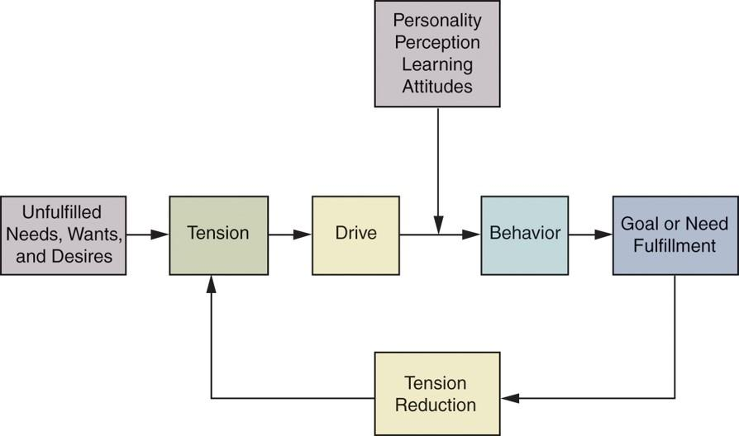(UTB moodle)

- Perception is the process by which an individual selects, organizes, and interprets stimuli into a meaningful and coherent picture of the world. It has four elements:
1.Sensation is the immediate and direct response of the sensory organs to stimuli.
2. The absolute threshold is the lowest level at which an individual can experience a sensation.
3. Differential threshold: The difference between two stimuli or between one level of a stimulus and another level of that stimulus
4. Subliminal perception is when they perceive a marketing message without their conscious awareness.

- Attitudes and beliefs: They influence buying behavior by making up brands and product images in the consumers' heads. These characteristics can change their preferences and influence their decision-making process. Belief can also be emotionally charged.
- Learning is the process that evolves and changes consumers' behavior by acquiring knowledge from experience and interactions with others. Acquired knowledge affects future behavior. It has four elements: motivation, cue motivation, cue, and response.
- Personality: Personal characteristics can also influence consumer behavior while shopping online. For example, a person with high-quality theoretical knowledge will feel more comfortable searching on online platforms. (Psychological Factors Affecting Consumer BehBehavior.d.)

5. Social and Cultural Factors Affecting Consumer Behavior:

Social and cultural factors can also play a significant role in online shopping and consumer behavior. Some of the most important factors that you could discuss are: (Cultural Factors Affecting Consumer Behavior, n.d.)

- Reference Groups: Reference groups are normative friends and family; they can influence consumer behavior by providing recommendations and opinions. Many times we want to buy something, but in the end we end up buying something else because of recommendations from family or friends. Others who can also be a reference group are the influencers. Many of the teenagers follow in their footsteps. So, many of the clothes or objects that the influencers wear or sponsor are bought because they have a lot of influence on people.
- Culture: Cultural factors, such as values and beliefs, can also shape consumer behavior. For instance, we can see something very nice on some website and want to buy it, but sometimes, because of culture, we don't end up buying it. Cultural factors have a lot of weight in online shopping as well.
- Social Class: Social class can also influence consumer behavior by affecting their preferences, attitudes, and beliefs. Social class, for example, can affect the perception of quality in the search for brands. Many times, we are very influenced by what others do or what they think of us.
- Family and Household: These factors, such as the size of the family and their income, can also influence consumer behavior. A household is a group of people who live together, regardless of whether there are any kinship ties, occupy a housing unit, and share the costs of living (to some extent). Consumers with higher household incomes have a more positive attitude towards online shopping because they can afford to buy things they like without looking too much at the price, which is the most important feature in a purchase.

6. Marketing Implications:

Consumer behavior in online shopping can have significant marketing implications for businesses. Here are a few ways that businesses can leverage this knowledge to improve their marketing strategies:

- Targeted Marketing: By understanding the needs, preferences, and behaviors of different consumer segments, businesses can tailor their marketing messages and promotions to target specific groups. For example, a business might offer discounts to first-time customers or send personalized recommendations based on a customer's browsing and purchase history.
- Personalized Marketing: With access to consumer behavior data, businesses can personalize their marketing efforts to create a more engaging and relevant experience for their customers.
- Customer Relationship Management: By understanding consumer behavior, businesses can improve their customer relationship management (CRM) strategies. This might involve using data analytics tools to track customer behavior and preferences and using this information to create targeted marketing campaigns, improve product offerings, or enhance the customer experience.
- Improved Online Shopping Experience: Businesses can use consumer behavior data to optimize their website and create a seamless online shopping experience. For example, by analyzing customer search queries and purchase patterns, businesses can make it easier for customers to find what they're looking for and streamline the checkout process.

7. Conclusion

In conclusion, consumer behavior in online shopping is influenced by a wide range of factors, including psychological, social, cultural, and marketing factors. Consumers engage in a decision-making process that involves several stages, such as problem recognition, information search, evaluation of alternatives, and purchase decisions. Companies can use marketing strategies to influence consumers' behavior, such as targeted advertising, personalized recommendations, and social media campaigns.
With the rise of e-commerce, it is crucial for companies to understand the factors that drive consumers to shop online and to tailor their strategies accordingly. As technology continues to advance and online shopping becomes even more ubiquitous, it is likely that consumer behavior will continue to evolve. Understanding these trends will be essential for businesses to remain competitive in the online marketplace.
Finally, this seminar paper attempts to analyze consumer behavior in online shopping based on psychological, cultural, or other factors.

8. Sources of information:
- Hsiao, & Kuo. (2016). “Understanding consumers’ online shopping behavior: What drives consumers to shop online?” Journal of Internet Commerce.
- Osbourne, S. (2022, December 14). Webrooming vs. Showrooming: A Marketing Guide for Retailers | Qudini. Retail Choreography Software. https://www.qudini.com/webrooming-vs-showrooming/
- Ayalew, M., & Zewdie, S. (2022). What Factors Determine the Online Consumer Behavior in This Digitalized World? A Systematic Literature. Human Behavior and Emerging Technologies, 2022, 1–18. https://doi.org/10.1155/2022/1298378
- Psychological Factors affecting Consumer Behaviour. (n.d.). https://www.managementstudyguide.com/psychological-factors-affecting-consumer-behaviour.htm
- Cultural Factors affecting Consumer Behaviour. (n.d.). https://www.managementstudyguide.com/cultural-factors-affecting-consumer-behaviour.htm
- Amit, K., Singh, A. K., & Sailo, M. (2014). Consumer Behavior in Online Shopping: A Study of Aizawl. ResearchGate. https://www.researchgate.net/publication/293517608_Consumer_Behavior_in_Online_Shopping_A_Study_of_Aizawl
- Moodle files.

