PUBLIC ADMINISTRATION REFORM

Content

1. About public administration and its reform in general
1.1 Public administration
1.2 Public administration reform
a) Defining public administration reform
b) The scale and limits of public administration reforms
c) Public administration reforming and international organizations

2. Public administration reform in the Czech Republic

2.1 The starting points and the development of the reform
2.2 Territorial public administration and its reform in Czechoslovakia and the Czech Republic
2.3 Central public administration reform
2.4 Public administration reform and the growth of civil servants’ qualification

2.5 Other selected (and important) issues
a) Control of Public Administration
b) Standards in Public Administration

1. About public administration and its reform in general

Before introducing particular concrete parts of the issue of public administration reform in the Czech Republic, it is necessary to define both of its components - public administration and reform. Both terms are interdisciplinary. The following will source mainly from the Czech administrative law as well as from the administrative science.

1.1 Public administration
Public administration is defined as the administration of public affairs within a society that is organised in a state. Public administration is a social phenomenon that is linked with the realization of the executive power of the state, including the specific position of the self-government.
STATE POWER TRIPARTITION
LEGISLATIVE
POWER
EXECUTIVE
POWER
JUDICIARY

Public administration is also defined by utilizing the term power, particularly the so called public power. Generally, power is a capacity to force the certain way of behaving on somebody and in case of violating this command also to enforce such behaving and eventually to punish such violation of the command. The so called public power is the power that is in hands of the so called subjects of the public power - primary, in disposition of the state; secondly, in disposition of subjects that are approbated by the state. That is why the public power is divided by theorists into the state power and the residual public power.

PUBLIC POWER

STATE POWER - exercised by the"state mechanism"
RESIDUAL PUBLIC POWER ("DECENTRALIZED STATE POWER")
- by " non-state subjects" approved by the state

The state power is exercised by the state through the specific apparatus - the so called state mechanism. The residual public power is exercised by "non-state subjects", that means other subjects than the state, however, they have to be - as mentioned above - approved by the state. Sometimes the residual public power is defined as the "decentralized state power."
The term public administration has also to be distinguished from the term private administration. Administration in general is a management of society.
a) Public administration as the administration of public affairs is exercised in the name of the so called public interest as a duty prescribed by law, because of the public law status of the public administration authorities.
b) Private administration as the administration of private affairs is exercised in the name of private interest by individuals that pursue their own goals on the base of their own will. Such meaning can be related to public administration only in case it is used for the territorial unit (e.g. state interest, regional interest, municipal interest) not in relation to an individual (in this case it is corruption).

The term public administration is in the administrative science defined also in the so called
a) organizational (or institutional) way - public administration = public administration authorities
- state authorities and
- non-state authorities approbated by the state - "public law corporations" and individuals (however only in the name of public interest and it must be approved
by law)
b) functional (or material) way - public administration = a specific activity of public administration authorities = the exercise of public administration as an application of law and the decretory activity of public administration authorities.
While speaking about the public administration in the meaning of the administration of public affairs within the territory of a state in the name of public interest, it is important to differentiate the state administration and the self-government. This differentiation is related mainly to the mentioned division of public power and the organizational definition of public administration.
PUBLIC ADMINISTRATION

State administration
Self-government

State administration is a specific kind of the management of a society that is exercised in the name of state. It is a one form of activities of the state and is extrapolated from the essence, status and goals of the state. It is a form of activity of the state related mainly to the executive part of the state power tripartite.
Self-government is the public administration that is exercised by public law subjects other that the state ("public law corporations"). Self-government includes the area of public administration that is approved by law to specific public law corporations to which this area of public administration is directly linked. Self-government is derived from the relatively autonomous (relatively because of the financial dependence on the state budget, the degree of centralization of public administration etc.) status of public law corporations. This "part" of public administration is also a specific kind of the management of a society, however, in this case exercised in the name of self-governmental public law corporation (that is why the self-government is related to the mentioned "decentralized state power". Side by side with the state administration it realizes the administration of public affairs. Self-government is a part of public administration that is specified by its focusing on itself.
Roots of the modern self-government can be found in the times of medieval cities self-government and medieval guilds.
This paper will deal especially with the organizational (institutional) level of public administration reform in the Czech Republic to introduce the background of the organizational structure of the public administration in the Czech Republic.

1.2 Public administration reform

a) Defining the term public administration reform
Public administration with both of its components (state administration and self-government) is considered to be the most dynamic part of the modern state. That is why the word “reform” is inherited feature of public administration. The constant reform of public administration sources also from the character of public administration itself. Public administration is often said to be the administration of public affairs with certain functions. Because of the constant growth of these functions reform of public administration has been perpetual since the public administration structures have originated.
It is necessary to said that the development of public administration reforms reflects the values that are accepted by the socienty during the history. These values also influence the rate between centralization and decentralization of public administration. We will not discuss time of the public administration origin as well as the range of public administration activities that differs theory by theory.
The definition of public administration reform is often discussed. That is why it is complicated to agree on a single definition of administrative reform. Opinions are various.
a) Some introduces the reform of public administration as a complex rebuilding of public administration,
b) others consider the reform to be also just a particular change within public administration or just a modernising or improving of public administration procedures.
Generally, the word reform means to make something better, to improve something or to remove the faults of something, in our case - the change of public administration.
Public administration reform has also many aspects that can be (and often are) interlinked, e. g.
- political,
- legal,
- institutional,
- technical (IT utilization - e-government, e-democracy etc.)
- personnel,
- financial,
- social,
- psychological and many more.
It is also important to distinguish the following stages of public administration reform
- theoretical and
- practical stage of the reform,
or
- the stage of preparation and
- the stage of realization of the reform. They are mutually linked and influence the final success in reaching stipulated aims.

b) The scale and limits of public administration reforms
The scale of public administration reforms can be very heterogenous in the world. Generally, we can distinquish three groups of states whose public administration reforms can have very similar features. The comparative public administration speaks about:
a) developed (especially Western) countries
b) Central and Eastern European (CEE) countries that were a part of the socialist block
c) development countries of Africa, South America and Asia.
This paper will focus on the case study from b). However, we can compare in general the first two groups and we can find especially the following differents.
- Western countries have started reforming in the modern way mostly in the 1960’s, states in b) have started mainly since 1990’s. This disproportion is expressed also in the character and the level of development of public administration reforms.
- Western countries do not have to face the complex reform of public administration and the strategies of their administrative reforms have or had been realized in different economic and political environment.
- The postcommunist countries on the other hand try to cope with their recent totalitarian regime characteristics in order to make themselves more democratic, to decentralize and deconcentrate their public administration that was based mostly on the state administration and on the minimum of self-government.
- The CEE countries try to catch up with their western neighbours, e.g. in order to become a member of the EU etc. That is why their reforms can be inproportionately fast (especially changes in legislation). This may also cause many problems and increase the costs of the administrative reform (because of amendments to legislation, adequate education of civil servants etc.).
- The facts mentioned above do not mean that plenty of problems must not be solved in Western countries. They still try to increase the participation of public, to focus their public administration to citizens, to make their public administration serve the public, to eliminate corrupcy etc. The democratic deficit still exists in the Western world.

c) Public administration reforming and international organizations
The role of international organizations should be stressed here. These organizations (such as OECD, EU etc.) can provide the countries with quide-like information (especially the “lessons learned information” or “best practice” information) and with financial resources as well. They also push some contries to reform their public administration. (And there are also many intentions to do so - e.g. economic purposes, ensuring the peace etc.).
For example SIGMA´s „European principles for Public Administration“ attempts to identify the standards to which EU candidate countries are expected to conform in order to align their public administration with those of EU Member States. These shared principles of public administration among EU members constitute the „European Administrative Space“(EAS). The EAS includes the following set of common standards for action within public administration which are defined by law and enforced in practise through procedures and accountability mechanism:
a) reliability and predictability (legal certainty) - based especially on the rule of law mechanism, timeliness in the action of public administration, professionalism and professional integrity in the civil service (that especially relies upon the notions of impartiality and professional independence);
b) openness and transparency - this means that the PA is avalable for the outside world and can be seen through for the purpose of scrutiny and supervision;
c) accountability - it means that one person or authority has to explain and justify its actions to another.
d) efficiency and effectiveness - Efficiency is characteristically a managerial value consisting in essance of maintaining a good ratio between resources employed and results attained. Effectiveness basically consists of ensuring that the performace of public administration is successful in achieving the goals and solving the problems set for it by law.
However, in my opinion the practice of these principles is discutable even in the EU Member States. Modern public administration reform should not also violate the spirit of these principles.
Also the importance of European Charter of Local Self-Government (The Czech Republic signed the European Charter of Local Self-Government on 28 May 1998, and ratified it on 7 May 1999) and European Charter of Regional Self-Government (the final version of this charter has not been passed yet) of the Council of Europe should be stressed here.

2. Public administration reform in the Czech Republic

2.1 The starting points and the development of the reform
From February 1948 to November 1989 (in practice to the beginning of 1990) the Czechoslovak Republic and its public administration had been developing in the spirit of communism and socialism. In 1968, the unitary state was replaced by the federation of Czechoslovak socialist republic with the central public administration on the federal and republic level. The lower level of the state administration was institutionally ensured by the regional, district and local “national committees”.
This system of public administration was characterized by centralization and was governed by the influence of the communist party. The separation of the civil service and the political structures did not exist. Self-government authorities did not exist in practice as well. That is also why the administrative theory speaks about the system of state administration rather than about the system of public administration while dealing with this period of the Czechoslovak history.
After November 1989 (the “velvet revolution”) the change of regime has come. Transformation of the society had to be accompanied by the reform of public administration or better to say by the reform of the state administration (because of the above mentioned facts). Renaissance and enhancement of the self-government as well as decentralization and deconcentration of accountabilities, financial flows etc. have become major goals. The realization of the principle of subsidiarity in the meaning of the European Charter of Local Self-Government was one of the main goals of the changes of public administration in Czechoslovakia too. „Public responsibilities shall generally be exercised, in preference, by those authorities which are closest to the citizen. Allocation of responsibility to another authority should weigh up the extent and nature of the task and requirements of efficiency and economy.“
According to the words of the creators of the Czech reform, the reform of public administration in Czechoslovakia should have been inspired by experience of countries that have started the reform earlier. The attempt of enhancing of the prestige of public administration in the eyes of public, elimination of corruption as well as creation of public administration that should serve citizens and also the establishment of an effective administrative control mechanism were also an important part among creators’ intentions.

2.2 Territorial public administration and its reform in Czechoslovakia and the Czech Republic
- 1990 - 1992
Throughout its history the Czech Republic had been divided into supra-municipal units. In the communist period there were 8 regions ("kraje"). They were abolished in the 1990s but for the long time there had been no move to replace them with regions established on a decentralised basis or in line with the principles of the draft European Charter of Regional Self-Government, in particular the requirement to have democratically elected regional councils.
On the basis of the above mentioned ideas, during the year 1990 the system of the “national committees” was abolished. Their activity was supposed to be exercised by other subjects that should have been established on the fundamentals of modern constitutional democratic principles that were provided by individual constitutional and other acts (especially acts that anchored the new system of public administration - Act 367/1990 on municipalities, Act 425/1990 on district authorities, 418/1990 on the capital Prague etc.). New Czechoslovak constitution in the form of a single constitutional document was not passed.
The new legislation did not solve the question about the second level of the
self-government. Since the elections of November 1990 the self-government had institutionally existed only on the lowest (municipal) level. The second level of the self-government and its form had been a matter of discussion for a long time.
At the time of the Czechoslovak federacy, four alternatives were proposed - territorial, regional, combined and federal. The government of that time accepted the territorial alternative and proposed the steps for its realization. However, they had not been discussed by the parliament because of the solving of upcoming separation of the federation in 1992.
The state administration was exercised by the municipal level as well (the so-called connected model of public administration) and also by the level of district authorities.
Besides these state administration authorities other offices and state authorities (the so-called “deconcentrates”) had existed at the place of abolished regional level as well as in districts. These institutions were established by subjects of the state administration (ministries, other central authorities etc.) in order to fulfil their tasks on lower levels. In some cases these “deconcentrated” authorities founded their own offices. Their creation had often no strategy and caused the chaotic situation in the system of public administration (or better say state administration) of Czechoslovakia and increased the number of public administration employees.

- 1992 - 1996
The political programme of new government from June 1992 announced the attempts to realize decentralization, “deconcentration” and the principle of subsidiarity. However, the practice had not changed much, in spite the fact, that in its article 99, the new constitution of the Czech Republic from 1993 (Act 1/1993) presupposed the administrative system consisted of municipalities as basic local self-governmental units and also of “regions or lands” as higher self-governmental units. This provision did not solve the mentioned discussion on the form of the second self-governmental level. It has just constitutionally established the second self-governmental level. Its form depended on politicians and their consensus.
According to some experts, the discussion on the concept of the
regional self-government had been politicized. There only existed the political agreement on the importance and the need to reform the regional self-government. The public, especially the experts from the field of public administration theory had not been included to this discussion-making process. The disputed questions on the number of higher self-government units should have been solved too.
For example in 1994, the government accepted a document called “Intentions of the government in the field of public administration reform” that was passed to parliament. According to this document the government wanted to add the level of higher regional self-governmental units to the system of public administration of the Czech Republic. The government also wanted to delegate a part of the state administration on this higher level. In this document, the government also expressed that no agreement on institutional system of the higher public administration level had been found. Besides all, according to this document, the government did not reckon the abolishing of the district authorities that had represented the second level of the state administration.
The constitutional deficit and the factual non-existence of the second level of self-government was criticized by the European Commission still in 1997 while annually evaluating the candidates for the EU membership.
- 1996 - 1998
The insufficient practice has been solved by the constitutional act 347/1997 that has established 14 regions. This act has specified the mentioned article 99 of the Czech constitution and has solved the question of form of the second level of regional self-government in our country. However, its activity should be the matter of new legislation that would realize the practice of regions (the act 129/2000 on regions is mentioned beneath). This constitutional act has come in force since 1. 1. 2000) and was a result of discussion of the second Czech government of 1996 - 1997 and the temporary government of 1997 - 1998.
In 2000, in the Council of Europe´s report on the local democracy in the Czech Republic, the following was mentioned among the problems of local democracy: "Insufficient local autonomy, the existence of districts and the lack of real intermediate level of local self-government." and "The simultaneous existence of districts, outlying components of central administration and a large number of municipalities (6 244), most of them small, highlights undoubted centralisation in Czech administrative system. The insufficiency of municipal autonomy is not offset by the existence of any local or regional authority that might have developed an intermediate role. All there is the district assembly, but that body is of only minor importance and in addition has limited budget powers. The existence of district-like cities with their own statutes must be seen as a centralising device rather than a decentralisation measure, for the district-cities have the status of deconcentrated state organs."
Finally, the politicians created the regional level of public administration that should exercise both the state administration and the self-government. Regions of the Czech Republic represent the so-called connected model of public administration. The establishment of regions should have solved also the mentioned chaotic situation in the state administration by abolishing the mentioned “deconcentrates” of ministries and other authorities.
- 1998 till present
The mentioned facts had to be taken into consideration by the new government of 1998. The submission of new legislation (mentioned because of explanatory reasons above) that would fulfil the constitutional provisions and would enable the realization of the constitutionally presupposed public administration reform was the main initial task of this government. The document “Conception of public administration reform” from 1999 has become a political way-out of the solution. This document presupposed two stages of the regional public administration reform:
a) during the first stage, the regional level of public administration should have been created in practice;
b) during the second stage, the activity of the second level of the state administration - the districts - should have been finished till 31. 12. 2002 (although the mentioned intentions of the government of 1994 were different). Their tasks should have been transferred both to the regions and municipalities while securing the criteria of the accessibility to public administration, the effectiveness of the public administration activities etc.
The government decided to abolish the district level (in practice the second level) of the state administration, although some experts considered them to be the most stable subjects with eleven years’ experience. The government stated the reason that these districts that were established in 1960 had not represented in many cases the natural micro-regional centers. The number of 76 of these district authorities should have been replaced by 180 - 200 of the so-called “municipalities with enlarged sphere of activity”.
The government also stated the criteria that led it to such decision:
- the statements of the municipal self-governmental assemblies,
- the minimum extent of the administrative unit was designated to 15000 inhabitants,
- the complex of geographical criteria - especially the accessibility of the proposed administrative centre, the density, the commuting to work and for services, traditional administrative centre etc.
The creators of this conception fell back on expert opinions of researches of the Charles University in Prague and of the Masaryk University in Brno. However, the abolishment of the district authorities is still criticized by other experts, mayors etc. They claim that the mentioned criteria have not been fulfilled - the accessibility of the public administration has become worse, the reform caused the increase of bureaucracy etc.
In order to realize the mentioned conception, a huge amount of legislation on the organization of public administration and its competence, property, financial sources etc. was passed in 2000. The following acts are the most important: act 128/2000 (on the municipalities), act 129/2000 (on regions: this act has established the practice of regions in the Czech republic; it has been enacted that it should came in force - with exceptions related to the exercise of state administration (that have come in force since 1. 1. 2001) - since the date of elections to regional assemblies - 12. 11. 2000), act 130/2000 (on the elections to the regional assemblies), act 147/2000 (on the district authorities), act 131/2000 (on the capital Prague; our capital is simultaneously a municipality and a region), act 218/200 (on budgetary rules).
According to the Czech ministry of interior, during the second quarter of 2002 the legislative framework of the mentioned second stage of the public administration reform had been accomplished. This was secured by proposals of many acts that would change some of the previously stated legal documents. Many of these proposals have been passed by the parliament and have come in force since the beginning of 2003 or earlier during the 2002. This legislation should solve the problems of the regional public administration system, the transfer of competences from the district authorities, the transfer of the property of district authorities, the transfer of employees of the district authorities, the logistic activities related to the abolishing of the district authorities etc.
These acts have also created a legal framework for the activity of 206 “municipalities with the enlarged sphere of activity” (especially the act 314/2002 and only in relation to the amount of state administration exercised by the certain municipality) that should bring the public administration in the Czech Republic closer to its citizens. However, this part of the public administration reform is still the matter of many discussions. In reality, in the Czech Republic, more kinds of municipalities have been established since 1. 1. 2003 - they differ by the extent of state administration they exercise and are divided into the following three categories:
a) municipalities with ordinary municipality bodies (municipality body is one of bodies of a municipality that should exercise the state administration deconcentrated from the central level of state administration);
b) municipalities with "commissioned" municipal office (they also serve citizens as a registry office, offices for building matters etc.);
c) municipalities with enlarged sphere of activity (this category of municipalities has been founded in relation to the abolishment of mentioned district authorities and the transfer of their competencies to municipal level - e.g. primary education etc.)
[categories b) and c) are specified in act 314/2002, that has come in force since 1. 1. 2003] (today we have 6274 municipalities).
The mentioned steps of public administration reform have also determined the tasks for the government of June 2002. According to its political program, the new Czech government has bound itself to finish the public administration reform. It also understands public administration as a service for citizens.
E.g. till the first half of 2003 the government wanted to create the generally accepted reform of public finance (this has not been passed yet) in order to reduce the public deficit and to fulfill the budgetary criteria of the European Monetary Union. However, according to many opinions the process of the public administration reform was slowed down by the long presidential elections.
Contemporary problems:
- As it was already mentioned, the district authorities has finished their activities since 31. 12. 2002. At the beginning of this paper, it was stressed, that the paper would mainly deal with the institutional aspect of public administration reform in the Czech Republic. It must be stressed, that the district as an territorial unit is still existing. We still have e. g. district courts and also district labour authorities, district financial authorities, district cadastral authorities etc. - the group that is called by the ministry of interior as "special territorial agencies of state administration".
- Acts related to the so called 2nd phase of public administration reform (abolishing of district authorities) were accepted by the Parliament at the second half of 2002. This caused the lack of time for establishment of necessary capacities (personnel, financial, technical etc.) on municipal as well as regional level. Because of the transfer of state administration functions, municipalities and regions are still requesting more financial resources for exercising state administration etc., although the ministry of interior in its regular reports concerning the PA reform still claims, that the exercise of state administration is functioning as a whole.
2.3 Central public administration reform
If we compare the territorial (municipal and regional) public administration reform and the central public administration reform in Czechoslovakia and the Czech Republic, we can say that not enough systematic attention has been paid to the reforming of central authorities for a long time since 1990s. This fact had been criticized many times by the European Commission, OECD, the Council of Europe etc.
Reforms of these two segments of public administration (territorial and central) were understood to be separated, although experts often claim that the reform of the central level and the reform of the regional level of public administration should be linked rather then separated. For example, some of them say that “the continuation only in the regional public administration reform was the fundamental system mistake... as if the central administration had not required a cardinal reform and as if the public administration reform had not been the complex issue.”
The important change for the modernization of the central public administration has been made in 2001 when the government accepted the resolution no. 619 that dealt with the conception of central state administration modernization with the special emphasize on the systematization and organizational structures of administrative authorities.
- The harmonization and systematization of the ministries’ as well as other central authorities’organization structures and the increase of effectiveness, improving of horizontal and vertical cooperation had become a short-term priority for the period from June 2001 to June 2002.
- This conception considered consolidation of the central state administration system, strengthening of conceptual, coordinating and control functions of ministries, improving the management of ministries and other central administrative authorities to be the medium-term priority (for the period from July 2002 to December 2003).
For example, the PHARE projects (with twinning etc.) are utilized to fulfil the mentioned tasks. These projects tries to support the improving of the communication between the public administration and citizens, the creation of the public administration educational system and the preparation of some conceptual documents. For example, PHARE 98 and PHARE 2000 projects have been focused on modernization of central state administration. PHARE 2001 project should have ensured the effective coordination of the exercise of the state administration competences that had been transferred from the central level to the regional level. PHARE 2002 project reacts to the transfer of the central state authorities’ tasks to municipalities and regions. The main goal of these projects is to contribute to the creation of conditions for implementing and enforcing the acquis communautaire.
New government of June 2002 has set among its priorities also the start of the central state administration modernization that would make public administration activities more efficient and effective, improve the horizontal coordination of public administration activities while larger utilization of the modern technologies (e-public administration) and modern managerial methods.

2.4 Public administration reform and the growth of civil servants’ qualification
The text of this sub-chapter and also the text of the following sub-chapter is related to the Czech public administration as a whole. The Czech Republic had been at least since 1997 annually criticized also for the absence of the legislation on civil servants status and for the non-existence of civil service educational system. The education of civil servants had been managed ad hoc by many central and local public administration institutions without any coordination. No central authority for coordination of the education of public administration employees had been established. Generally speaking, in the Czech Republic, there had been no coordinated systematic “human resources” management within public administration.
In 2001, the Czech Republic had been still criticized by the European Commission for the mentioned deficiencies. Rights and duties of civil servants had been enacted in general labour law, especially in the Labour law code.
The passing of complex legislation has a long history and was more or less accomplished in 2002 by the act no. 218/2002 on a civil service of state authorities’ employees and about rewarding these employees and other employees of administrative authorities and act no. 312/2002 on officials of self government and amendments of other acts. These acts emphasize the political independence of the officials of the state administration and self-government and the professionalism of these civil servants and try to define their legal status. They are more concrete than the Code of public administration ethics from 2001 that was not able to be enforced because of its form of recommendation.
The mentioned act no. 218/2002 has established the Institute of State administration. This institution becomes a central authority for the education of the state administration employees as well as of employees of other administrative authorities.
The new government of 2002 has bound itself to implement this new legislation. In autumn of 2002 (when it published the annual regular report on the Czech Republic) the European Commission recommended the Czech Republic to implement the mentioned civil service legislation as soon as possible in order to facilitate the enter of our country to the European Union (May 2004 is the presupposed term for the access). This report of 2002 also recommended to increase the efforts in fighting the corruption.

2.5 Other selected (and important) issues
a) Control of public administration
While speaking about the public administration reform in the Czech Republic, it is necessary to add information about the reform of the control mechanism of public administration.
The issue of administrative judicature reform is of the crucial importance. Although the Constitution of the Czech Republic (Act 1/1993) presupposed the institution of the Highest Administrative Court, the factual situation was similar to the mentioned case of the higher regional self-governmental units (CONSTITUTIONAL DEFICIT). The provisions of the constitutional law had not been fulfil till 2002. This had caused that many activities of public administration or its inactivities had not been under the control of courts. That is also why, in the first half of 2001, the Constitutional Court of the Czech Republic abolished the provisions of Civil courts procedures act (Act 99/1963 with its amendments) on administrative judicature in order to make our politicians reach a consensus on making the administrative control more effective by the way of administrative judicature reform. These facts led - besides all - to passing the Act 150/2002 (on judicial procedure of administrative courts) that realized the mentioned constitutionally deficit - after a decade it has established the Highest Administrative Court and provided the legal framework for its activities.
It is also important to introduce the act no 106/1999 on free access to information that tries to specify the article 17 of the Charter of fundamental rights and freedoms (Act 2/1993). In the paragraph 1 of this article, it is proclaimed that the freedom of expression and the right to information are guaranteed. Afterwards, the paragraph 5 of this article anchors the duty of organs of the State and local self-government to provide in “an appropriate manner” information on their activity. The act 106/1999 represents a lex generalis of the freedom of information legislation in the Czech Republic. In comparison with some similar foreign legal documents, its provisions are imperfect, however, this act creates an important mechanism of requesting certain information from public administration and tries to realize the ideas of the modern principle of openness and of transparency of public administration. The administrative control reform could be an important part of the subject “Transformation of Public Sector” too.
Here, the role of the Czech ombudsman should be mentioned as well. His status is prescribed by the act 349/1999 (this act speaks about "public protector of rights"). The Czech ombudsman is elected by the Chamber of Deputies of our Parliament for six years and should serve the public (with the residence in Brno) in order to protect individuals against activities of public administration authorities (with some exceptions - Parliament, President, Government, The Highest Control Authority, The Intelligence Service, courts etc.) that are unlawful, against the principles of democratic legal state and against the principles of "good governance" and also against inactivities of these authorities, in order to contribute to the protection of basic rights and freedoms (that are enacted by the constitutional act no. 2/1993). The main instruments to achieve these goals is the recommendation or informing the public.
b) Standardization of public services
Finally, it is important to mention the debatable proposal of the act on standardization of selected public services from 2001 that has not been passed yet. In accordance with this bill, its provisions should solve the accessibility of selected public services by guaranteeing the equal access of citizens to them. According to the creators of this proposal, such equality must be secured also because of the mentioned transfer of competences from the abolished district authorities to the self-governmental authorities - regions and municipalities.

PA
ORGANISATION
FUNCTIONS
FINANCE
CONTROL
REFORM

Organizational structure of municipalities
MUNICIPAL (or TOWN) ASSEMBLY
- directly elected deliberative and decision-making body (from 5 to 55 members)
BOARDS: always the Financial board and Control board
= initiative and control bodies

MUNICIPAL (OR TOWN) COUNCIL
- executive organ elected by municipal assembly, not elected in municipalities where the municipal assmebly has less than 15 members (in that case, municipal assembly fulfill its tasks); 5 - 11 members
COMMISSIONS
= initiative and deliberative bodies

MAYOR and DEPUTY MAYORS
- deputize the municipality, elected by municipal assembly from its own members;
MUNICIPAL SECRETARY
- appointed by the mayor in municipalities with municipalities with "commissioned" municipal office and in municipalities with enlarged sphere of activity; the agreement of the director of regional committee is required
MUNICIPAL OFFICE
- comprising the mayor, the mayor's deputies, the municipal secretary and employees of the municipality thate are included into municipal office

Organizational structure of regions
REGIONAL ASSEMBLY
- directly elected deliberative and decision-making body (from 45 to 65 members)
"HEJTMAN OF THE REGION" AND HIS DEPUTY (- IES)
- deputize the region, elected by regional assembly from its own members;
REGIONAL COUNCIL
- executive organ elected by regional assembly,
BOARDS: always the Financial board and Control board and Board for upbringing, education and employment; = initiative and control bodies

REGIONAL OFFICE
- comprising director and employees of the region

COMMISSIONS
= initiative and deliberative bodies

Summary

The Czech theory of public administration distinguishes There have been the following levels of public administration in the
the following components of public administration: Czech republic:
PUBLIC ADMINISTRATION
TERRITORIAL
State administration
Municipal
Self-government
District

Regional
CENTRAL

In the period 1948 - 1990 the structure of the Czechoslovak public administration was (with a level of simplification) following:
PUBLIC ADMINISTRATION
State administration
TERRITORIAL
Municipal
District
Regional
CENTRAL

The territorial public administration had been exersised by the system of „national committees“

Self-government
- in practice the importance of the self-government was minimal because of the political influence

In the period of 1990 - 2001 (11. 11. 2000) the practice (the legal situation was different) was following:

PUBLIC ADMINISTRATION
TERRITORIAL
Municipal
District
Regional
CENTRAL

State administration
municipalities

district authorities

Self-government

the central level created the so-called „deconcentrates“ especially on the territory of former (abolished) regional and district national committees

According the reform of public administration from 12. 11. 2000 to 31. 12. 2002 we can make following:
Regional
PUBLIC ADMINISTRATION
Regional

(The practice of regions has started. They exercise both the state administration and the self-government tasks - the so-called “connected model of public administration)
In the act 147/2000 on district authorities it was stipulated that the activity of the district authorities will have been finished since 31. 12. 2002. According to this change we can depict following - period 1. 1. 2003 till present:
It must be stressed, that the district as an territorial unit is still existing and is important for territorial competencies of some institutions. We still have e. g. district courts and also district labour authorities, cadastral authorities etc. - the group that is called by the ministry of interior as "special territorial agencies of state administration" (= "ASSYMETRIC MODEL")
PUBLIC ADMINISTRATION

State administration

Self-government

TERRITORIAL
Municipal
District
Regional
CENTRAL
municipalities ("microregions")
district authorities

according to the goals of the reform the most the „deconcentrates“ should be replaced by the new regions and their tasks, however the practice is different

- new MINISTRY OF INFORMATICS
regions
THE HIGHEST ADMINISTRATIVE COURT and lower subjects of administrative law courts

Regions of the Czech Republic

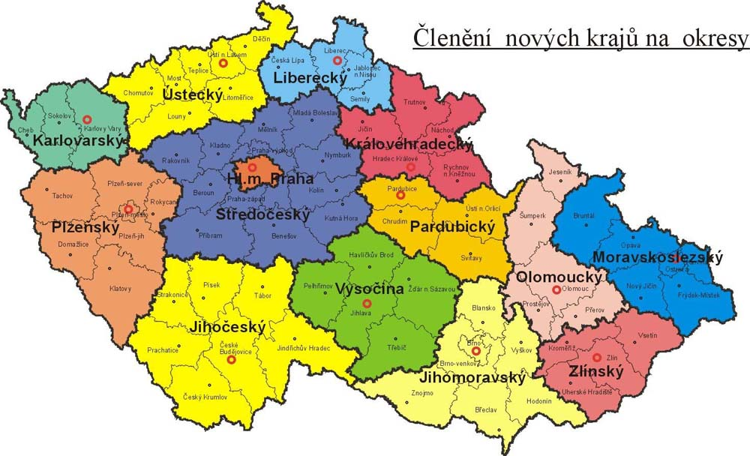

NUTS 2 areas ("regions of coherence") and regions (in our lang, region = "kraj") (NUT 3) of the Czech Republic
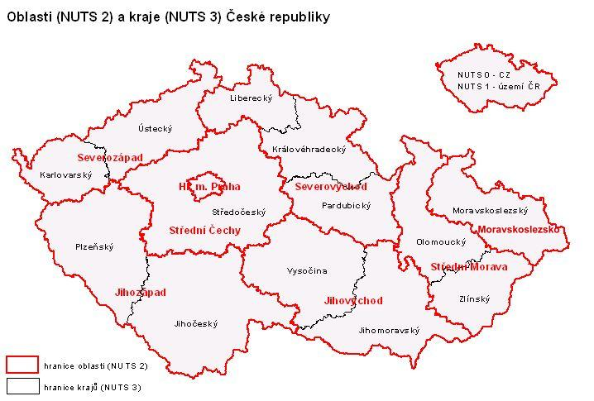

Regions (NUTS3) and former districts (NUTS4)
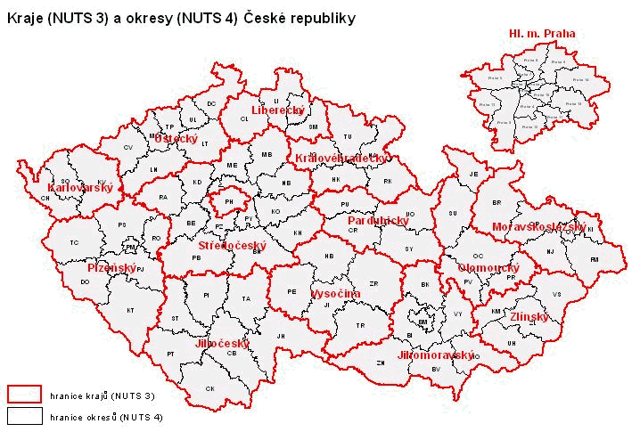

SIGMA - Support for Improvement in Governance and Management in Central and Eastern European Countries - a joint initiative of the OECD and the EU established in 1992. The document can be found on http://www.oecd.org.
The paragraph 3 of the article 4 of the European Charter of Local Self Government (Council of Europe, 1989, available on http://conventions.coe.int/Treaty/EN/Treaties/Html/122.htm).
Vidláková, O.: Public Administration Reforms. In Czech language. The University of Pardubice 2000, p. 41.
You can find some information about the PA reform in the Czech Republic in English also on http://www.nvf.cz/versprava/gb/vystupy_gb.htm. Some of the constitutional documents are available in English on http://www.psp.cr.
Source: http:\\www.mvcr.cz (the www site of the Ministry of interior of the Czech republic)
Source: http:\\www.mvcr.cz (the www site of theMinistry of interior of the Czech republic)
? Source: http:\\www.czso.cz (the www site of the Czech Statistical Authority)

