Introduction to MS Dynamics ERP NAV 5.0 SP1 in concise clauses = part four
Created by : Jaromír Skorkovský
Date : 03.11.2010
Reason : Concise instrument helping in tuition and study
Accompanying mat. : PSP Sales Discounts Basic (6 slides)

Discounts as a one the most important incentives.

1. Setup the working date by enter t

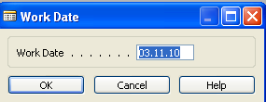

- Enter form menu (Sales and Marketing, Purchase, as you wish,..) Item Card. Than by use of key F5 display list of all items and by Filtering F7 (standing on the column number find Item LS-10PC) and by Shift-F5 go to the card of the Item.

- Go to the tab Invoicing and remark Unit price (Selling price) . In our case it is 59 .

- Go to the button Sales ->Prices and you get this window :

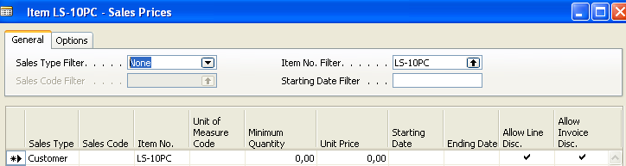

This I a window from where user can change a selling price by use some parameters controlling the period, when the price will be automatically generated and minimum quantity at which or above the new price will be applied. Sales Type can be use to specify for which customer, customer group or campaign this price will be valid

Change the window as follows and try to explain meaning of entered data (parameters) !!!

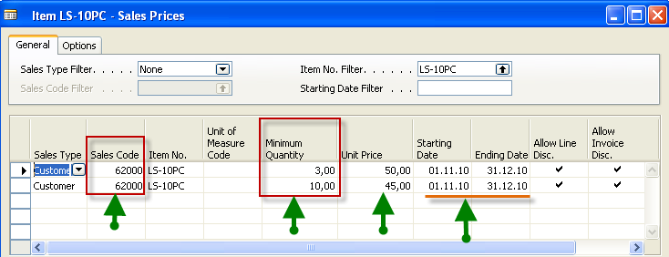

- Go to Sales ->order Processing ->Order and enter new order by F3 an make a choice of customer number 6200!
- Enter to one line Item number LS-10PC and quantity 1,next line 3 and next line 10
- See the selling price – you will get :

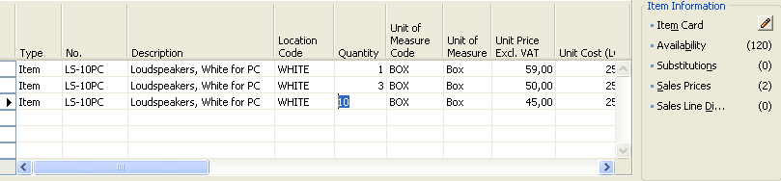

- What has changed and why?
- Go to the Item card LS-10PC again and use again button Sales

- Make a choice Line discounts and you will get :

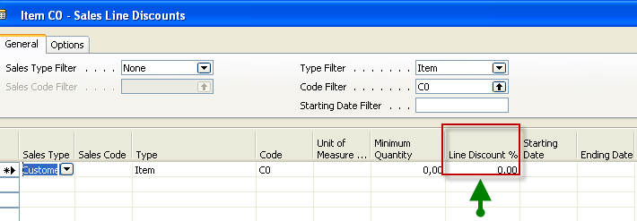

- See the difference?

- Enter data as specified on the next window! To copy information form previous line use key F8 (copy)

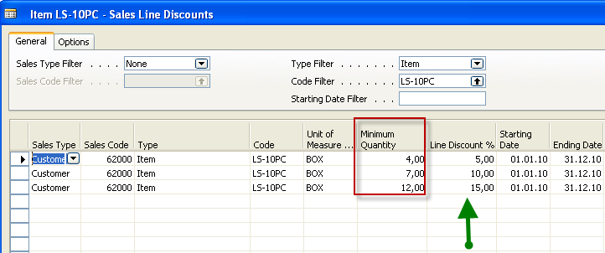

- Go to the previous order, erase all selling lines and enter again the following lines and you can see the change of the price and line discount. Before you should move by use of drag and drop column line discount more to the left of the sales line.

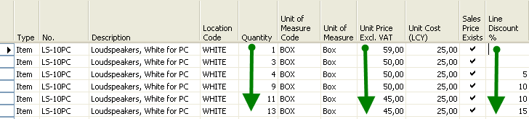

- Try to setup similar absolute prices discounts and % line discount for Item 1908-S and use in line stock location BLUE. What can you see?

