BPH_EPS1 (Enterprise Resource Planning Systems) – questions 2011
Created by : J.Skorkovský, KPH ESF MU BRNO, Czech Republic ; 1730@mail.muni.cz;skorka@cmail.cz
Date : 3.5.2011
Version : I.

All questions could be studied with the help of related study materials handed over to students during lessons.

Resources:

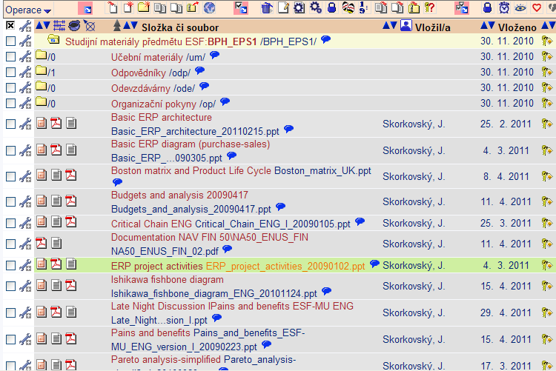

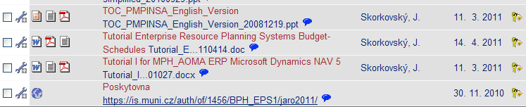

Detail specification taken from above list of stored study materials which have been handed over to students during spring term 2011

Warning : below are listed other relevant files, which have been stored to the study materials at 2.5.2011 by tutor and will be commented 6.5.2011 and 13.5. respectively. Alphanumeric codes specifying files are used in order to better link questions and study supplied materials :

I: Introduction to MS Dynamics ERP NAV 5-part one
J: Introduction to MS Dynamics ERP NAV 5-part two
K: Introduction to MS Dynamics ERP NAV 5-part three selling : simple business case
P: Introduction to MS Dynamics ERP NAV 5-part four
Q: Introduction to MS Dynamics ERP NAV 5-part five see specification below
F3: Applying principles MS Dynamics NAV
M: Sales discount basics
Z: Basic ERP diagram (purchase-sales) – PWP stored at 4.3.2011
S: Documentation NAV FIN 5.0-02 (meaning Chapter 02)- stored at 11.4.2011
Tutorial ERP Systems Budget-Schedules stored at 14.4.2011 (Alessandro only for known reason)

Theory resources

A. ERP project activities _ 20090102
B. Pains_and_benefits_ESF-MU_ENG_version_I_20090223
C. Critical_Chain_ENG_20090105
D. TOC_PMPINSA_English_version_20081219
E. Short explanation of applying principles
F2. Boston Matrix and Product Life Cycle
G1. Ishikawa fishbone diagram ENG
G2. Pareto Analysis Simplified

ERP resources (practice)

- Demo version of MS Dynamics NAV 5.0 W1
- 1st Part of Helping material
- 2nd Part of Helping material
- 3th Part of Helping material –selling (simple business case)
- Sales discount basic for foreign students (PWP)
- Material related to Sales Discount setup (Intro to MS Dynamics ERP NAV in concise clauses-part four)
- Tutorial I for MPH_AOMA (Step-by-step Hands On) stored at 11.3.2011
- Basic ERP diagram (purchase-sales)
- 4th part of Helping material
- 5th part of Helping material (Exercise for payment of the open entries)
- Documentation NAV FIN 5.0-02 (Chapter 02)- stored at 11.4.2011
- Budget and Analysis
- Applying principles MS Dynamics NAV 20090320
- Basic ERP architecture stored at 25.2.2011

Theory (resources A-G2):

Structure of the theory question:

Number Description : Resource (slides if required )

1. What is required by competitive ERP markets: A, B, F2 (innovation, road map, PLC,SWOT,..)
2. Name some reason for change the old ERP system: A and B
3. Name key activities of the implementation project (project entries): A
4. What is a Gantt chart: A and C
5. Evaluation of the project result. How we can know, that the project was successful? : A
6. Which knowledge is necessary for project management? : A
7. Simplified chart (diagram) of ERP functions : A, Z
8. Specify the basic concept of the Theory of Constraints : D
9. empty (no question for the time being)
10. TOC basic metrics : D
11. Cost World and Throughput World : D
12. TOC five steps: D – you could use tocca presentation from the web if you please
13. Basic trees (Thinking process tools) – CRT,EC and FRT : D
14. Project and its budget: C
15. What is bad multitasking? : C
16. Critical path and Critical Chain: C
17. Use of project buffer (buffer management concept) : C
18. Pains and benefits: B
19. Creation of the vision: B (nine steps slide)
20. Ishikawa fishbone diagram: G1
21. Boston matrix and product life cycle- PLC: F2
22. Pareto analysis: G2

Practice (resources H-Z):

Warning : some questions are not strictly linked to the resources due to the fact, that
If you go through helping materials marked 1-5 and Tutorial I you will get all necessary information.

1. Modularity of the ERP systems and architecture of the system. (H and U)
2. Main windows (forms) used in ERP and syntax for Debits and Credits. (H)
3. Users modifications of the ERP windows (show, hide, move,...)
4. Main tables (Item, Customer, Vendor and Account).
5. Purchase of an item and impacts of F11 (posting) -> item and vendor entries, G/L entries.
6. Sale of an item and impacts of F11 (posting) -> item and customer entries, G/L entries.
7. What is an applying principles. Direct connection to the question 8. (T)
8. Payment of the open entry (customer or vendor) by use of the Financial Journal (Q)
9. Discounts and the use of this. (L,M)
10. Contact card and its profile and use of it – Demo version of NAV (H)
11. Show and explain main principles and use of budget (business plan setup) – S
12. Main function keys and their combination use (helping question)

