Tutorial Enterprise Resource Planning Systems - Budgeting, Account Schedule construction

Created by : Skorkovský Jaromír
Date : 14.4.2011
Reason : tutorial, self study
Requested tools : MS Dynamics NAV 5.0 SP1 W1

- Charts of accounts

Make a filter in the columns No. by F7 (8320) – Consulting Services

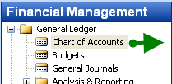

and

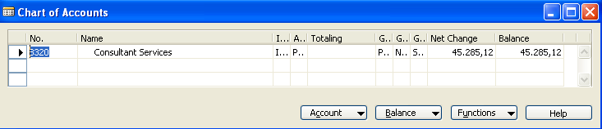

and by using Ctr.-F5 combination we can get G/L Entries represented already posted orders (invoices)

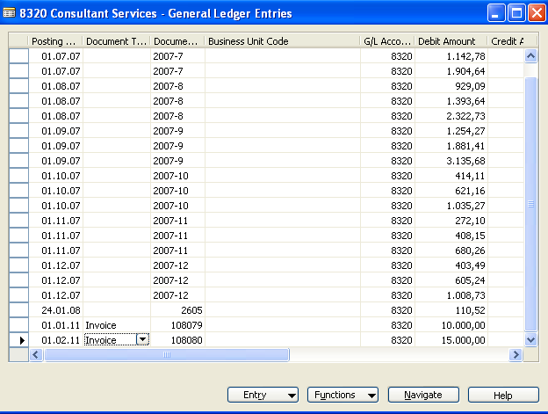
2. Create two times purchase order to create real entries which will be used to compare later with budget ledger entries which will be created manually by us.

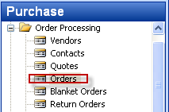

and (header and lines) created by F3, Enter, from the filed Buy from vendor by F6 enter any Vendor using local currency (e.g. 10000) and in the line Type=Account and account 8320 and 100 hours and the hours rate.

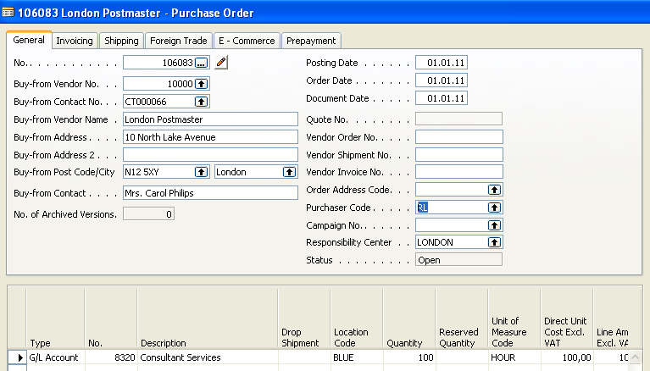

and enter Vendor Invoice number and F11. Do it again, but firstly use as a posting date 1.2.2011 (enter it manually) and secondly change hourly rate to 200. From the account 8320 You will get by use of Ctrl- 5 beside already created G/L Entries also entries created by above mentioned Purchase orders.

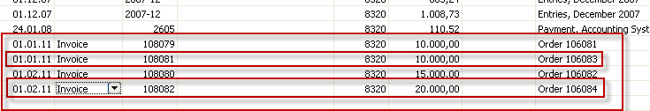

3. Creation of two sales order using same account 8320 .This account can be posted on debit and credit sides as well. Only change selling price to 250 . Make a choice of two different customers (10000 and 40000) for every sales order and enter by use of button Order check preset dimensions (different areas and Customer groups). Mind you, that order for the customer 10000 will be posted in January and order for the customer 40000 in February.

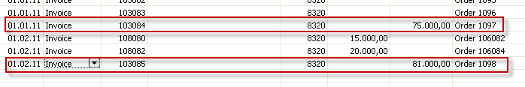

4. Creation of the budget.
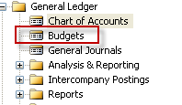

and

You will get matrix window where you enter manually expected amounts for period January and February 2011 and for account 8320. Create a new budget header for the Year 2011

do it as follows:
- put the cursor to the field and by F6 you will open lines where you enter two lines for different department codes and optionally also for Customer group Code dimension (the choice by use of F6) and area code. This will be used as a dimensions for later analysis .Enter suggested amounts and ESC.

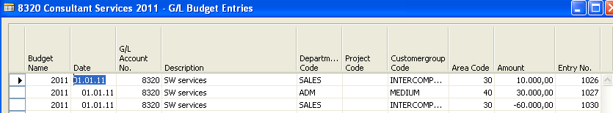

Where selling budget is 10000+30000 (Debit side) and purchase is -60000= Credit side

do it similarly for the second field (from budget windows) valid for February 2011 :

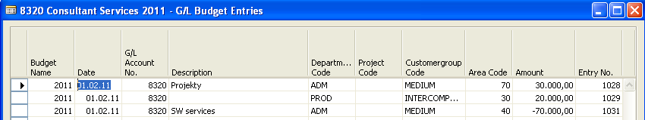

Where selling budget is 30000+20000 (Debit side) and purchase is -70000= Credit side

and the budget matrix window be as follows :

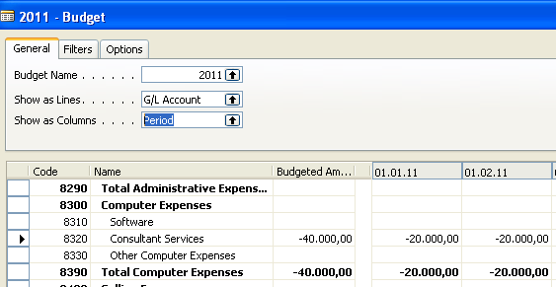

- Use a button Balance and G/L Balance/Budget and enter period manually 01.01.11..31.12.2011 and you will get

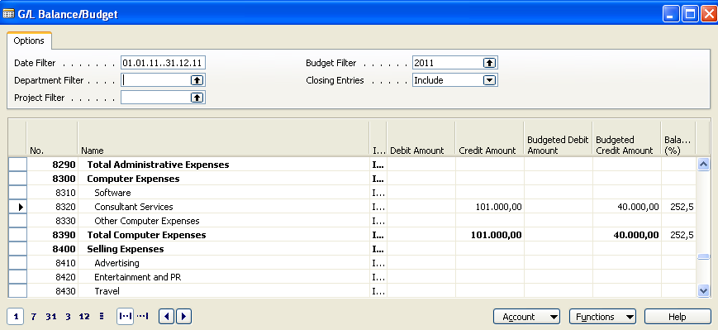
Try to explain the numbers !!! What will be the result if the sum of the amount on the credit will be smaller then the sum of the debit side amounts ?

6. Accounting schedule creation:

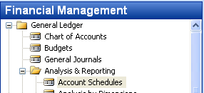

You will get some accounting schedule already created in demo. It could be e.g. :

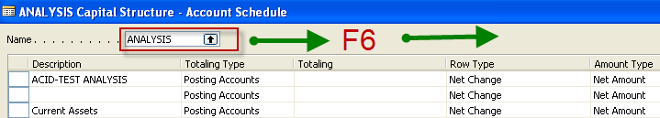

Enter the line Budget 2 (manually written) and from the marked field (see picture below) go to the already created Analysis view window. I could be look like this :

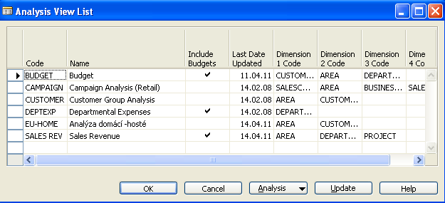

Go to the button Analysis to cerate your analysis view by F3 and put the data (parameters controlling accounting schedule view) . Budget 2 (manually two times).

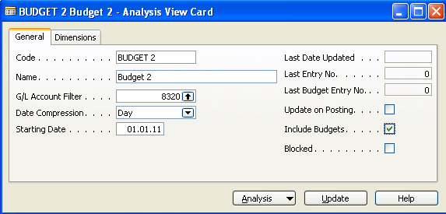

Go to the second tab and enter by F6 dimensions :

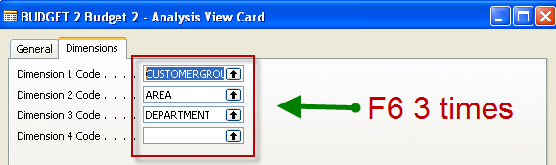

By use of Update button make Update an you will get :

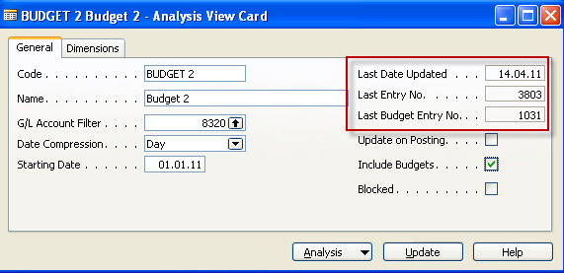

By ESC you will get a window below, where you see already entered dimensions . Enter OK and enter the template for the columns (Default columns layout) of the accounting schedule analysis:

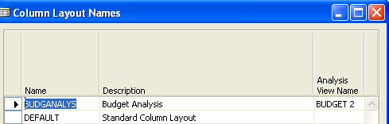

And OK. To see the column layout go to the

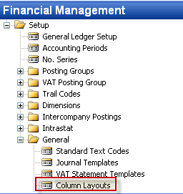

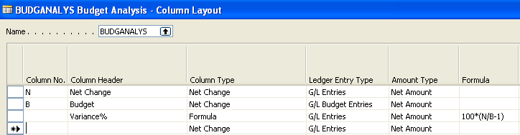

- Enter data as follow (from the menu bellow)

Row number manually, 8320 by F6 Description manually

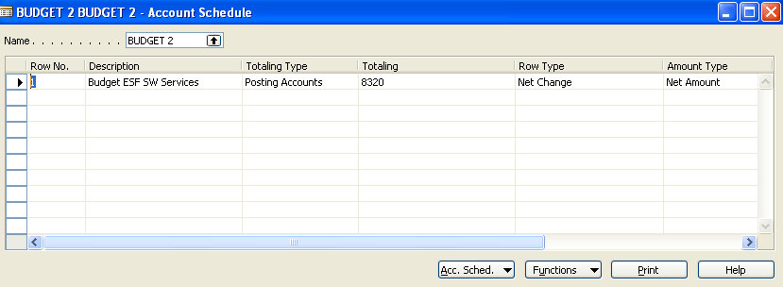

By use of button Acc.Schedule ->Overview and entering dates in Date filter 010111..311211 you will get the final result :
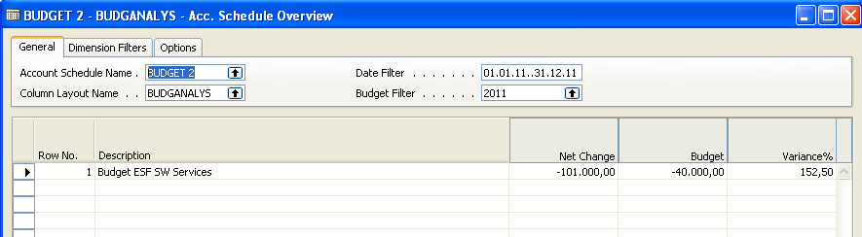

- You can use different Dimension filter (see tab) in order to see the impact of the dimensions

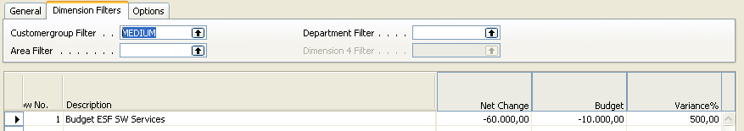
and another dimension added (Area) :

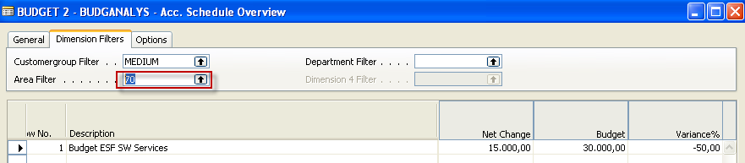

The calculation formula to calculate Variance % can be seen is in the column layout.
Account schedule name is Budget 2
Analysis of the G/L ledger entries and budget ledger entries

