Introduction to MS Dynamics ERP NAV 5.0 SP1 in concise clauses = part six
Created by : Jaromír Skorkovský
Date : 16.11.2011
Reason : Concise instrument helping in tuition and study
Accompanying mat. : no

Analysis

1. Basically in ERP system you create document (Sales orders, Purchase orders, Production orders, Credit Notes and so on. You register to the database all transaction connected to these documents by pressing F11. Then you create Item Ledger Entries, Customer Ledger entries, Dimension Entries, Vendor Entries, Value Entries and General ledger Entries. In order to get out of these records the reasonable reports you need a simple tool in order to create an easy reports.

2. Go to :

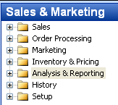

- From there you can open below stated menu and from this menu you can start already prepared analysis. This analysis consists of Name, Code for Line definition and code for column definition (see report below) :

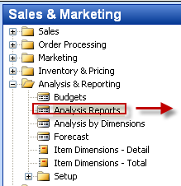
and the chosen report look like :
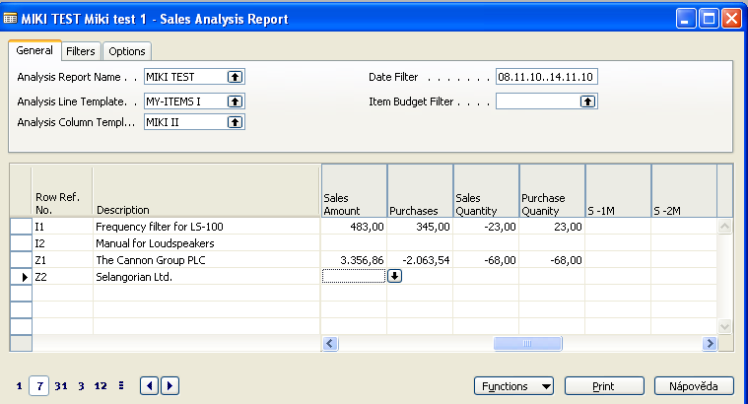
were you can see Analysis Line Template and Analysis Column Template shown below :

Line Template (example) :
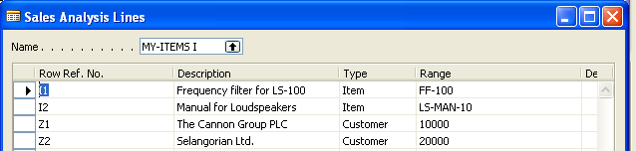

Column Template (example) :
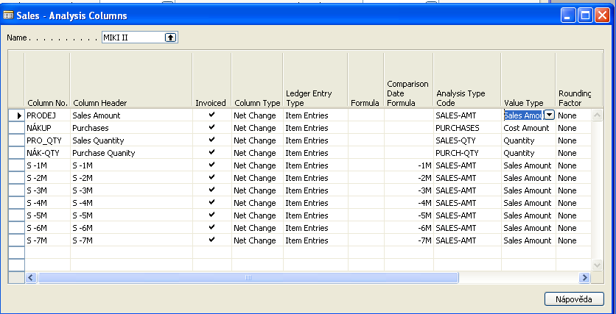

- Different report might look as follows :

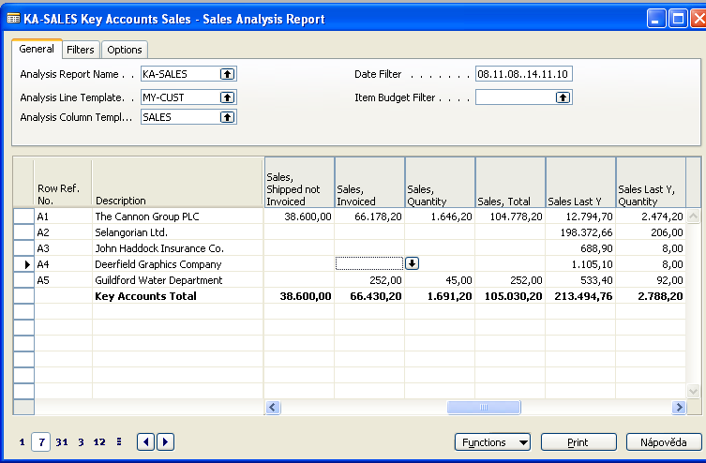

- Based on a simple rules you can create your own reports by definition of line and columns templates and chosen period and by use of filtering across dimensions as it is shown below :
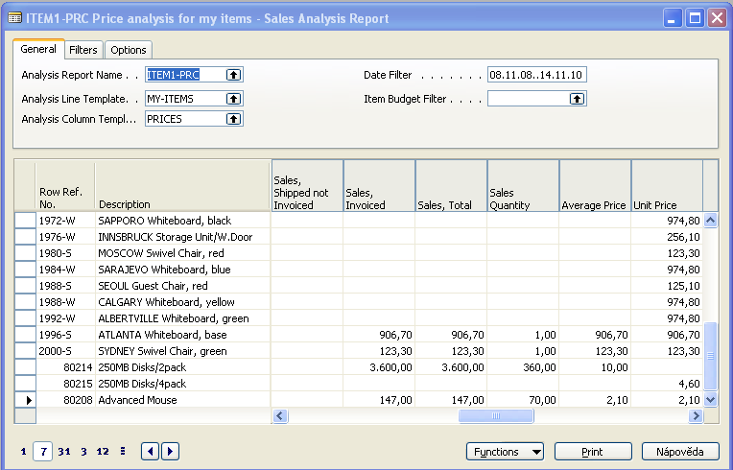

All Input Data for every above created report are different types of entries !!!!!!!!!

