The basic principles of applying open entries which were created by posting invoices, payment, credit notes…
Vytvořil (created) : Skorkovský
Datum (date) : 16.11.2010
Důvod (reason) : učební text (study material)

Invoice <->Credit Notes

- Create invoice by selling an item :

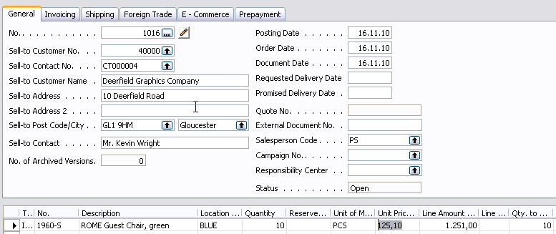

- Post it by F11 and go to Customer 40000 and Ctrel-F5 observe entries :

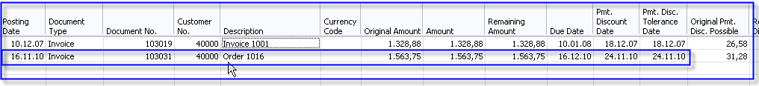

- Create manually Return Order (mind you that you have to show in the selling line a field Apply from Item Entry see marked filed where you wiil choose appropriame sales entry by F6

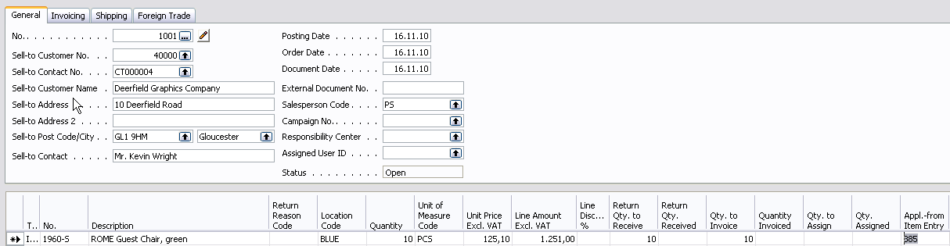

- Post it by F11 and you will se customer ledger entries as follows :
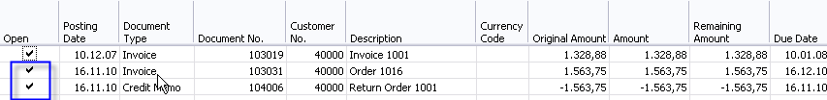

As you can see , when manually created return order (not by using function copy document) the credit note is created, but is t not applied to any invoice.

- From Customer Ledger Entries window use button Function->Apply Entries (Shift-F9)

And you will get :

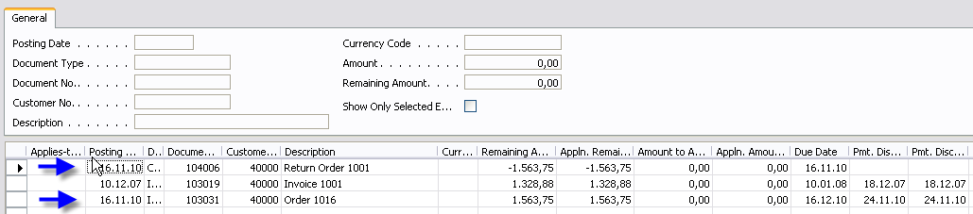

Where first and third line should be applied by tools as it will be shown:

- Put the cursor to one lien – e.g. Credit note and from the button Application (Vyrovnání) make a choice of Set Applying Entry (Shift-F9) . The amount will be transferred to th header of the window and on the lower part of the window you will get only two lines :
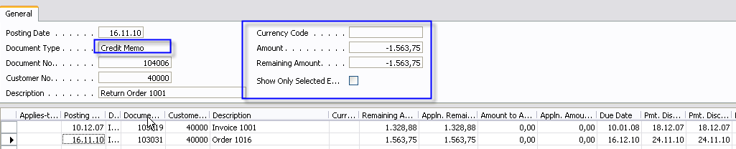

- Move cursor to the entry which will be applied and mark it by F9 (See Application button for meaning of it(Set Apply to ID):
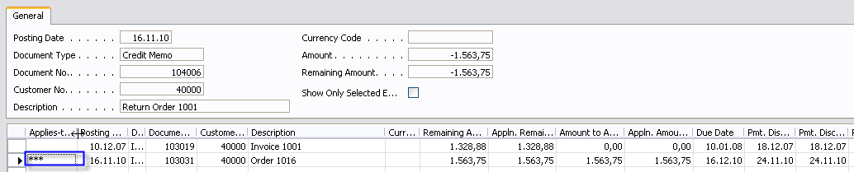

Instead of *** you will have 1 because this is the ID of the User.

- Post Application by F11 and you will get :

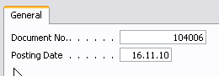

- Make OK button :

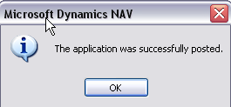

and entries will be closed (applied) :

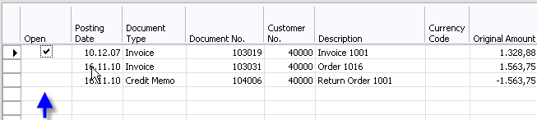

- To make a training you can from the button Function make a Unapply Entries and start again to Apply by Shift-F9.

