The French imperfect (imparfait) is a descriptive past tense which indicates an ongoing state of being or a repeated or incomplete action. The beginning and end of the state of being or action are not indicated, and the imperfect is very often translated in English as "was" or "was ___-ing." The imperfect can indicate any of the following:
I. Habitual actions or states of being
Quand j'étais petit, nous allions à la plage chaque semaine.
When I was young, we used to go to the beach every week.
L'année dernière, je travaillais avec mon père.
I worked with my father last year.
II. Physical and emotional descriptions: time, weather, age, feelings
Il était midi et il faisait beau.
It was noon and the weather was nice.
Quand il avait 5 ans, il avait toujours faim.
When he was five, he was always hungry.
III. Actions or states of an unspecified duration
Je faisais la queue parce que j'avais besoin de billets.
I stood in line because I needed tickets.
Il espérait te voir avant ton départ.
He was hoping to see you before you left.
IV. Background information in conjunction with the passé composé
J'étais au marché et j'ai acheté des pommes.
I was at the market and I bought some apples.
Il était à la banque quand il l'a trouvé.
He was at the bank when he found it.
Generally speaking, the imperfect describes past situations, while the passé composé narrates specific events. In addition, the imperfect can set the stage for an event expressed with the passé composé. Compare the uses of these two tenses:
1. Incomplete vs Complete
The imperfect describes an ongoing action with no specified completion:
J'allais en France. - I was going to France.
Je visitais des monuments et prenais des photos. - I was visiting monuments and taking pictures
The passé composé expresses one or more events or actions that began and ended in the past:
Je suis allé en France. - I went to France.
J'ai visité des monuments et pris des photos. - I visited some monuments and took some pictures.
2. Habitual vs Occasional
The imperfect is used for habitual or repeated actions, something that happened an uncounted number of times:
Je voyageais en France tous les ans. - I traveled (used to travel) to France every year.
Je visitais souvent le Louvre. - I often visited the Louvre.
The passé composé talks about a single event, or an event that happened a specific number of times:
J'ai voyagé en France l'année dernière. - I traveled in France last year.
J'ai visité le Louvre trois fois. - I've visited the Louvre three times.
3. Ongoing vs New
The imperfect describes a general physical or mental state of being:
J'avais peur des chiens. - I was afraid of dogs.
J'aimais les épinards. - I used to like spinach.
The passé composé indicates a change in physical or mental state at a precise moment or for an isolated cause:
J'ai eu peur quand le chien a aboyé. - I was scared when the dog barked.
Pour la première fois, j'ai aimé les épinards. - For the first time, I liked spinach.
4. Background + Interruption
The imperfect and passé composé sometimes work together - the imperfect provides a description/background info, to set the scene of how things were or what was happening (past tense of "be" + verb with -ing usually indicates this) when something (expressed with the passé composé) interrupted.
J'étais à la banque quand Chirac est arrivé. - I was at the bank when Chirac arrived.
Je vivais en Espagne quand je l'ai trouvé. - I was living in Spain when I found it.

Once you understand the different uses of the imperfect and passé composé as explained on page 2, take a look at these passages to compare how these two French past tenses may be used.
Imperfect
Quand j'avais 15 ans, je voulais être psychiatre. Je m'intéressais à la psychologie parce que je connaissais beaucoup de gens très bizarres. Le week-end, j'allais à la bibliothèque et j'étudiais pendant toute la journée.
When I was 15, I wanted to be a psychiatrist. I was interested in psychology because I knew a lot of really weird people. On the weekends, I used to go to the library and study all day.
Passé composé
Un jour, je suis tombé malade et j'ai découvert les miracles de la médecine. J'ai fait la connaissance d'un médecin et j'ai commencé à étudier avec lui. Quand la faculté de médecine m'a accepté, je n'ai plus pensé à la psychologie.
One day, I got sick and discovered the wonders of medicine. I met a doctor and started studying with him. After the medical school accepted me, I didn't think about psychology any more.
Indicators
The following key words and phrases tend to be used with either the imperfect or the passé composé, so when you see any of them, you know which tense you need:
Imperfect |  | Passé composé
chaque semaine, mois, année | every week, month, year | une semaine, un mois, un an | one week, month, year
le week-end | on the weekends | un week-end | one weekend
le lundi, le mardi... | on Mondays, on Tuesdays... | lundi, mardi... | on Monday, on Tuesday
tous les jours | every day | un jour | one day
le soir | in the evenings | un soir | one evening
toujours | always | soudainement | suddenly
normalement | usually | tout à coup, tout d'un coup | all of a sudden
d'habitude | usually | une fois, deux fois... | once, twice...
en général, généralement | in general, generally | enfin | finally
souvent | often | finalement | in the end
parfois, quelquefois | sometimes | plusieurs fois | several times
de temps en temps | from time to time
rarement | rarely
autrefois | formerly

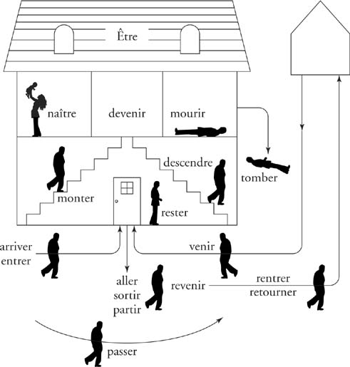

TABLE 1 | Verbs Using Être

 | Verb | Past Participle
D | devenir (to become) | devenu*
R | revenir (to come back) | revenu*
M | mourir (to die) | mort*
R | retourner (to return) | retourné
S | sortir (to go out) | sorti
V | venir (to come) | venu*
A | arriver (to arrive) | arrivé
N | naître (to be born) | né*
D | descendre (to descend) | descendu
E | entrer (to enter) | entré
R | rentrer (to return) | rentré
T | tomber (to fall) | tombé
R | rester (to remain) | resté
A | aller (to go) | allé
M | monter (to go up) | monté
P | partir (to leave) | parti
P | passer (to pass by) | passé

